OS, SOFTWARE 2014-2015 (PAPER 1)

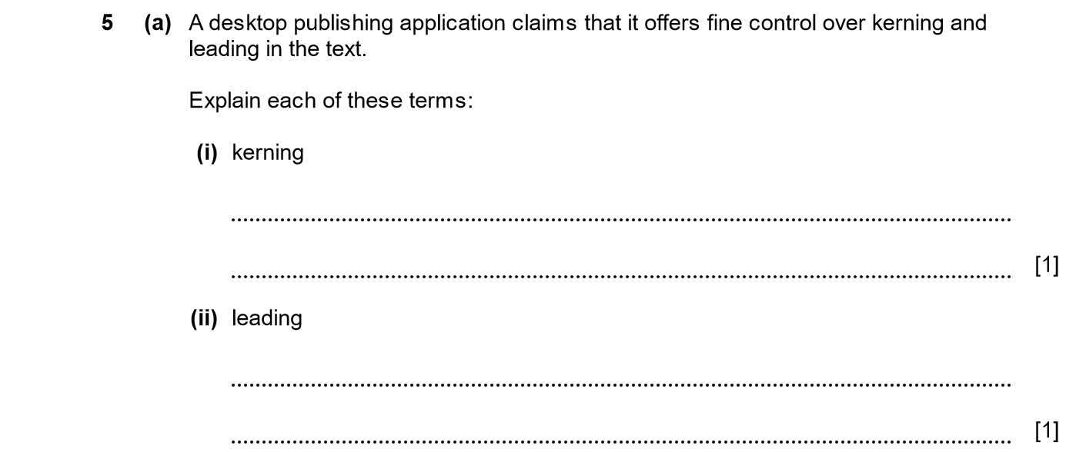
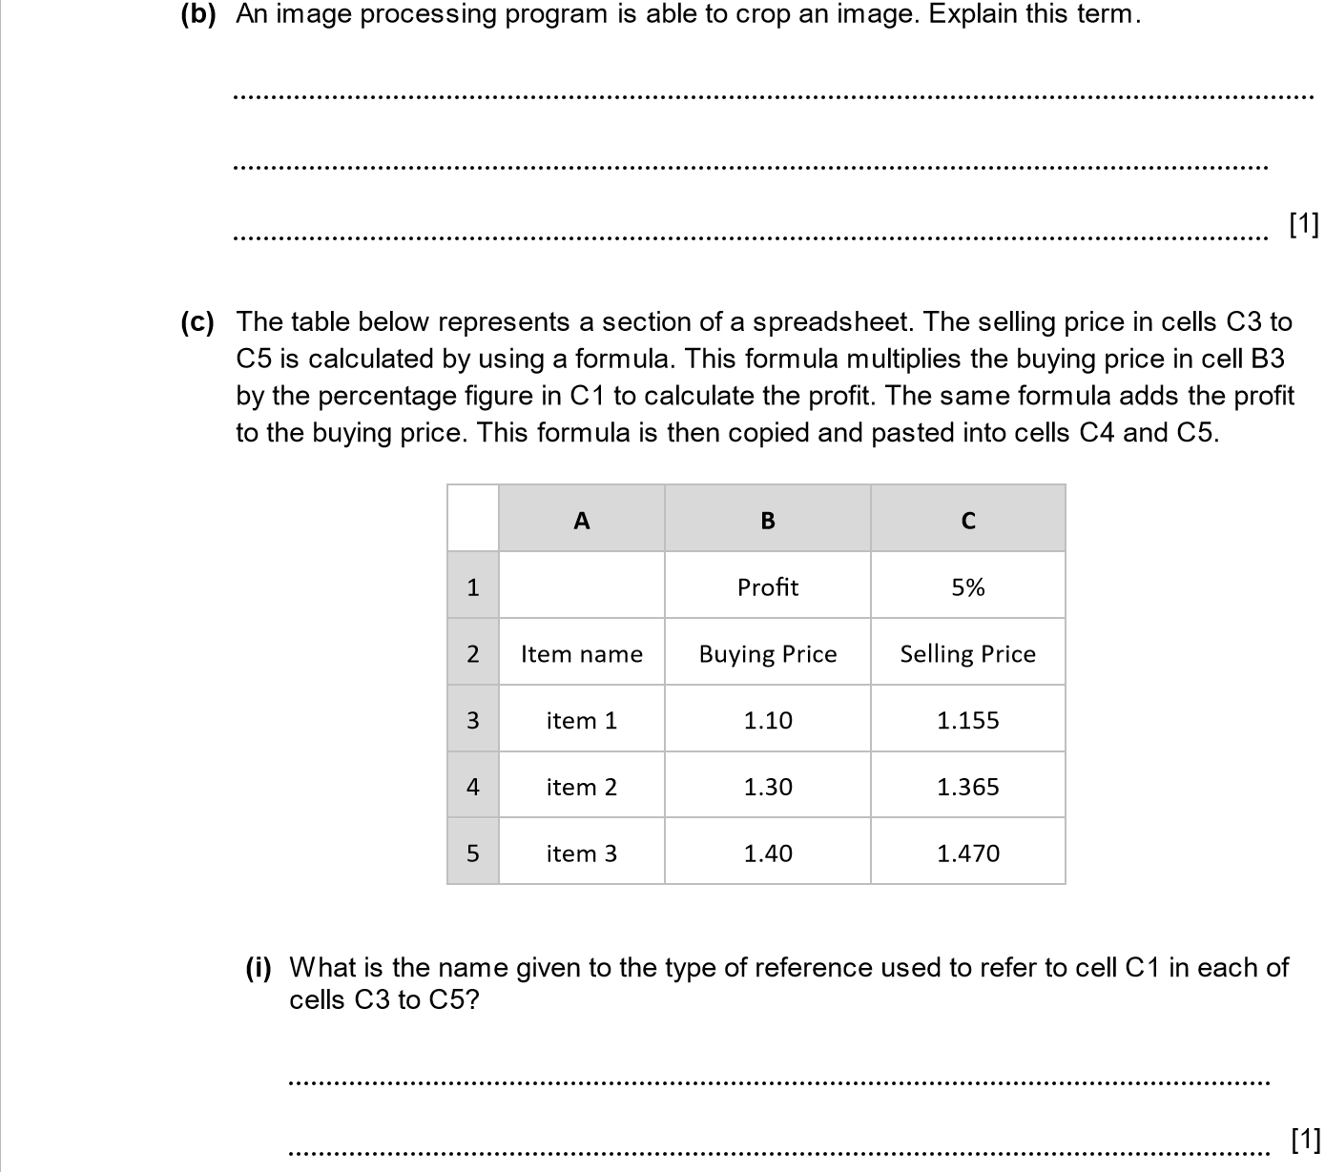
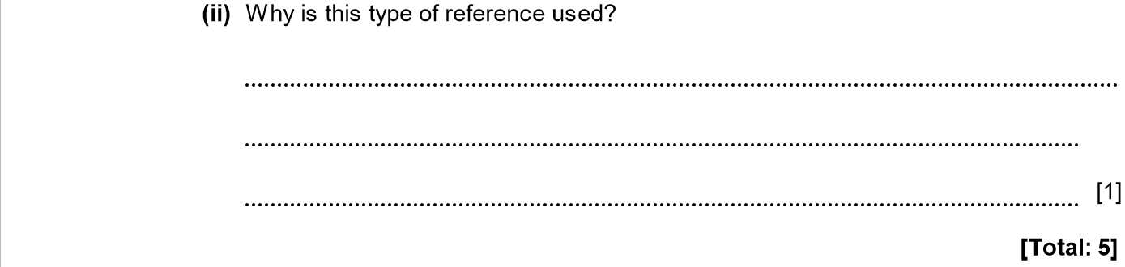

ANSWERS
Part | Answer | Mark | Additional Guidance
5 (a) (i) | Kerning refers to the spacing between letters in the word.  A package which can control kerning will allow pairs of letters to be moved together or apart to make text more readable.  Kerning refers to the automatic process of moving letters together or apart to improve readability. | 1 | Accept any one point for 1 mark.
(a) (ii) | Leading refers to the spacing between lines of text.  A package which can control leading will allow the spacing between lines of text to be controlled precisely.  Leading refers to automatically adjusting the spacing between lines in paragraphs or whole documents. | 1 | Accept any one point for 1 mark.
(b) | Image cropping means that areas of the picture can be removed as if with a pair of scissors or guillotine. | 1 | No need to refer to scissors or other tool.
(c) (i) | Absolute reference | 1
(c) (ii) | Absolute reference is used so that when the formula is entered in cell C3 it can be copied to C4, C5 and will still refer to the fixed cell C1 for profit but the selling price will be picked up from B4, B5 | 1
Total |  | 5

OS, SOFTWARE 2014-2015 (PAPER 1)

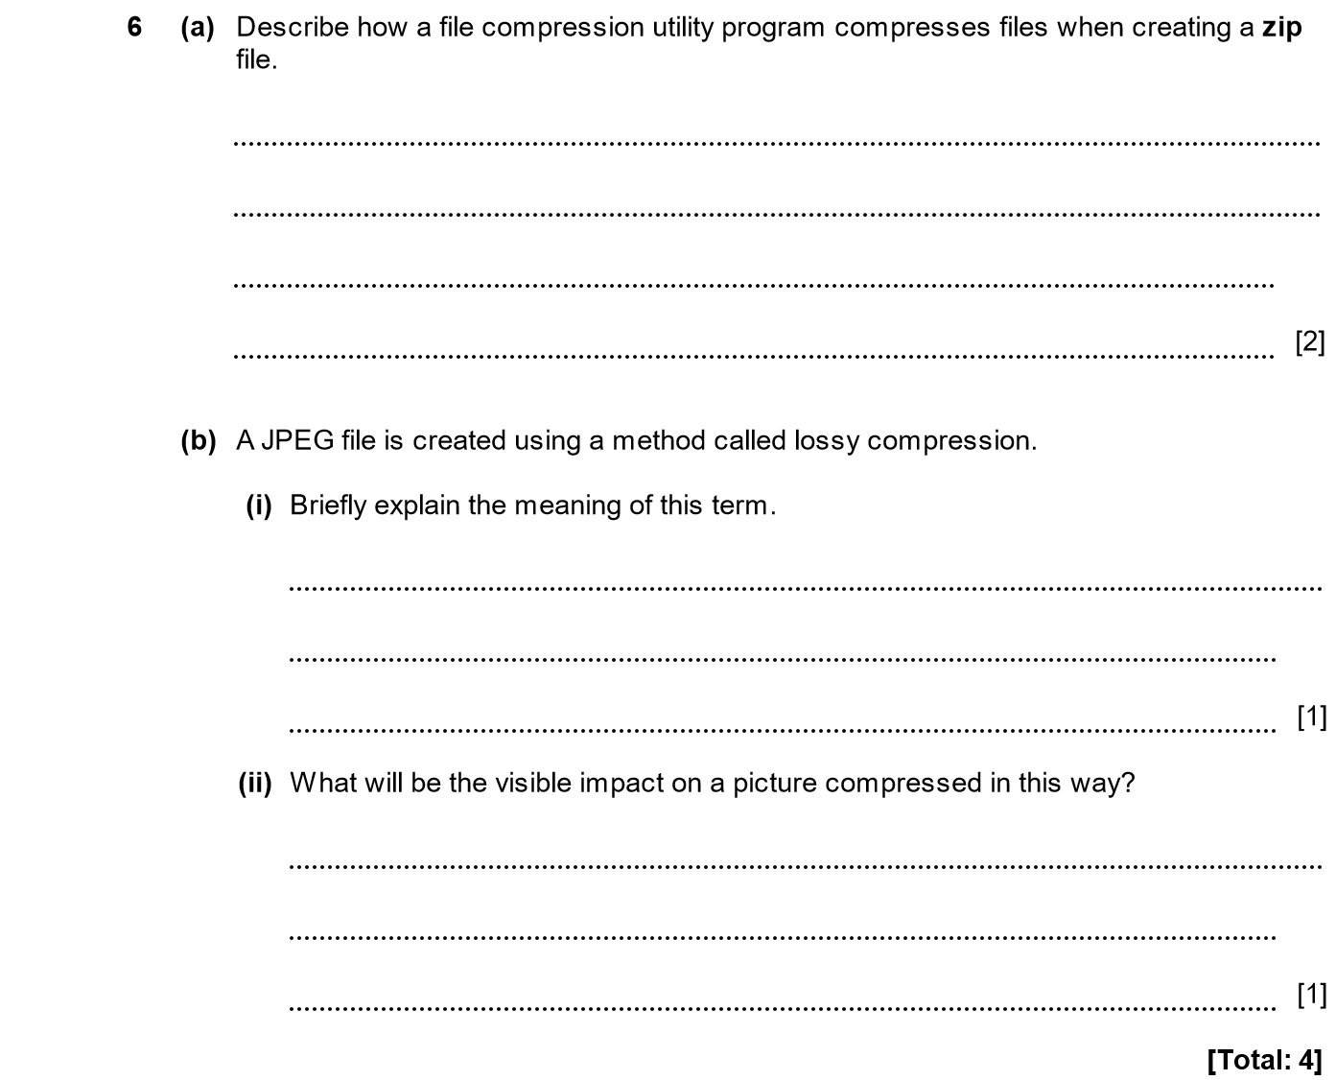

ANSWERS
Part | Answer | Mark | Additional Guidance
6 (a) | The compression programme will reduce the space taken up by each file using a compression algorithm.  The files are then combined into a single archive. | 1  1 | 1 mark for referring to space saving.  1 mark for referring to single archive created from multiple files.
(b) (i) | The file is compressed in a way which means that some data is lost and cannot be re-created. | 1
(b) (ii) | Fine detail is lost from the picture. There may be solid blocks of colour replacing shaded regions.  Artefacts may appear (for example mosquito noise). | 1  1  [Max 1] | Accept any one point.
Total |  | 4

OS, SOFTWARE 2014-2015 (PAPER 1)

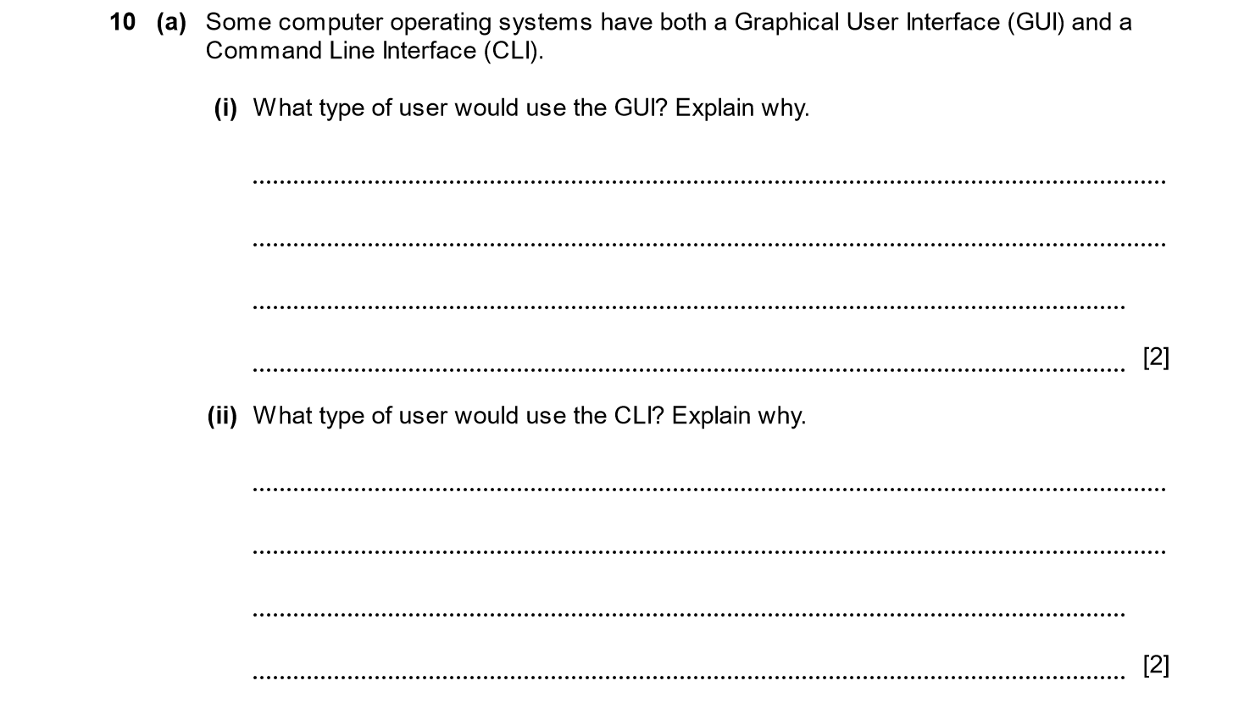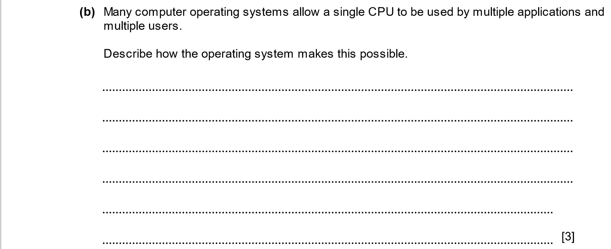
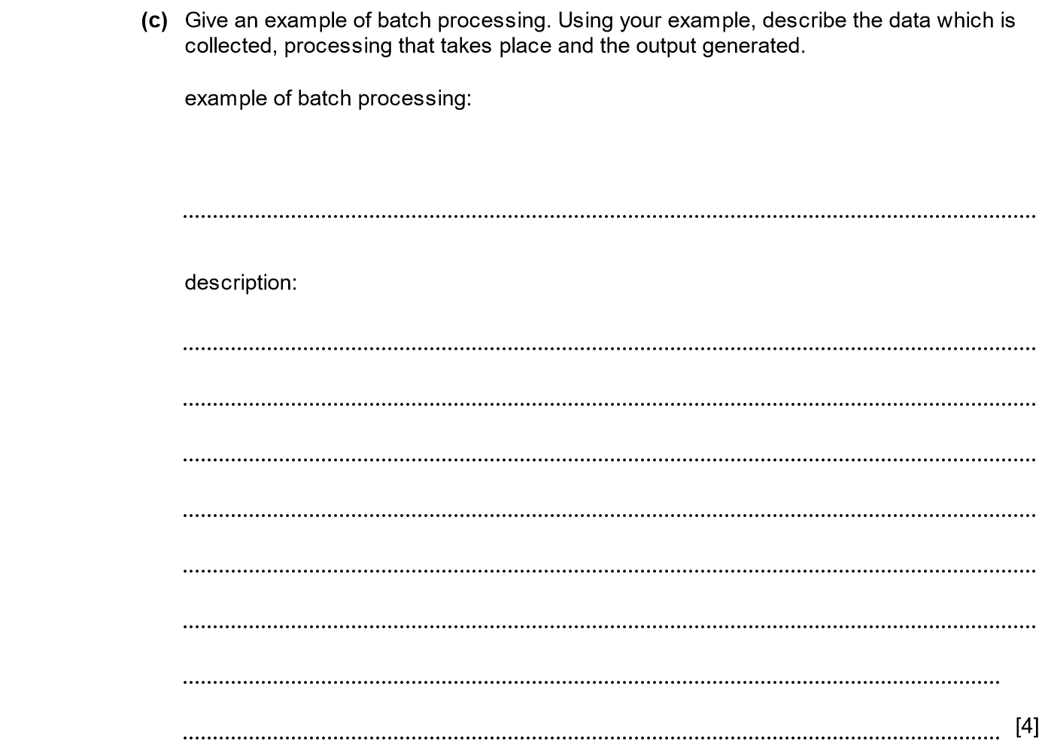
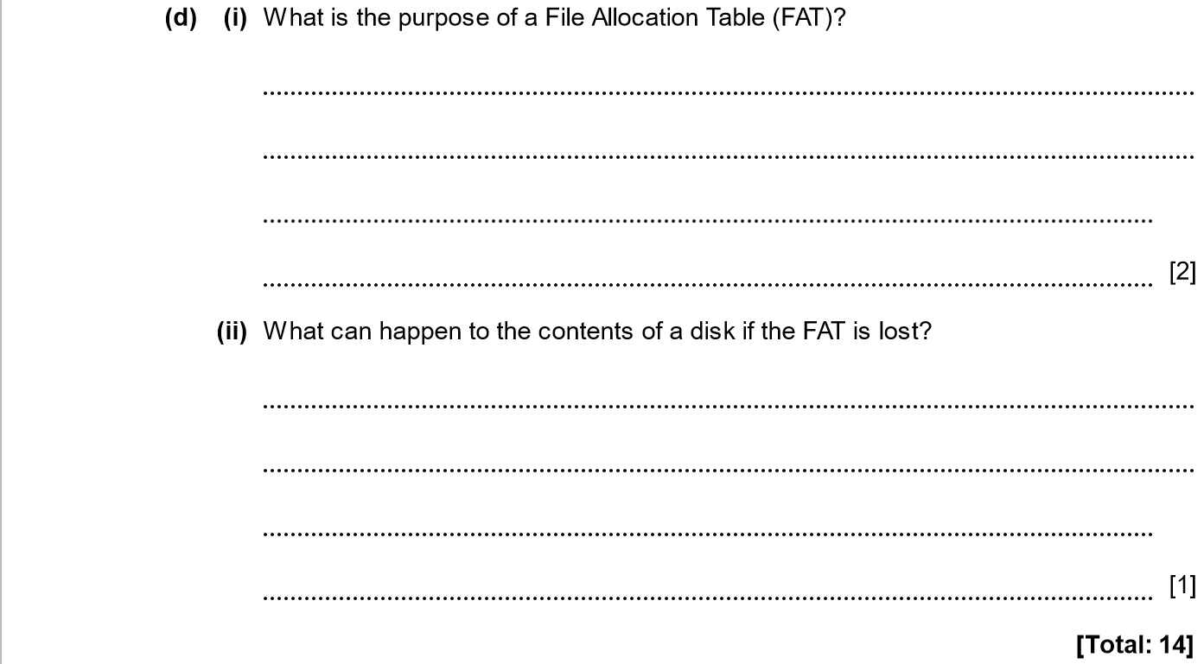

ANSWERS
Part | Answer | Mark | Additional Guidance
10 (a) (i) | The type of user for a GUI is a beginner/novice.  The interface is designed to provide guidance for each state of a process. | 1  1 | Accept answer where explanation fits with the type of user.  Accept reference to use of icons / menus to guide user.  Accept reference to no need to learn commands.
(a) (ii) | The type of user for a CLI is a more experienced or power user.  It is preferred for complex or repetitive tasks which are more likely to be done by an experienced or power user. | 1  1 | Accept answer where explanation fits with the type of user.  Accept reference too easy / rapid completion of repetitive tasks.
(b) | OS will schedule a small amount of time for each process and each user.  Provided that the time slices are small, each user will appear to have a responsive computer.  OS also needs to be able to allocate memory between processes so that enough is available.  At any time an interrupt can be generated, forcing the OS to move to processing a different process or user. | 1  1  1 | 1 mark for each of 3 reasonable points.
(c) | Batch processing could be used to handle payroll/utility bills/phone bills, etc.  Example (for payroll):  System has details of hours worked, amount paid per hour etc.  Carries out multiplication of rates and hours, calculation of tax and net pay for each person.  Output is payslips, output to bank etc. | 1  1  1  1 | 1 mark for example.  1 mark for data collected.  1 mark for processing.  1 mark for output.
(d) (i) | To share a record for each cluster of sectors (in a disk’s data region).  A record may contain:  - a link to the record of the next cluster (in a chain of clusters) used to store an unspecified file  - a value indicating end of chain (EOC) of clusters allocated to an unspecified file  - a value indicating an unused / free cluster  - a value a bad / unusable cluster |  | 2 | Accept any two reasons.
(d) (ii) | If the FAT is lost then none of the files can be read and all data is lost.  If there is a backup copy of the FAT then this can be used to access the data.  Data recovery software may be needed to recover the data. |  | 1  1  1  [Max 1]
Total |  |  | 14

OS, SOFTWARE 2015-2016 (PAPER 1)

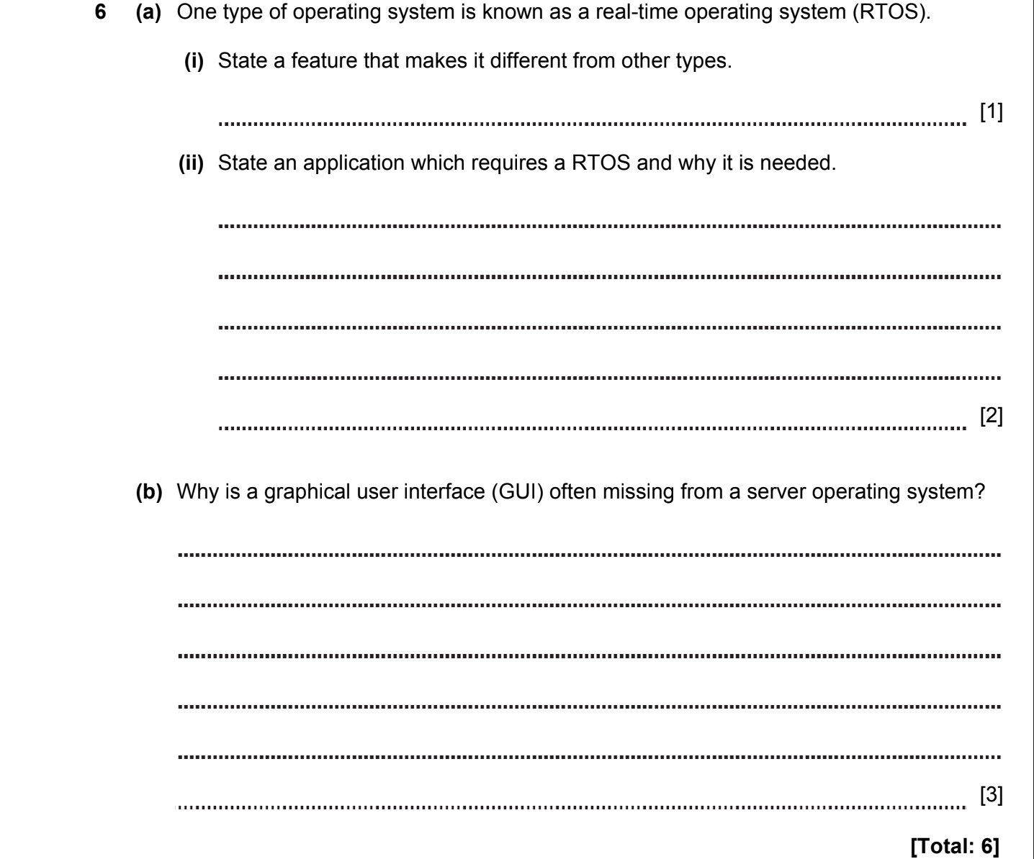

ANSWERS
6a) A real-time system is defined as a data processing system in which the time interval required to process and respond to inputs is so small that it controls the environment.

6b)
Real-time operating systems are commonly used in life-saving situations. It is enough to consider examples:
- flight control system
- the patient life support system in intensive care (heart rate monitoring)
- radar systems
- satellite monitoring systems
- oil refinery
- manufacture control
- computer games
- controlling robots

6c) The server OS is focused on the CLI. Real-time operating systems offten server OS, and are as follows:
Limited Tasks
Use Heavy System Resources
Complex Algorithms

OS, SOFTWARE 2016-2017 (PAPER 1)

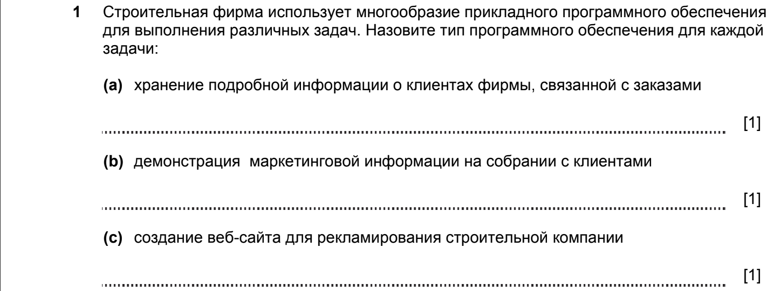

ANSWERS
Part |  |  | Answer | Mark | Additional Guidance
1 | (a) |  | Database | 1
 | (b) |  | Presentation or video | 1
 | (c) |  | Web authoring software | 1
Total |  |  |  | 3

OS, SOFTWARE 2017-2018 (PAPER 1)

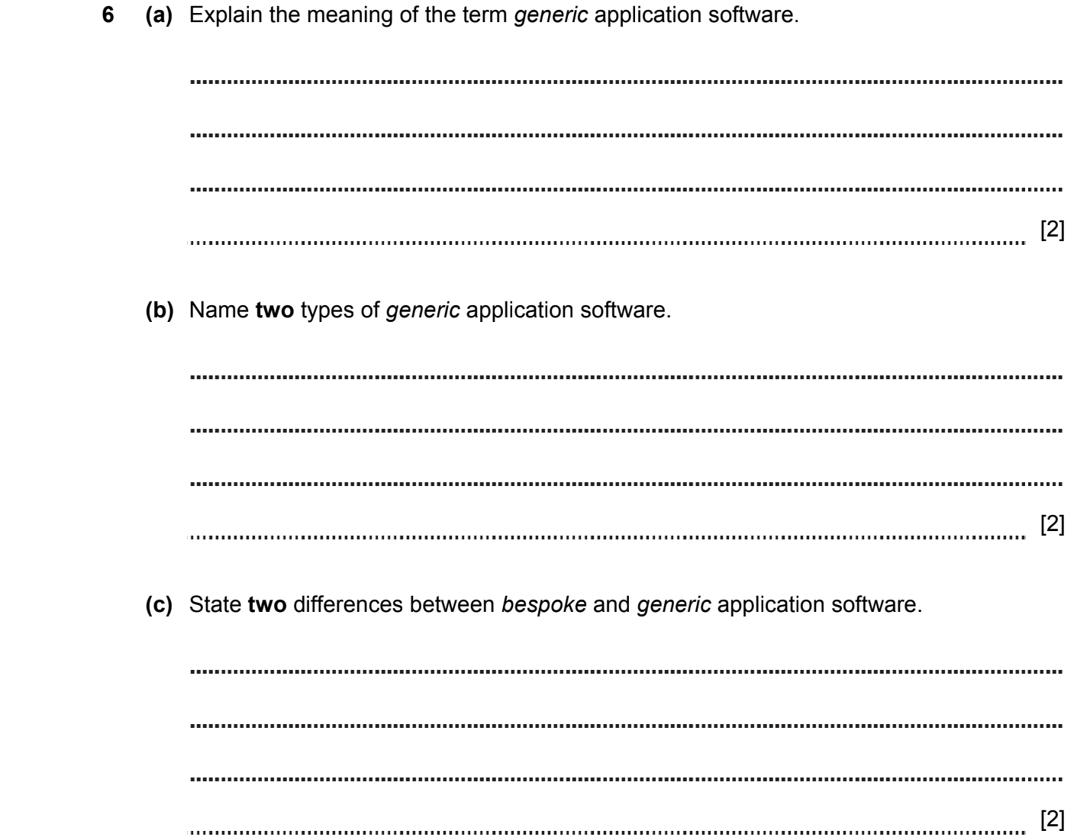
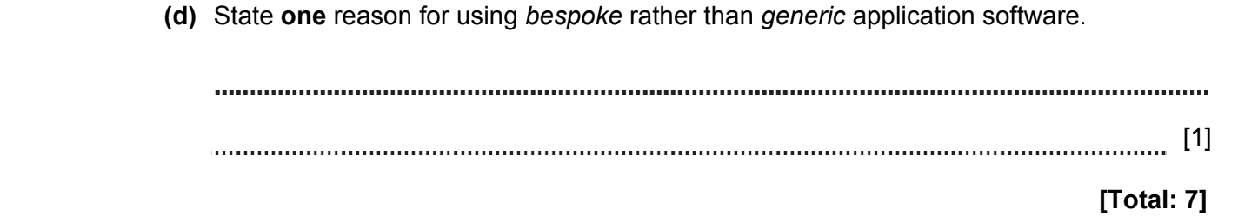

ANSWERS
Part | Answer | Mark | AO | Further Information
6(a) | Generic application software can perform many different tasks  Generic application software is general purpose software  Users can use it in different ways  Consider the interface between user and software | 1  1  1  [max 2] | AO1 | 2 marks in any case.  Because inaccurate translation into Russian.
(b) | Spreadsheet.  Word processor.  Presentation.  Graphics. | 1  1  1  1  [max 2] | AO1 | 2 marks in any case.  Because inaccurate translation into Russian.
(c) | Bespoke software is written for a specific purpose.  Bespoke software only has one use and may only be used by a specific company. | 1  1 | AO1 | Accept opposite characteristics of generic software.  Accept answers with reference to the development time needed.
(d) | It is used because it exactly meets the needs of the user / company. | 1 | AO1
Total |  | 7

OS, SOFTWARE 2017-2018 (PAPER 1)

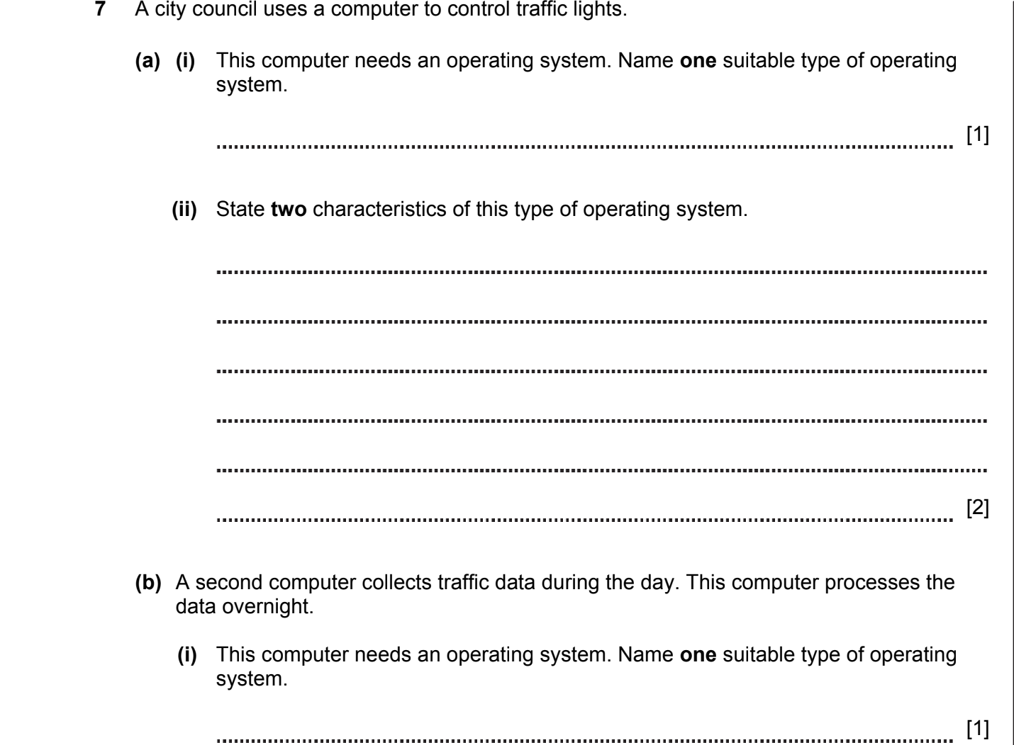
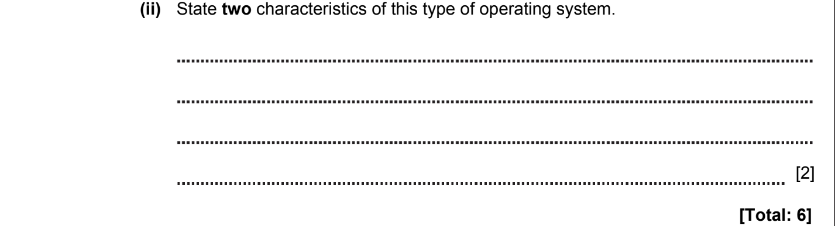

ANSWERS
Part | Answer | Mark | AO | Further Information
7(a)(i) | Real time (operating system). | 1 | AO2 | Allow RTOS.
(ii) | Captures rapidly occurring events / data.  It immediately processes data and makes decisions in real time.  The operation should be processed in exact time slot. | 1  1  1  [max 2] | AO1 | Allow other suitable answers.
(b)(i) | Batch (operating system). | 1 | AO2
(ii) | No data processing takes place during the day.  All the data is stored.  Data is processed in batches. | 1  1  1  [max 2] | AO1 | Allow other suitable answers.  Example,  Doesn’t need human’s intervention for data capture.  Data will be processed after it is collected.
Total |  | 6

OS, SOFTWARE 2017-2018 (PAPER 1)

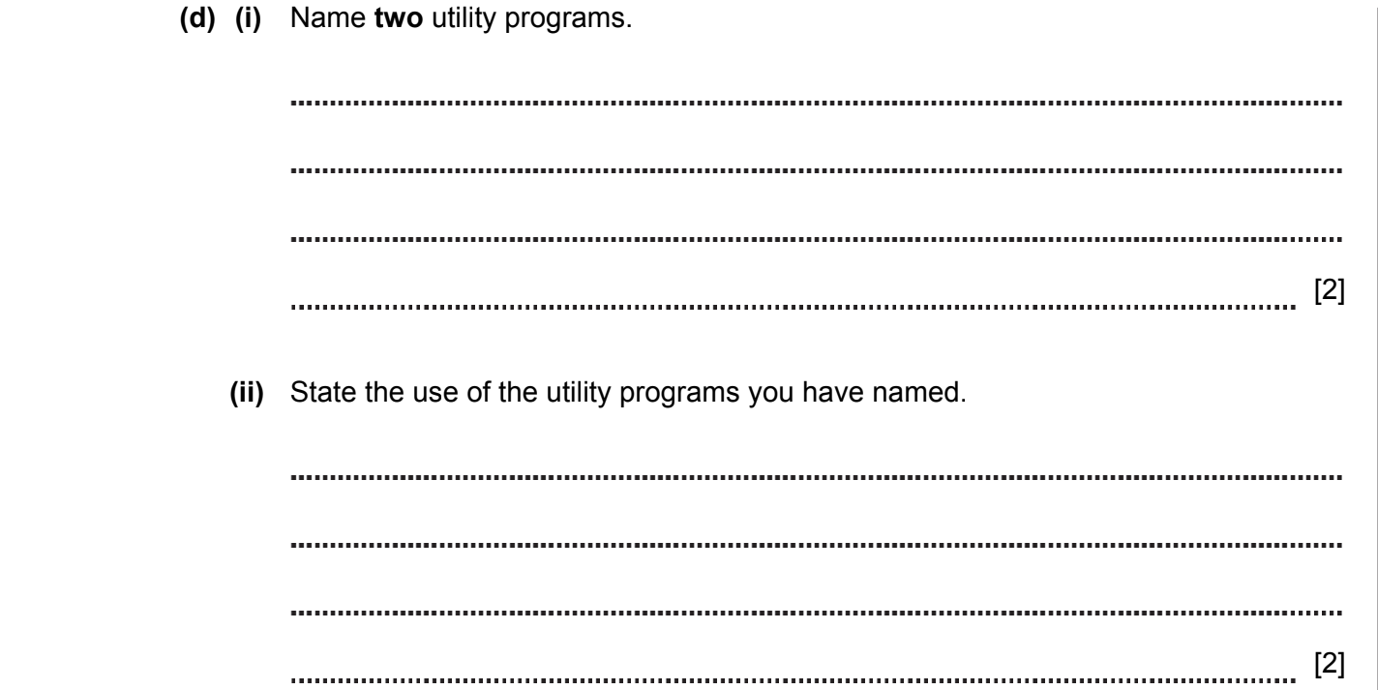

ANSWERS
Part | Answer | Mark | AO | Further Information
(d)(i) | Compression  Backup  Virus scanner  Defragmenter | 1  1  1  1  [max 2] | AO1 | Allow other examples of utility programs  Allow brand names
(ii) | Compression:  Used to compress files to reduce usage of disk space  Used to optimise disk space  Backup:  Used to make copies of files elsewhere to avoid data loss  Virus Scanner:  Scans the computer to find and remove malware / viruses  Protects the computer from viruses  Isolates / quarantines viruses once they are found  Defragmenter:  Used to organise the distribution of data in the hard drive to be more efficient  Increases read / write speeds  Increases hard drive efficiency | 1  1  1  1  [max 2] | AO1 | Allow other reasonable descriptions.  Max 1 mark per description of utility

OS, SOFTWARE 2017-2018 (PAPER 2)

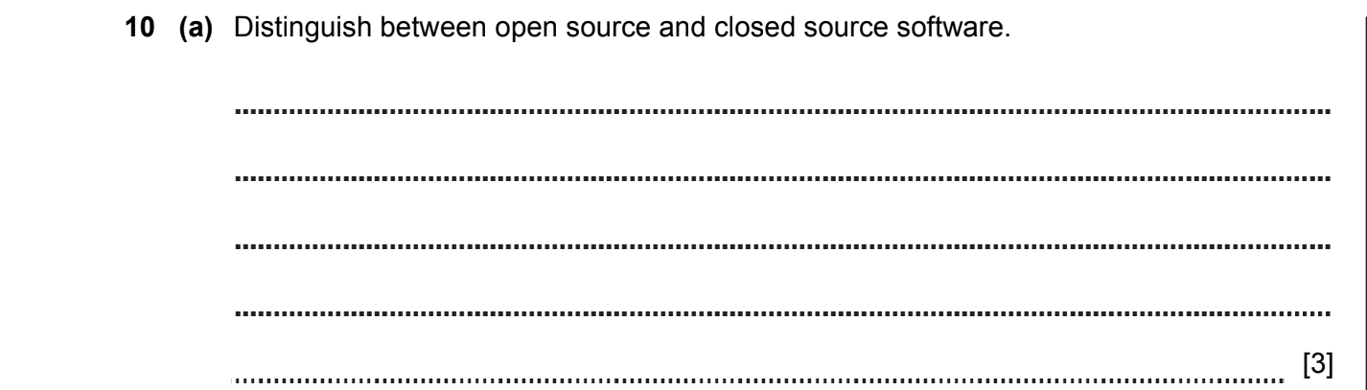

ANSWERS
Part | Answer | Mark | AO | Further Information
10(a) | Open source software means that the source code of the program can be seen by anyone | 1 | AO1 | Max 2 marks from  these points
10(a) | OR  closed source only allows the binary content to be used | 1 | AO1 | Max 2 marks from  these points
10(a) | You can make changes to open source code | 1 | AO1 | Max 2 marks from  these points
10(a) | OR  You cannot make changes to closed source code | 1 | AO1 | Max 2 mark from  here
10(a) | Closed source software is subject to copyright | 1 | AO1 | Max 2 mark from  here
10(a) | Copyright in open source software is normally retained by the  author … | 1 | AO1 | Max 2 mark from  here
10(a) | … but you can make changes to it provided you acknowledge the original author | 1 | AO1 | Max 2 mark from  here
 |  | [max 3]

OS, SOFTWARE 2018-2019 (PAPER 1)
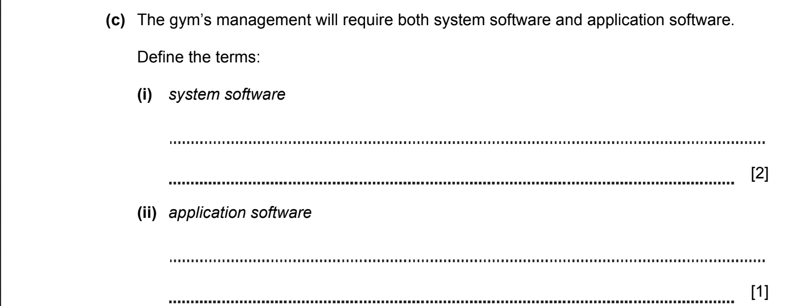
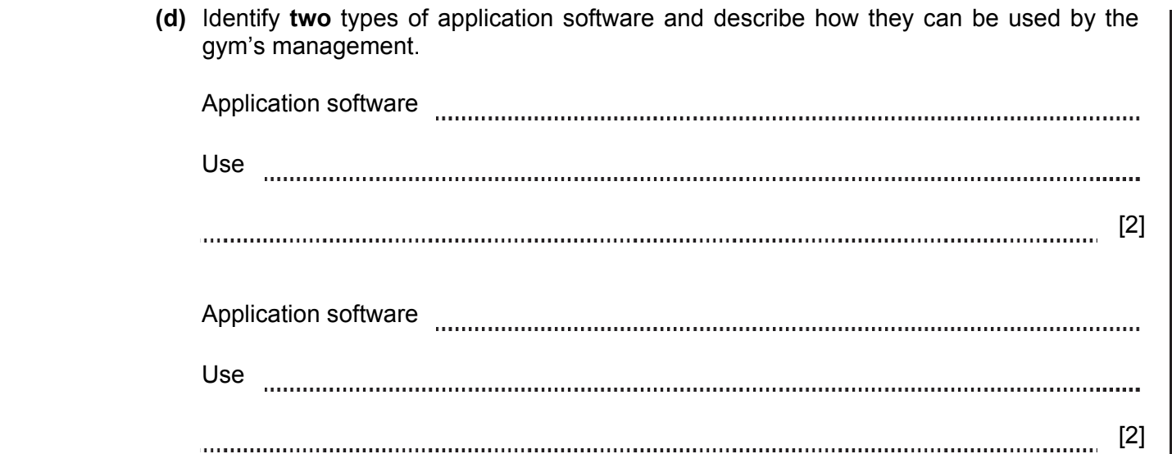

ANSWERS
Part | Answer | Mark | AO | Further Information
6(c)(i) | Software that controls the hardware.  Software that provides an interface on which the application software can run. | 1  1  [2] | AO1 | Accept other correct answers
6(c)(ii) | Software which allows users to perform tasks. | [1] | AO1
6(d) | Spreadsheets:  Tracking payments at the gym  Creating figures and analysing them  Calculating staff wages  Database:  Searching and filtering members’ data  Can be used for recording membership details  Image editing:  Creating membership cards  Word processor:  Writing letter to gym members  Merging documents | 1  1  1  1  1  1  1  1  1  1  1  1  [Max 4] | AO2 | Max per suitable application: 2 marks  Award 1 mark for identifying an application.  Award 1 mark for stating its use.  Accept other valid examples.

OS, SOFTWARE 2018-2019 (PAPER 1)

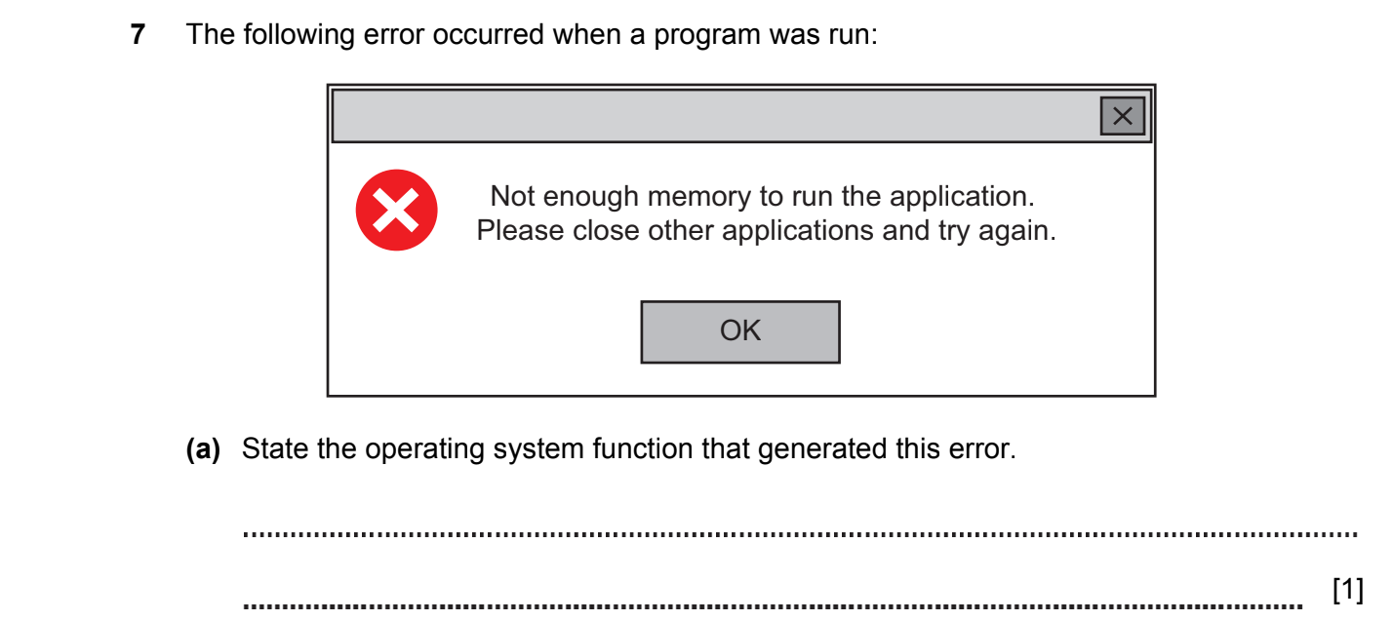

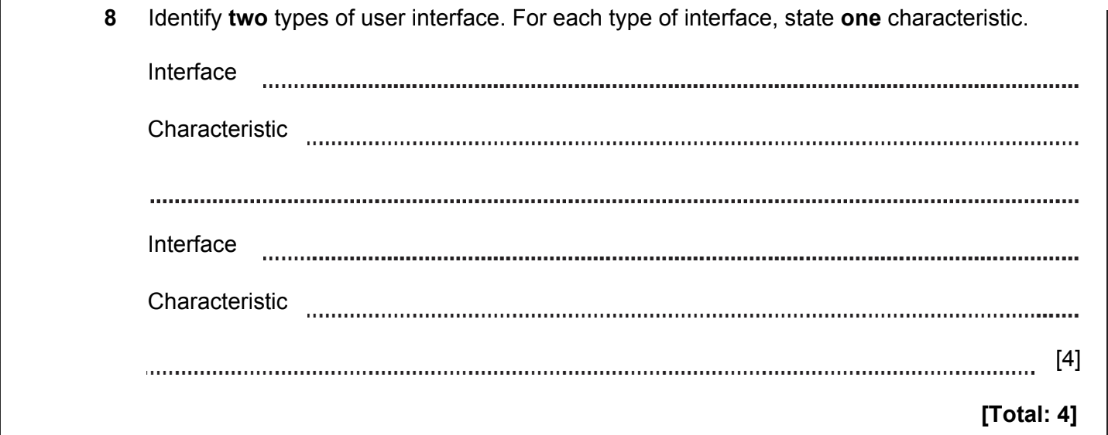

ANSWERS
Part | Answer | Mark | AO | Further Information
7(a) | Planning and organising of program processing  Resource allocation  Memory management | 1  1  1  [Max 1] | AO1

Part | Answer | Mark | AO | Further Information
8 | Graphical user interface or GUI  Interface that allows the user to interact with electronic devices through windows, icons, menus and pointers  Command-line interface or CLI  Interface that allows the user to interact with the computer by typing in commands | 1  1  1  1  [Max 4] | AO1 | Accept natural language and gesture recognition user interfaces.  Accept any other suitable example of an interface and characteristic.
 | TOTAL | 4

OS, SOFTWARE 2018-2019 (PAPER 1)

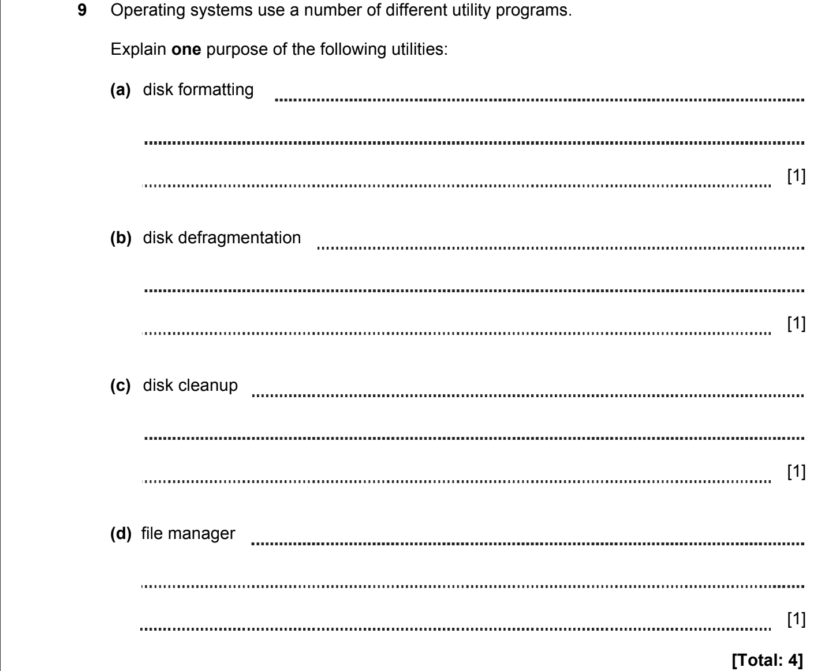

ANSWERS
Part | Answer | Mark | AO | Further Information
9(a) | Disk formatting prepares storage media for initial use.  Disk formatting can be used to remove all content from a disk. | 1  1  [Max 1] | AO1
9(b) | Disk defragmentation increases access speed  Disk defragmentation rearranges files (so that they are stored in contiguous locations) | 1  1  [Max 1] | AO1
9(c) | Disk cleanup is a program that deletes temporary files / removes unnecessary installation files | [1] | AO1
9(d) | File manager is a software program that helps a user manage all the files/ files and folders on their computer.  Allows copying, moving and deleting files. | 1  1  [Max 1] | AO1 | Accept any other suitable answer.
 | TOTAL | 4

OS, SOFTWARE 2020-2021 (PAPER 1)

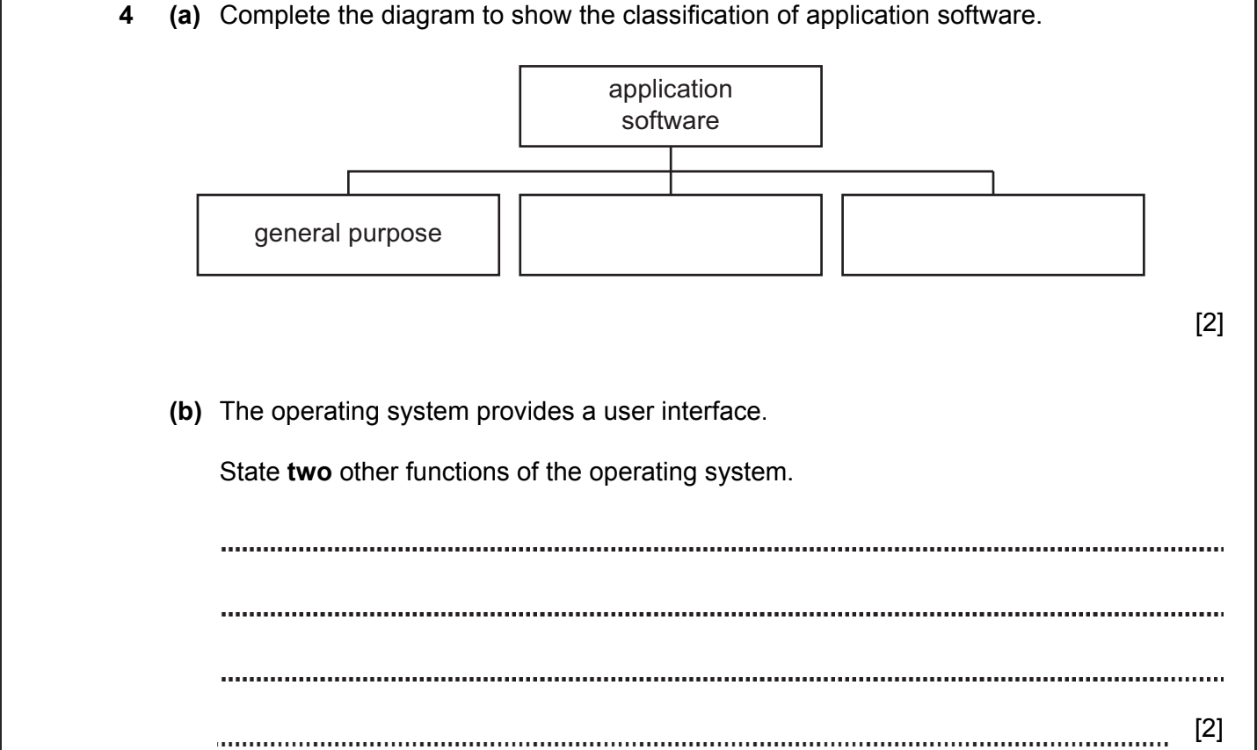
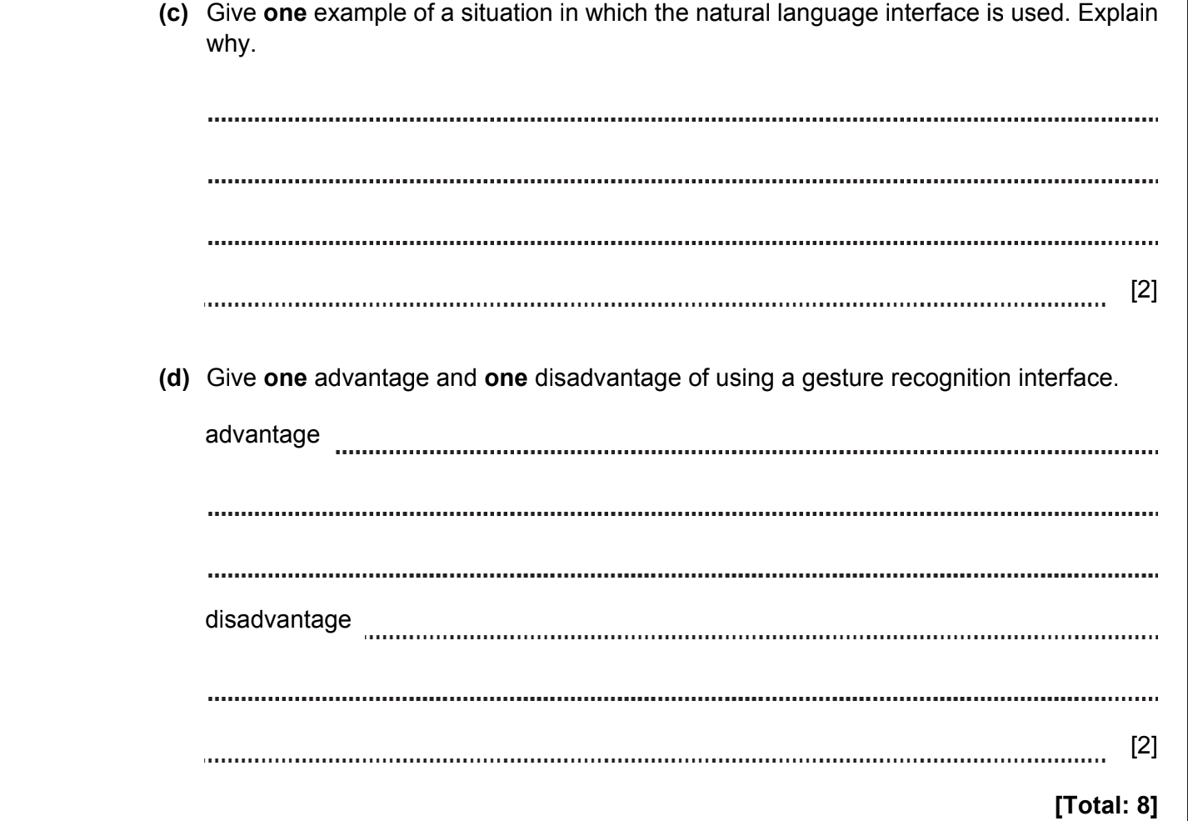

ANSWERS
4a | Specific / special purpose  Bespoke | 1  1  [2] |  | Accept ‘specialist software’ instead of ‘specific’
4b | Input-output and data management.  Allocation of resources (RAM and cache, processor, external devices).  Provides platform on which software applications can be run. | 1  1  1  [max 2] |  | Allow any reasonable answers.
4с | Disabled people such as a person who cannot use their hands.  They cannot type.  OR  A person in a factory.  His hands are occupied.  OR  Kid.  He cannot read/write. | 1  1  1  1  1  1  [max 2] |  | Allow any reasonable answers.
4d | Advantages  No physical contact is required.  OR  Communicate at a distance.  OR  Intuitive to use.  Disadvantages  Only simple commands can be used.  OR  Difficulties in interpreting gestures.  OR  Distance limitation (min, max). | 1  1  1  1  1  1  [max 2] |  | Allow any reasonable answers.  1 mark for advantage  1 mark for disadvantage
 | Total | 8

OS, SOFTWARE 2021-2022 (PAPER 1)

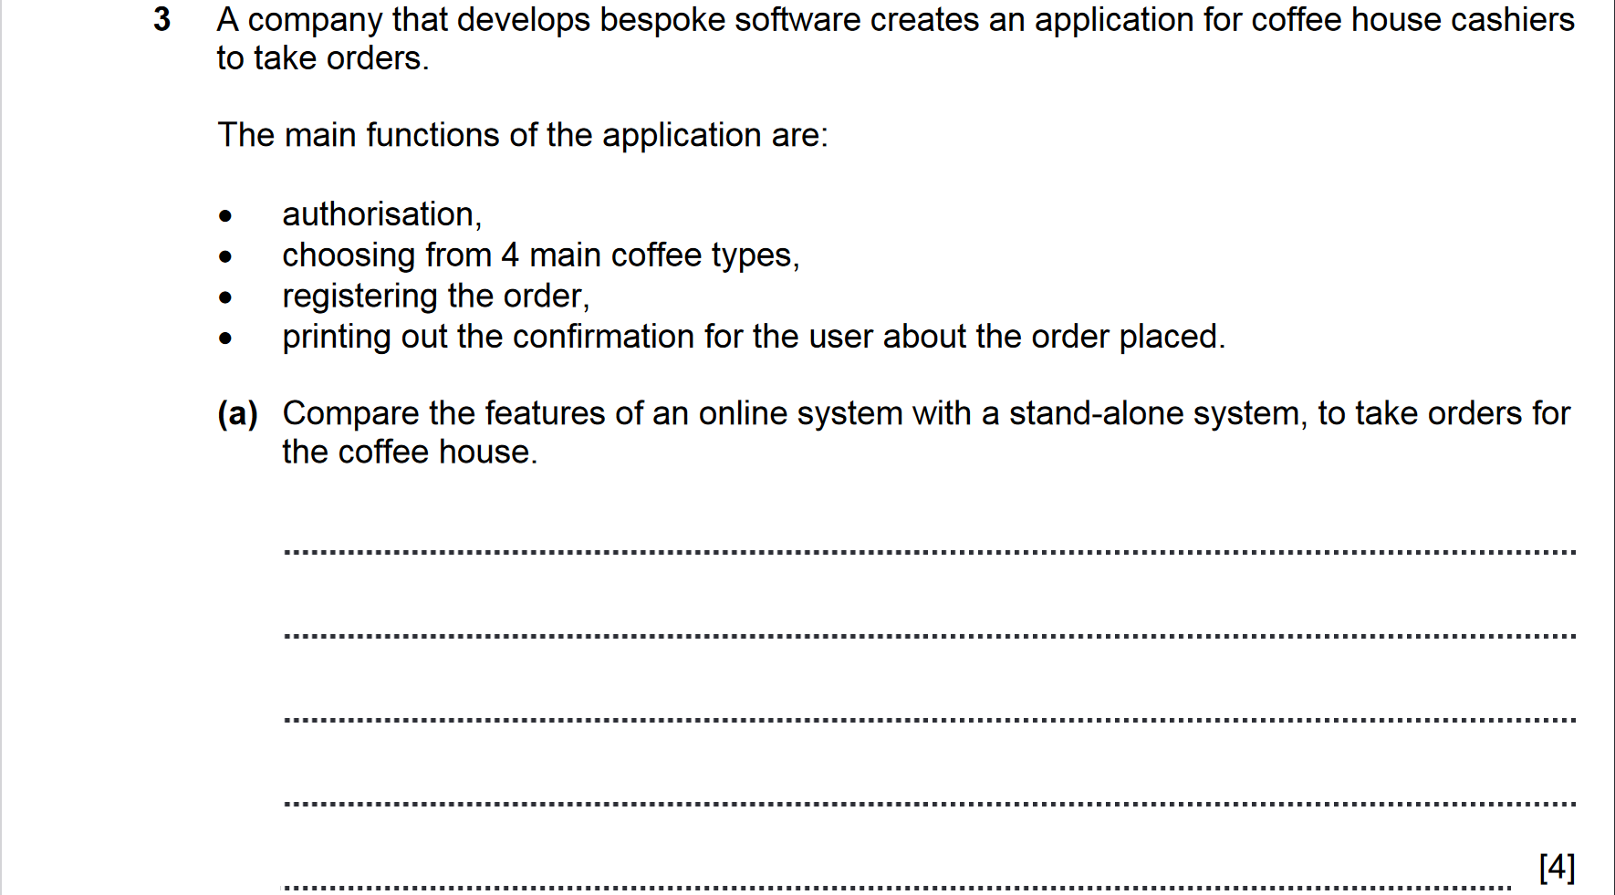
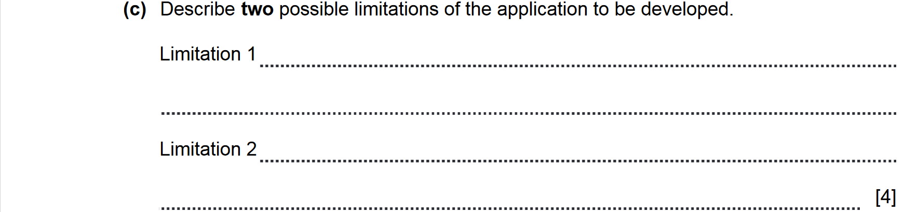

ANSWERS
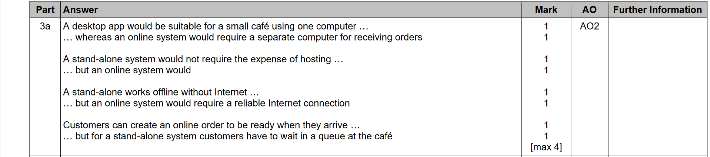
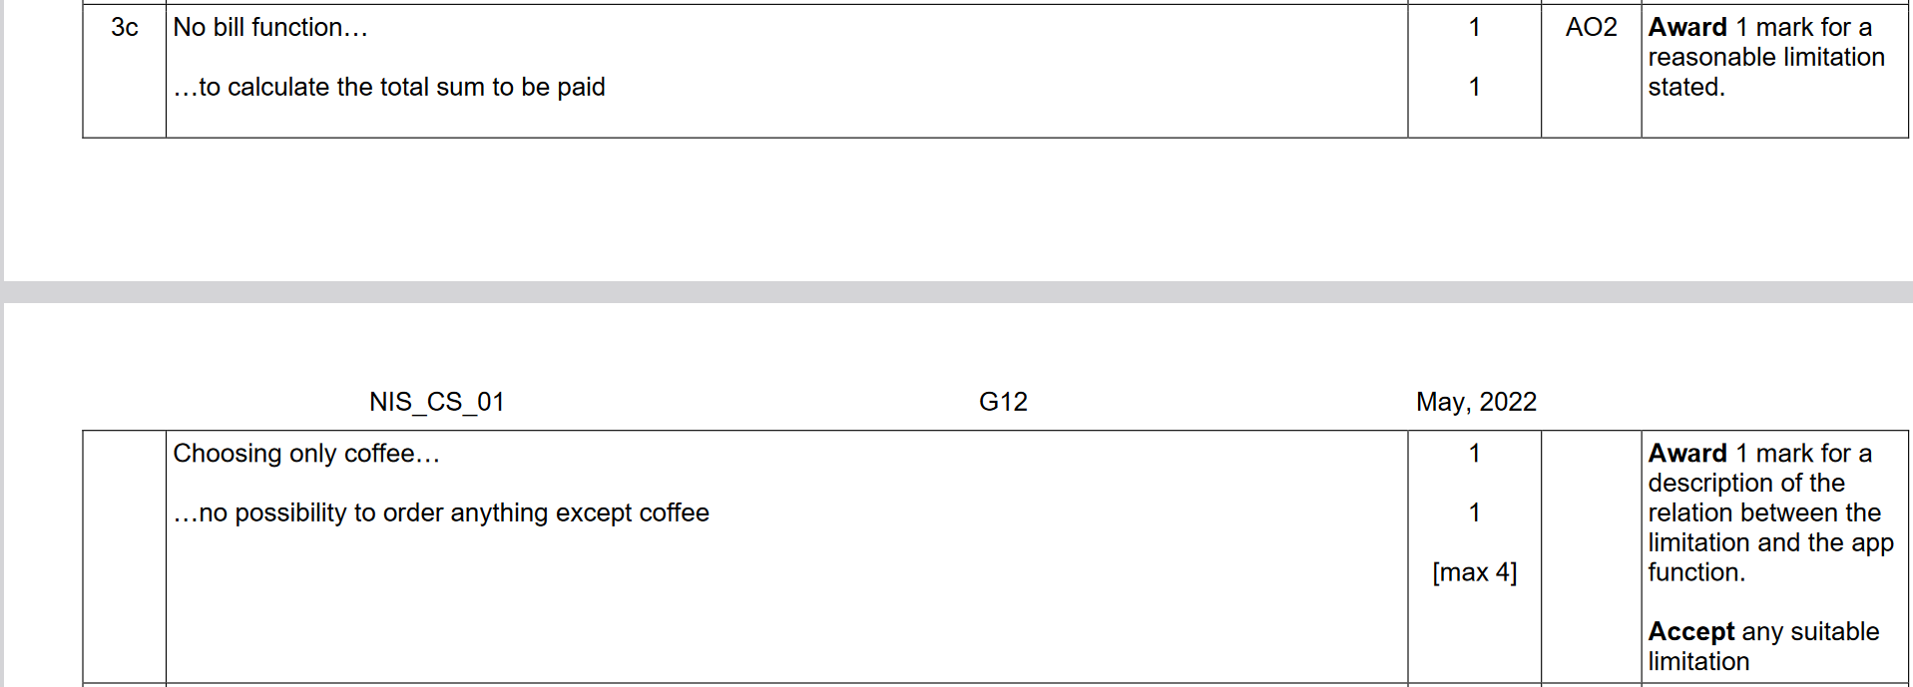

OS, SOFTWARE 2021-2022 (PAPER 1)

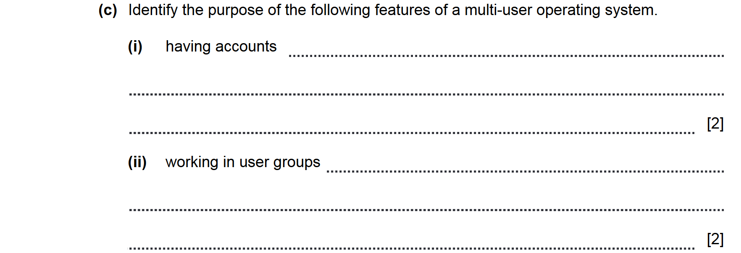

ANSWERS
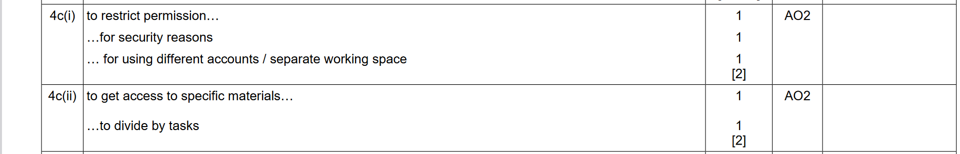

OS, SOFTWARE 2021-2022 (PAPER 1)

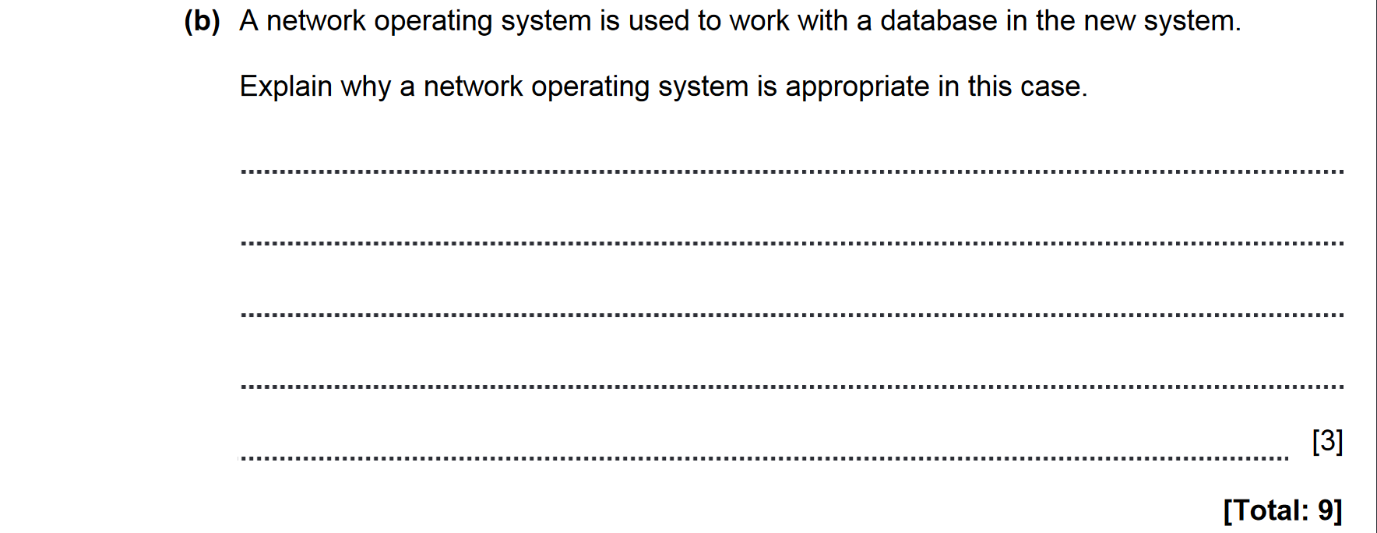

ANSWERS
