CPU, MEMORY. SYSTEM ARCHITECTURE 2013-2014 (PAPER 2)

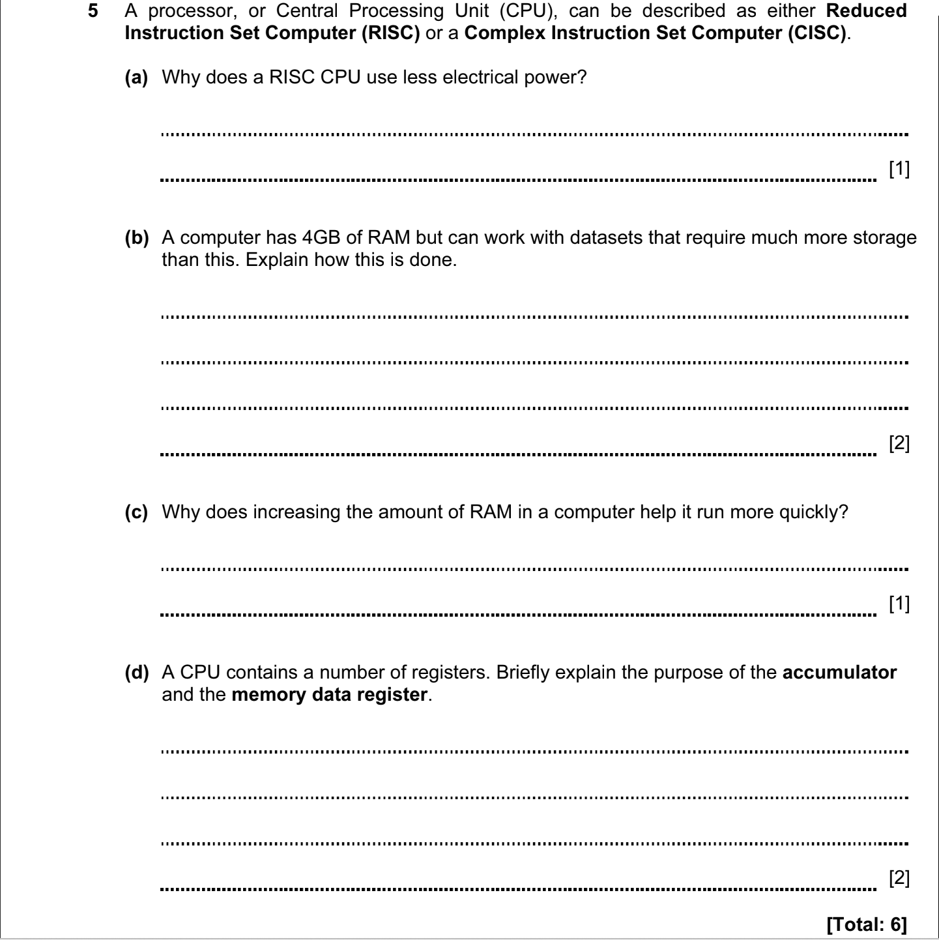

ANSWERS
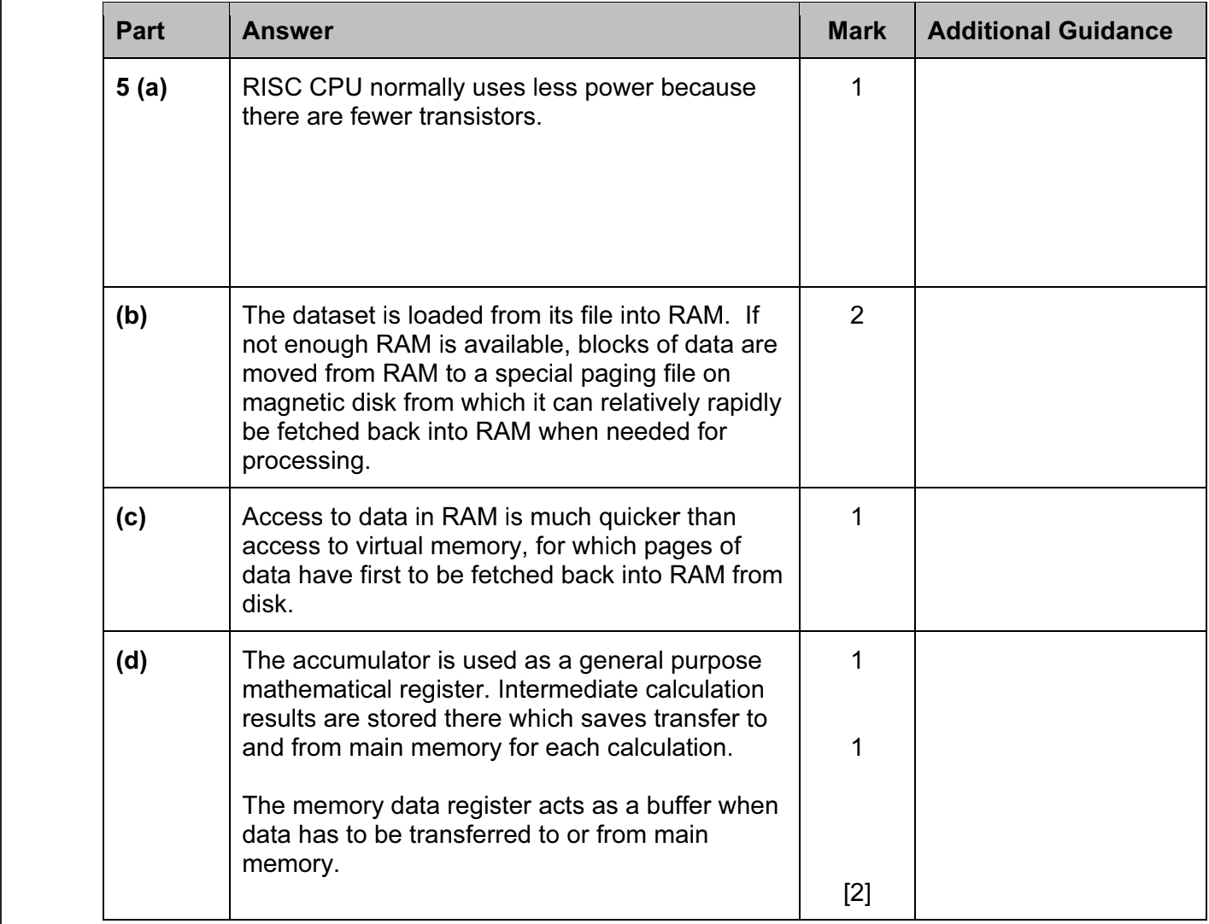

CPU, MEMORY. SYSTEM ARCHITECTURE 2014-2015 (PAPER 2)

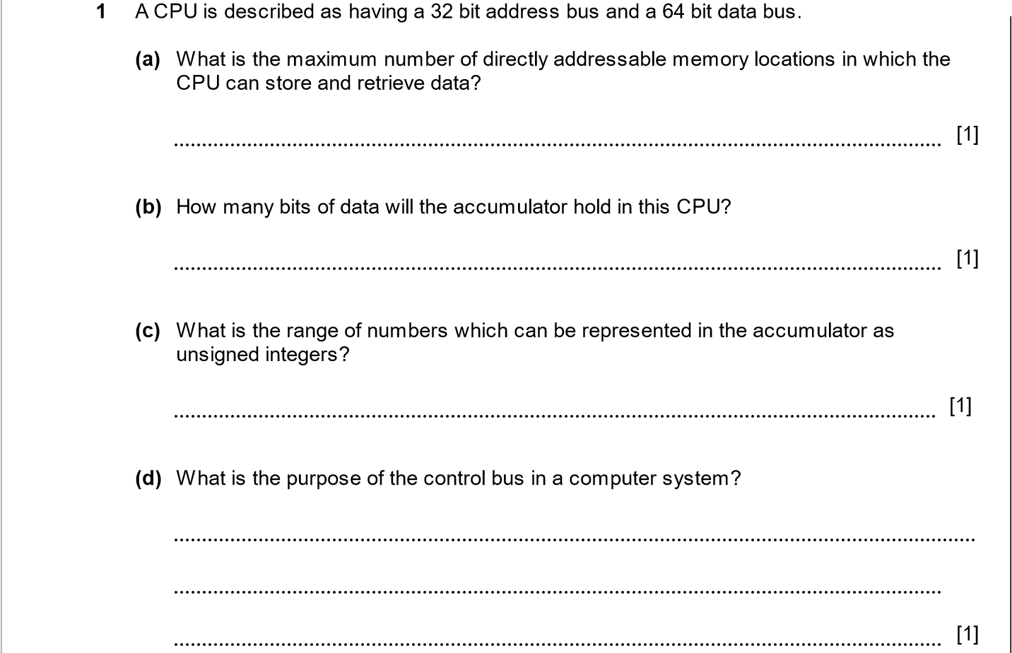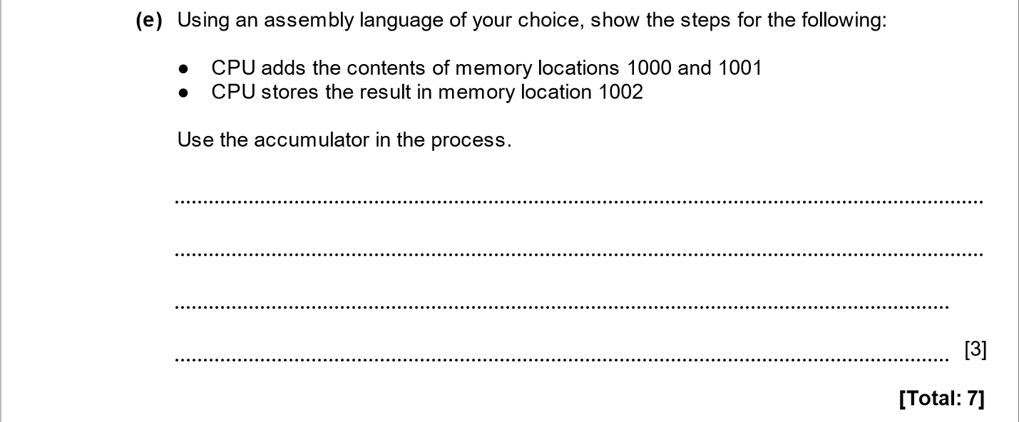

ANSWERS
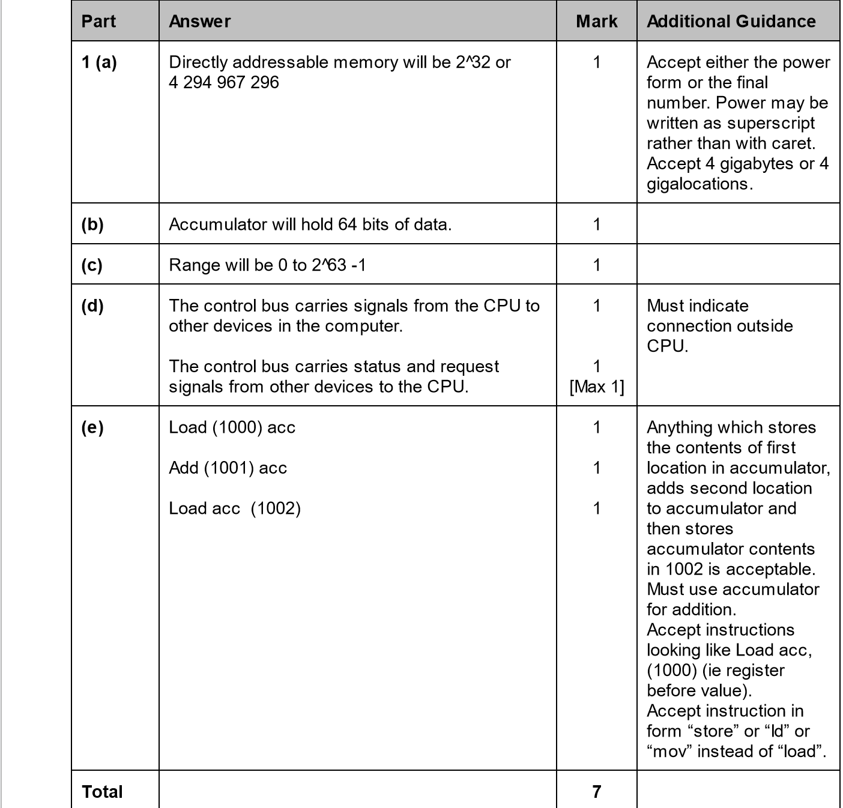

CPU, MEMORY. SYSTEM ARCHITECTURE 2014-2015 (PAPER 2)
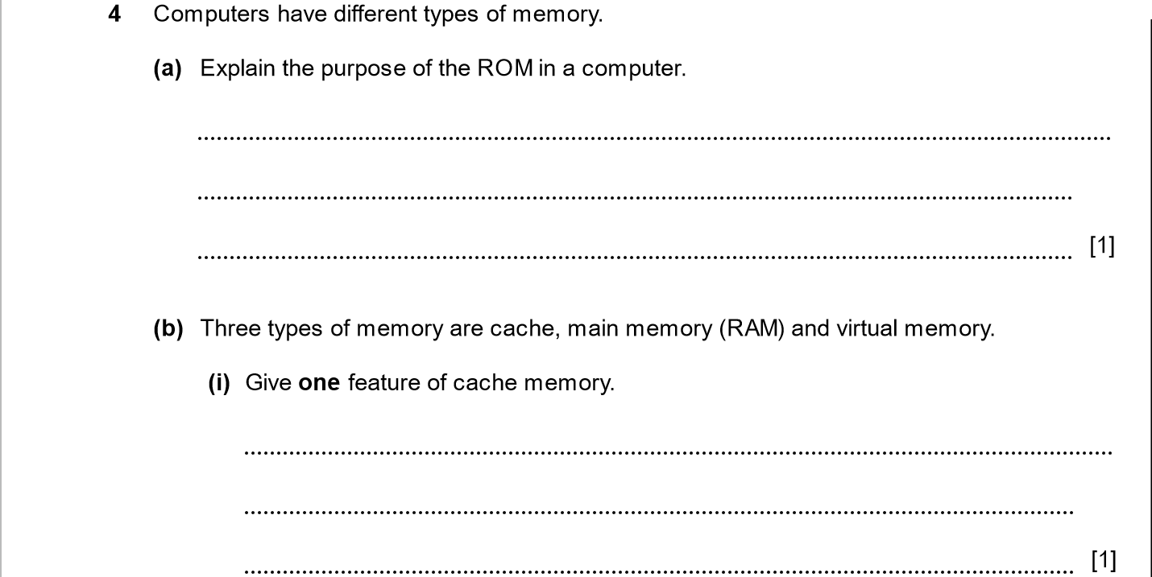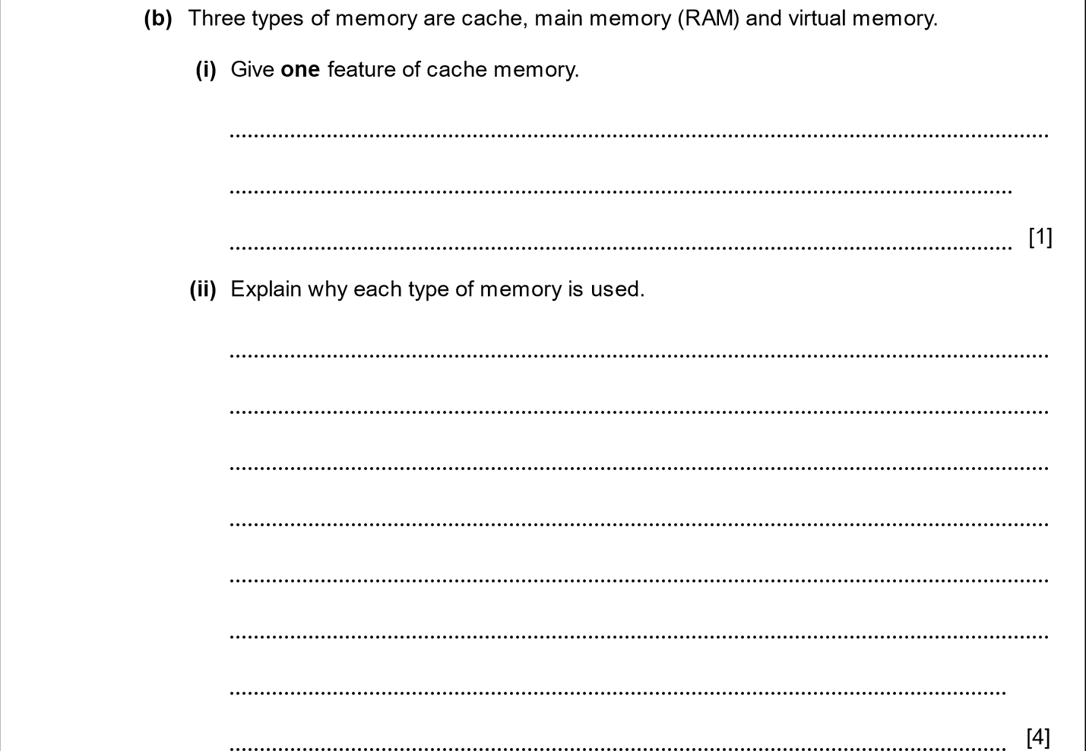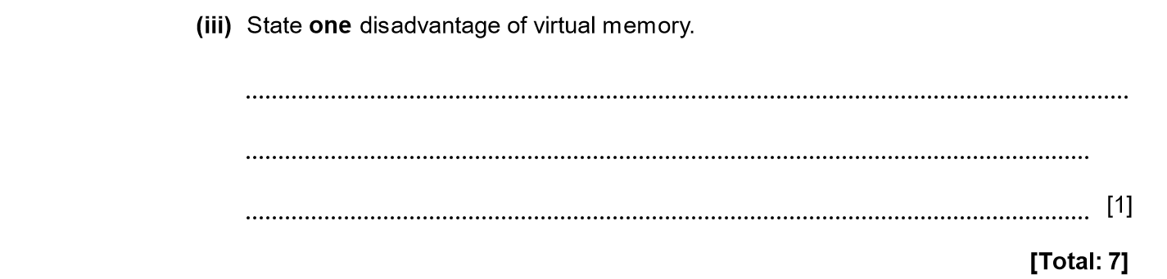
ANSWERS
Part | Answer | Mark | Additional Guidance
4 (a) | The ROM contains the programs needed to start the computer and load the operating system from disk.  The ROM contains the BIOS which loads the computer operating system from disk (boots the computer).  The ROM contains the BIOS which can be used to perform tests on the computer hardware.  The ROM contains firmware which includes application programs for an embedded device. | 1  1  1  1  [Max 1]
(b) (i) | It is very fast / very expensive / static uses RAM (SRAM). | 1
(ii) | Main memory:  - used to store applications and data files currently open  - used to store the operating system while running  Cache memory:  - used to provide a fast buffer for CPU access  - used to hold data / instructions currently being processed  Virtual memory:  - provides a page file / swap space on a disk. | 1  1  1  1  1  [Max 4] | No more than two points from any one memory type.
(iii) | Disk storage is much slower than memory so using VM slows down processing.  Disk thrashing may occur.  Using VM slows down processing | 1  1  1  [Max 1] | Any point for 1 mark.
Total |  | 7

CPU, MEMORY. SYSTEM ARCHITECTURE 2015-2016 (PAPER 2)

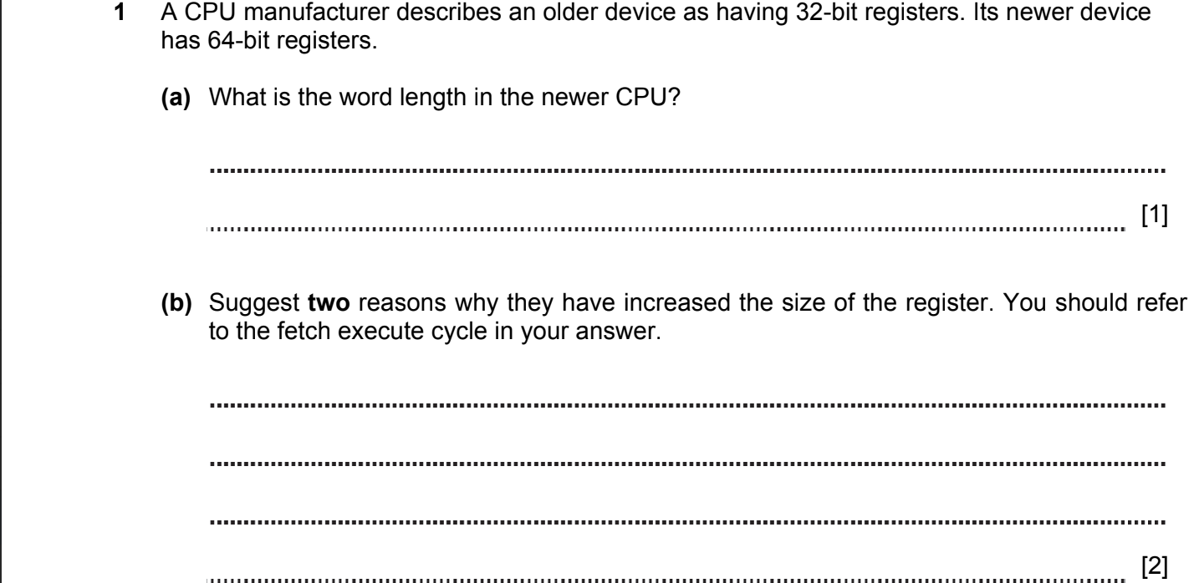
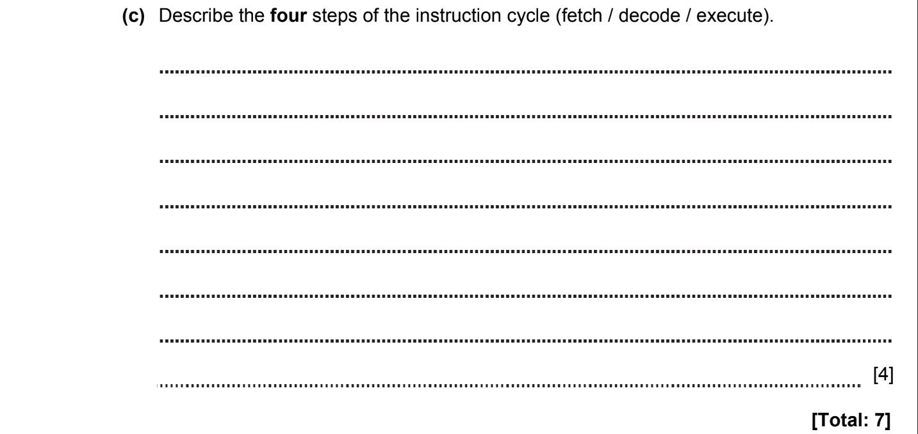

ANSWERS
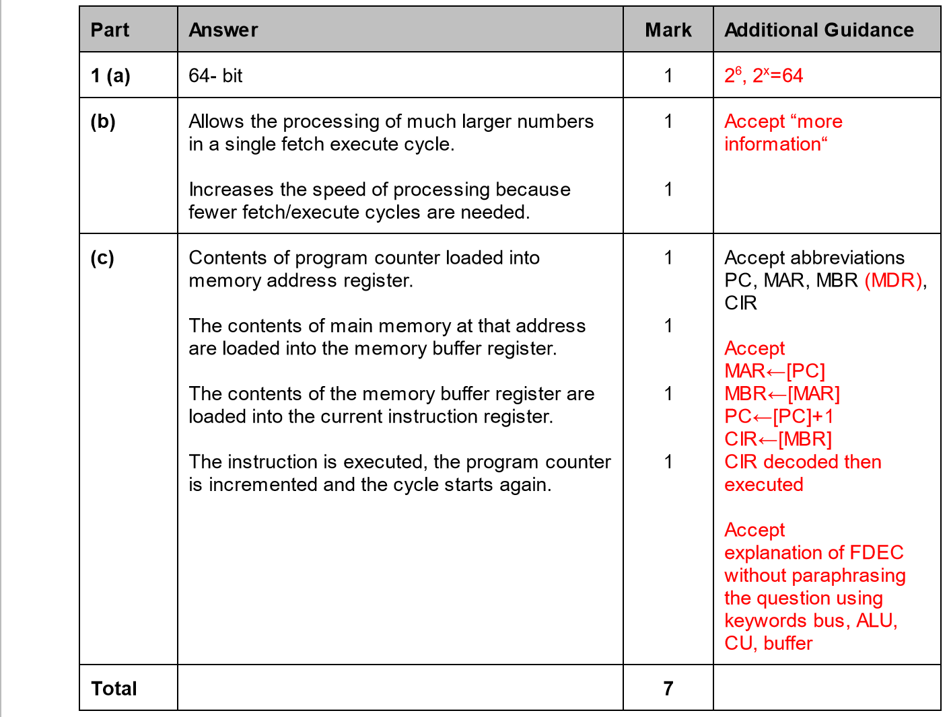

CPU, MEMORY. SYSTEM ARCHITECTURE 2015-2016 (PAPER 2)

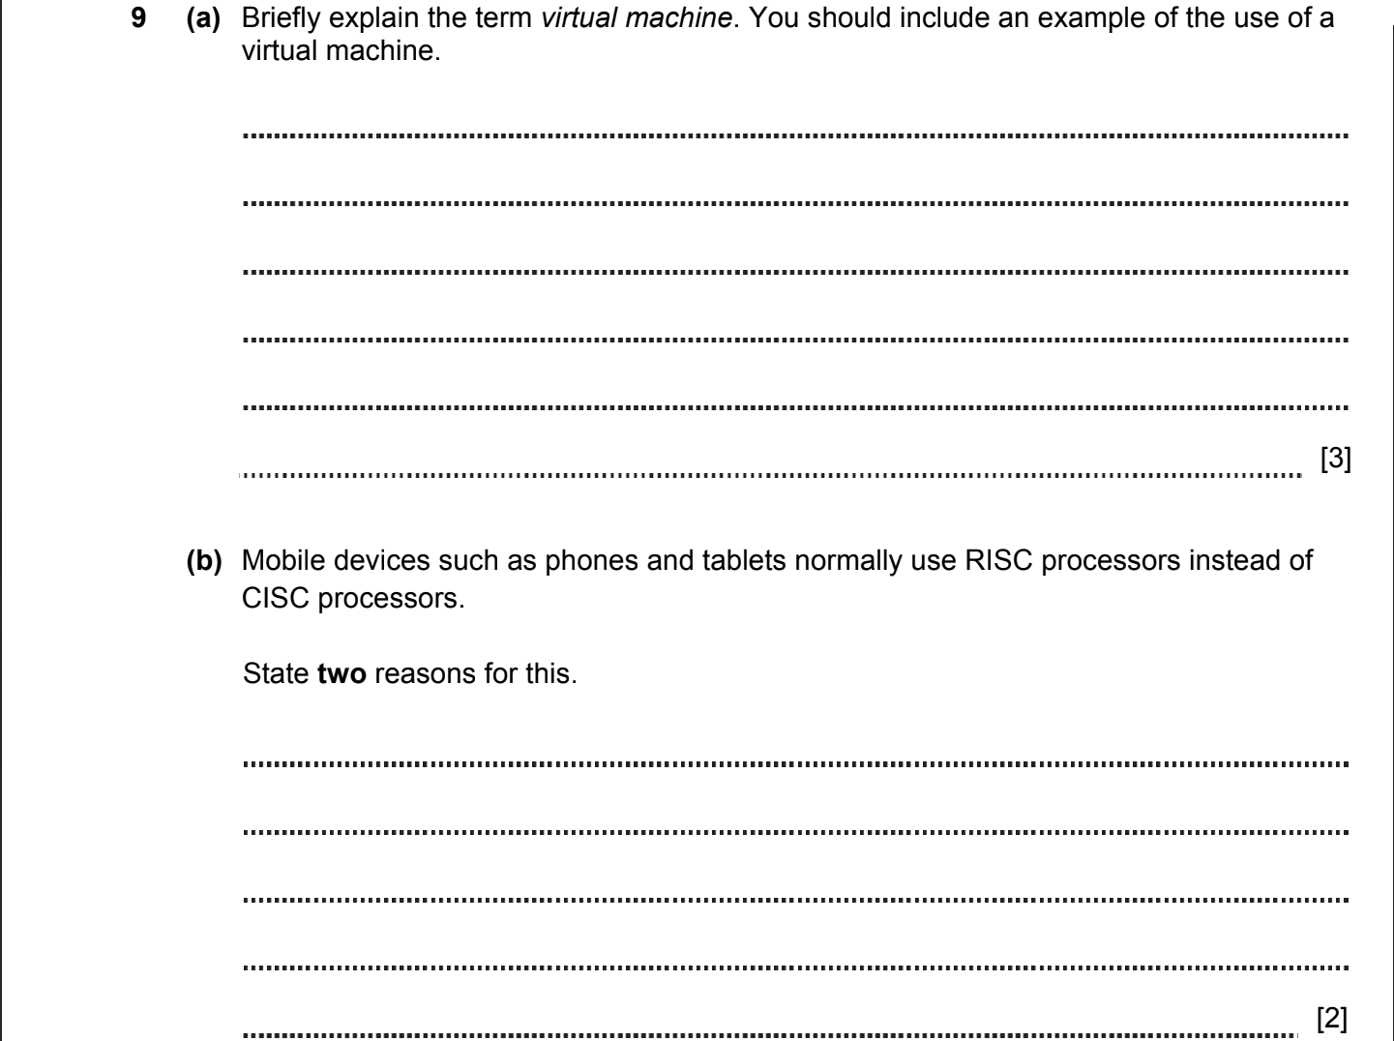
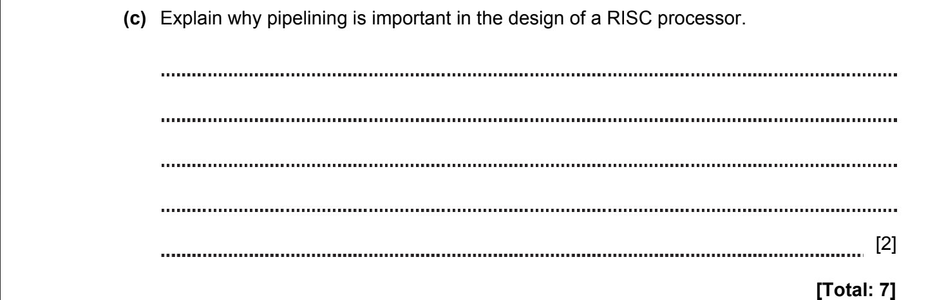

ANSWERS
Part | Answer | Mark | Additional Guidance
9 (a) | A virtual machine is an operating system running as a guest on a host machine.  Modern hardware allows complete isolation of the guest from the host.  A virtual machine is a way of running more than one operating system simultaneously on a single computer.  This can allow development work for a machine which you don’t have.  For example, it can be used to run  - Windows XP on a Windows 7 machine  - Linux on a Windows machine  - Windows on an Apple Mac  - Windows on a Linux machine  - Arcade game emulators such as MAME on standard computer | 1  1  1  1  [max 2]  1 | 1 mark for each of 2 reasonable sentences explaining VM (but do not allow reference to dual boot)  Accept emulator  VM used to test software in different environment.  Checking suspicions software to avoid damage of host OS  Use old software  1 mark for any reasonable use of a VM  Accept as an alternative the use of a single process VM such as the Java Virtual Machine – a similar set of points to the above is needed.
(b) | RISC chips used because:  - Use less power / extend battery life  - Smaller  - Run cool without heatsink  - Cheaper | 1  1  1  1  [max 2]
(c) | A RISC chip carries out several simple instructions for each complex instruction on a CISC chip.  Pipelining carries out instructions in parallel so that the instruction set is completed more quickly. | 1  1 | 1 mark for recognising need to handle more instructions in RISC.  1 mark for showing that pipelining allows the instructions to be parallelised.
Total |  | 7

CPU, MEMORY. SYSTEM ARCHITECTURE 2016-2017 (PAPER 1)
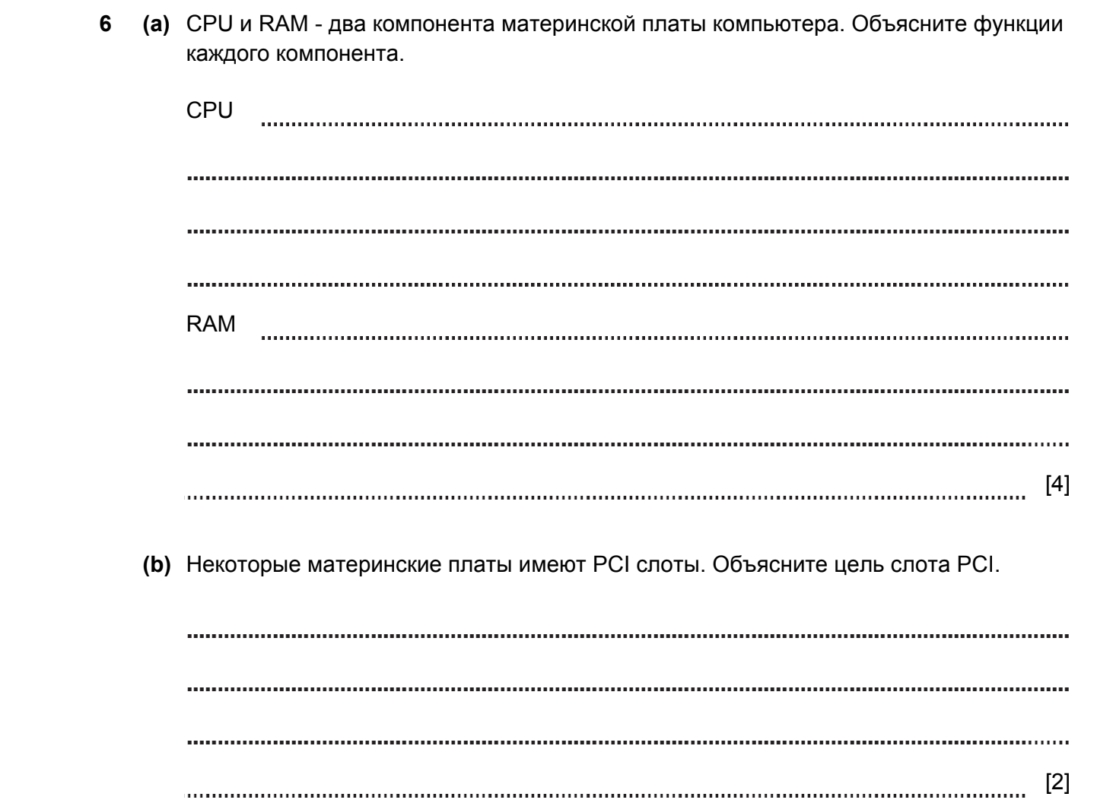

ANSWERS
Part |  |  | Answer | Mark | Additional Guidance
6 | (a) |  | Handles calculations / comparisons  controls the fetching and execution of all instructions.  RAM stores the currently executing program and the data being processed. | 1  1  1  1 | 1 mark for calculation or similar  1 mark for fetch / execute  1 mark for program storage, and 1 mark for data
 | (b) |  | Allows extra interface cards to be added to the computer.  The cards might be for graphics or sound  Allows for fast disks to be connected. | 1  1  1  Max 2 | One mark for each valid point.
 |  |  |  | 6

CPU, MEMORY. SYSTEM ARCHITECTURE 2017-2018 (PAPER 1)

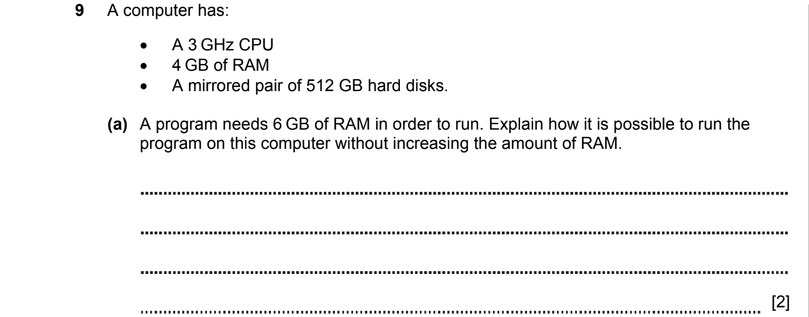
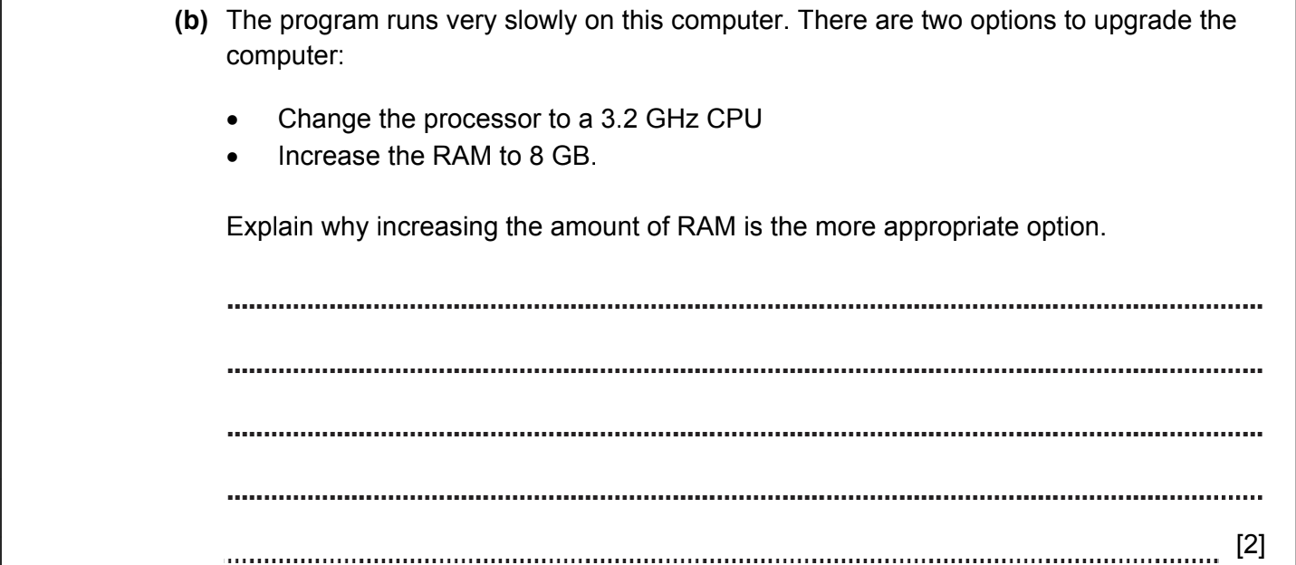

ANSWERS
Part | Answer | Mark | AO | Further Information
9(a) | The computer uses part of the hard disk as virtual memory.  Data which is not currently needed in RAM is swapped to the virtual memory, freeing up RAM.  When the RAM is full the data is transferred to pagefile. | 1  1  1  [max 2] | AO1
(b) | More RAM reduces the amount of swapping (pagefile).  Swapping is a very slow process.  A more cost effective option (RAM is cheaper to buy than CPUs).  RAM is easier to install.  More operations/ processes can be stored in RAM. | 1  1  1  1  1  [max 2] | AO1 | Must mention removing swapping, need not mention RAM  Accept answers with the reference to the problems with the installation of CPU can.

CPU, MEMORY. SYSTEM ARCHITECTURE 2017-2018 (PAPER 2)

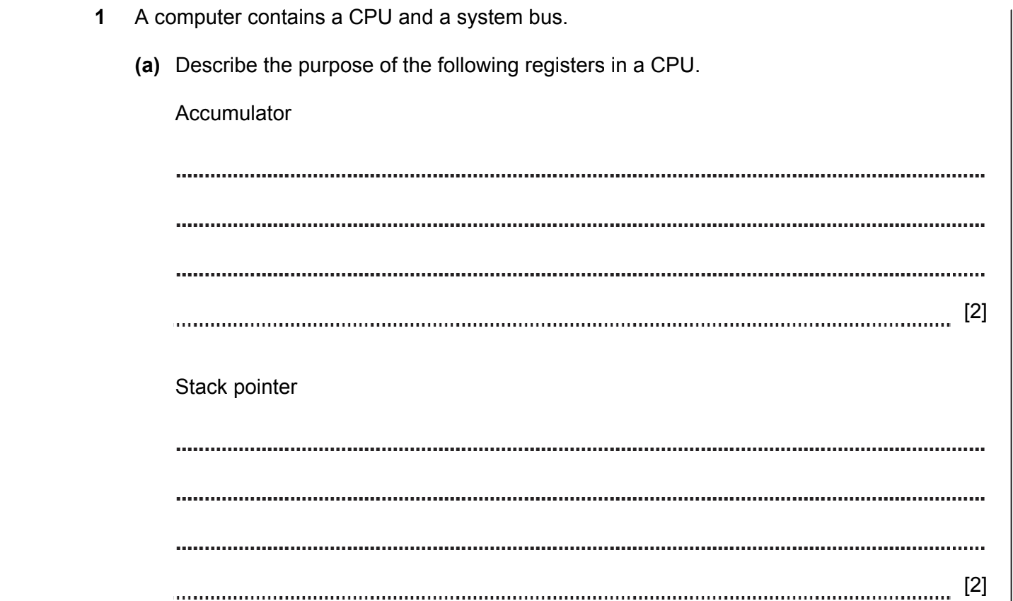
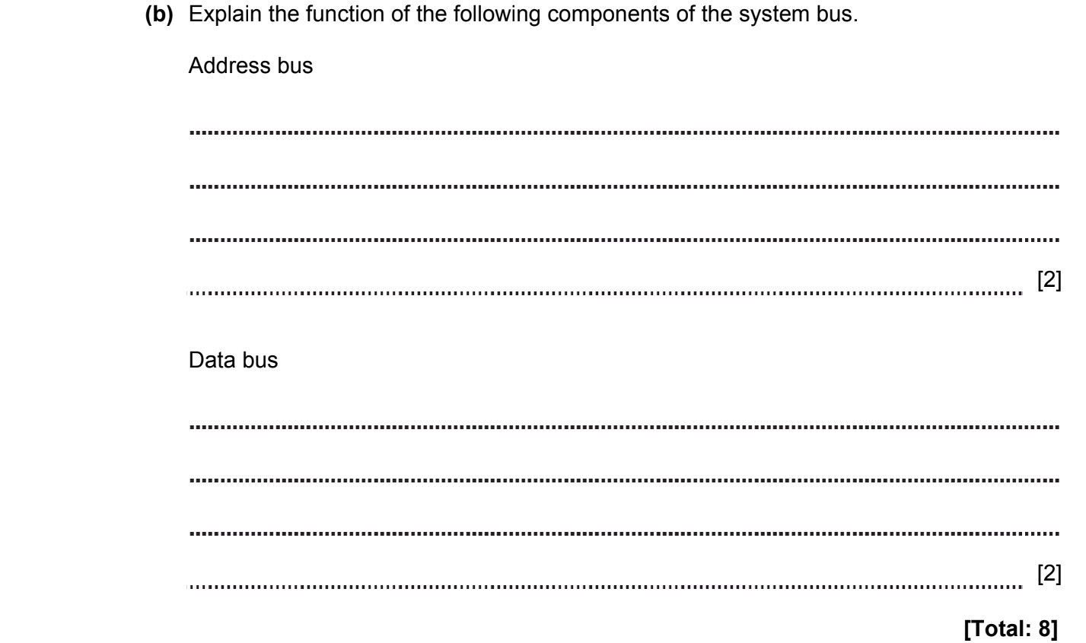

ANSWERS
Part | Answer | Mark | AO | Further Information
1(a) | The accumulator is used for doing calculations | 1 | AO1
1(a) | Values read from memory can be added / subtracted from the value in the accumulator | 1 | AO1
1(a) | Results of calculations are stored in the accumulator | 1 | AO1
1(a) |  | [max 2] | AO1 | Accept any 2 valid points  Accept temporary/ input / output / intermediate values
1(a) | The stack pointer stores the address of the top of the stack in memory | 1 | AO1
1(a) | The stack pointer stores the address where the next item can be stored on the stack in memory | 1 | AO1
 | The stack pointer stores the address where the program can retrieve the last item that the program placed on the stack | 1
 |  | [max 2]
(b) | Address bus is used to transfer an address ….  …. of the memory location | 1  1 | AO1
(b) | Data bus is used to transfer data …..  …..from / to the main memory to / from the CPU | 1  1 | AO1
Total |  | 8

CPU, MEMORY. SYSTEM ARCHITECTURE 2017-2018 (PAPER 2)

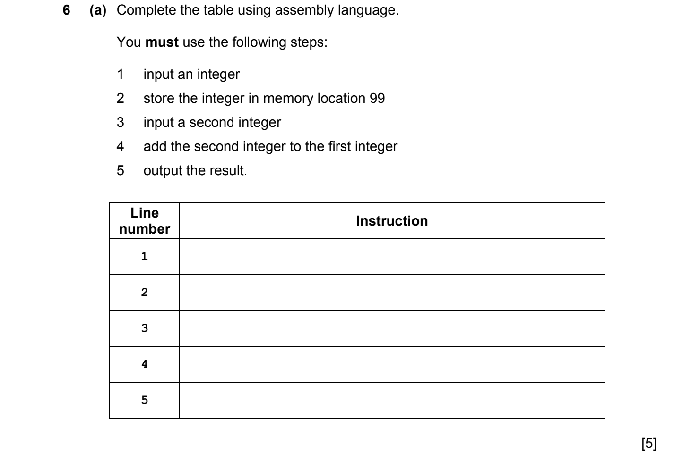
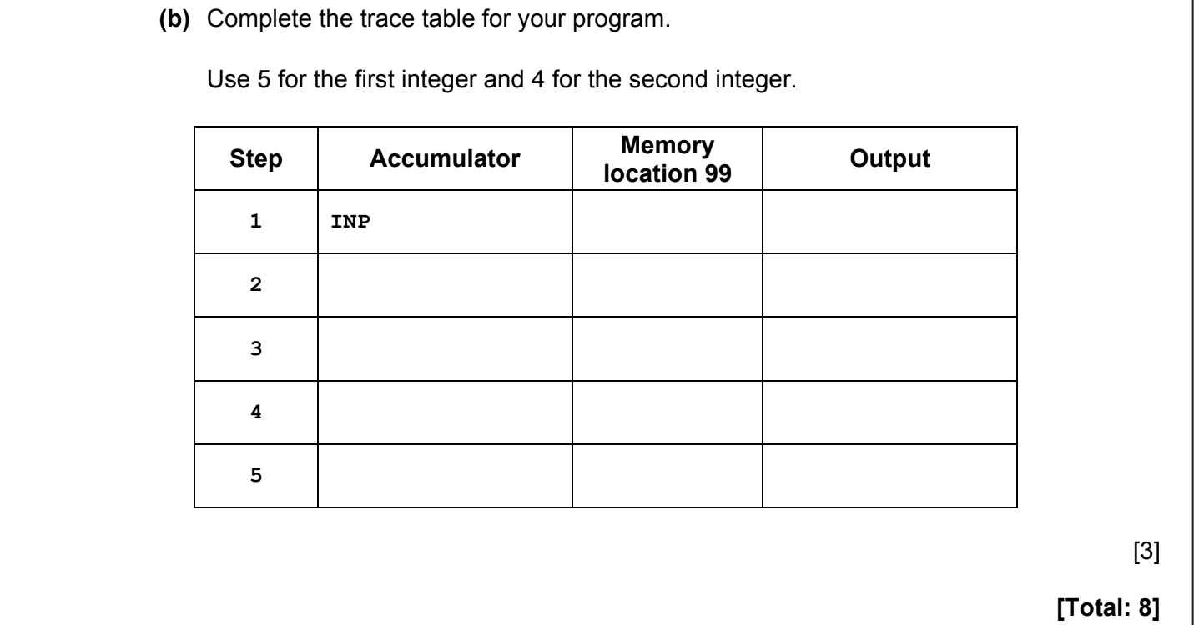

ANSWERS
Part | Answer | Mark | AO | Further Information
6(a) | Line 2: STA 99 – 1 mark for STA | 1 | AO2 | Allow reasonable attempts for STA/STO, ADD and OUT
6(a) | Line 3: INP | 1 | AO2 | Accept just INP without any symbols
6(a) | Line 4: ADD 99 – 1 mark for ADD | 1 | AO2
6(a) | Line 5: OUT | 1 | AO2
6(a) | 1 mark for both uses of 99 in lines 2 and 4 | 1 | AO2
(b) |  | 3 | AO2 | Award 1 mark for each correct column  Note: Bracketed values need not be shown
  Step | Acc | 99 | Output
  1 | 5
  2 | (5) | 5
  3 | 4 | (5)
  4 | 9 | (5)
  5 | (9) | (5) | 9
Total |  | 8

CPU, MEMORY. SYSTEM ARCHITECTURE 2018-2019 (PAPER 1)
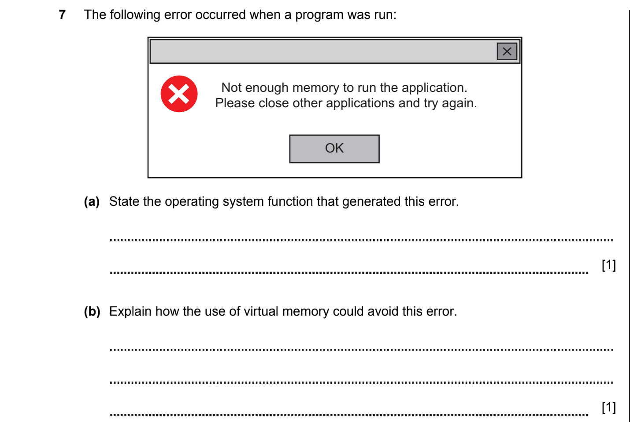
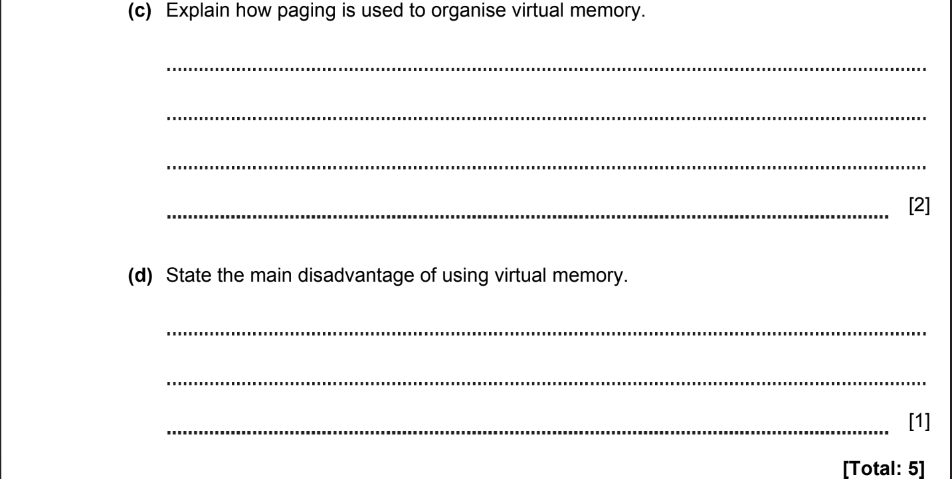

ANSWERS
Part | Answer | Mark | AO | Further Information
7(a) | Planning and organising of program processing  Resource allocation  Memory management | 1  1  1  [Max 1] | AO1
7(b) | An area on the hard disk drive is used when the RAM is full. | 1  [1] | AO1
7(c) | Code or data is organised into sections called pages.  Pages can be moved between RAM and hard drive.  Pages used by a process can be noncontiguous.  Pages are held in RAM whenever it is available.  Paging means dividing physical memory into fixed-sized blocks. | 1  1  1  1  1  [Max 2] | AO1
7(d) | Virtual memory is much slower than RAM so the more that virtual memory is used, the slower the system will be. | 1  [1] | AO1 | Accept disk thrashing (the idea that increased use of VM increases access to secondary storage and increases wear on the hard disk)
 | TOTAL | 5

CPU, MEMORY. SYSTEM ARCHITECTURE 2018-2019 (PAPER 2)

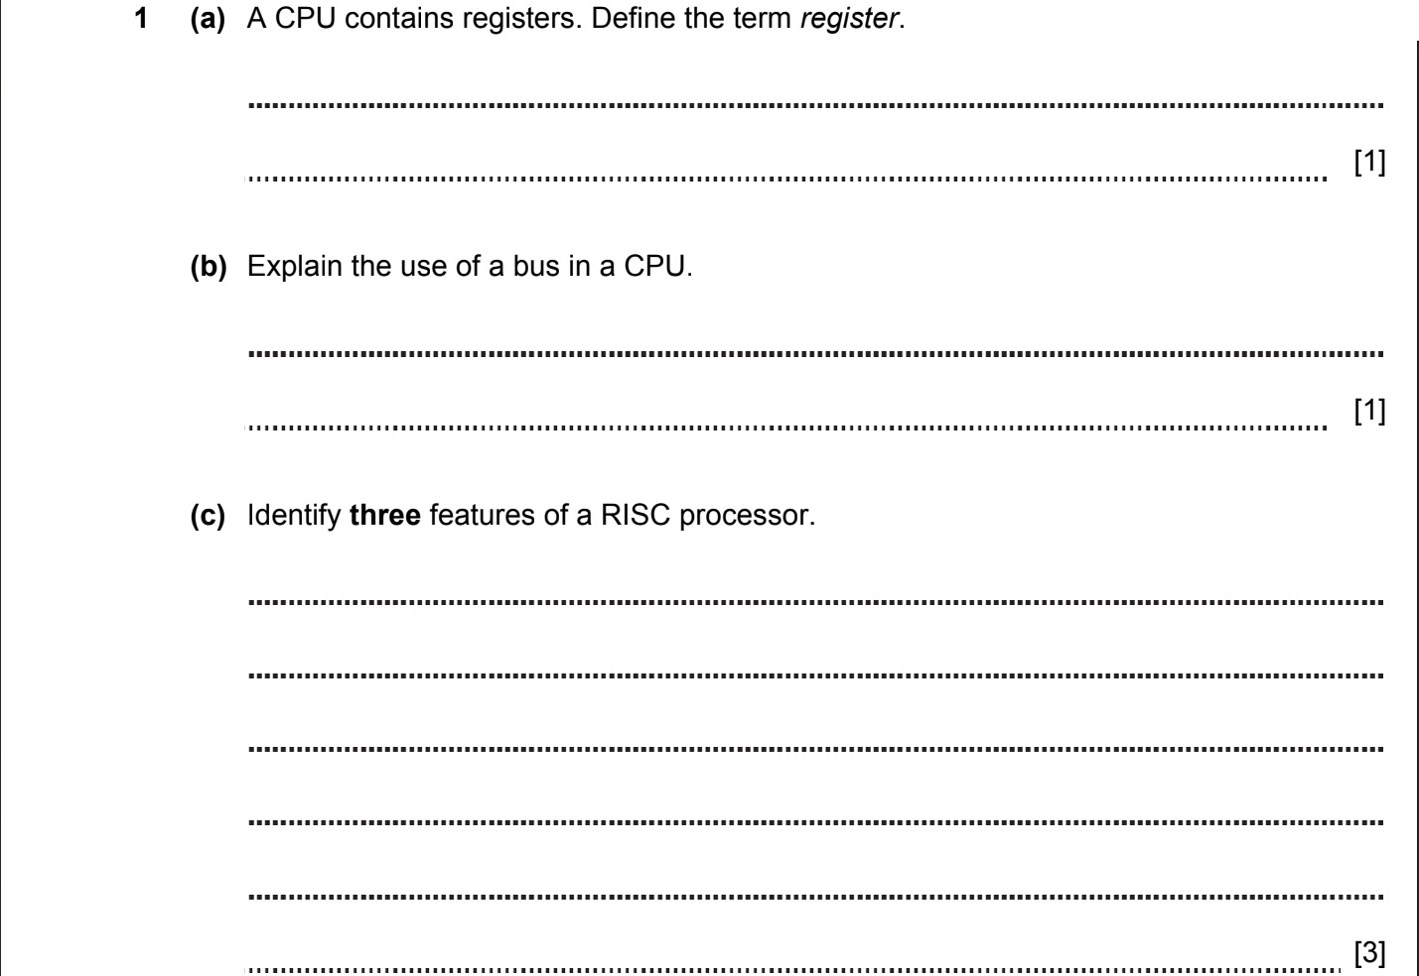
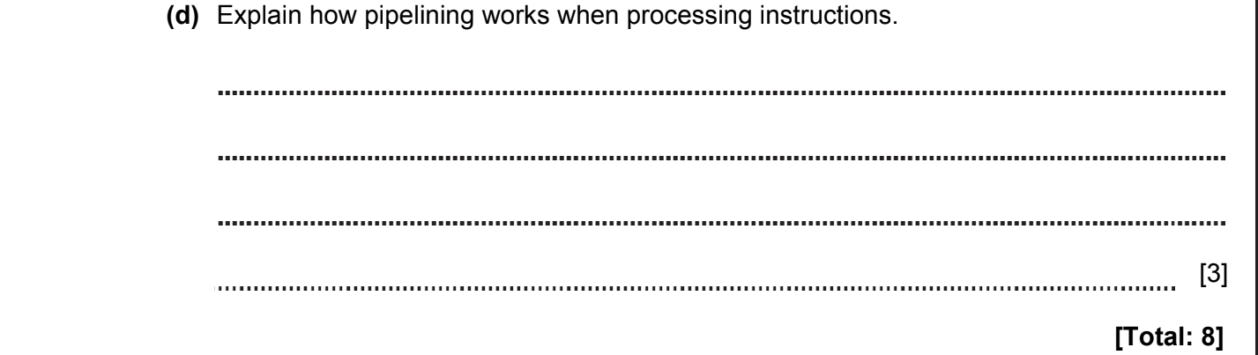

ANSWERS
Question or Part | Answer | Mark | AO | Further Information
1(a) | A section of storage (inside the CPU). | [1] | AO1 | Accept any suitable description of a register but not just an example.
1(b) | Transports bits (inside the CPU).  Transfers data between components (inside the CPU). | 1  1  [Max 1] | AO1 | Accept any suitable description of a bus (in a CPU).
1(c) | RISC architectures support a small number of very simple instructions.  Each instruction is completed in a single clock cycle.  Individual instructions are executed extremely quickly.  More instructions are needed to complete a given task.  RISC architecture requires more registers to provide faster access to data when programs are running.  less power usage / Less cooling required. | 1  1  1  1  1  1  [Max 3] | AO1 | Award 1 mark for each point up to a maximum of 3.
1(d) | А CPU completes a Fetch-Decode-Execute cycle.  Multiple instructions are overlapped in execution.  The pipeline is divided into stages (fetch / decode / execute).  Each stage completes a part of the instruction.  This happens in parallel. | 1  1  1  1  1  [Max 3] | AO1 | Award 1 mark only per point, up to a maximum of 3.  Accept step by step description of pipelining.  For example: one instruction is fetched, while a previous instruction is being decoded, while a third is being executed.
TOTAL |  | 8

CPU, MEMORY. SYSTEM ARCHITECTURE 2018-2019 (PAPER 2)

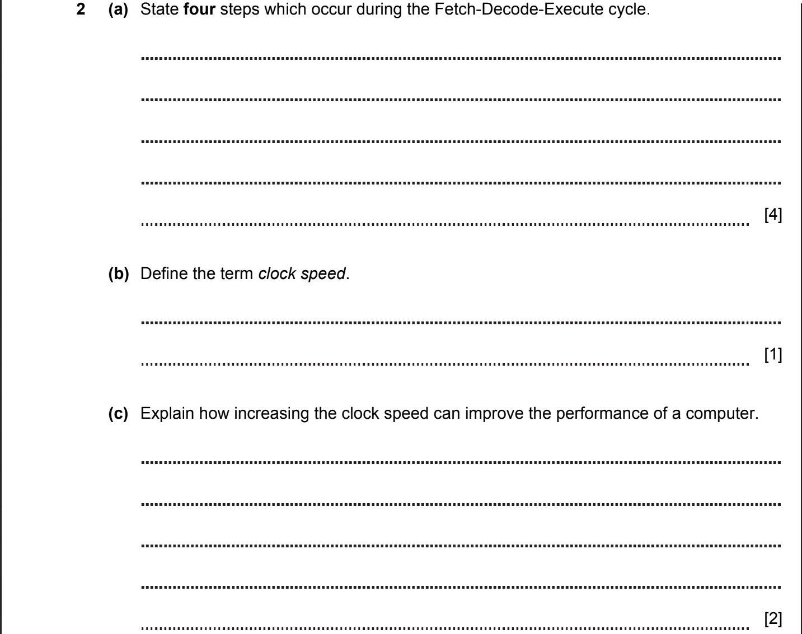
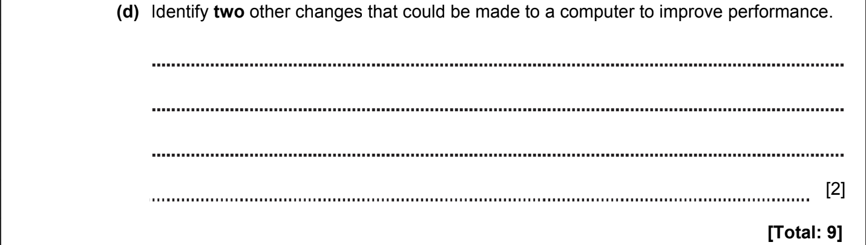

ANSWERS
Part | Answer | Mark | AO | Further Information
2(a) | Instructions are fetched from an address in main memory / from operand.  Data travels along the data bus.  The instruction is stored in the CPU’s register.  The CPU decodes the instruction.  The instruction is executed.  The cycle repeats. | 1  1  1  1  1  1  [Max 4] | AO1 | Accept data or instructions.  Award 1 mark only per point, up to a maximum of 4.
2(b) | The clock speed indicates how fast a CPU can run.  It indicates how many instructions the CPU can execute each second. | 1  1  [Max 1] | AO1
2(c) | Increasing the clock speed results in more instructions being processed each second.  More instructions can be completed in a given time. | 1  1  [2] | AO2 | Award 1 mark per point up to a maximum of 2 marks.
2(d) | Increase the RAM.  Use a CPU with more cores.  Use a CPU with more cache.  Overclock the CPU.  Use a hard disk with a faster read–write speed.  Upgrade HDD to an SSD.  Install a faster graphics card.  Install faster RAM. | 1  1  1  1  1  1  1  1  [Max 2] | AO2 | Allow other correct changes.
TOTAL |  | 9

CPU, MEMORY. SYSTEM ARCHITECTURE 2018-2019 (PAPER 2)

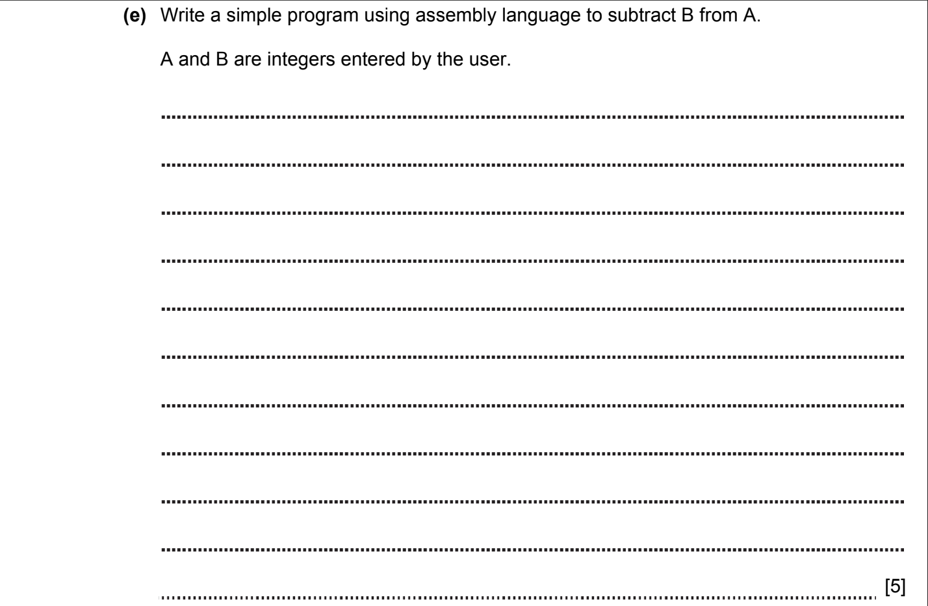

ANSWER
4(e) | INP  STA A  INP  STA B  LDA A  SUB B  OUT  HLT | 1  1  1  1  1  [Max 5] | AO2 | 1 Input AND Store A  1 Input AND Store B  1 Load accumulator with A  1 Subtract B from accumulator  1 Output contents of accumulator  Accept other suitable mnemonics.  Allow other routines that produce the same output.

CPU, MEMORY. SYSTEM ARCHITECTURE 2020-2021 (PAPER 1)
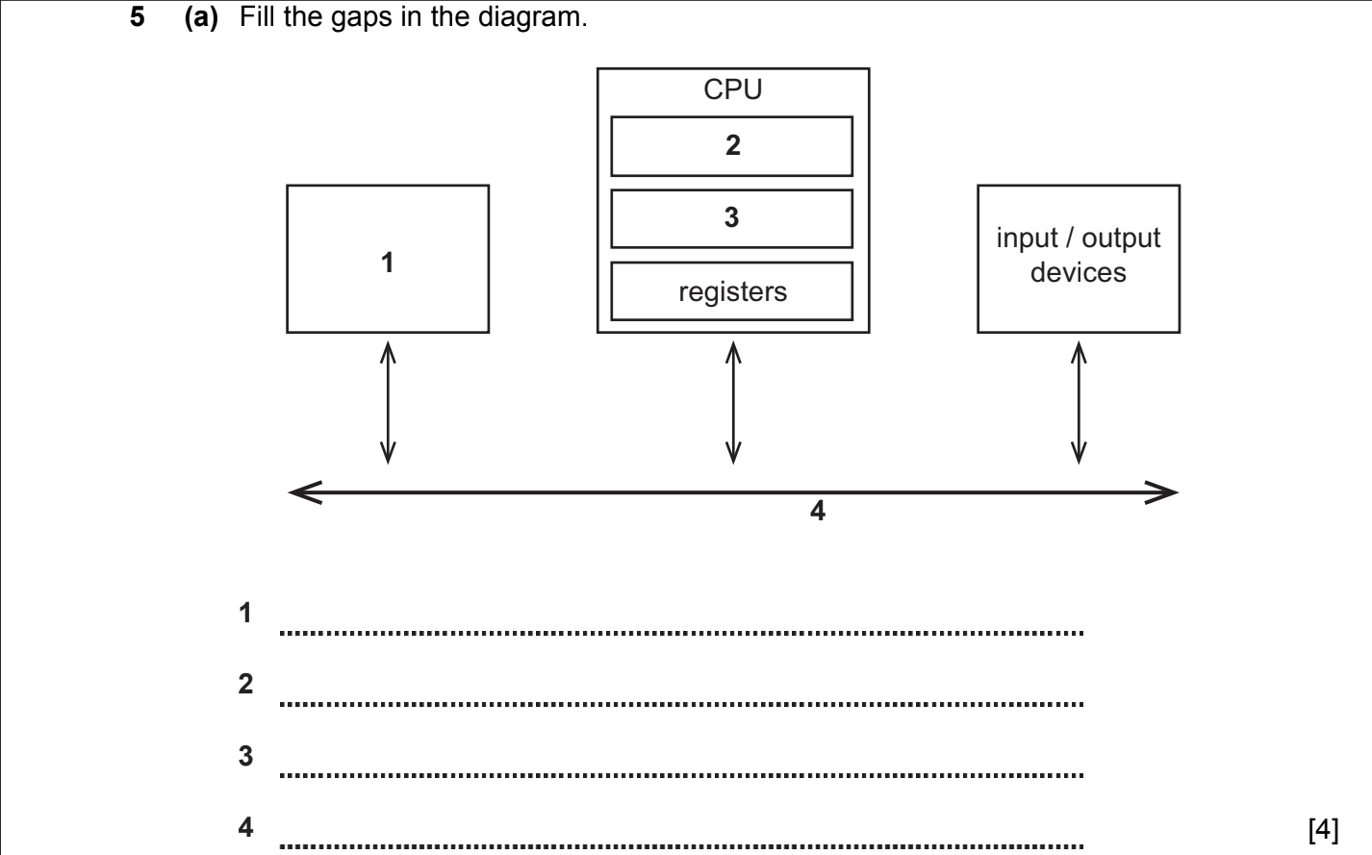

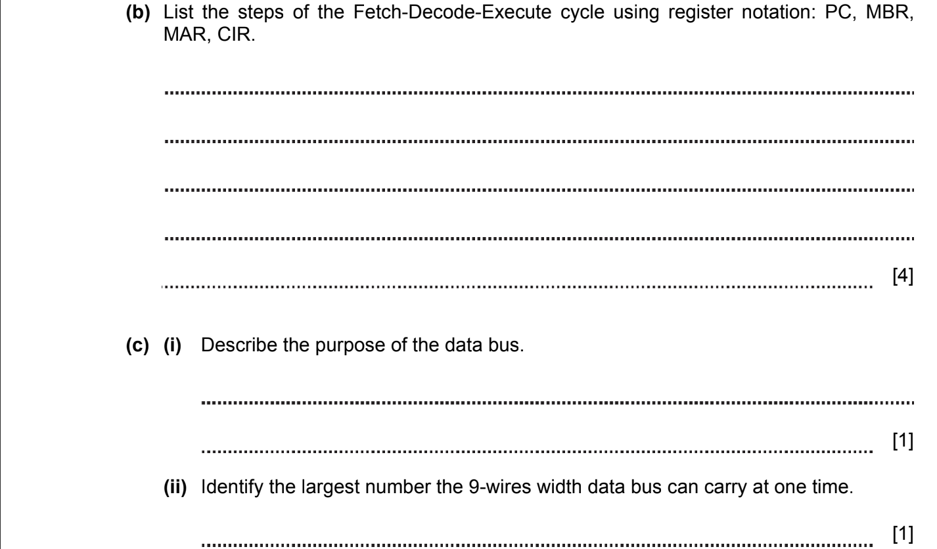
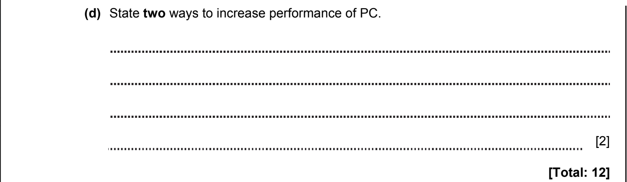

ANSWERS
Part | Answer | Mark | AO | Further Information
5a | 1. Main memory  2 / 3. Control unit / CU  2 / 3. Arithmetic logic unit / ALU  4. System bus | 1  1  1  1  [4] |  | Accept names of three busses instead of ‘System bus’
5b | MAR<-[PC]  MBR<-[Memory] and PC increases by 1  CIR<-[MBR]  CIR holds the command to be executed | 1  1  1  1  [4] |  | Allow any correct description with reference to registers.
5c(i) | Transfer of data / instructions between computer components. | [1]
5c(ii) | 2⁹-1=511 | [1]
5d | Enlarge the bus width.  Increase the clock speed of CPU.  Increase the word length. | 1  1  1  [max 2]
 | Total | 12

CPU, MEMORY. SYSTEM ARCHITECTURE 2020-2021 (PAPER 1)

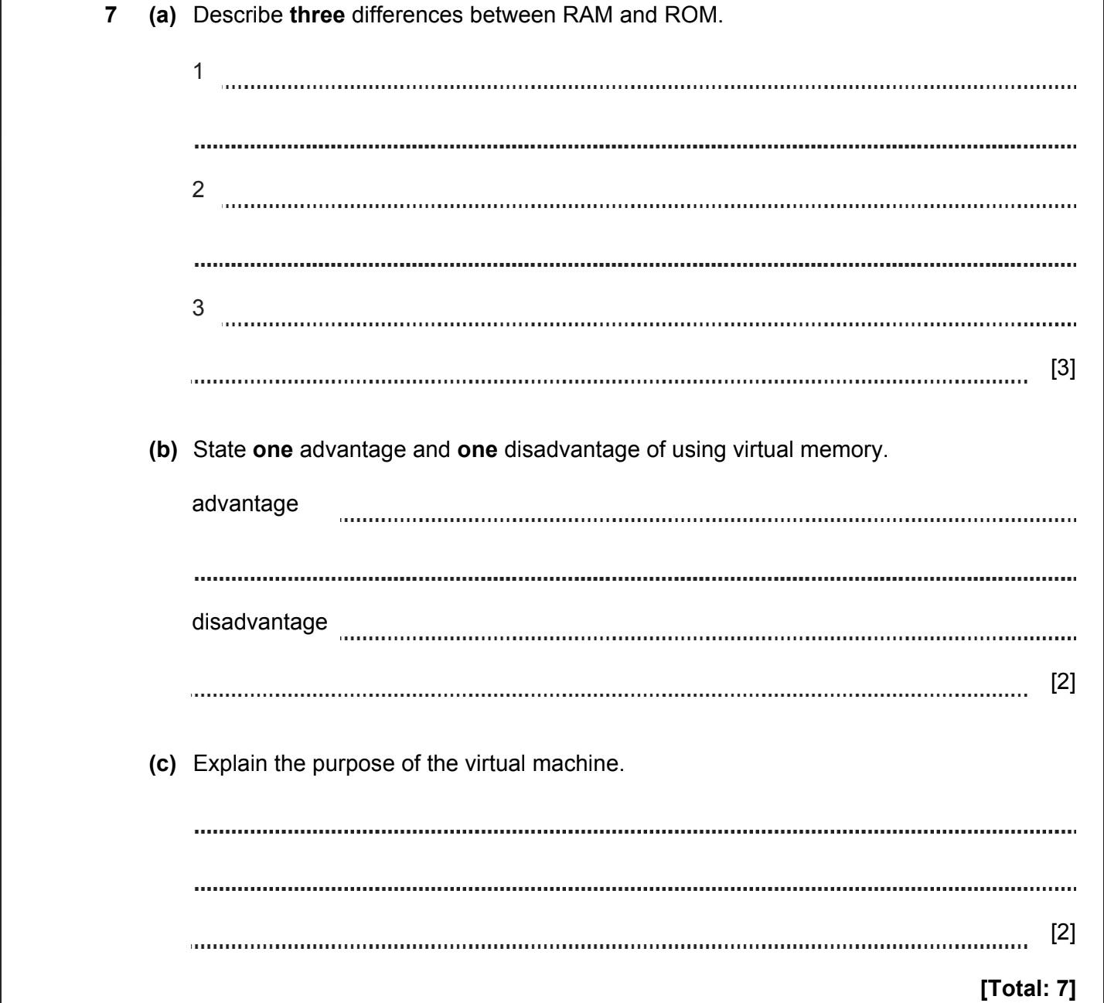

ANSWERS
Part | Answer | Mark | AO | Further Information
7a | RAM is volatile. ROM is non-volatile.  RAM stores OS and currently running programs. RОM stores start-up program (BIOS).  RAM can be changed. ROM cannot be changed by the operating system. | 1  1  1  [3] |  | Accept any correct differences.
7b | Advantages  Allows to run software even if RAM is full.  Provides an overflow which can be used as RAM.  Disadvantage  Slows down computer performance. | 1  1  1  [max 2] |  | Allow any reasonable answers.
7с | Allows several operating systems work on the same machine.  Any security faults of a guest OS cannot affect the host OS.  No need for any additional hardware. | 1  1  1  [max 2] |  | Allow any reasonable answers.
 | Total | 7

CPU, MEMORY. SYSTEM ARCHITECTURE 2020-2021 (PAPER 2)

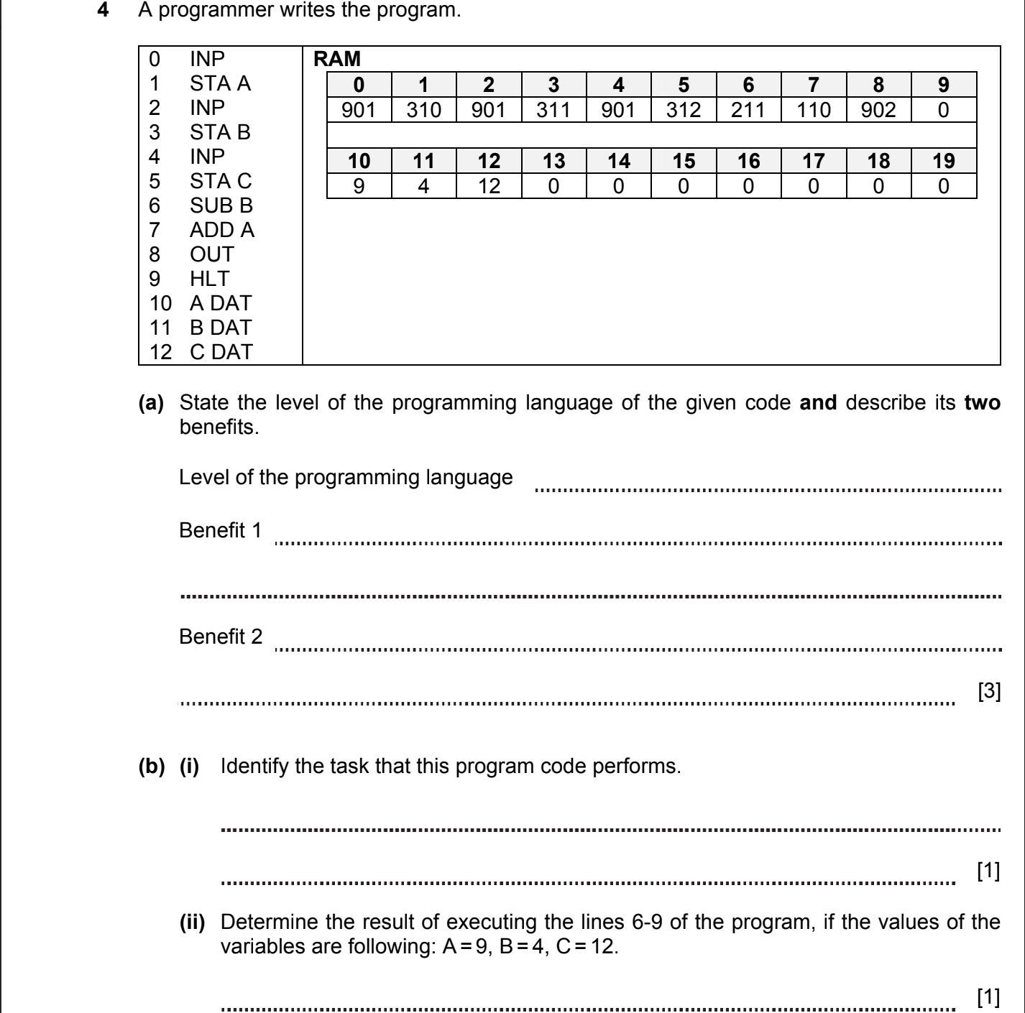

ANSWERS
Part | Answer | Mark | AO | Further Information
4a | Low level language  Benefits:  High speed of executing program.  Interacts with hardware directly. | 1  1  1  [3] | AO1 | Accept any reasonable answer
4b(i) | Returns the value of an expression C-B+A | [1] | AO2 | Accept either word description of task OR letter expression
4b(ii) | 17 | [1] | AO2

CPU, MEMORY. SYSTEM ARCHITECTURE 2021-2022 (PAPER 2)

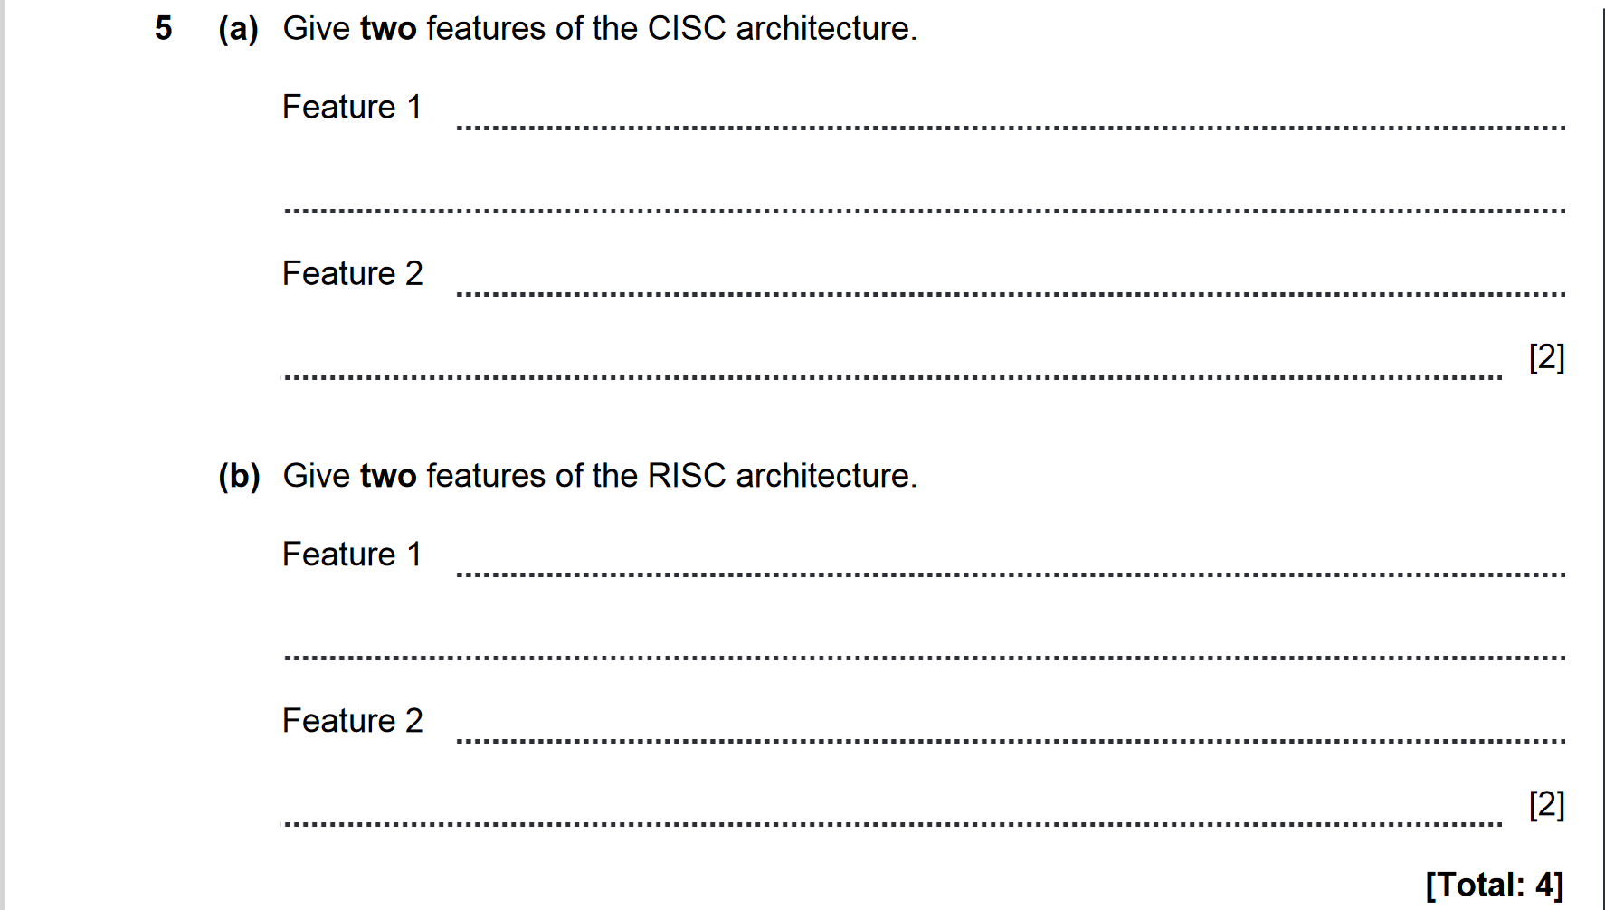

ANSWERS
