DATA REPRESENTATION 2013-2014 (PAPER 1)
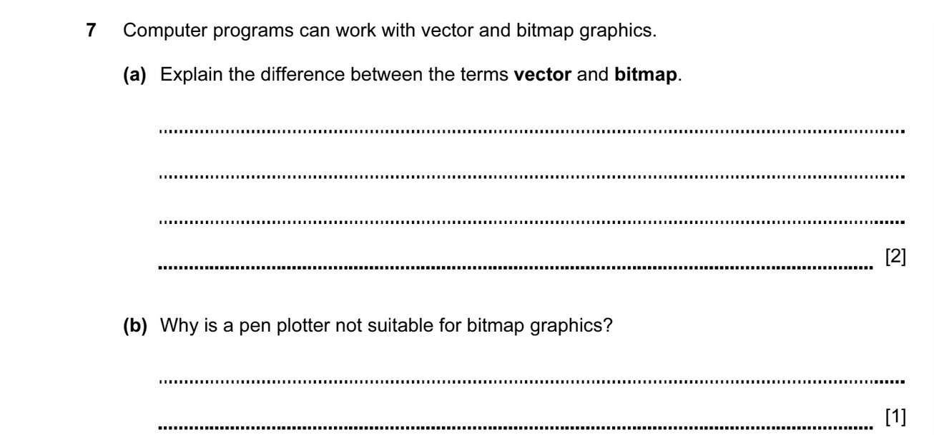

ANSWER

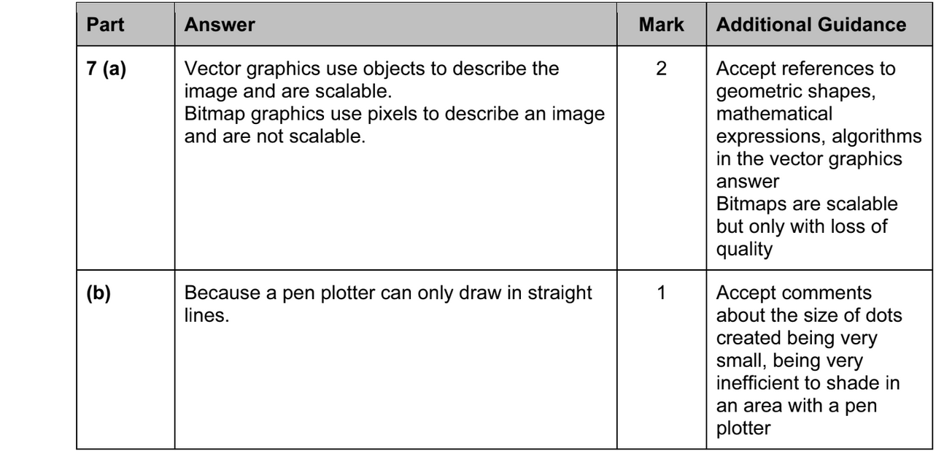

DATA REPRESENTATION 2013-2014 (PAPER 2)
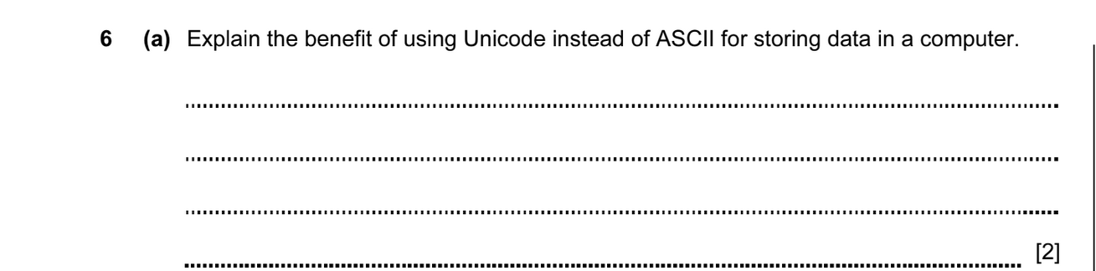

ANSWER

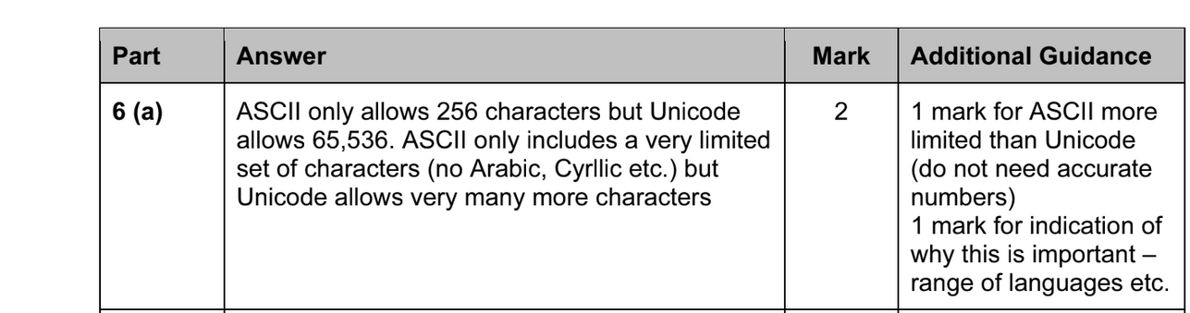

DATA REPRESENTATION 2013-2014 (PAPER 1)

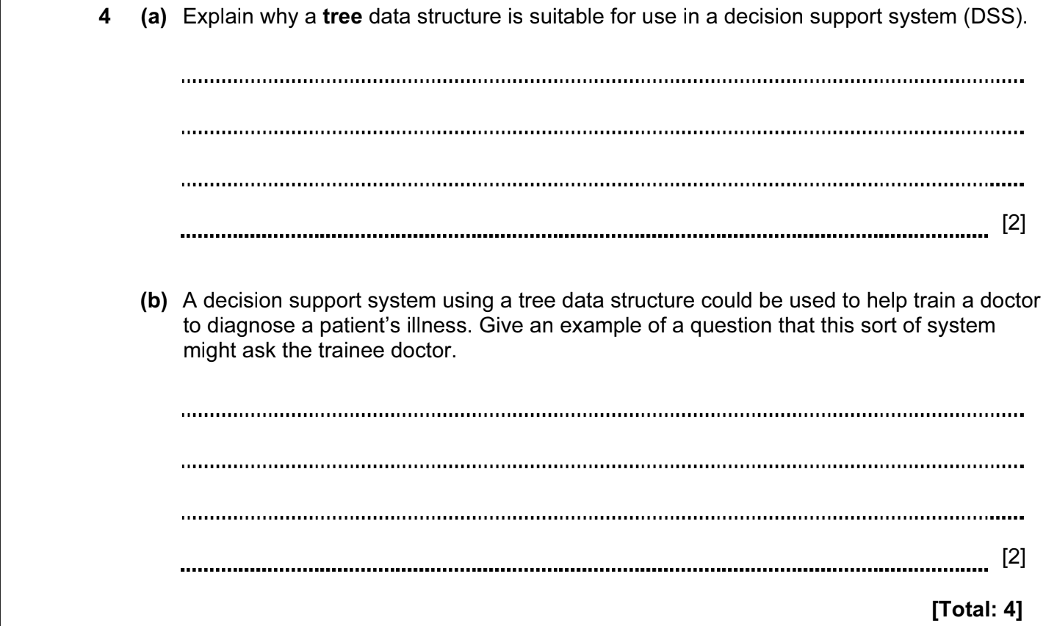

ANSWERS

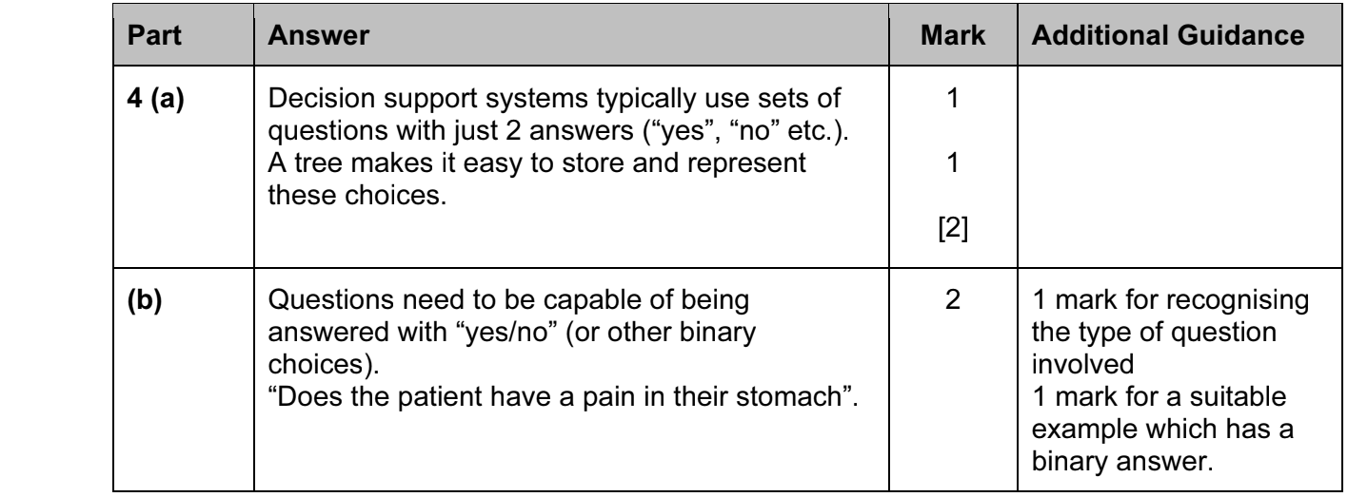

DATA REPRESENTATION 2014-2015 (PAPER 1)

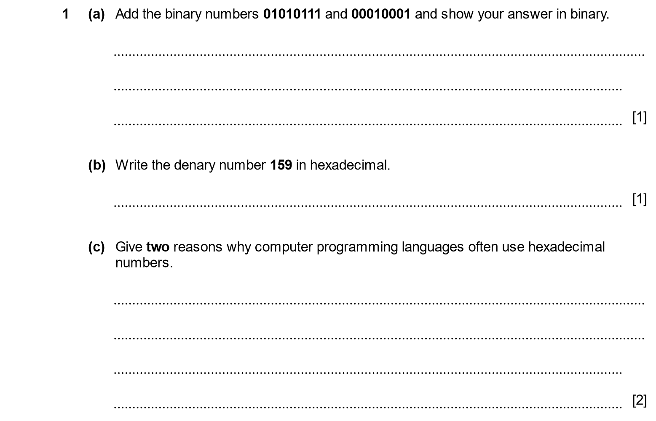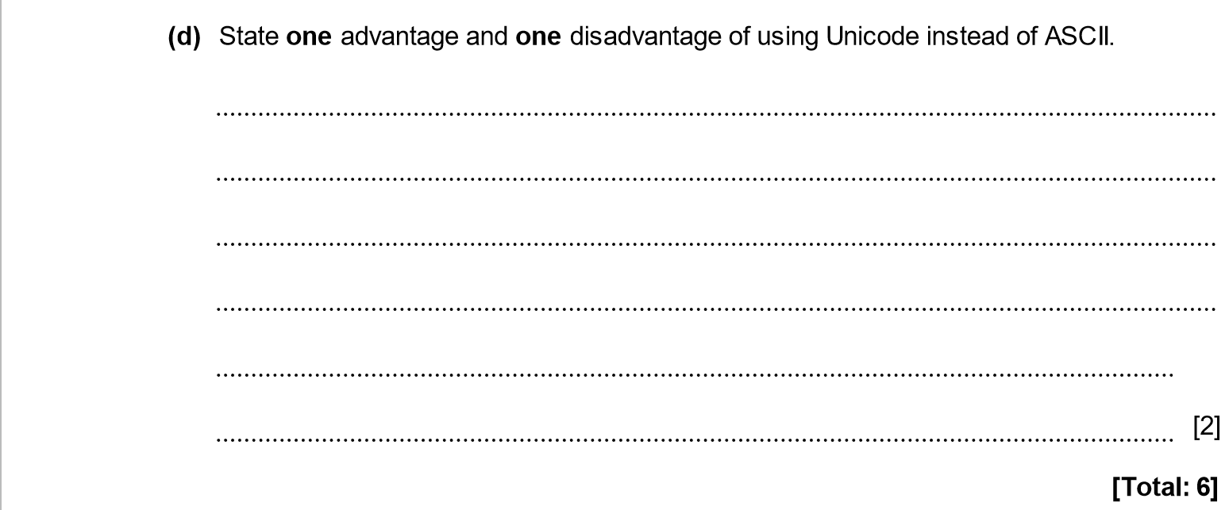

ANSWER

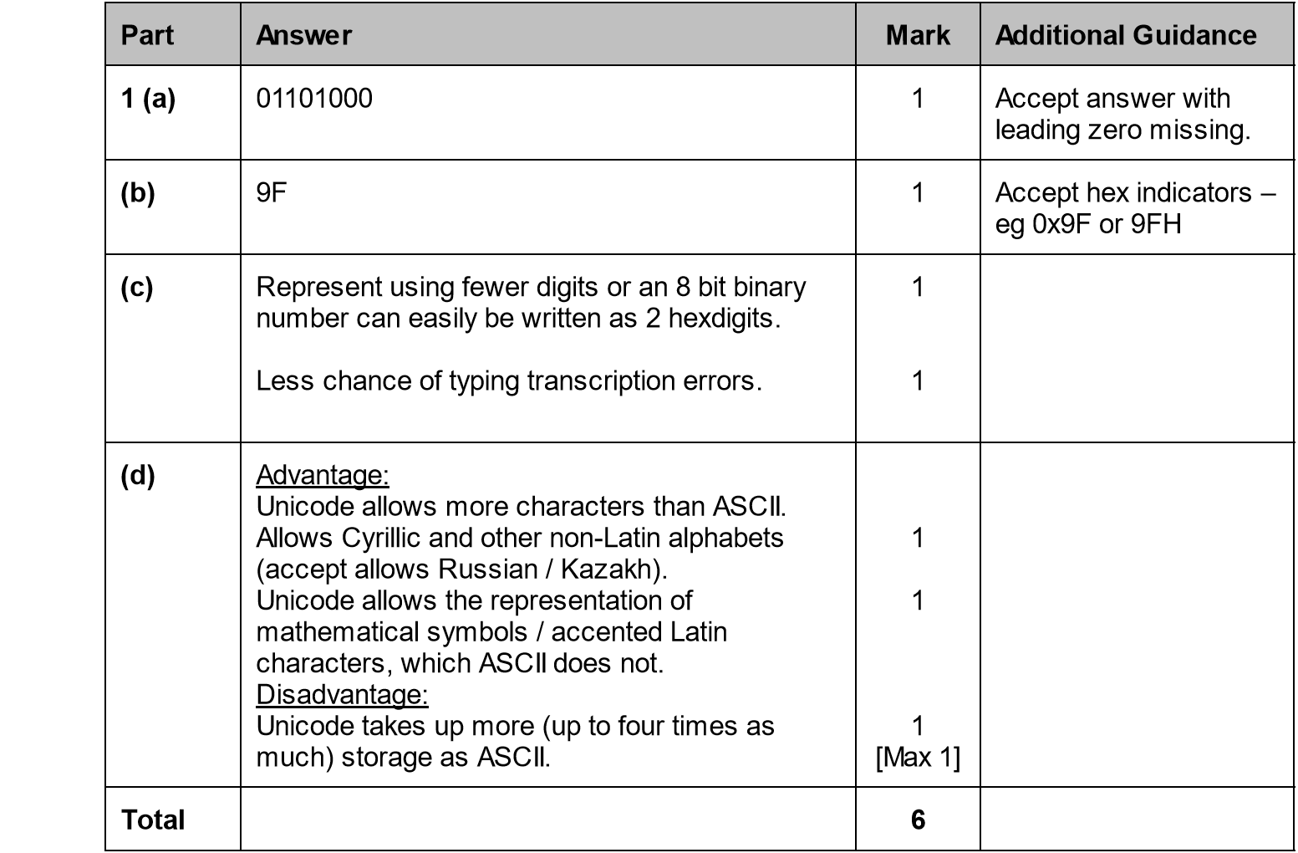

DATA REPRESENTATION 2014-2015 (PAPER 1)

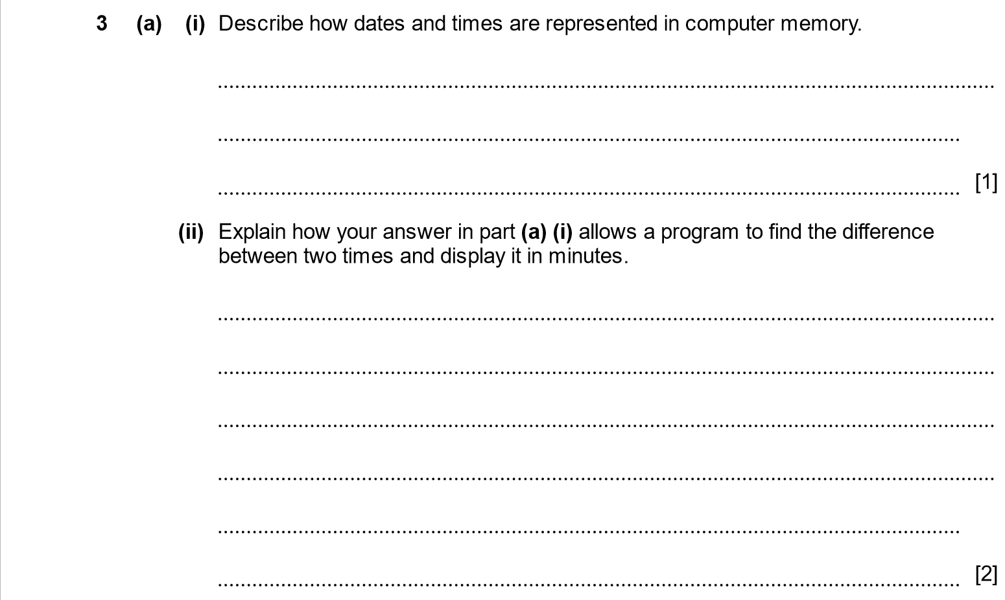

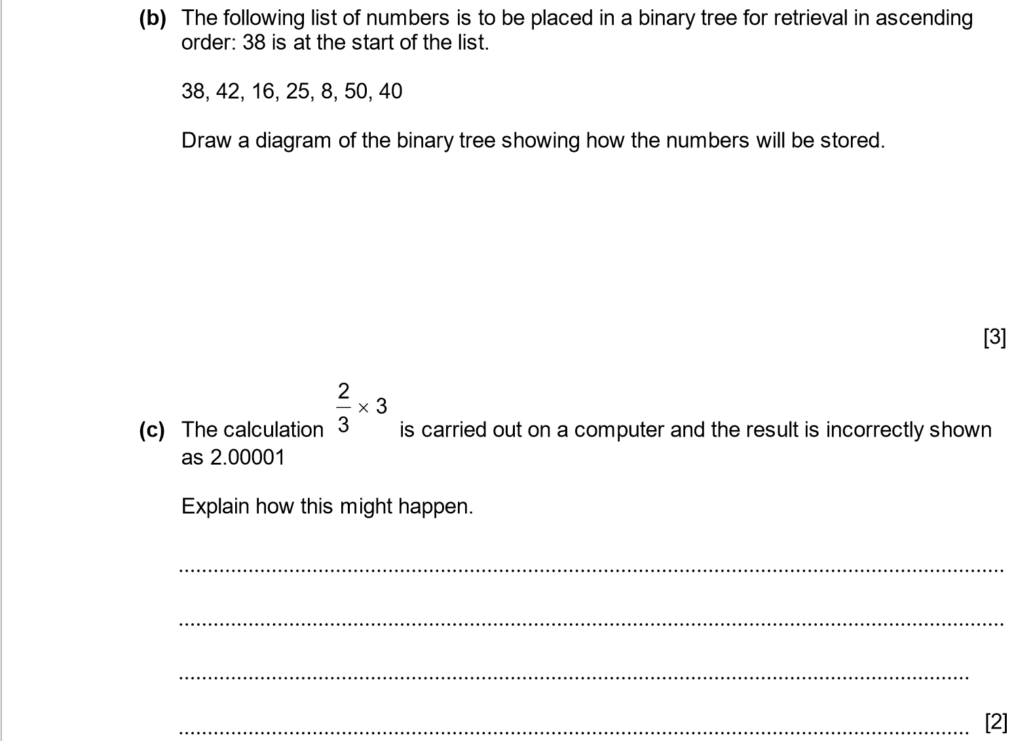
ANSWER

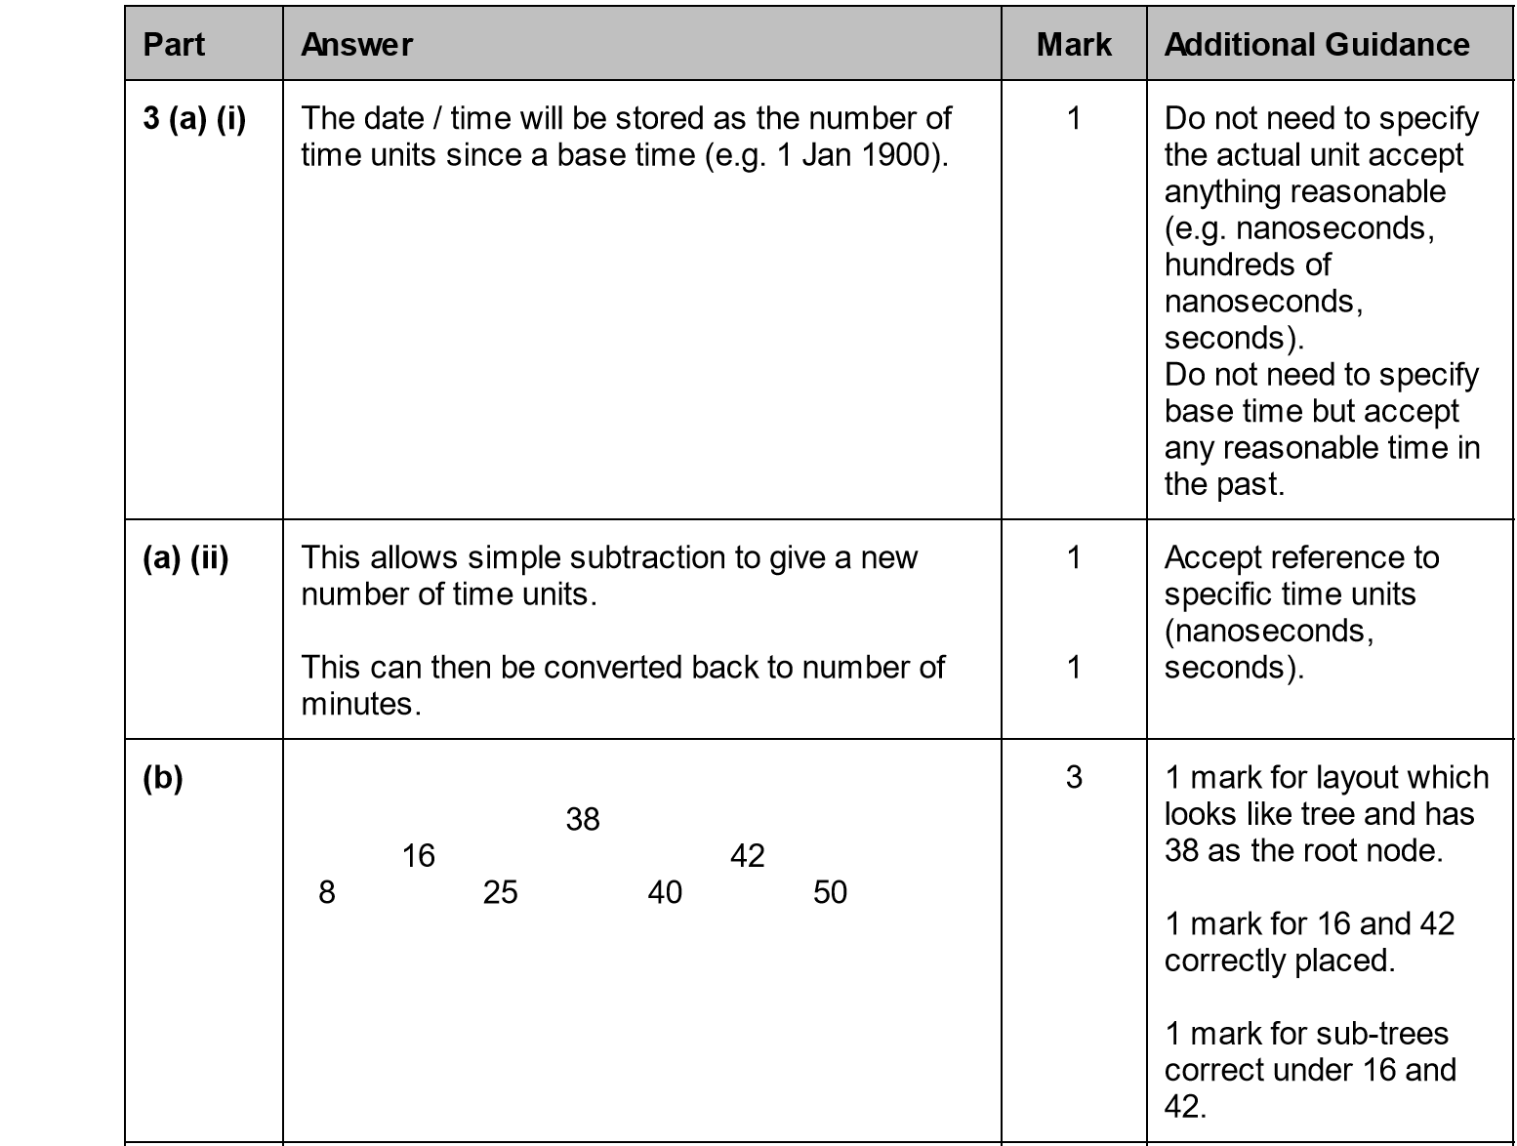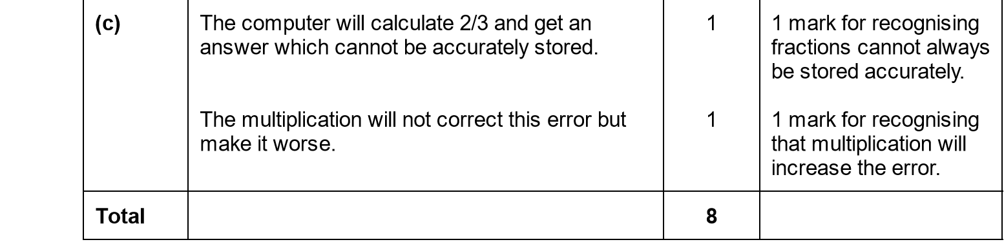

DATA REPRESENTATION 2014-2015 (PAPER 1)

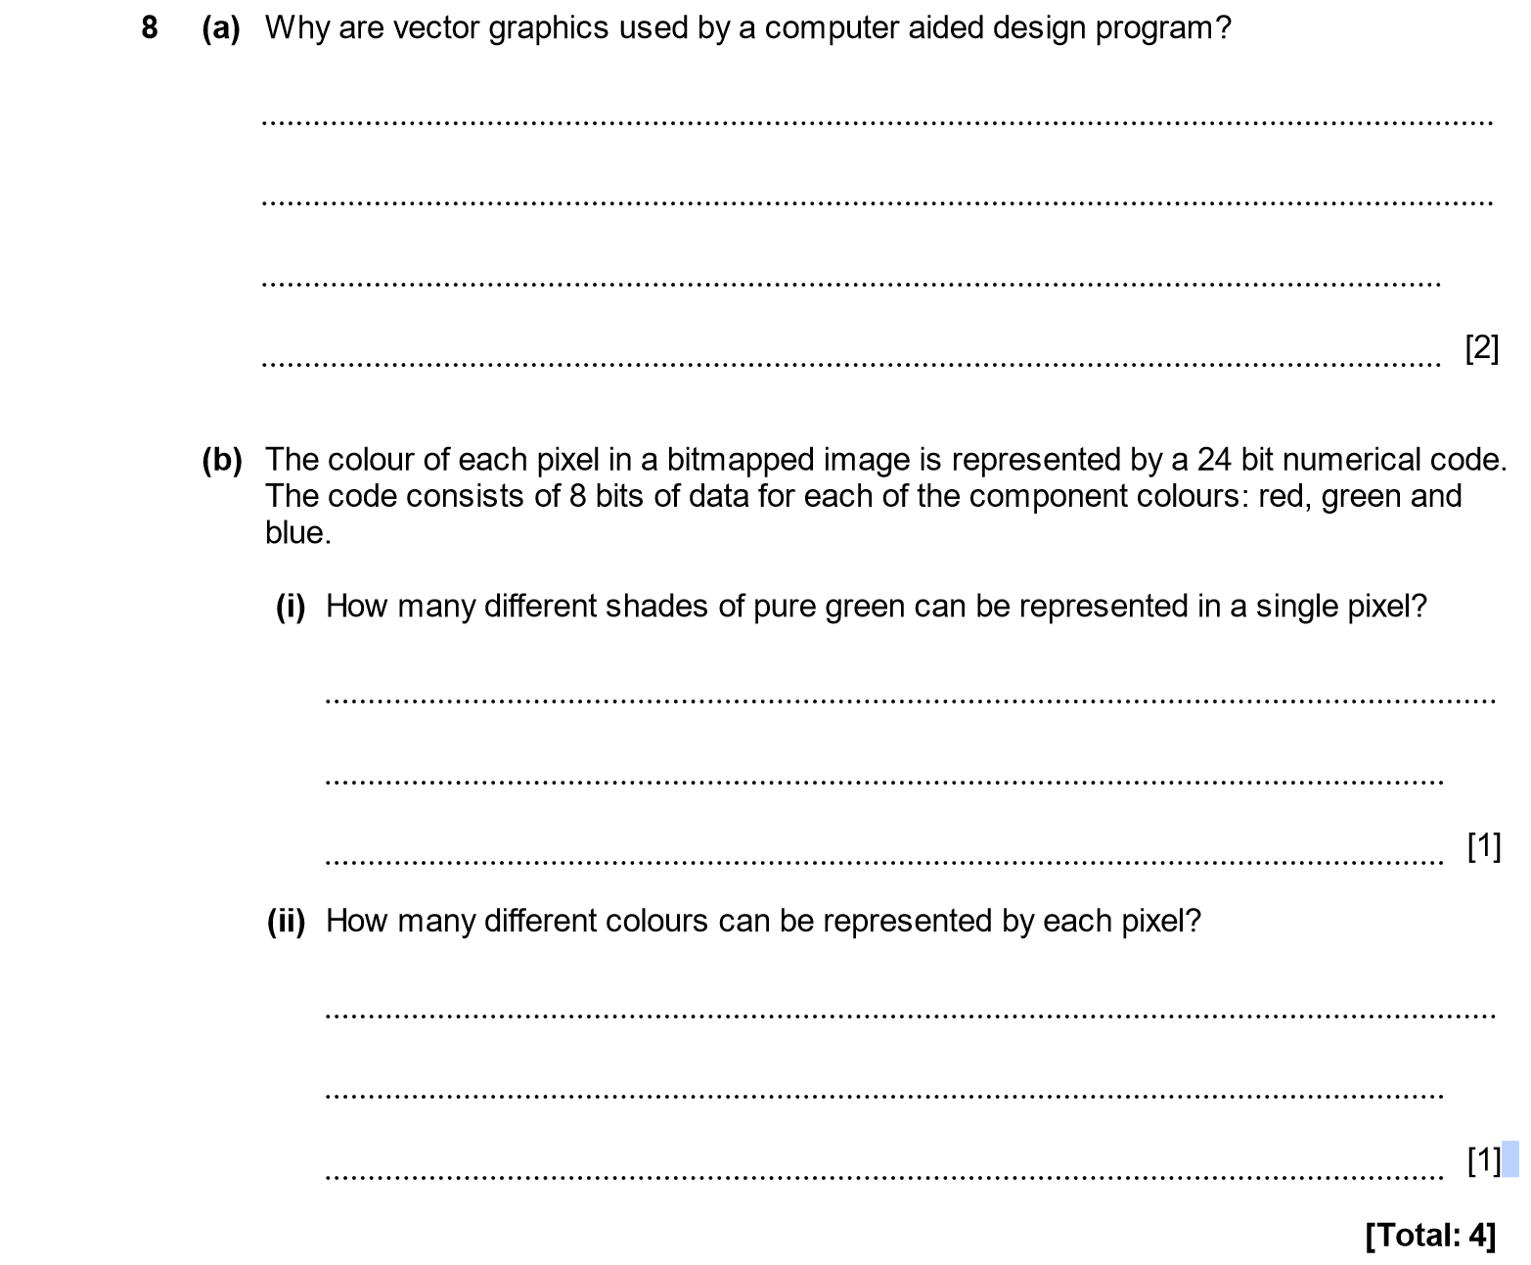

ANSWER

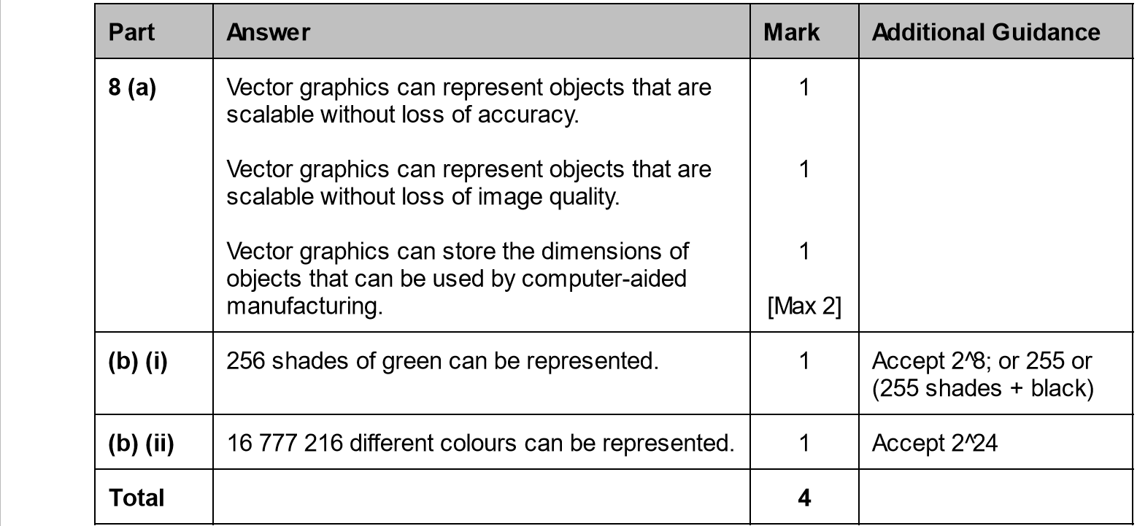

DATA REPRESENTATION 2015-2016 (PAPER 1)

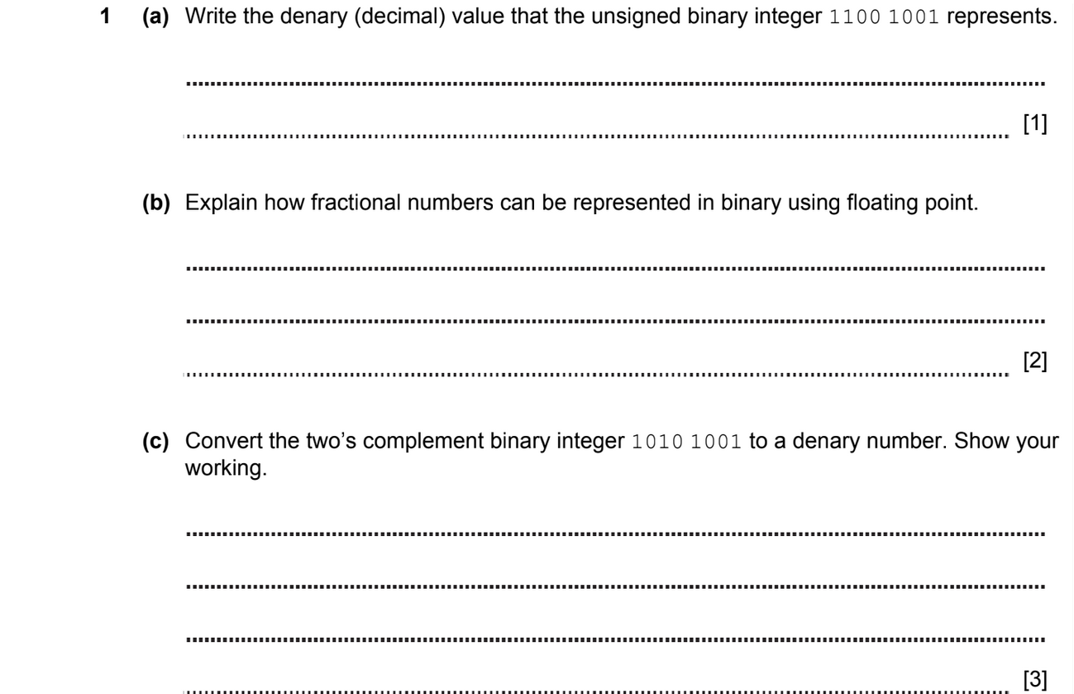

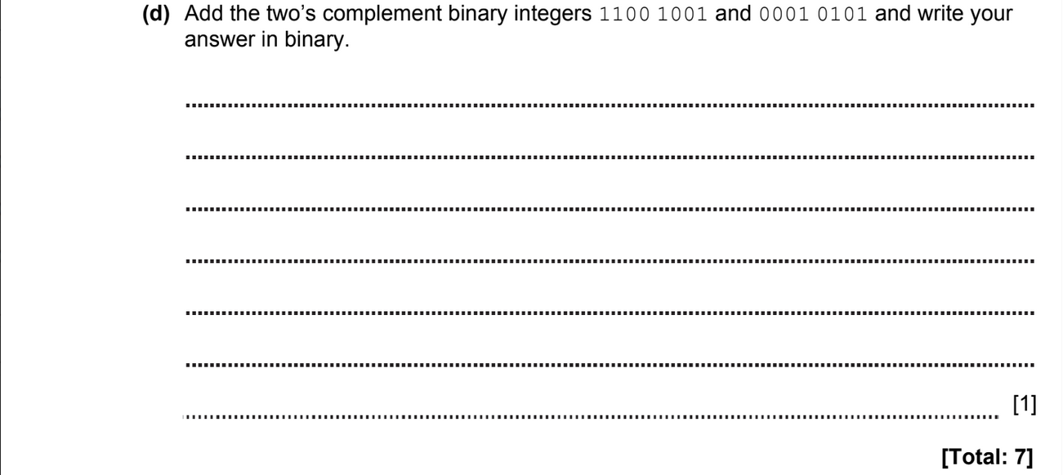

ANSWER

1a) 1100 1001 ₂ = 128 ₁₀ + 64 ₁₀ + 8 ₁₀ + 1 ₁₀ = 201₁₀

1 | 1 | 0 | 0 | 1 | 0 | 0 | 1
128₁₀ | 64₁₀ | 32₁₀ | 16₁₀ | 8₁₀ | 4₁₀ | 2₁₀ | 1₁₀
2⁷₁₀ | 2⁶₁₀ | 2⁵₁₀ | 2⁴₁₀ | 2³₁₀ | 2²₁₀ | 2¹₁₀ | 2⁰₁₀

1b) the floating point representation of a number using a mantissa and an exponent increases the accuracy of the number

1с) - 1010 1001 ₂ = - (64 + 16 + 4 + 2 + 1) = - 87 ₁₀

3 steps for solving exercise:

original | 1 | 0 | 1 | 0 | 1 | 0 | 0 | 1
inverted | 0 | 1 | 0 | 1 | 0 | 1 | 1 | 0
added 1 | 0 | 1 | 0 | 1 | 0 | 1 | 1 | 1

0 | 1 | 0 | 1 | 0 | 1 | 1 | 1
128₁₀ | 64₁₀ | 32₁₀ | 16₁₀ | 8₁₀ | 4₁₀ | 2₁₀ | 1₁₀
2⁷₁₀ | 2⁶₁₀ | 2⁵₁₀ | 2⁴₁₀ | 2³₁₀ | 2²₁₀ | 2¹₁₀ | 2⁰₁₀

1d) - 1100 1001₂ + - 0001 0101₂ = - 1101 1110₂

+ | 1 | 1 | 0 | 0 | 1 | 0 | 0 | 1
+ | 0 | 0 | 0 | 1 | 0 | 1 | 0 | 1
 | 1 | 1 | 0 | 1 | 1 | 1 | 1 | 0

DATA REPRESENTATION 2016-2017 (PAPER 1)
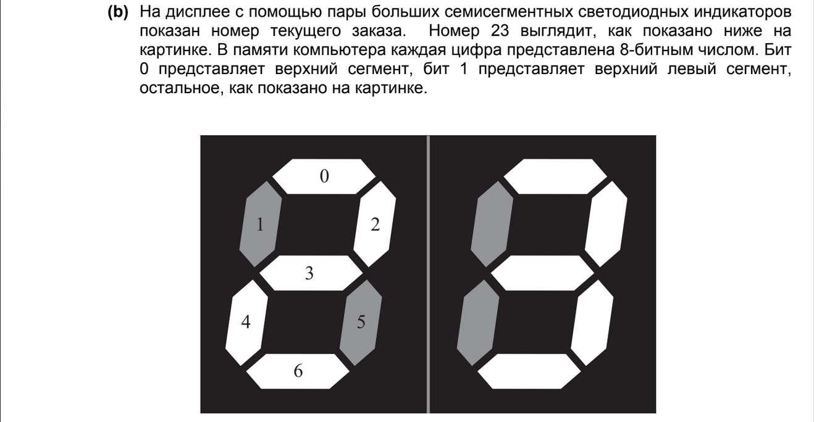

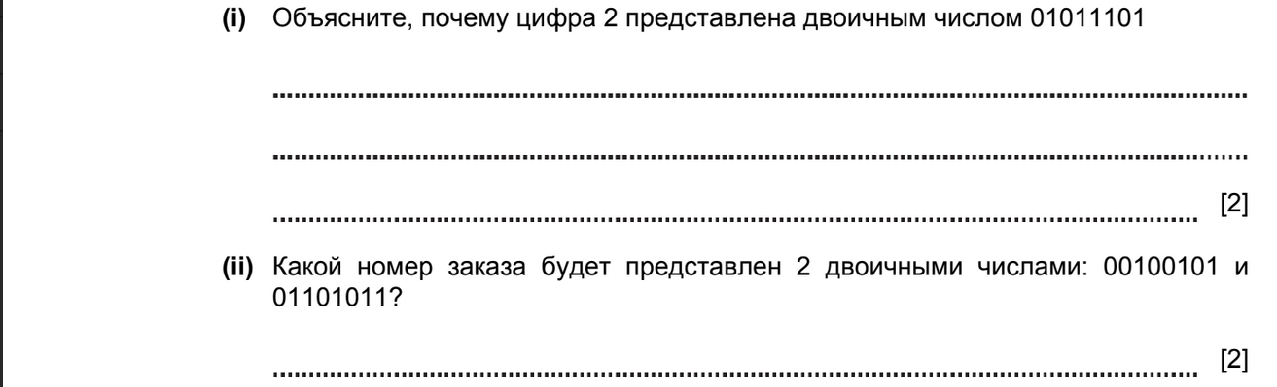

ANSWER

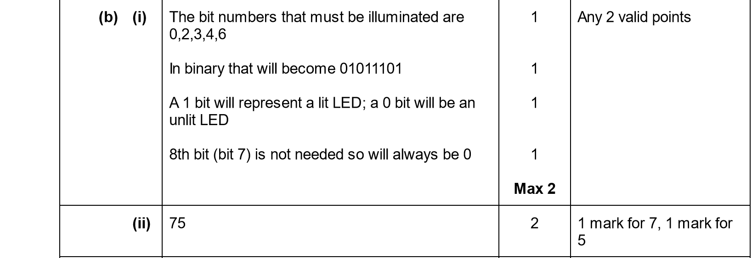
DATA REPRESENTATION 2017-2018 (PAPER 1)

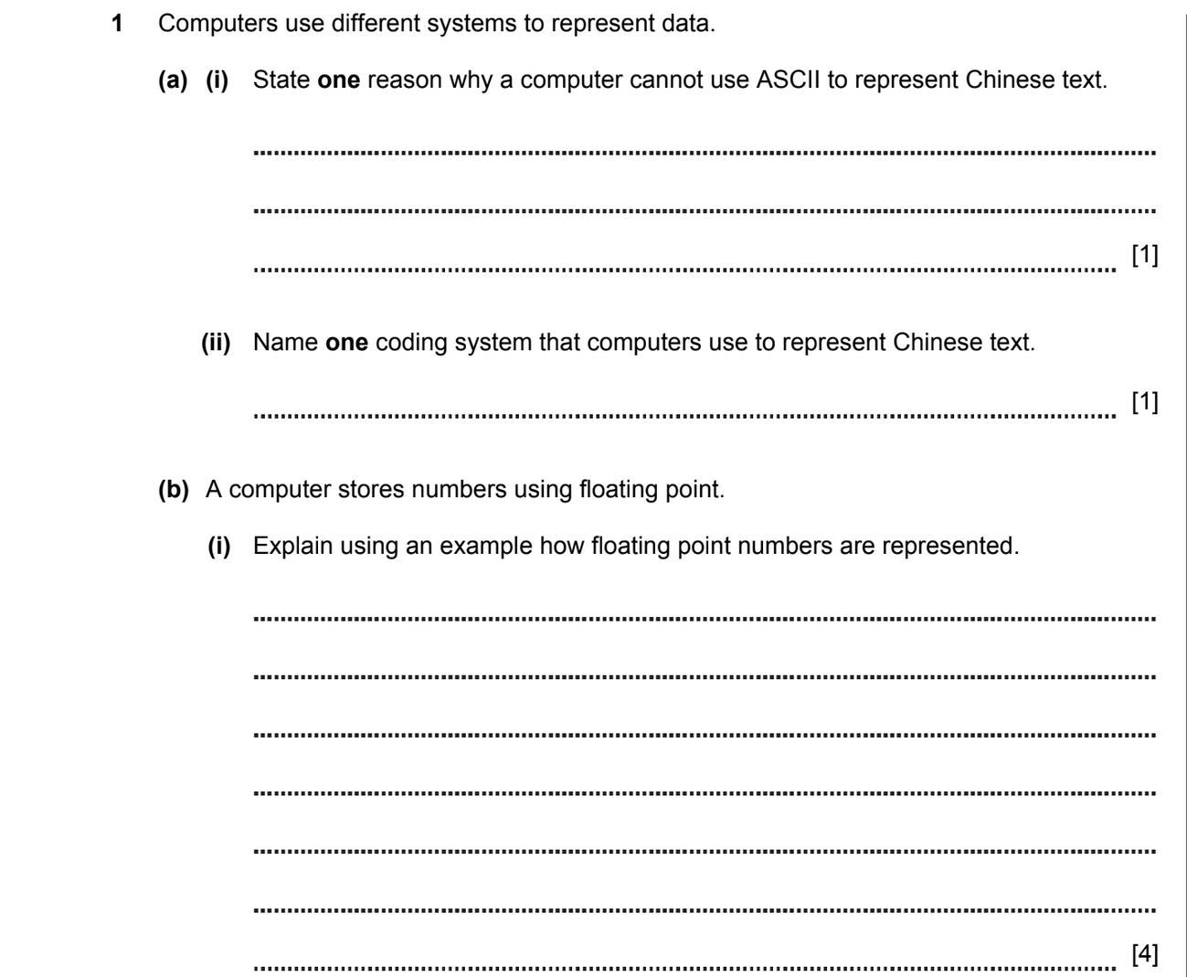

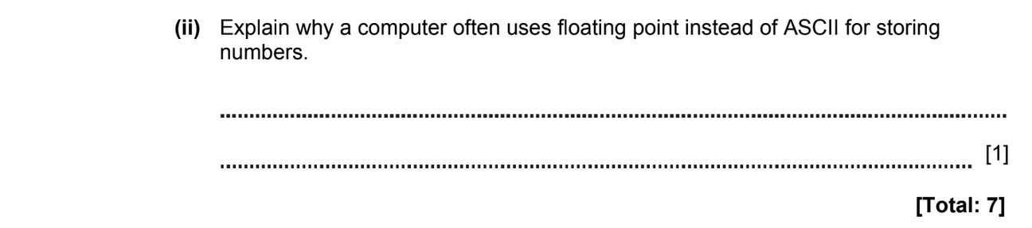

ANSWER

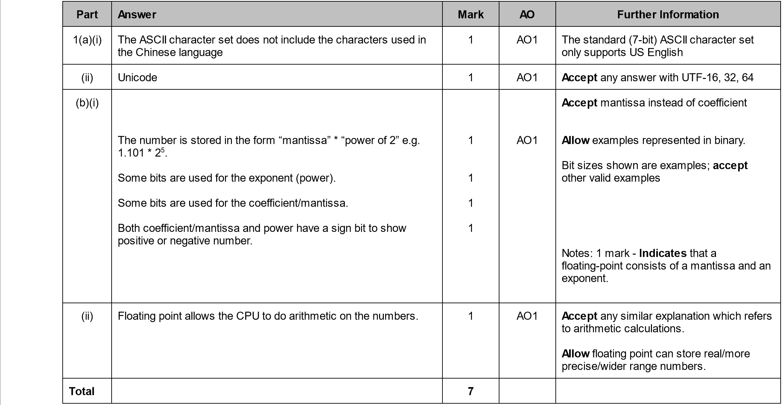

DATA REPRESENTATION 2017-2018 (PAPER 1)

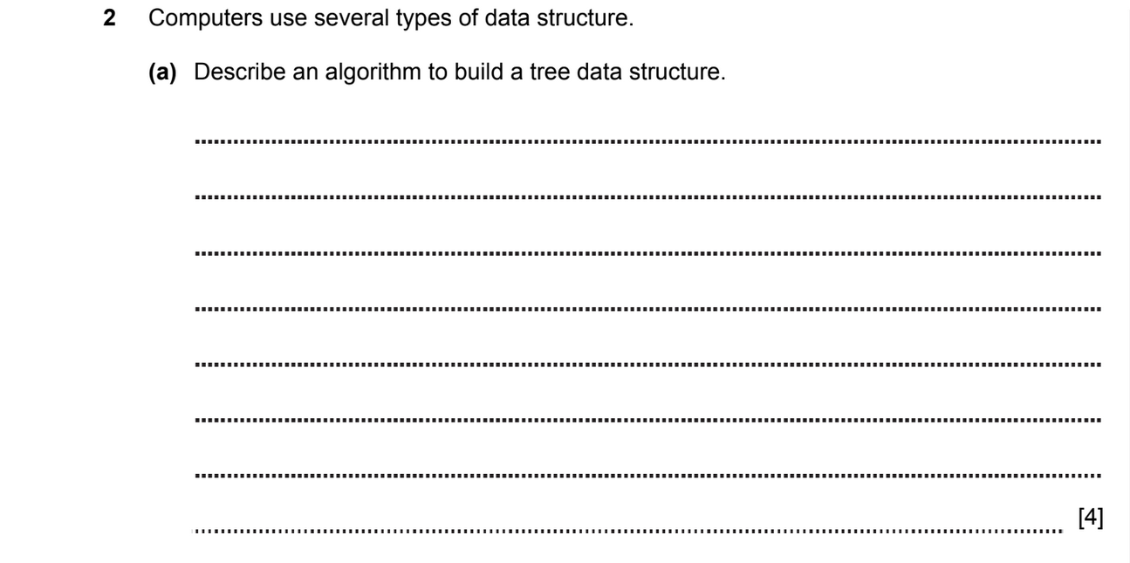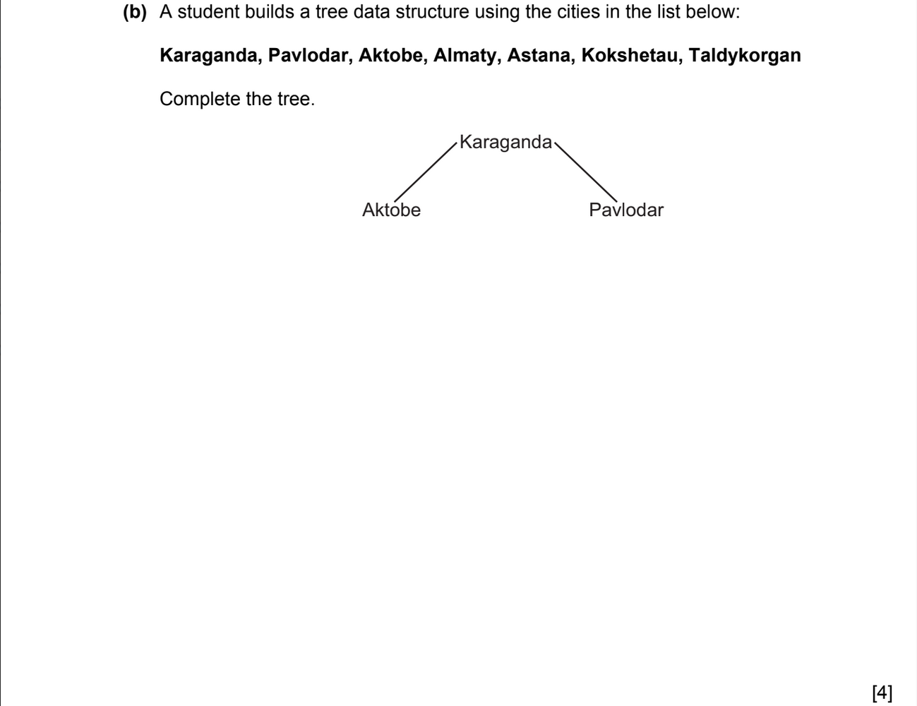
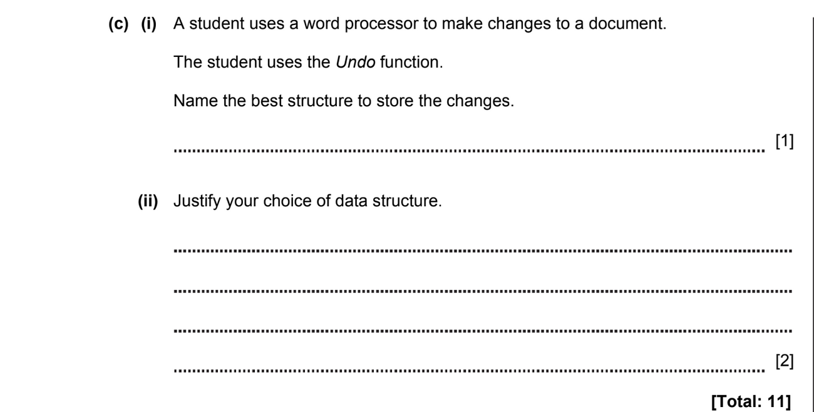

ANSWERS

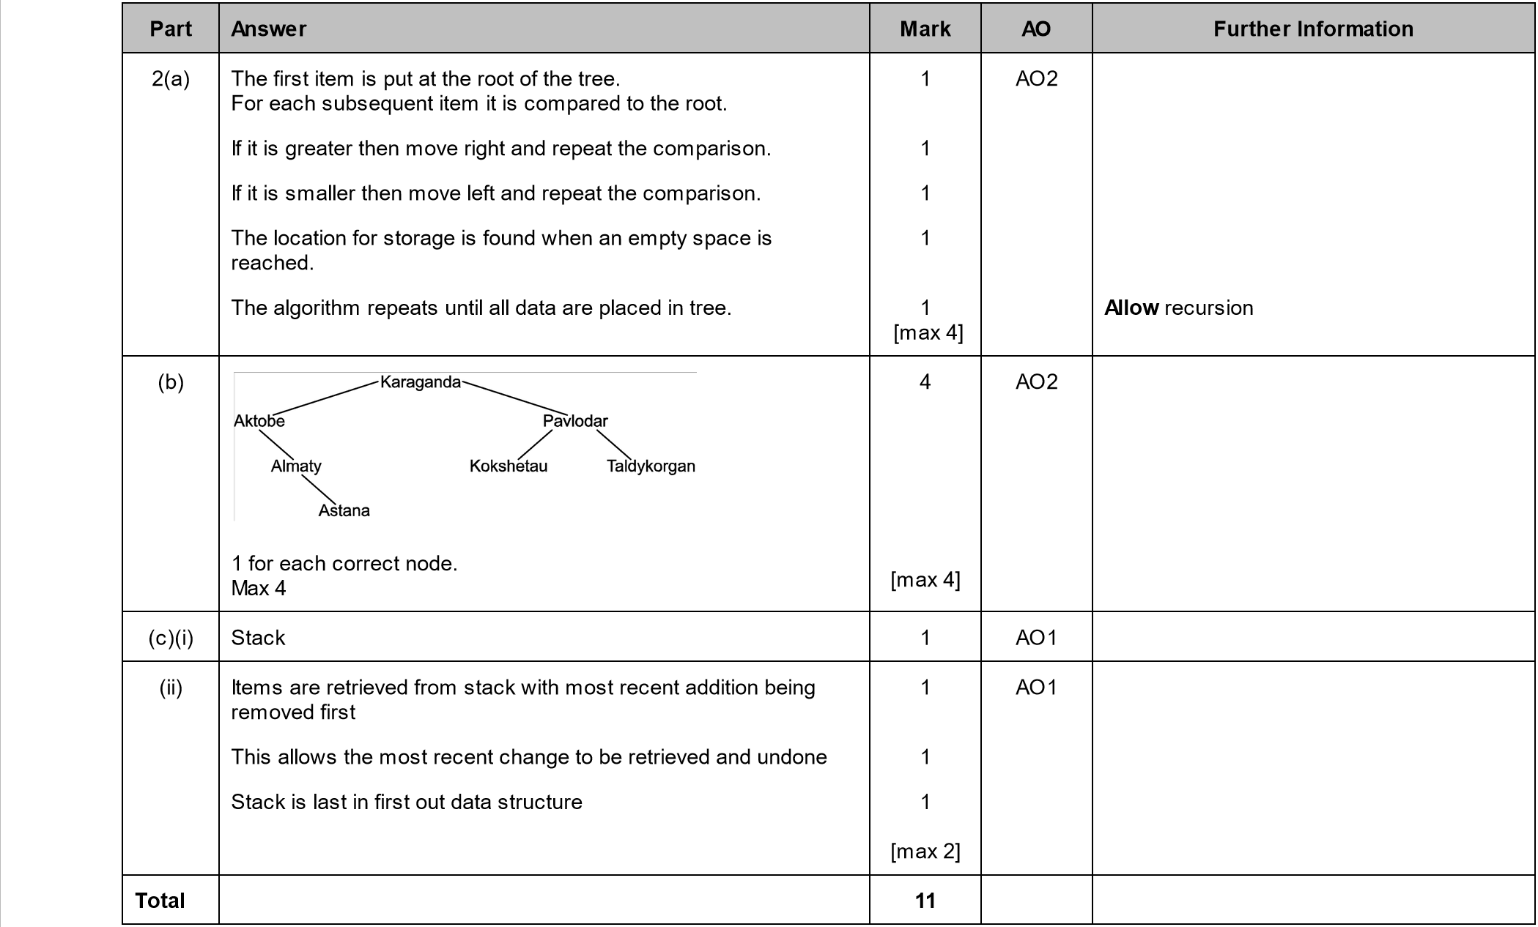

DATA REPRESENTATION 2018-2019 (PAPER 1)
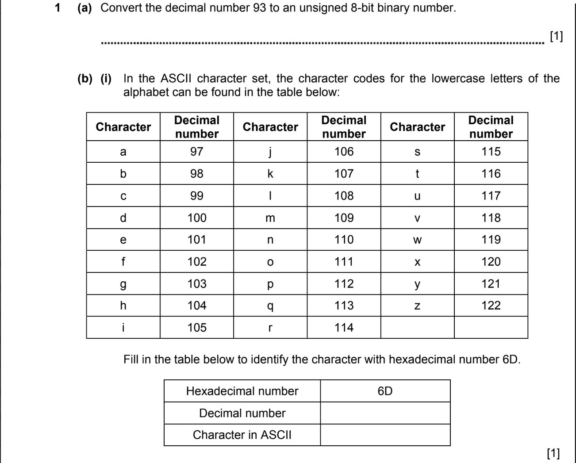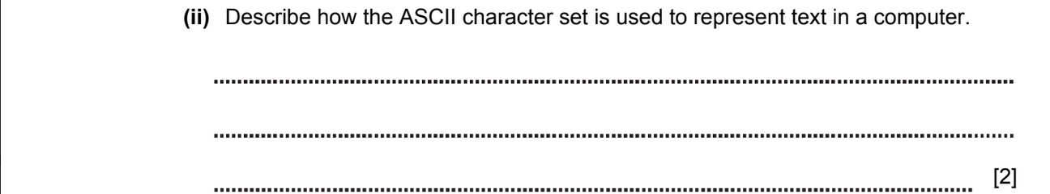

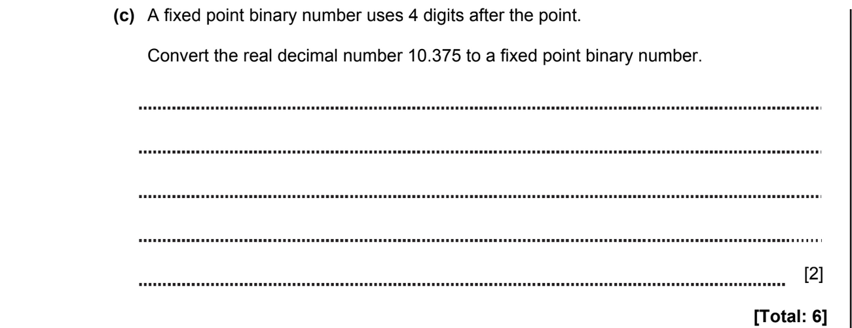
ANSWERS

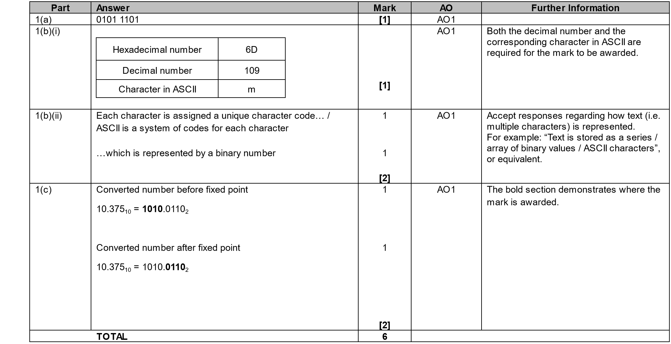

DATA REPRESENTATION 2018-2019 (PAPER 1)

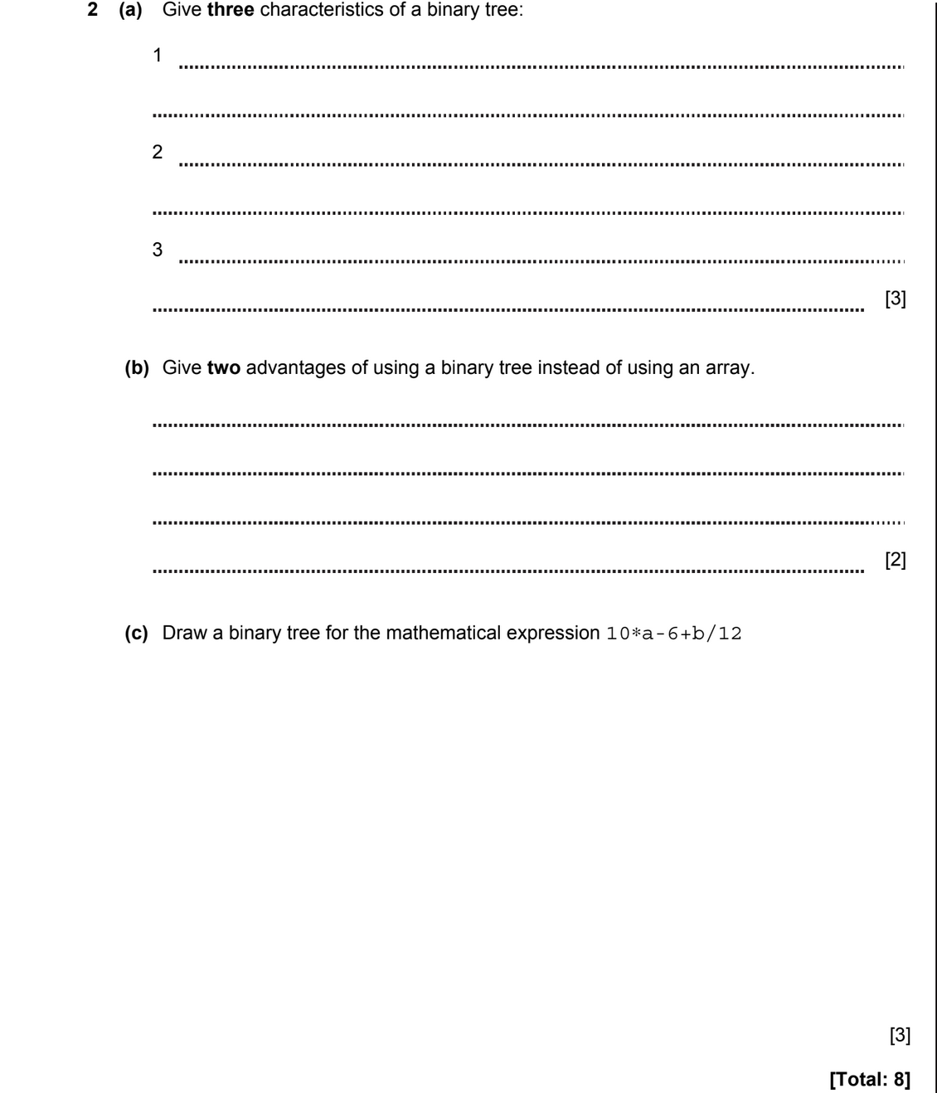

ANSWERS
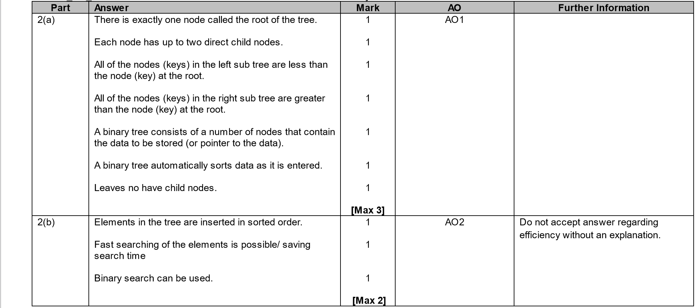

DATA REPRESENTATION 2018-2019 (PAPER 1)
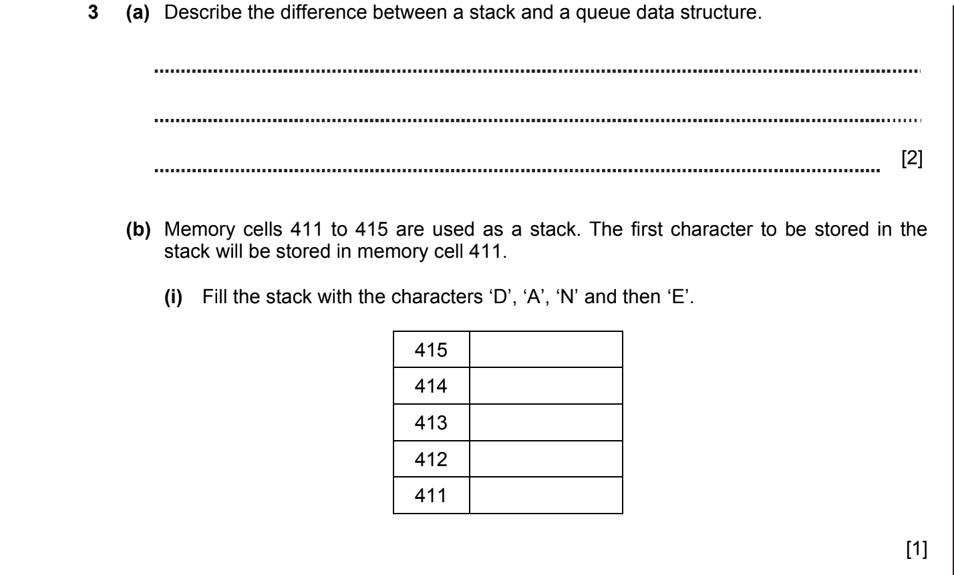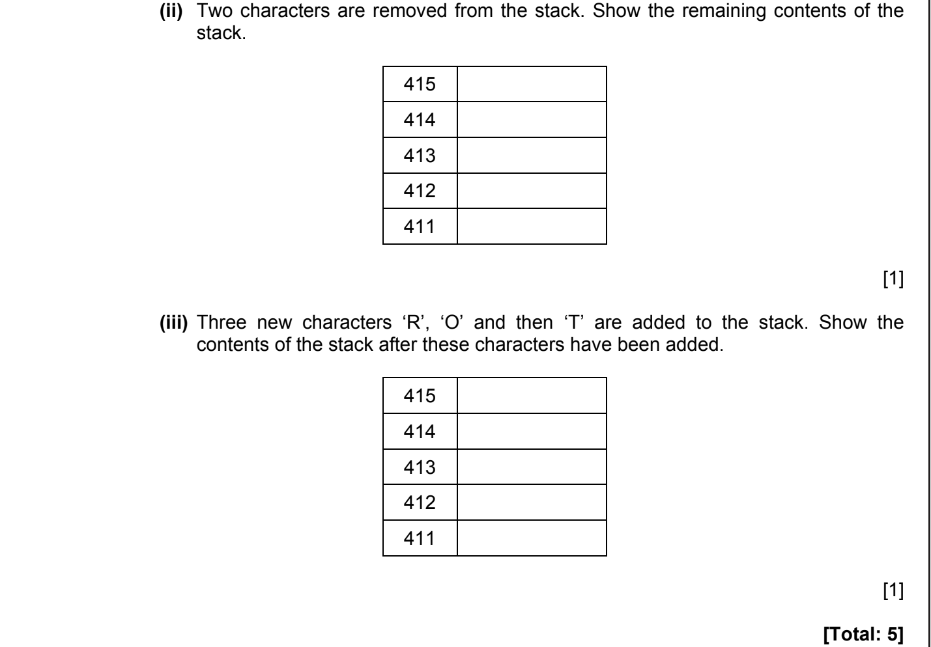

ANSWERS
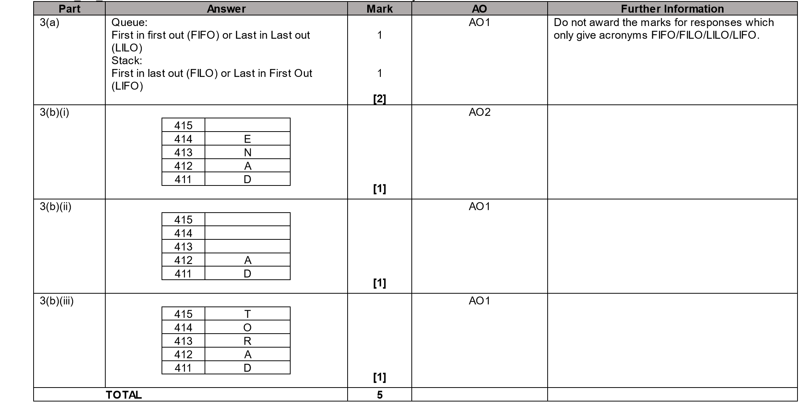

DATA REPRESENTATION 2020-2021 (PAPER 1)

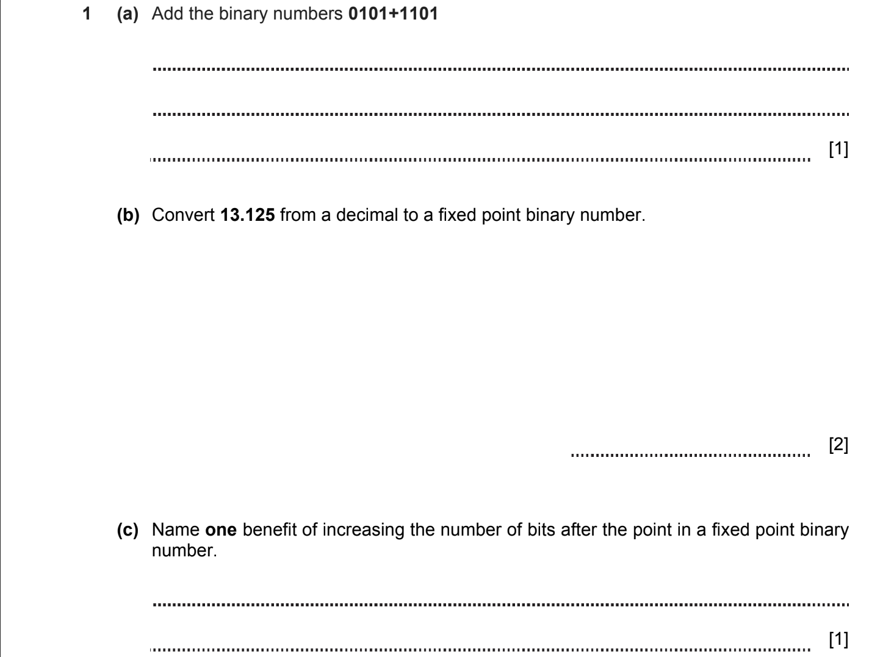
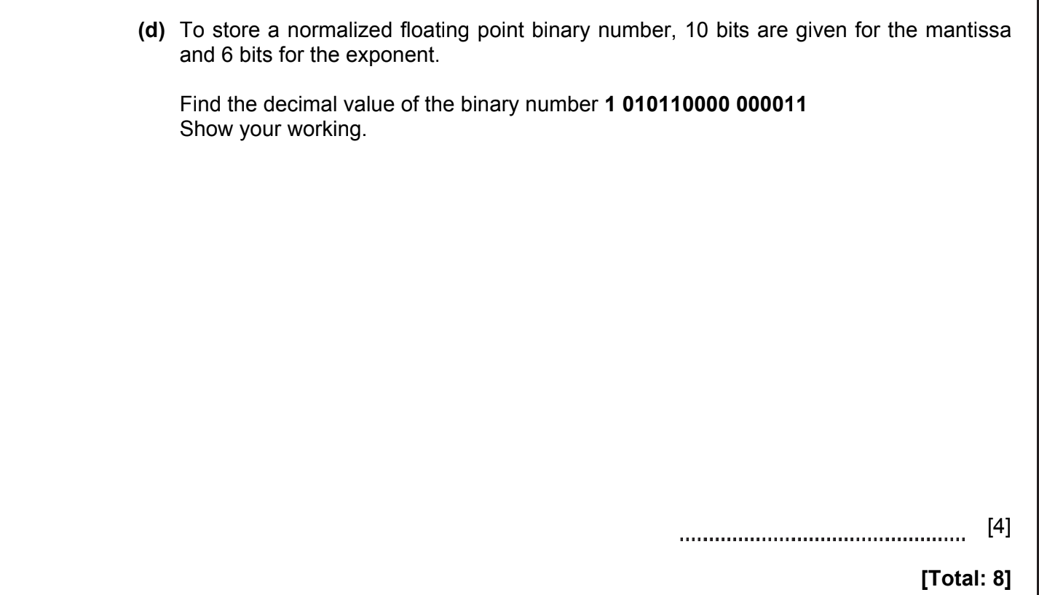
ANSWERS
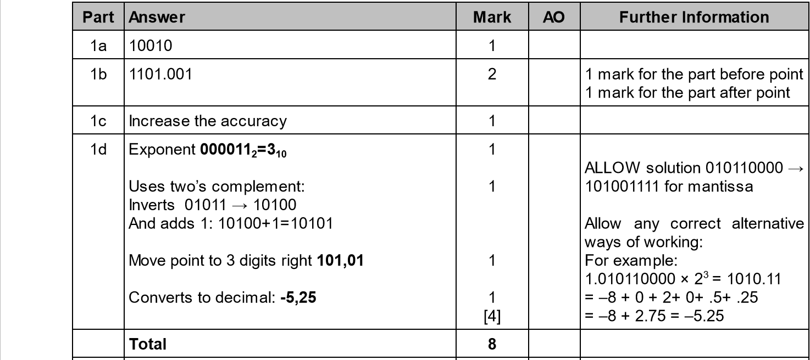

DATA REPRESENTATION 2021-2022 (PAPER 1)

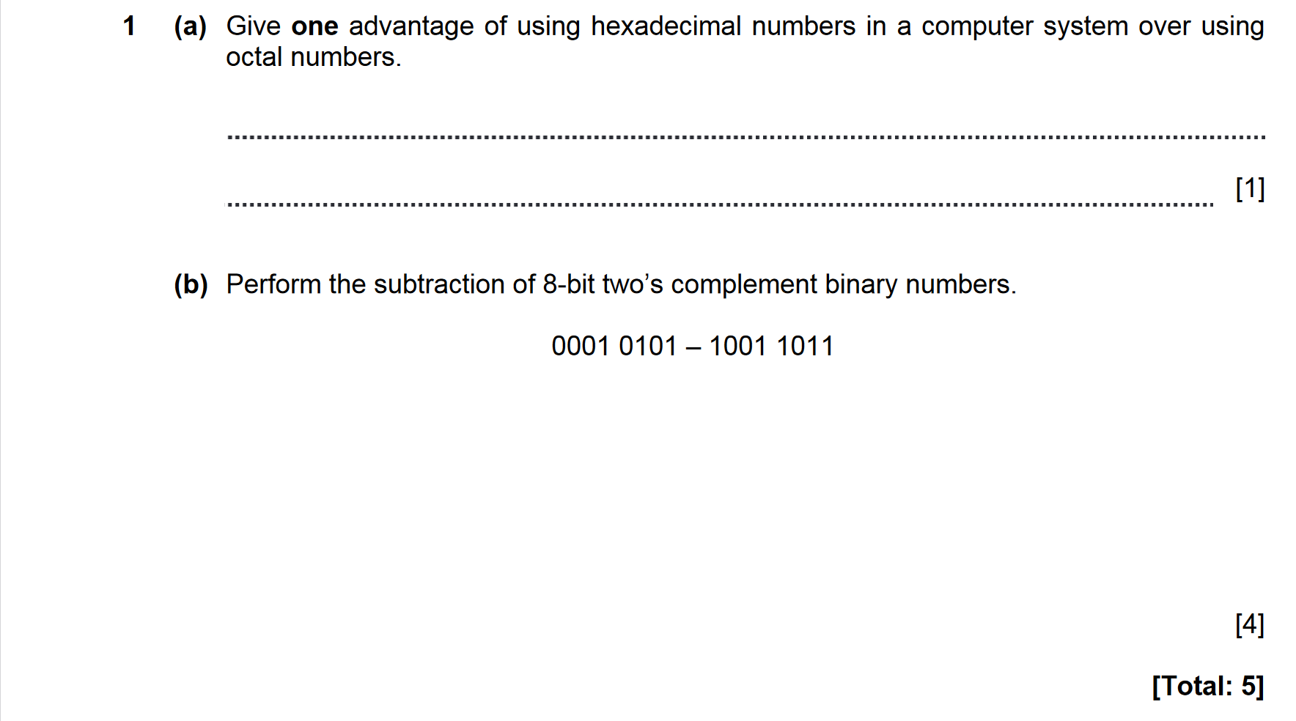
ANSWERS

