BOOLEAN LOGIC 2013-2014 (PAPER 2)

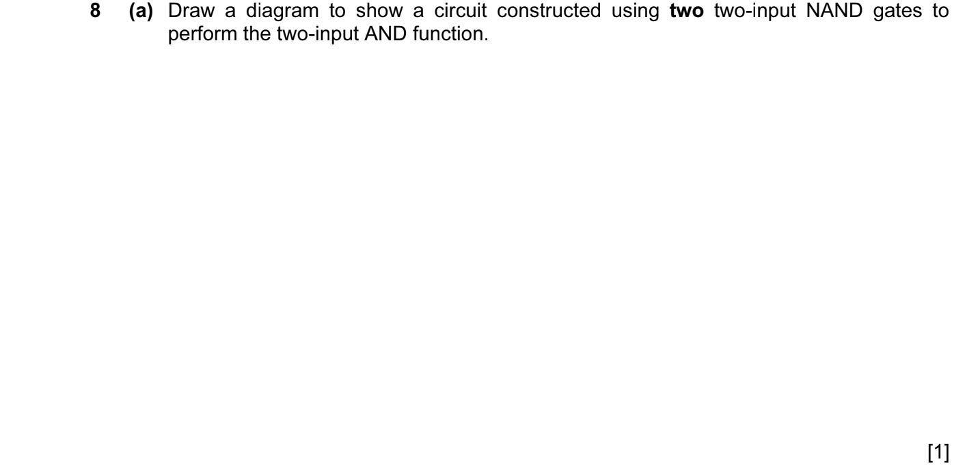

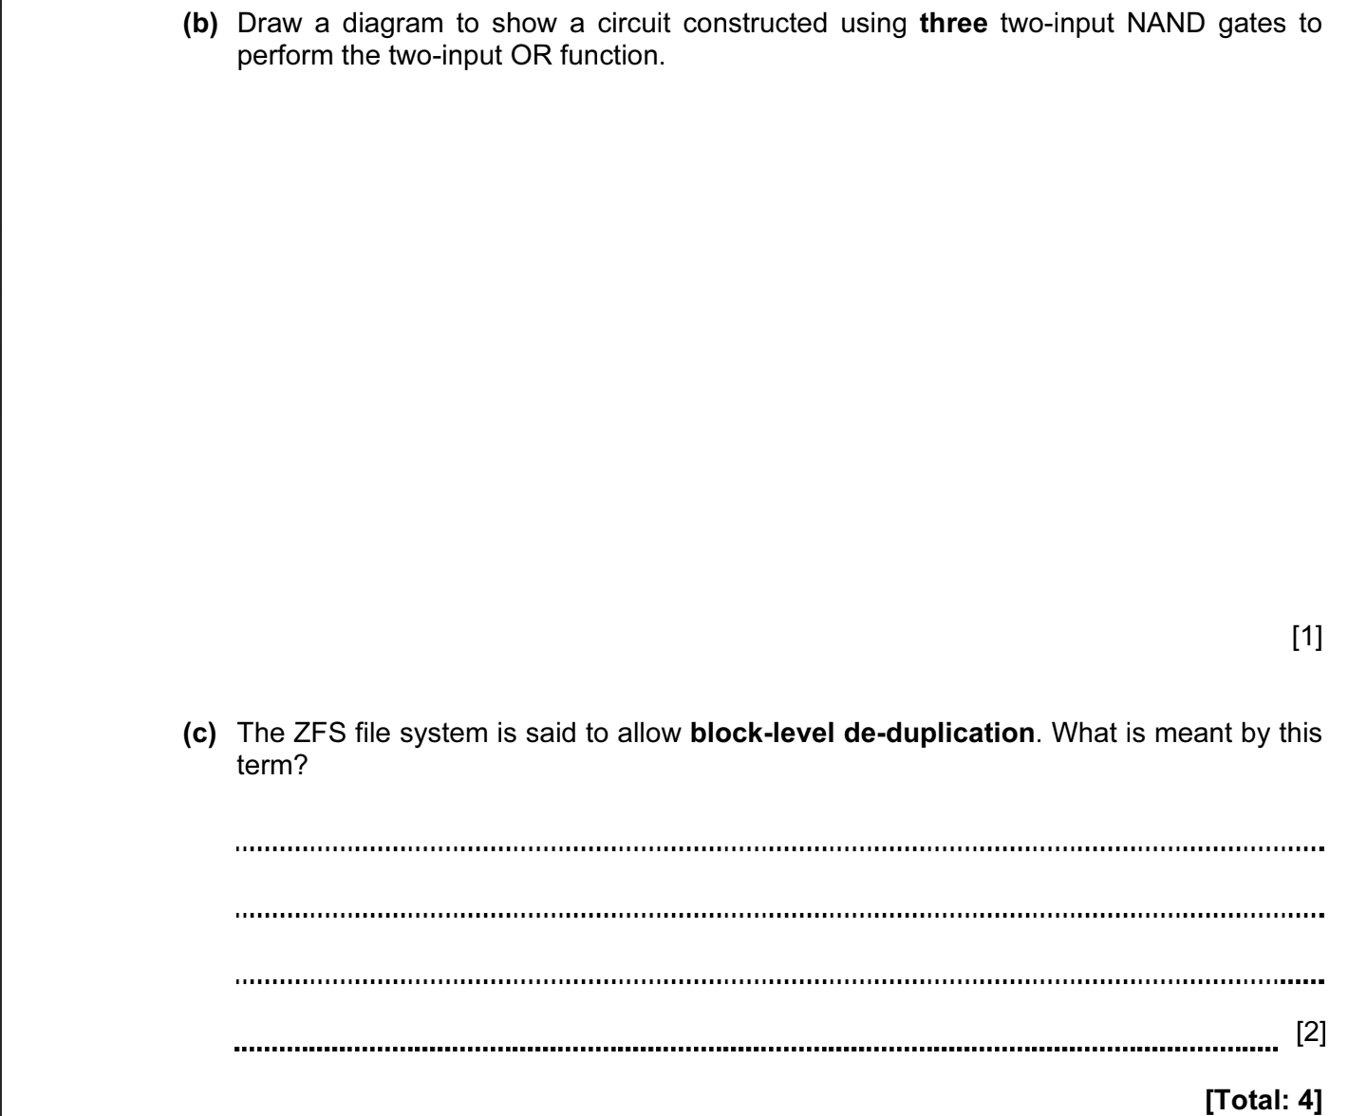

ANSWERS

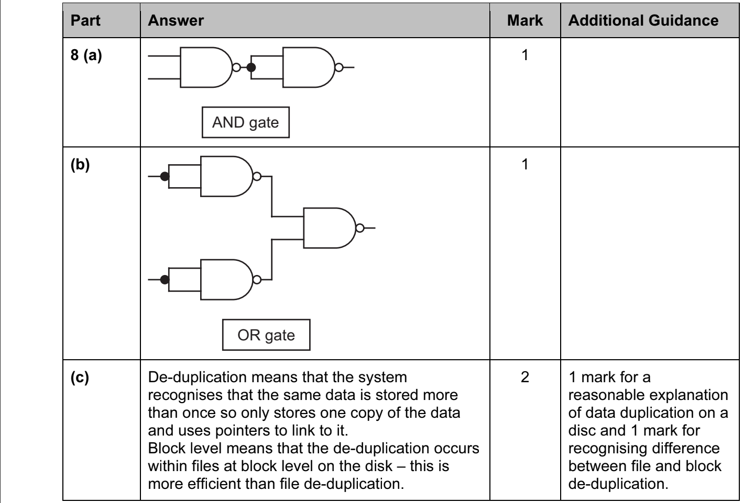

BOOLEAN LOGIC 2020-2021 (PAPER 1)

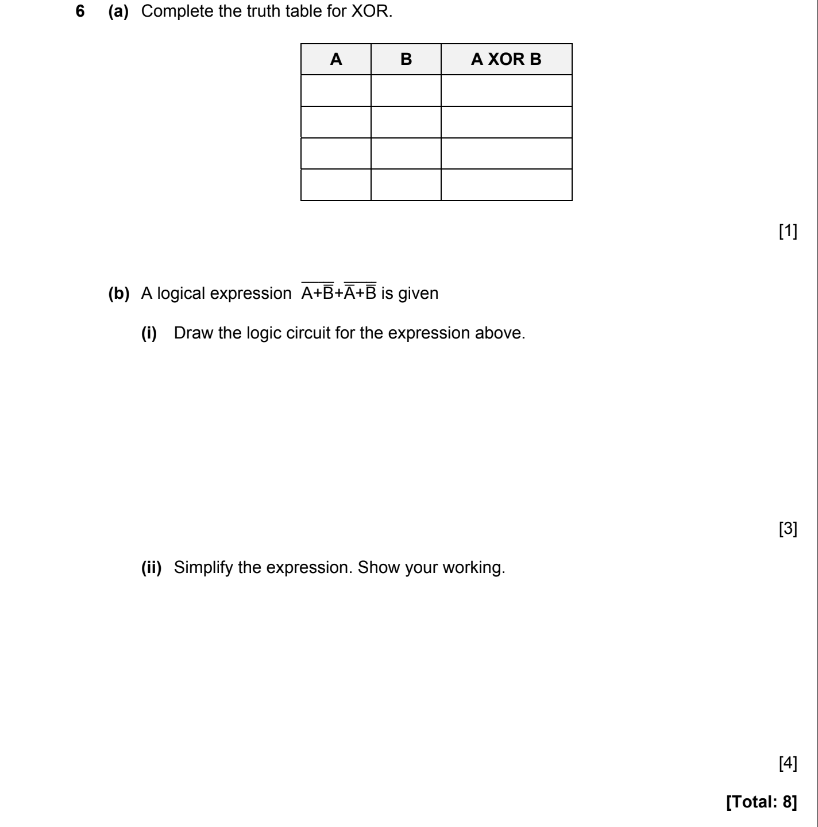

ANSWERS

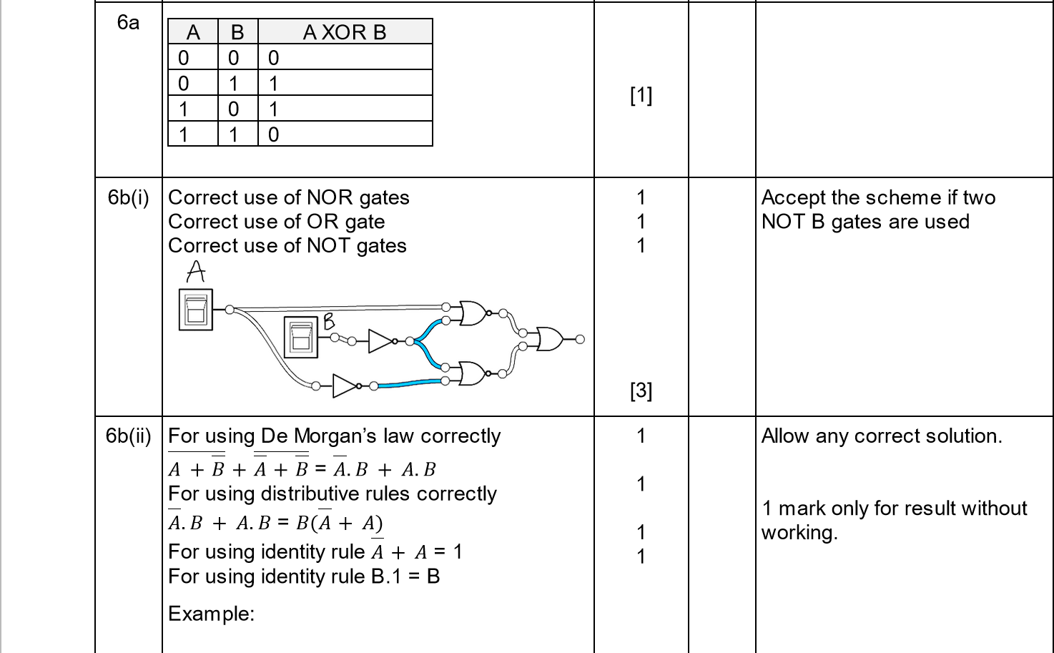
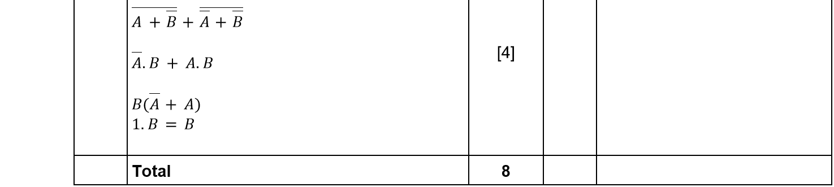

BOOLEAN LOGIC 2021-2022 (PAPER 1)

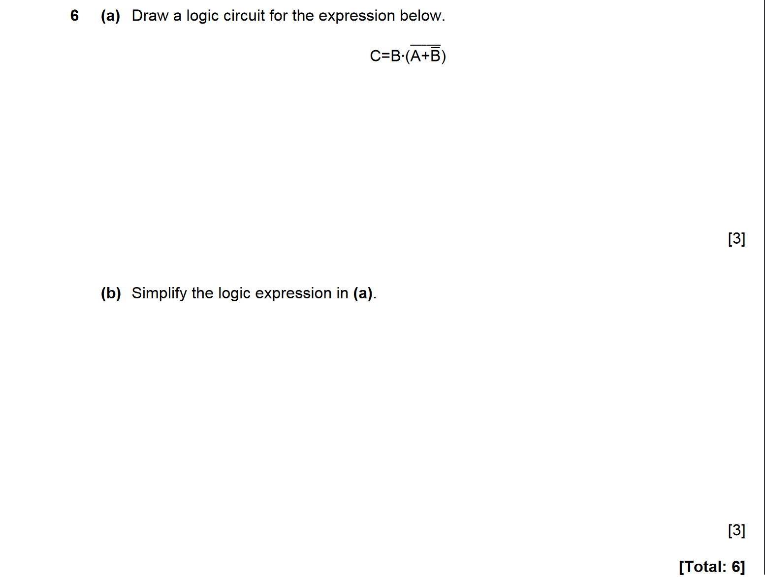

ANSWERS

