NETWORK AND COMMUNICATION 2013-2014 (PAPER 2)

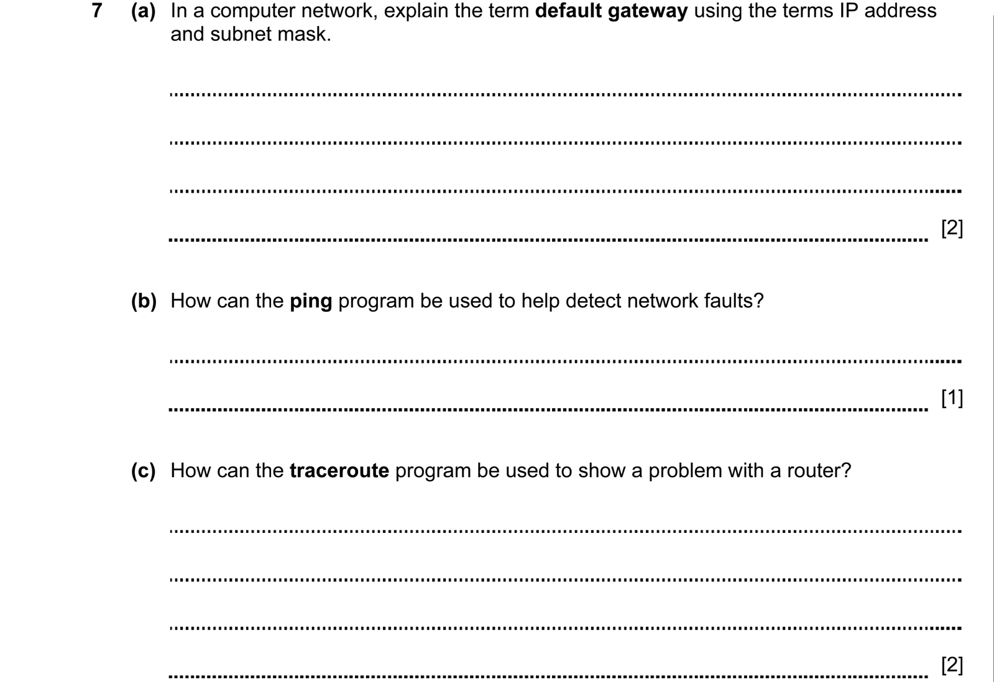
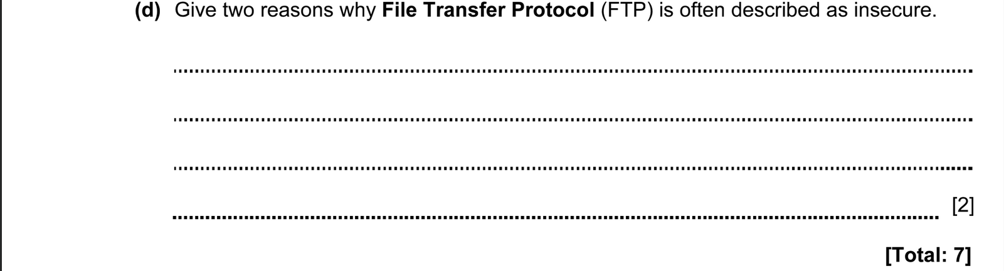

ANSWERS
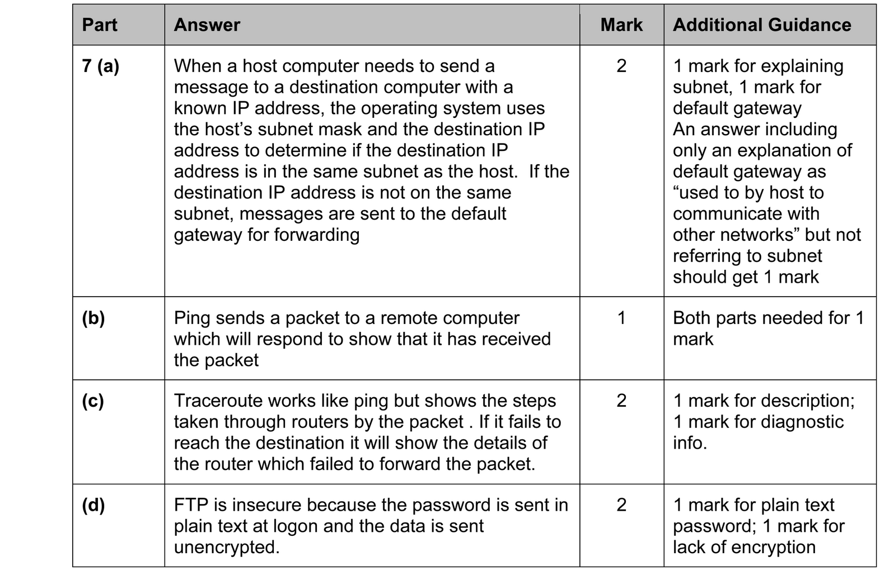

NETWORK AND COMMUNICATION 2014-2015 (PAPER 2)

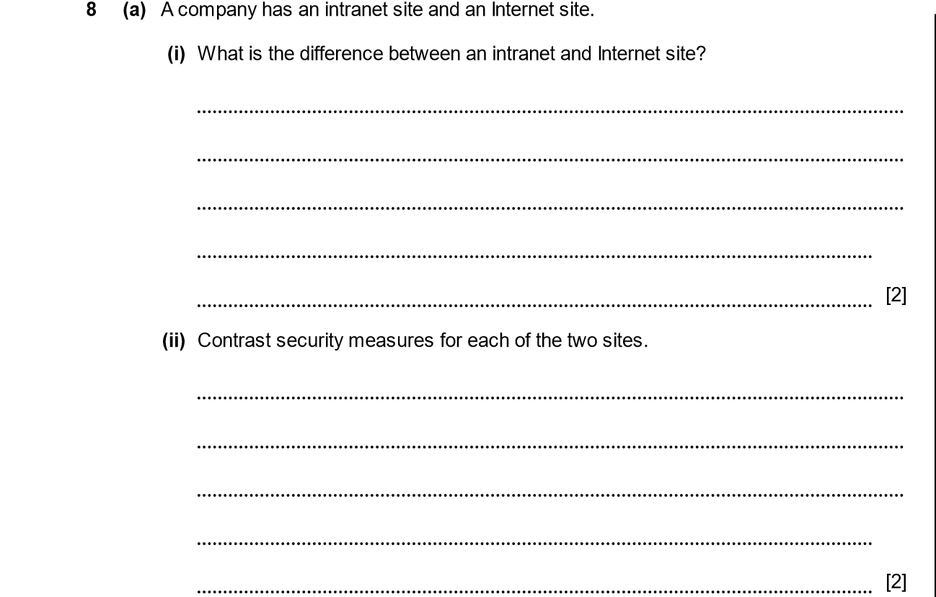
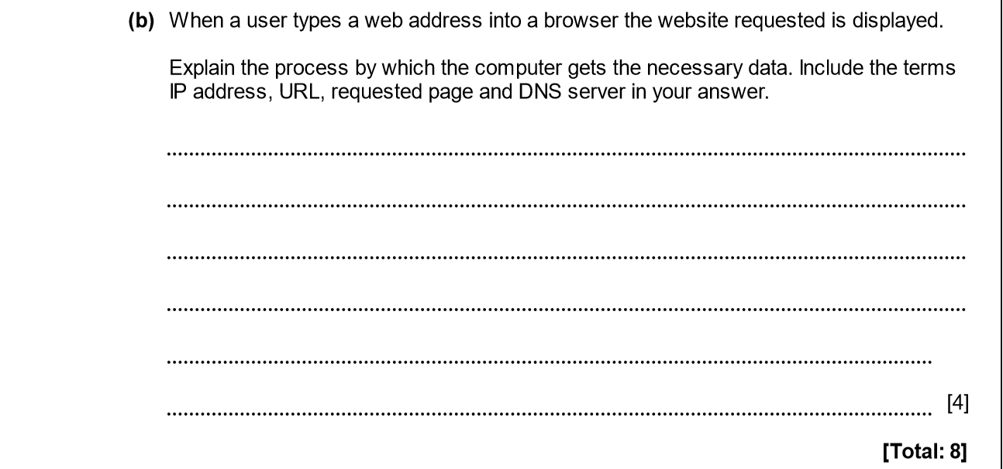

ANSWERS
Part | Answer | Mark | Additional Guidance
8 (a) (i) | An intranet site is used internally by company staff.  The Internet site is available to members of the public as well as company staff. | 1  1 | 1 mark for company only.  1 mark for public.
(ii) | The Intranet will be secured to prevent access by non-company members either by passwords or firewall or both.  Most of the Internet site will have no security restrictions but it may use passwords or other methods to restrict access to some or all of the site.  The Internet site may be positioned in the DMZ of the company’s network | 1  1  1  [Max 2] | Any two points.
(b) | The web address is a URL (uniform resource locator).  The browser will take the first part of the address (everything after the http:// and up to the next /) and pass it to the DNS server.  This will return an IP address for the web server.  The browser will then contact that server and ask it to return the requested page (everything after the “/”) from the specific site. | 1  1  1  1 | 1 mark for identifying URL is web address.  1 mark for splitting out website from URL.  1 mark for getting IP from DNS.  1 mark for asking server for page from website.
Total |  | 8

NETWORK AND COMMUNICATION 2014-2015 (PAPER 2)

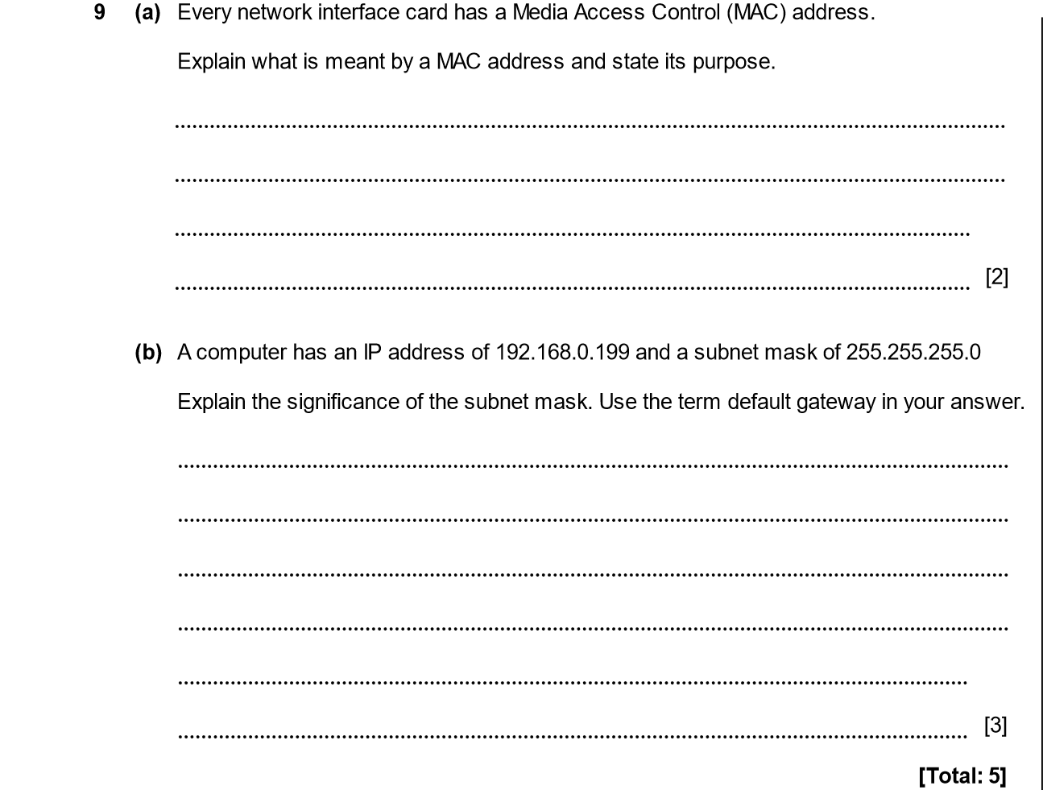

ANSWERS
Part | Answer | Mark | Additional Guidance
9 (a) | MAC address uniquely identifies the card.  It is used by the network switch or router, to route traffic.  MAC address is used to identify the destination NIC when the data is sent within a network. | 1  1  1  [Max 2] | Do not accept “media access control” without an indication of reason for use.
(b) | The subnet mask is used to work out the range of addresses which are on the same network as this computer.  In this case it will be addresses in the range 192.168.0.1 to 192.168.0.255  If the computer needs to contact another computer that is not on this network then it will send traffic to the default gateway and that will then route the traffic to the required location.  Network address is 192.168.0 | 1  1  1  1  [Max 3] | 1 mark for subnet identifies computers on the same network.  1 mark for identification of the range – either via IP range or by reference to 254 or 255 address locations in the network.  1 mark for default gateway is the route to external networks.
Total |  | 5

NETWORK AND COMMUNICATION 2014-2015 (PAPER 2)

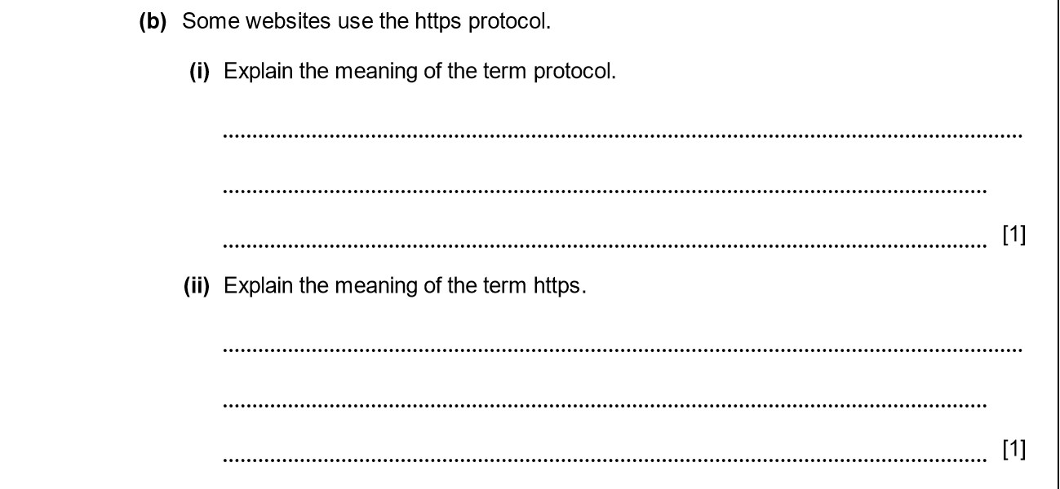

ANSWERS
Part | Answer | Mark | Additional Guidance
(b) (i) | A protocol is an agreed standard / set of rules used for transmitting data between computers. | 1 | Must show that both computers have to work in the same way.
(ii) | https is a specific protocol used by websites which need to make sure that data sent to / from the website is encrypted. | 1 | Must mention encryption / encrypted.

NETWORK AND COMMUNICATION 2015-2016 (PAPER 2)

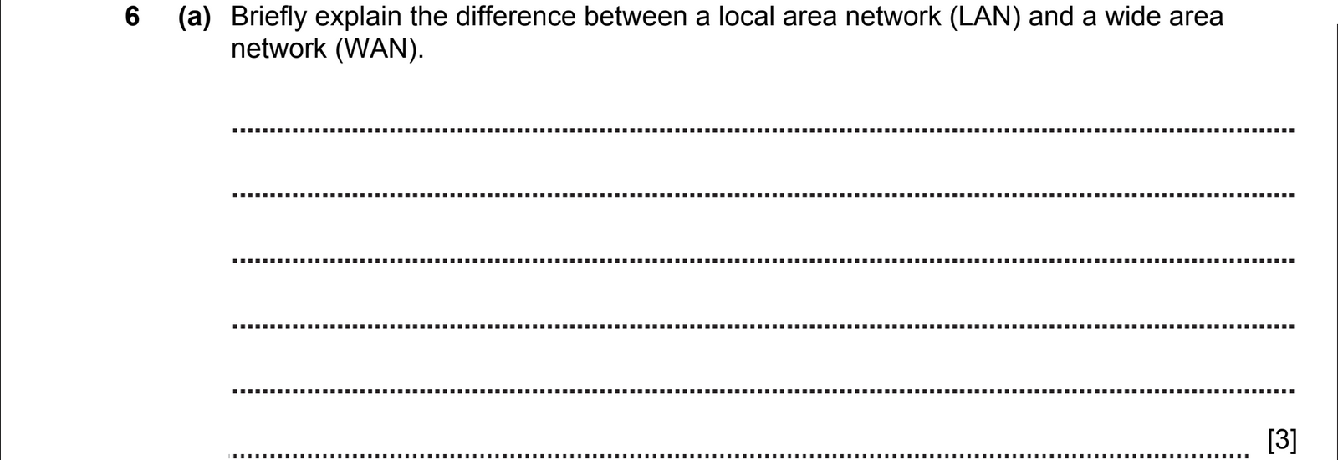
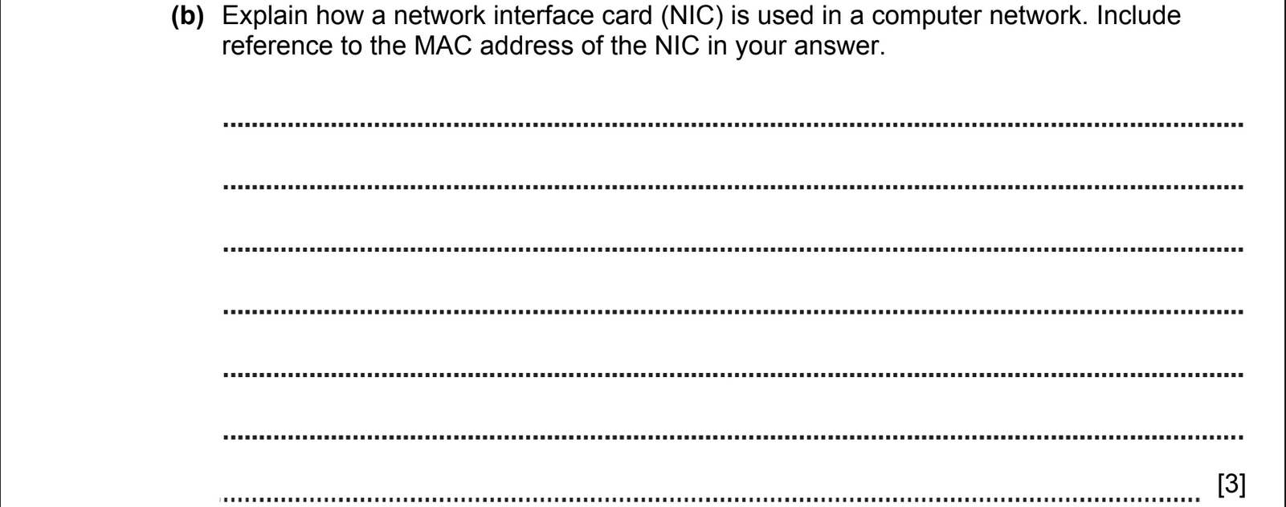
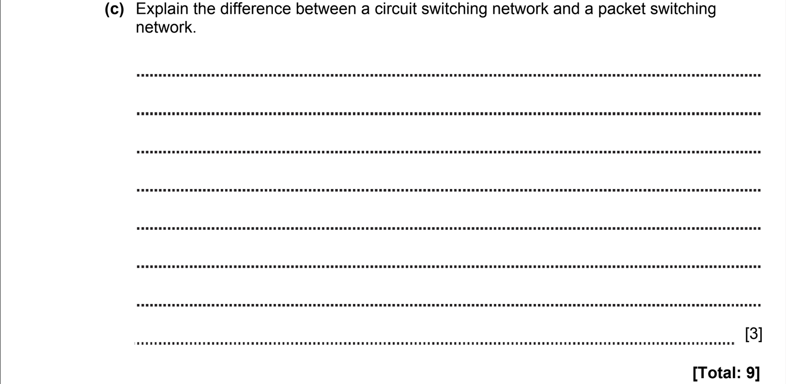

ANSWERS
Part | Answer | Mark | Additional Guidance
6 (a) | LAN – covers small area (eg single building or collection of buildings) whereas WAN covers large area (up to the entire world).  WANs are used to connect LANs together.  Devices in a LAN connected using hubs/switches whereas routers are needed in a WAN.  LANs typically run at higher speeds than WANs.  LANs normally use Ethernet but WANs can use a range of technologies. | 1  1  1  1  1  [max 3] | Any 3 points  Don’t allocate 1 point for things like “WAN is big” and a separate point for “LAN is small”  Accept  “LAN is more secure” (Intranet)  Do not accept “WAN is global network”
(b) | NIC connects computer to the network.  Converts parallel data from the internal bus to serial data to be sent over network cable.  Receives data sent to the computer, buffers it and sends it to the CPU for processing.  The MAC is a unique identifier and is used as the source/destination address for all packets. | 1  1  1  1  [max 3] | Any 2 points + 1 point for description of MAC
(c) | In a circuit switched network a direct connection is made between 2 devices which need to communicate and this connection is maintained for the duration of the “conversation”.  In packet switching, the data to be transmitted is split into packets. A connection is established for each packet to be sent.  This means that different routes can be taken for each packet in the “conversation”. | 1  1  1 | Accept poor explanation but with good example
Total |  | 9

NETWORK AND COMMUNICATION 2015-2016 (PAPER 2)

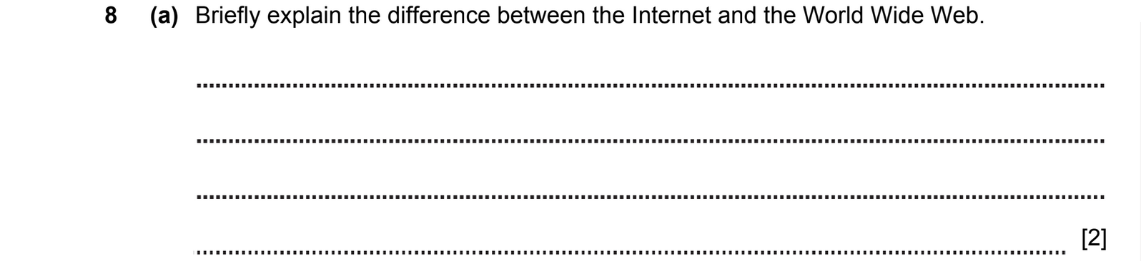
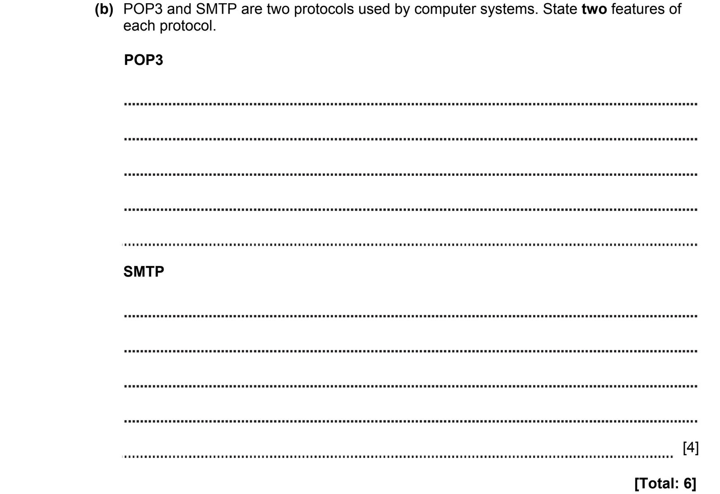

ANSWERS
Part | Answer | Mark | Additional Guidance
8 (a) | The Internet is a worldwide network of connected networks of computers.  The World Wide Web is a way of accessing information stored in documents on the Internet using the http protocol. | 1  1 | Key difference is that WWW is just part of the Internet.  Accept “Internet is a global network”  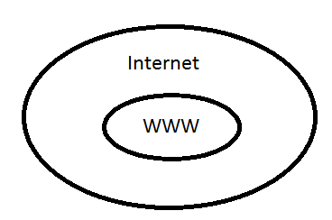
(b) | The POP3 protocol is used for reading email stored on a remote server.  A series of commands are sent to the server to fetch messages to be read on the local client.  Messages remain on the server until they are deleted by the client.  The SMTP protocol is used for sending email from one computer to another.  The computer sending email will find the address of the appropriate receiver using DNS.  The computer sends a series of commands to the server to setup a communication channel and allow a message to be sent.  SMTP is insecure but can be made secure by the use of SSL. | 1  1  1  [max 2]  1  1  1  1  [max 2] | Up to 2 marks for POP3 and up to 2 marks for SMTP.  Do not allocate marks for simply defining the abbreviations.
Total |  | 6

NETWORK AND COMMUNICATION 2016-2017 (PAPER 1)

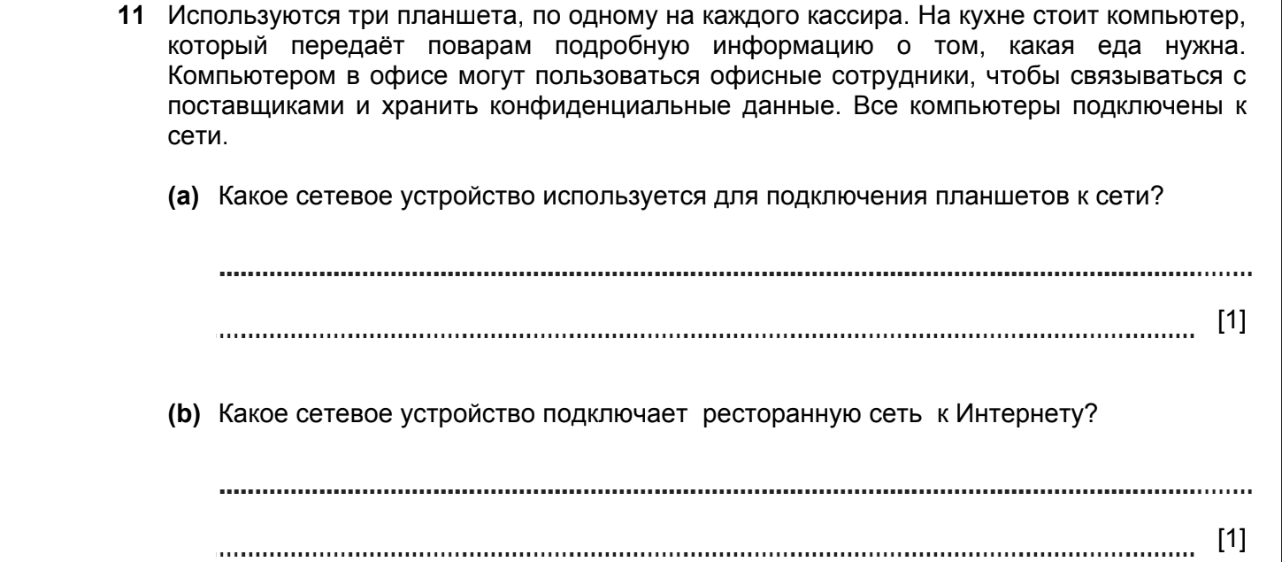
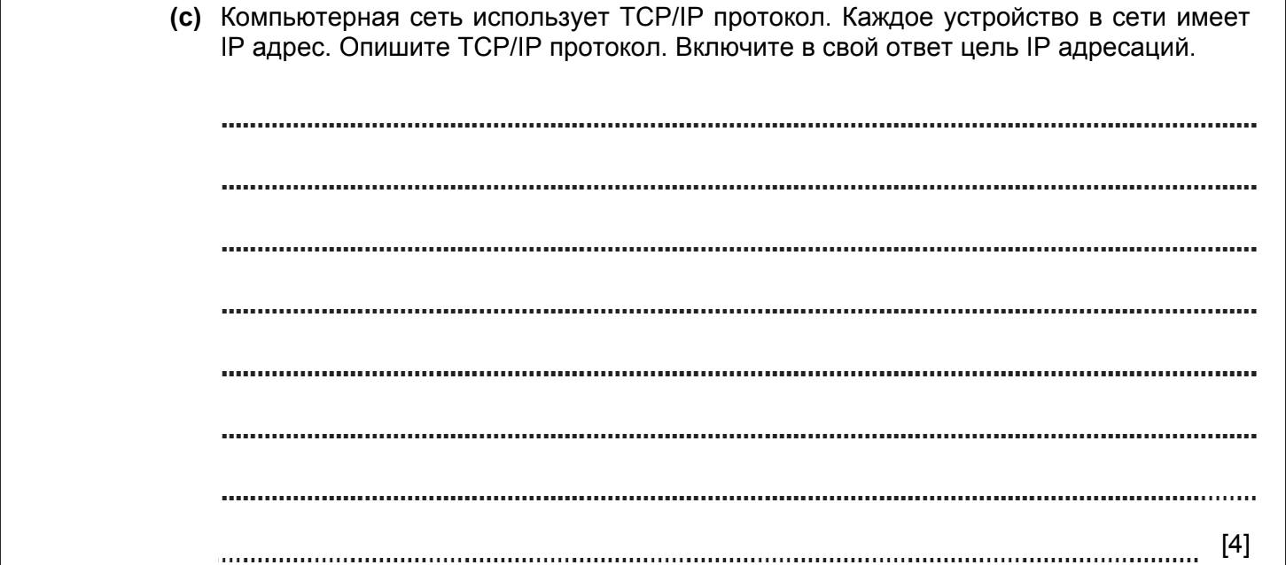

ANSWERS
Part |  |  | Answer | Mark | Additional Guidance
11 | (a) |  | Wireless access point | 1 | Accept wireless router
 | (b) |  | Router | 1 | Accept ADSL modem; cable modem
 | (c) |  | TCP (is the transfer control protocol) which ensures that the data is transmitted accurately  IP (internet protocol) makes sure that it is delivered to the correct address  Messages are split into packets tagged with source and destination IP  All computers have a unique IP address which identifies the computer on the network  TCP ensures all packets are received  Sequence number attached to each packet to allow for correct reassembly of message | 1  1  1  1  1  1  Max 4 | Any 4 reasonable points  Must mention unique
Total |  |  |  | 6

NETWORK AND COMMUNICATION 2017-2018 (PAPER 2)

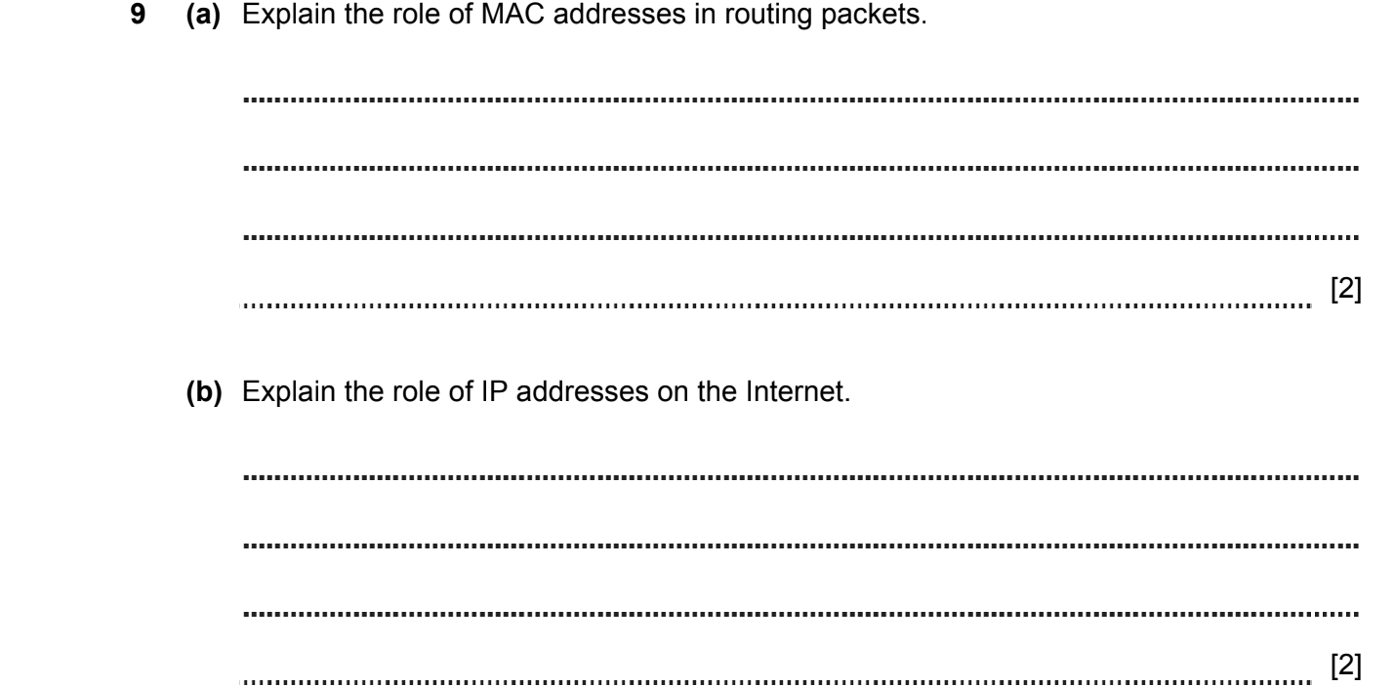
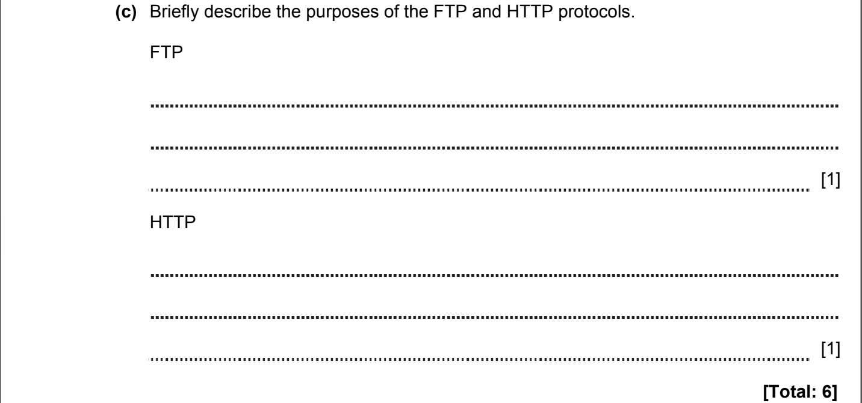

ANSWERS
Part | Answer | Mark | AO | Further Information
9(a) | The MAC address is the unique identifier for the NIC | 1 | AO1
9(a) | Network routers find devices by using the MAC address as a location address | 1 | AO1
9(a) | If 2 machines had the same MAC address then other computers would not know which one to communicate with | 1 | AO1
9(a) |  | [max 2] | AO1
(b) | On the Internet, the IP address is used as the unique identifier (at the Network Layer) | 1 | AO1
(b) | Routers have tables to show which route to take to get to a particular IP address | 1 | AO1
(c) | FTP can be used to transfer any file from a server to a client or from a client to a server | 1 | AO1 | Accept user instead of client  Allow HTTP can also transfer a wide range of files
(c) | HTTP is normally used to transfer HTML pages from a server to a client | 1 | AO1
Total |  | 6

NETWORK AND COMMUNICATION 2018-2019 (PAPER 2)

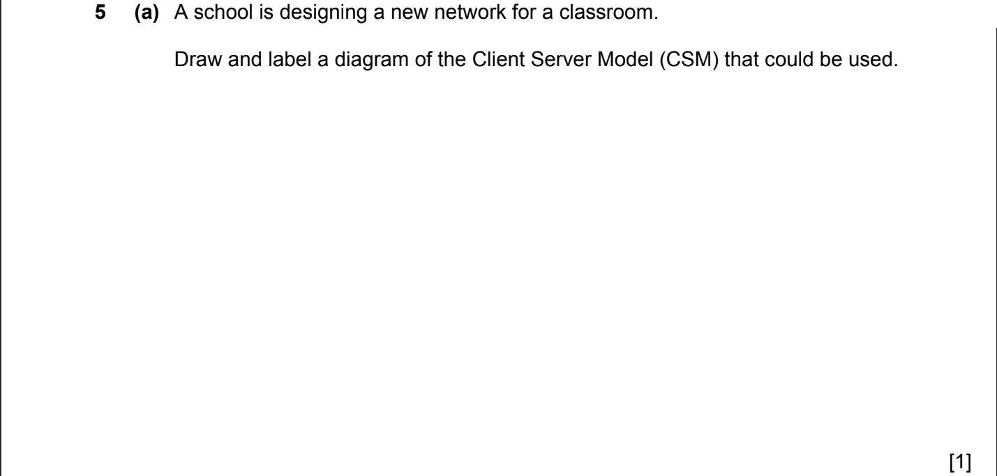
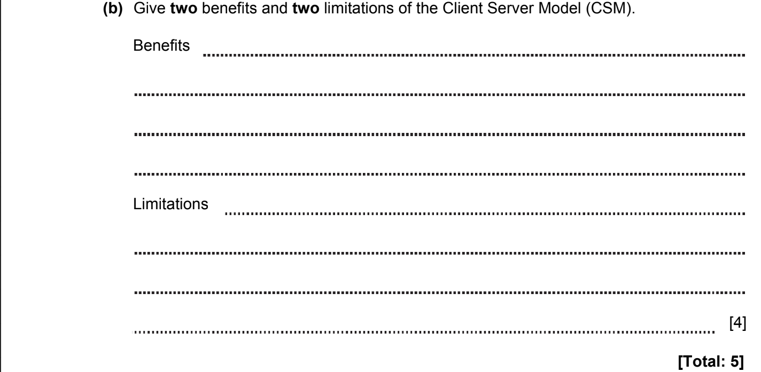

ANSWERS
Part | Answer | Mark | AO | Further Information
5(a) | 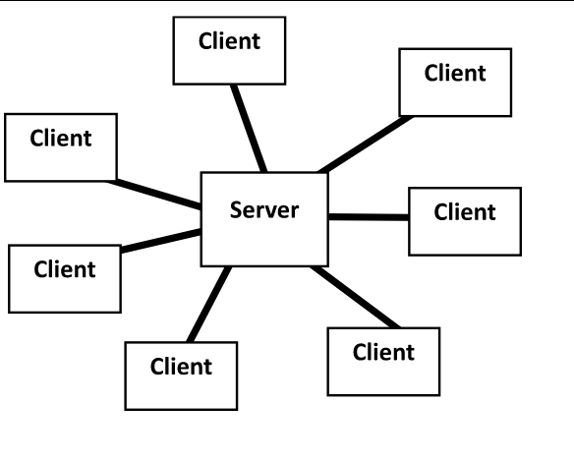 | [1] | AO2 | Accept 1 or more clients.
5(b) | Benefits  Networked peripherals can be shared.  Users can access data and peripherals from any client.  All files / data are stored in a central location.  Backups, updates, security are all managed centrally.  Limitation  Server hardware and setup are expensive.  Failure in parts of the network can cause issues for other users (less robust).  Single point of failure.  Additional costs may be incurred to employ trained staff to manage the network. | 1  1  1  1  1  1  1  1  [Max 4] | AO1 | Award 1 mark for each benefit, up to a maximum of 2 marks.  Award 1 mark for each limitation, up to a maximum of 2 marks.  Do not award further marks for additional benefits or limitations.
 | TOTAL | 5

NETWORK AND COMMUNICATION 2018-2019 (PAPER 2)

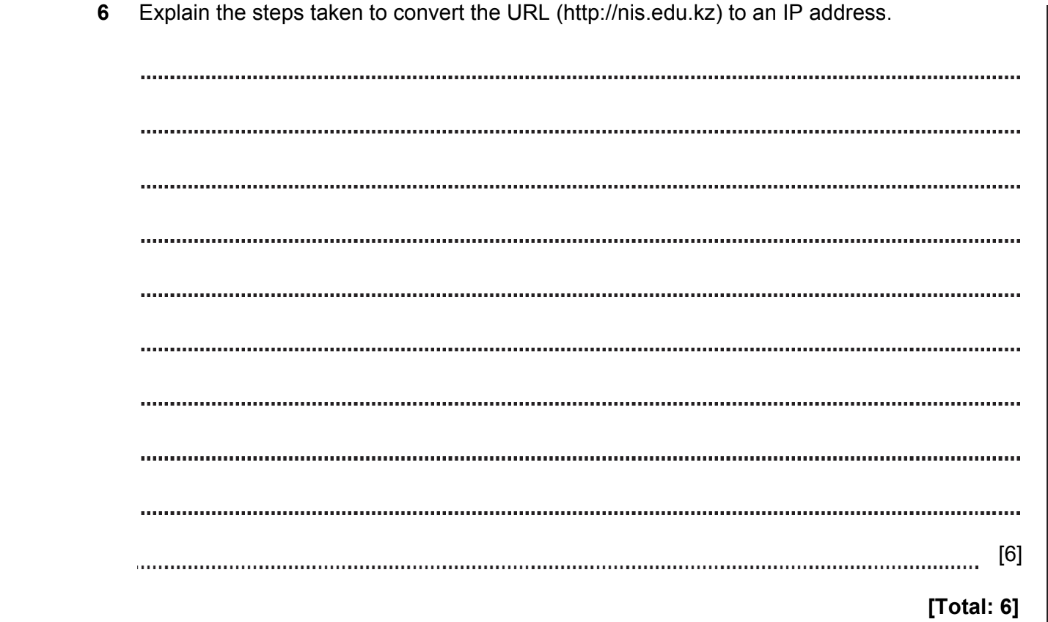

ANSWERS
Part | Answer | Mark | AO | Further Information
6 | The URL is split into sections at the full stops (.)  A DNS server processes this URL  It then finds the server dealing with .kz  That then resolves the server for .edu.kz  That then resolves nis.edu.kz  The IP address is found | 1  1  1  1  1  1  [Max 6] | AO2 | Accept correct flow charts.
 | TOTAL | 6

NETWORK AND COMMUNICATION 2020-2021 (PAPER 2)
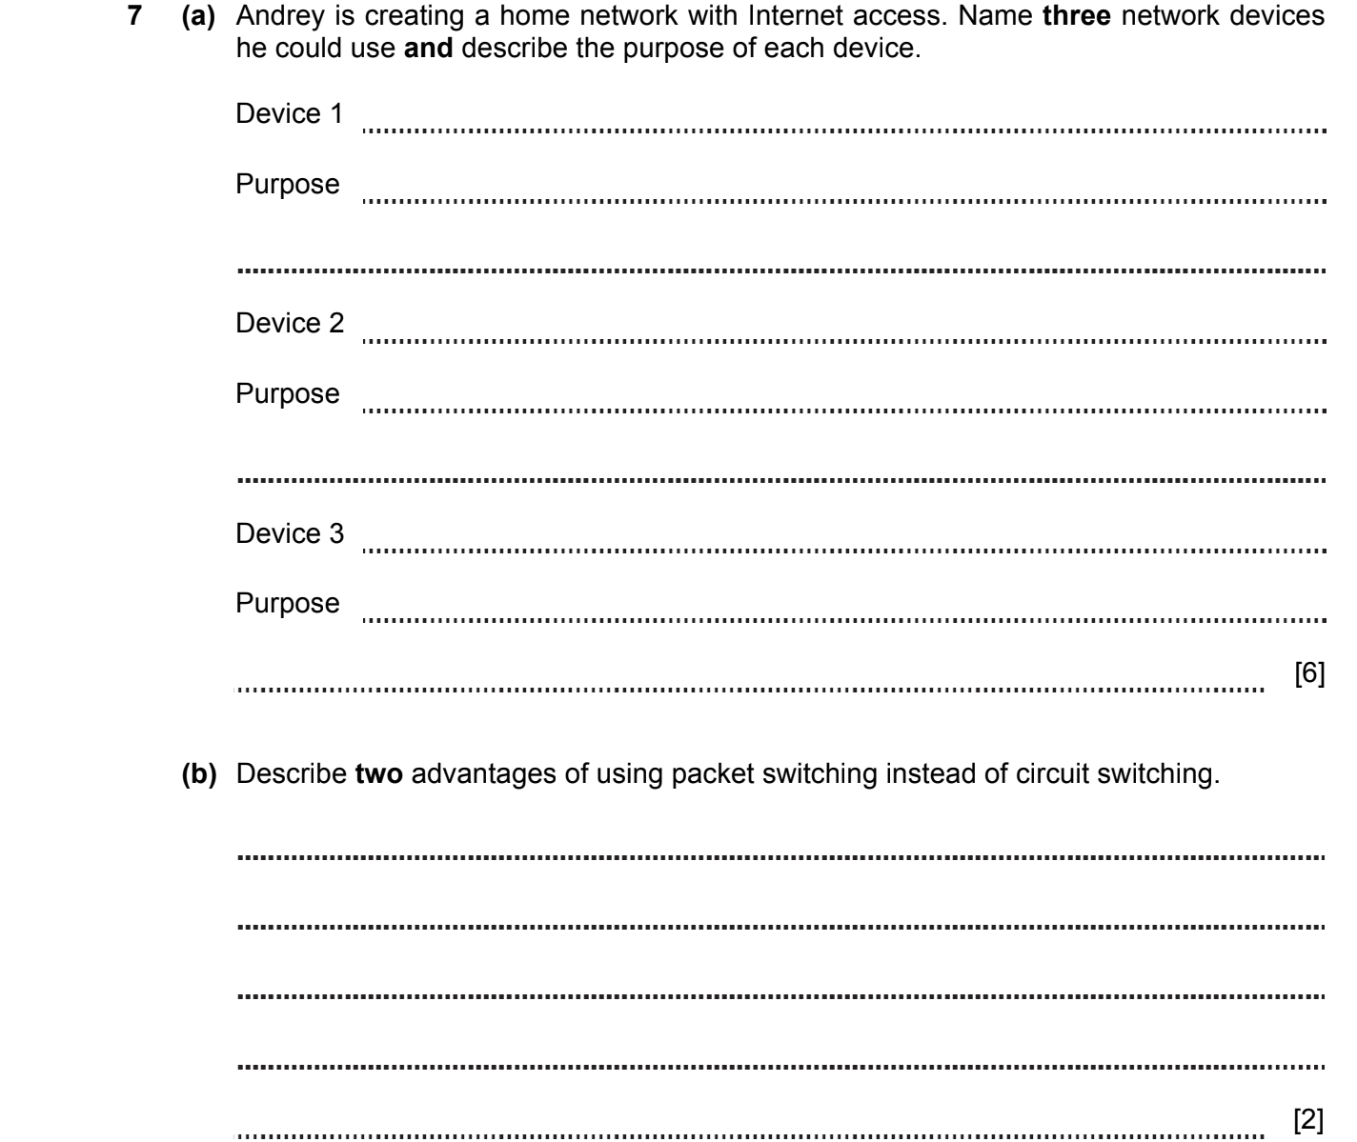
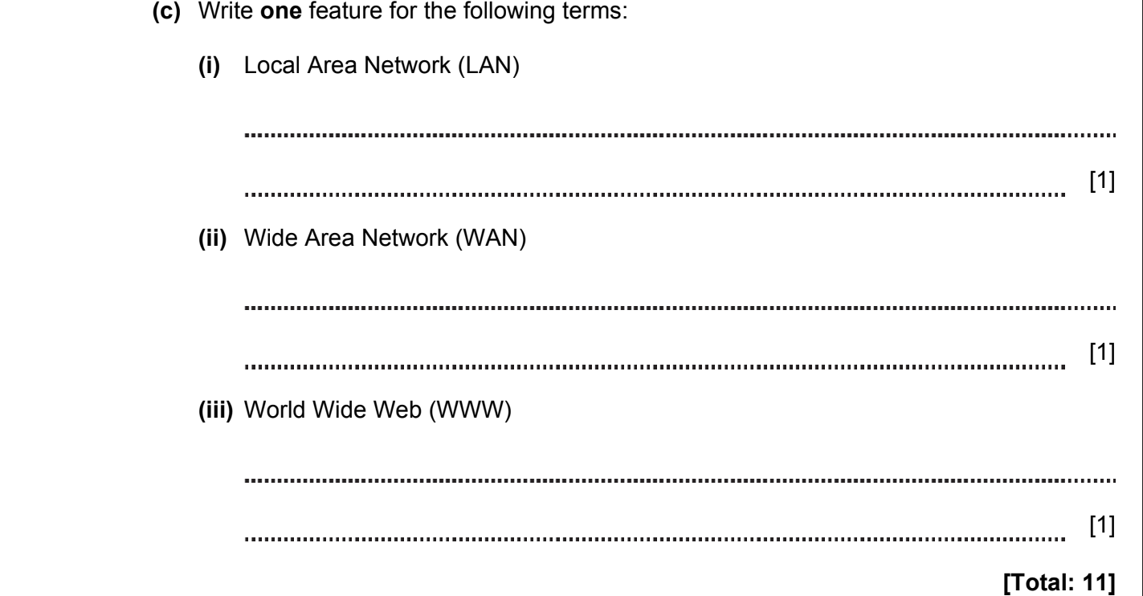
ANSWERS
Part | Answer | Mark | AO | Further Information
7a | Hub  Contains multiple ports that enable connection of computers into a LAN.  Switch  Provide access to the device via MAC addresses.  NIC / WNIC  required to communicate using a wired or a wireless connection  Router  Uses IP addresses to forward packets to other networks.  OR  Provides access to information on the Internet.  Wireless access point  Provide access to networks for wireless devices, example, notebooks, tablets, etc. | 1  1  1  1  1  1  1  1  1  1  1 | AO1 | Accept any reasonable answer.
7b | In the event of a communication failure during circuit switching, the data must be re-transmitted, and when switching packets, only those data packets that were not previously delivered must be re-transmitted.  When switching channels, data is transmitted only between two nodes of the network, while in packet switching more than two nodes of the network can participate. | 1  1 | AO1 | Accept any reasonable answer.  [max 2]
7c(i) | A network of computers that covers a small area.  OR  Usually used in one building.  OR  As Andrey will own all of the infrastructure in his LAN, he will not use any telecommunication hardware / cables. | 1  1  1 |  | Accept any reasonable answer.  [max 1]
7c(ii) | A network of computers that covers a large geographical area.  OR  Connects computers all over the world. | 1  1 |  | Accept any reasonable answer.  [max 1]
7c(iii) | A system of interlinked hypertext documents accessed via the Internet. | [1]
 | Total | 11
NETWORK AND COMMUNICATION 2020-2021 (PAPER 2)

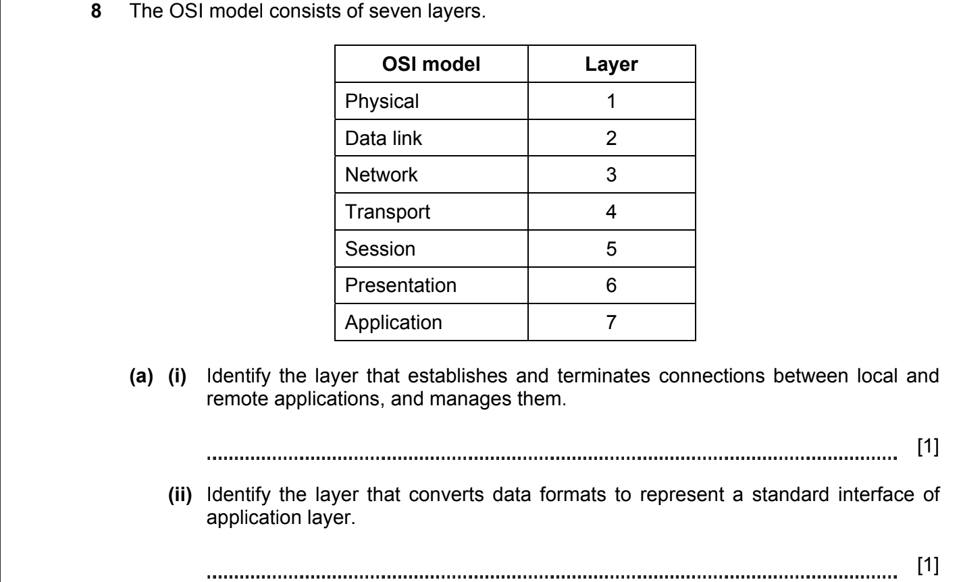
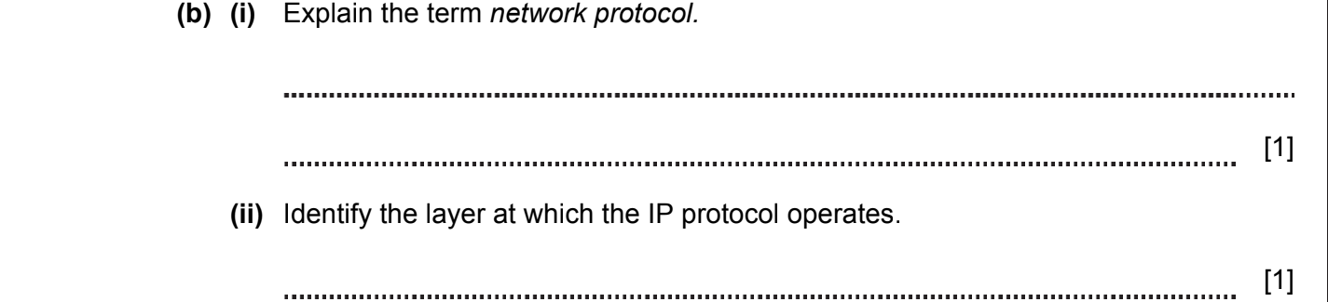
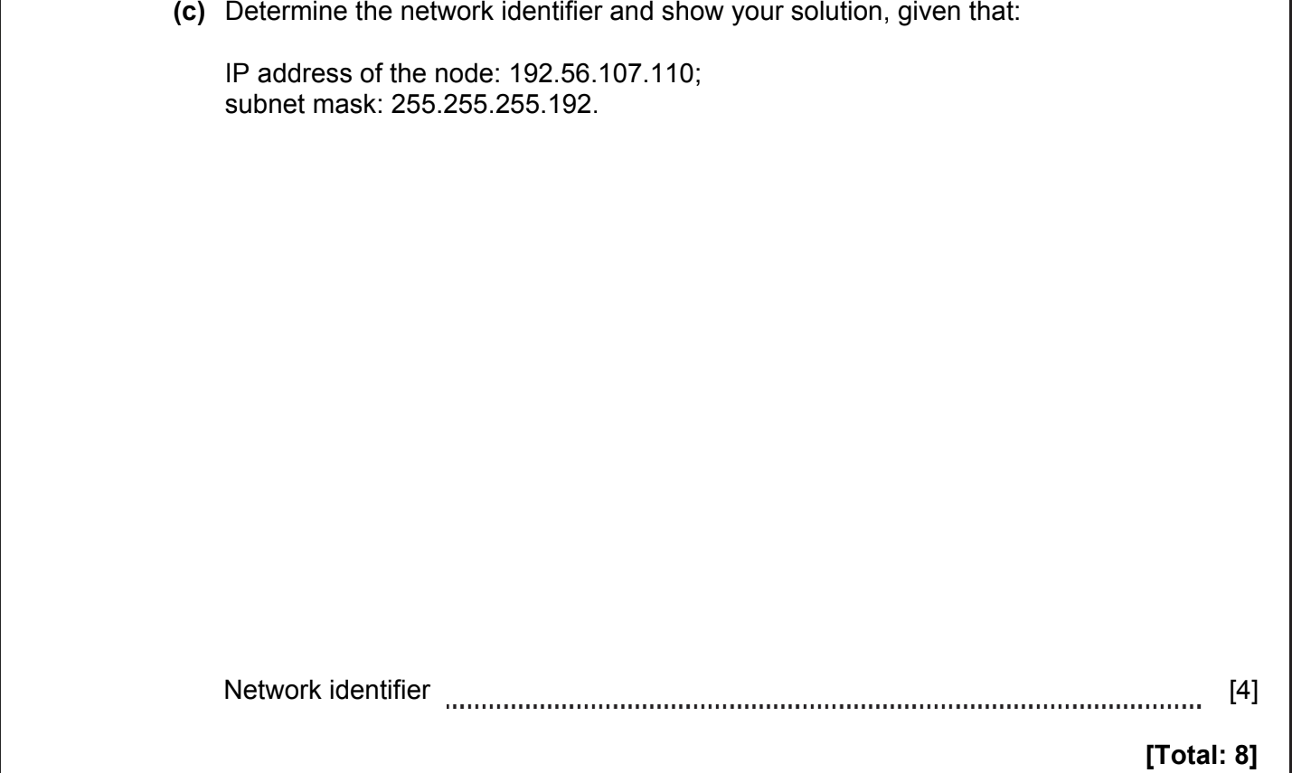

ANSWERS
Part | Answer | Mark | AO | Further Information
8a(i) | Session / 5 | [1] | AO1
8a(ii) | Presentation / 6 | [1] | AO1
8b(i) | A set of rules governing the way that devices communicate with each other. | [1] | AO1 | Accept any reasonable answer
8b(ii) | Network / 3 | [1] | AO1
8c | Converted a subnet mask 255.255.255.192 to binary  Result: 11111111.11111111.11111111.11000000  Converted IP-address 192.56.107.110 to binary  Result: 11000000.00111000.01101011.01101110  Performed operation AND for Subnet mask and IP-address  Result: 11000000.00111000.01101011.01000000  Converted to decimal  Result: 192.56.107.64 | 1  1  1  1  [4] | AO2 | Accept any reasonable answer.  1 mark – for correct answer without solution.
 | Total | 8

NETWORK AND COMMUNICATION 2021-2022 (PAPER 2)

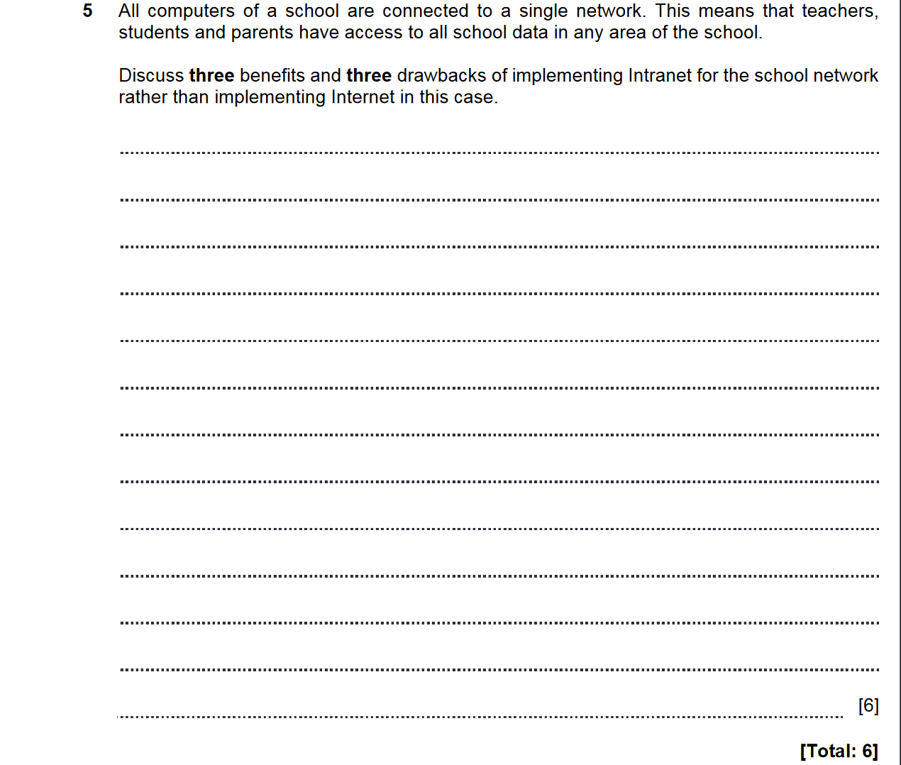

ANSWERS
