DATA SECURITY. DATA INTEGRITY. 2013-2014 (PAPER 2)

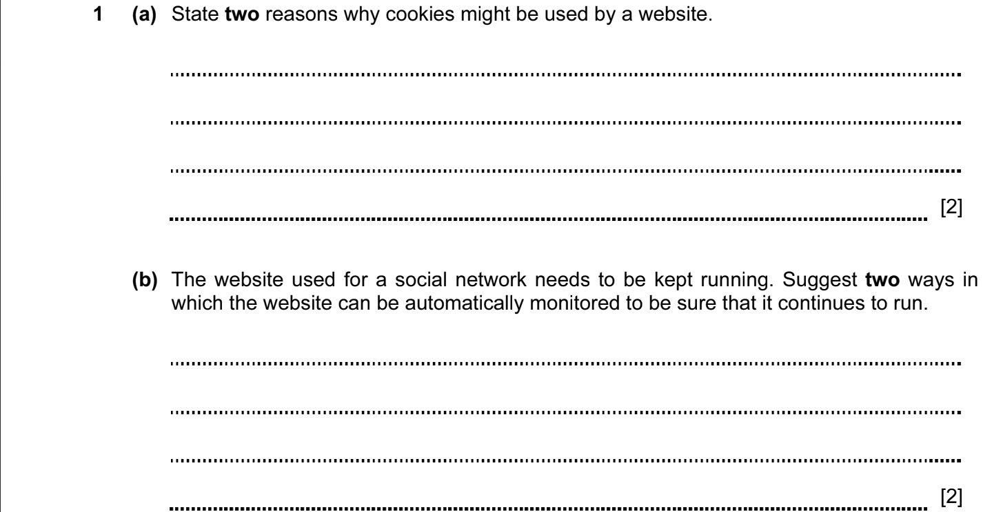
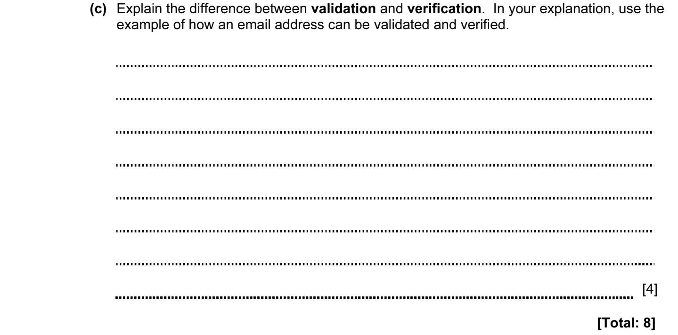

ANSWERS
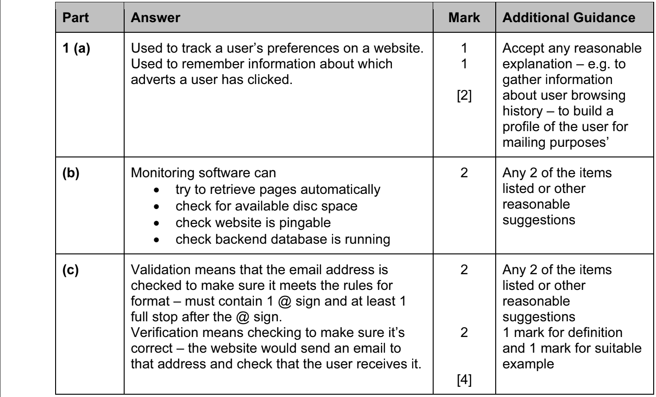

DATA SECURITY. DATA INTEGRITY. 2013-2014 (PAPER 2)

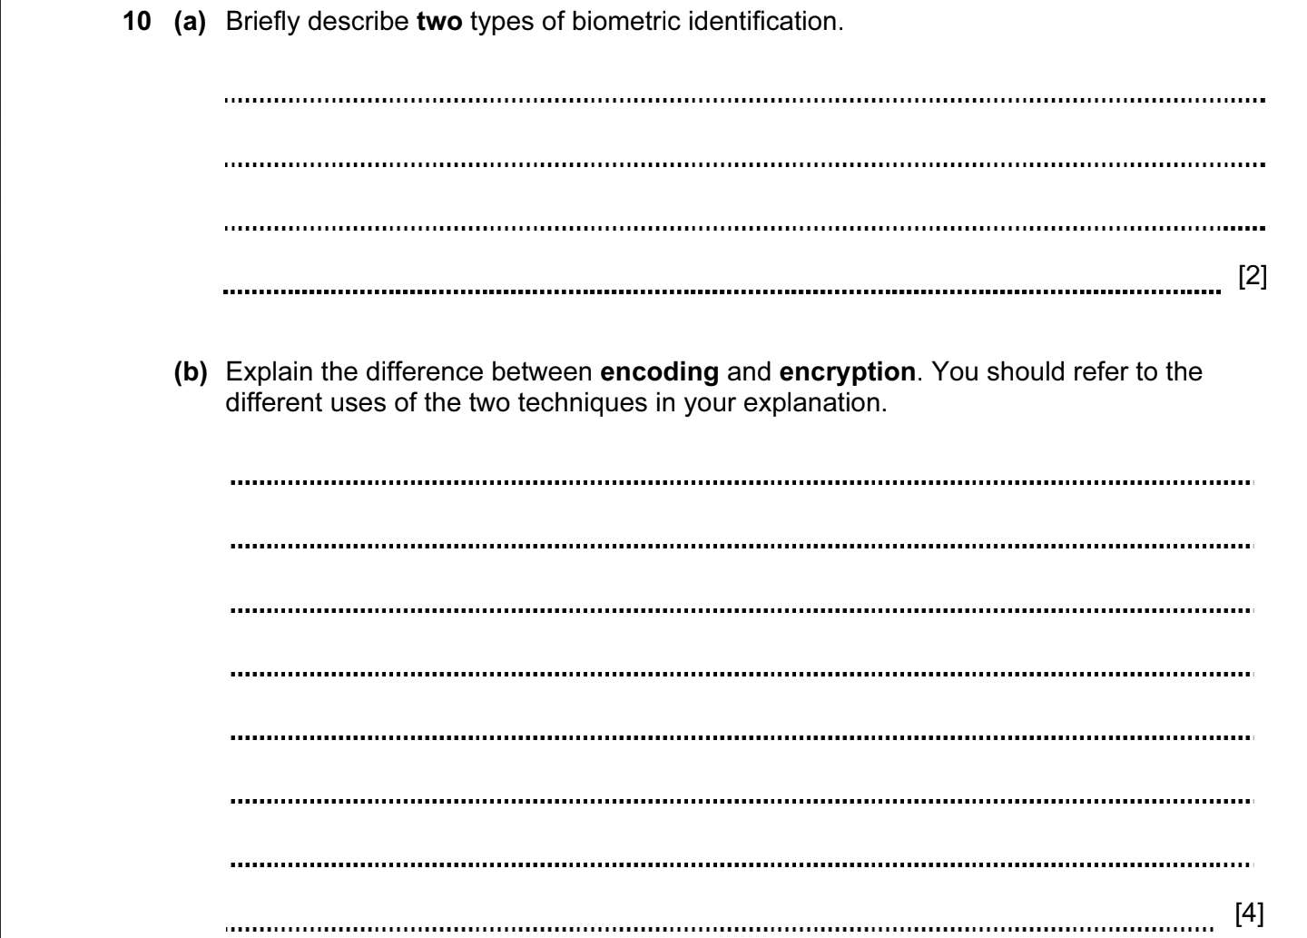

ANSWERS
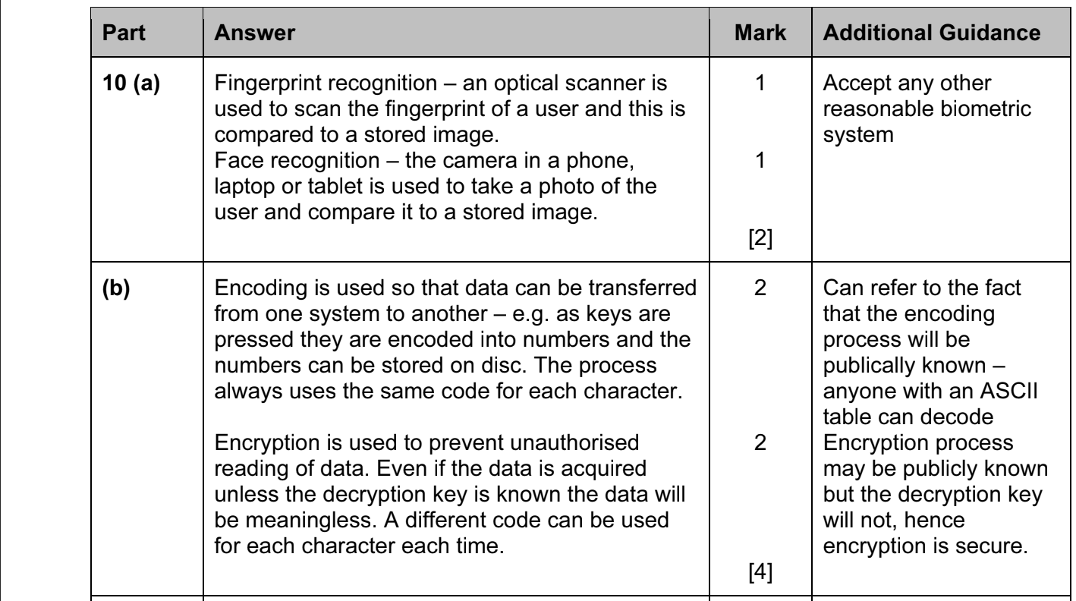

DATA SECURITY. DATA INTEGRITY. 2013-2014 (PAPER 2)

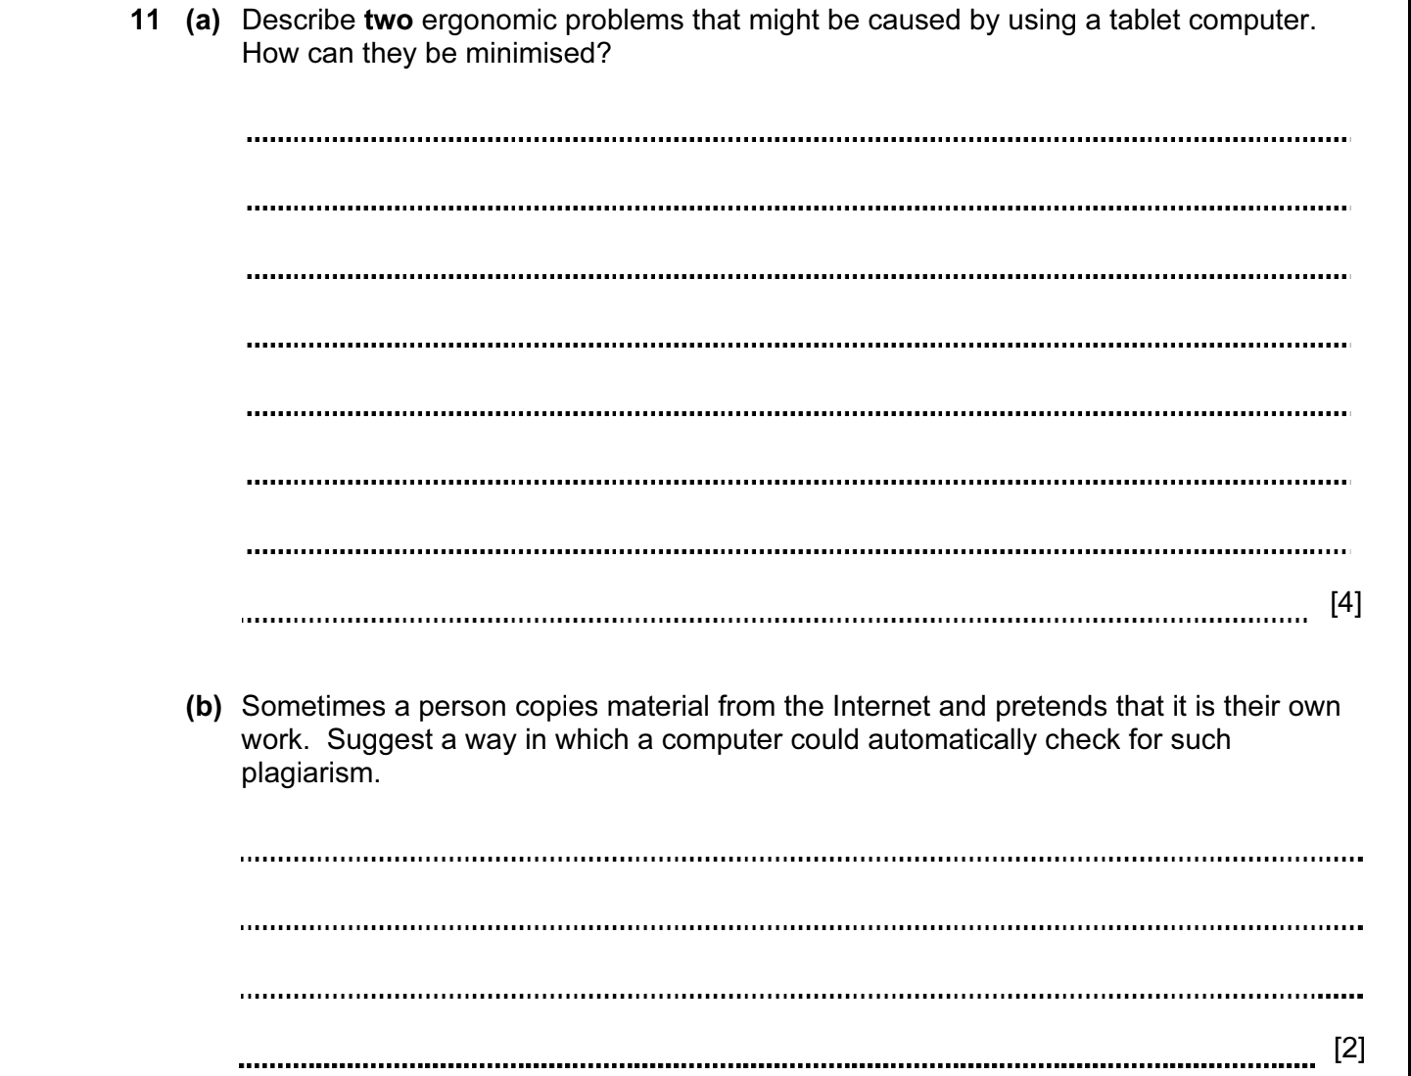

ANSWERS
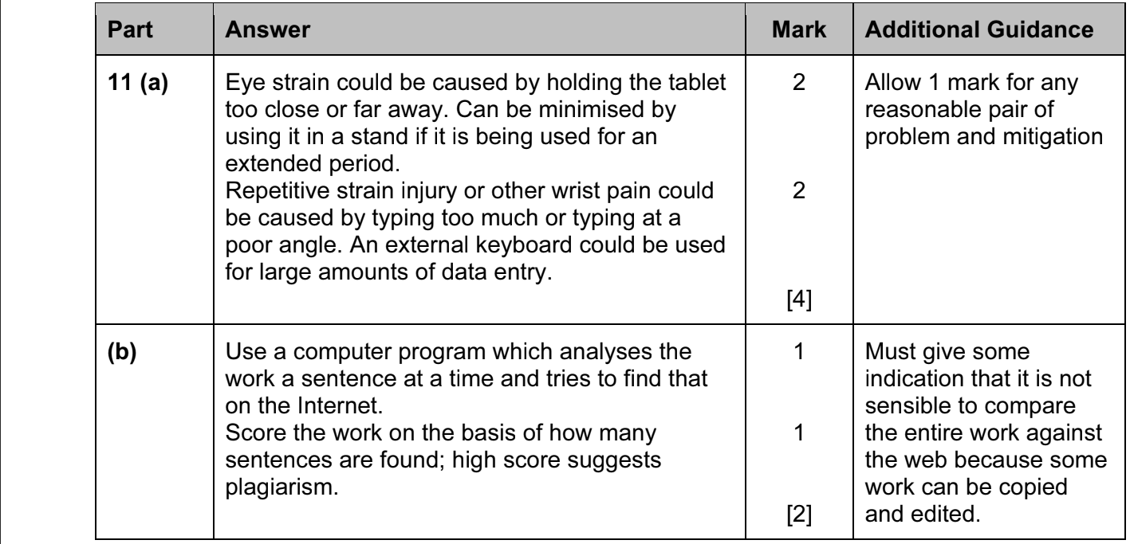

DATA SECURITY. DATA INTEGRITY. 2014-2015 (PAPER 1)

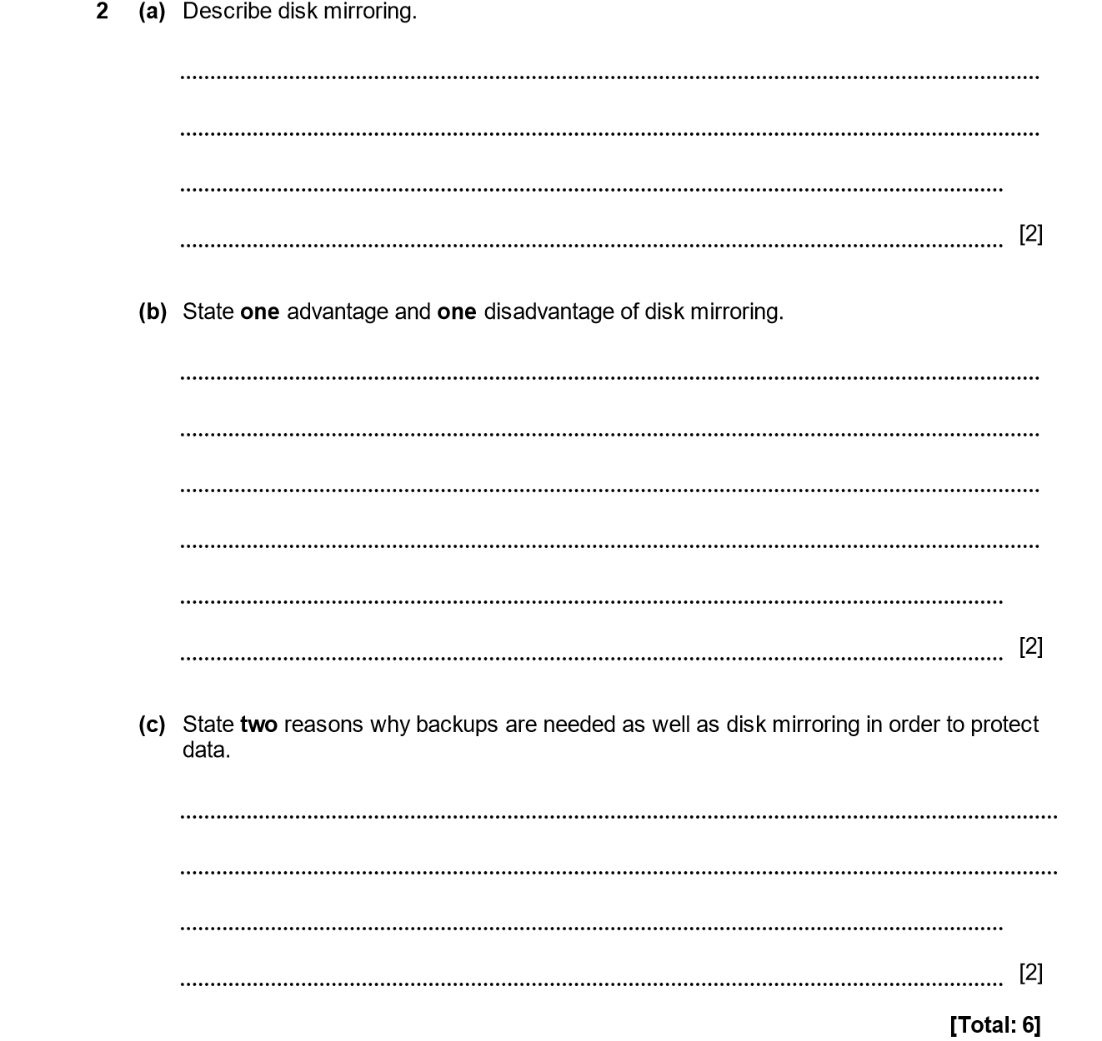

ANSWERS
Part | Answer | Mark | Additional Guidance
2 (a) | Disk mirroring means that disks are used in pairs.  Every time data is changed on one of the disks the mirror process makes the same change to the other disk. | 1  1 | Accept “disks are configured using RAID 1”.  Mention of two discs is 1 mark. Mention of simultaneous or synchronous is 1 mark.
(b) | Advantage is that if one disk fails, the other disk still has all the data.  Disadvantage is that it is twice as expensive / uses twice as much power / takes up twice as much space. | 1  1 | Only one reason needed.
(c) | Mirroring does not protect against fire / theft / etc.  Mirroring does not protect against accidental deletion of files / corruption of data / hacking. | 1  1 | Must show understanding that mirroring only protects against physical failure of one disk – no protection against other data problems.
Total |  | 6

DATA SECURITY. DATA INTEGRITY. 2014-2015 (PAPER 1)

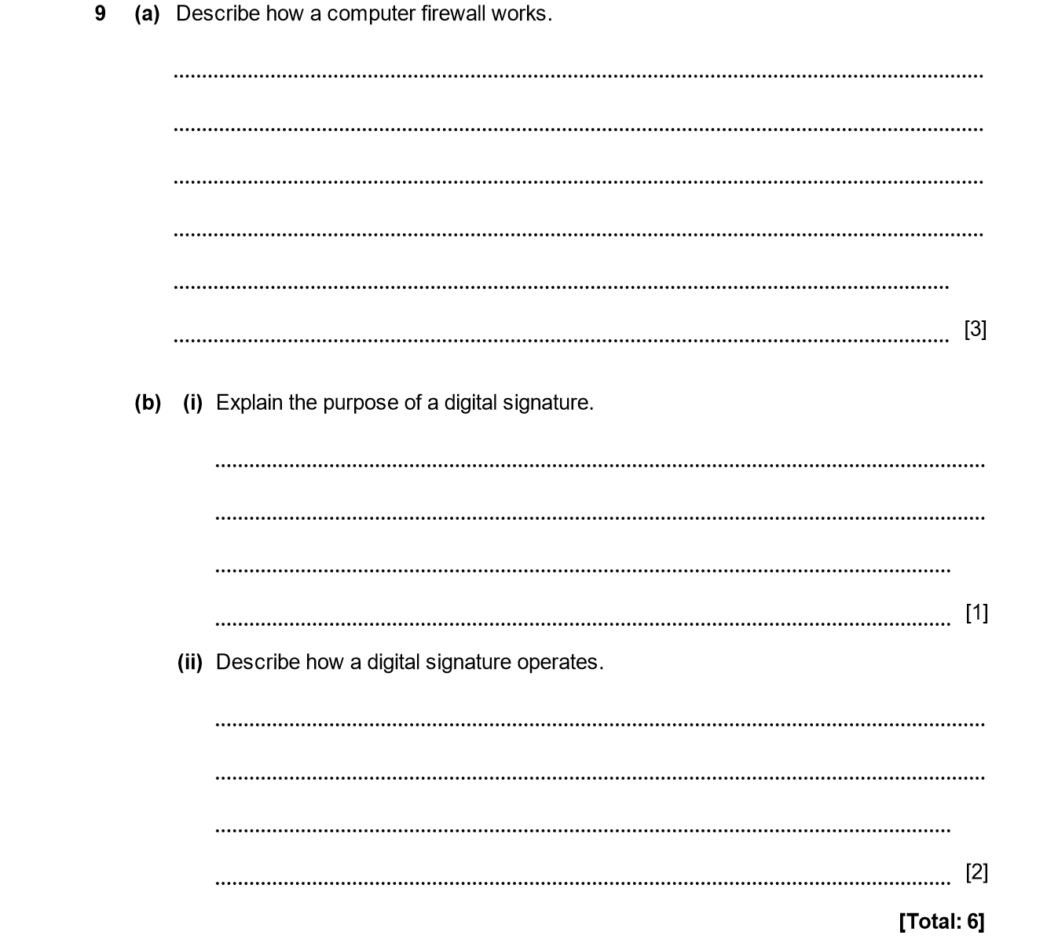

ANSWERS
Part | Answer | Mark | Additional Guidance
9 (a) | A firewall monitors all network traffic coming into it and going out from it.  It has a set of rules to decide whether to allow the traffic to pass or not.  The rules will be based on the port used for connection, the protocol or some other detail of the data. | 1  1  1 | 1 mark for monitoring traffic.  1 mark for recognising that there is a rule set.  1 mark for giving some information about the type of rule (eg port, protocol – don’t need all of them).
(b) (i) | Used to verify that the content of the file has not been tampered with or accidentally corrupted since it was created.  Used to authenticate that the message came from the same stated address and / or sender. | 1  1  [Max 1]
(b) (ii) | It is created by combining the signer’s private key with the contents of the document using a standard algorithm.  The receiver of the document will have access to the signer’s public key. A standard algorithm is used to make sure that the document was signed using the signer’s key. | 1  1 | Need to mention signing with private key and testing against public key.  No need for any details of algorithm.
Total |  | 6

DATA SECURITY. DATA INTEGRITY. 2014-2015 (PAPER 2)

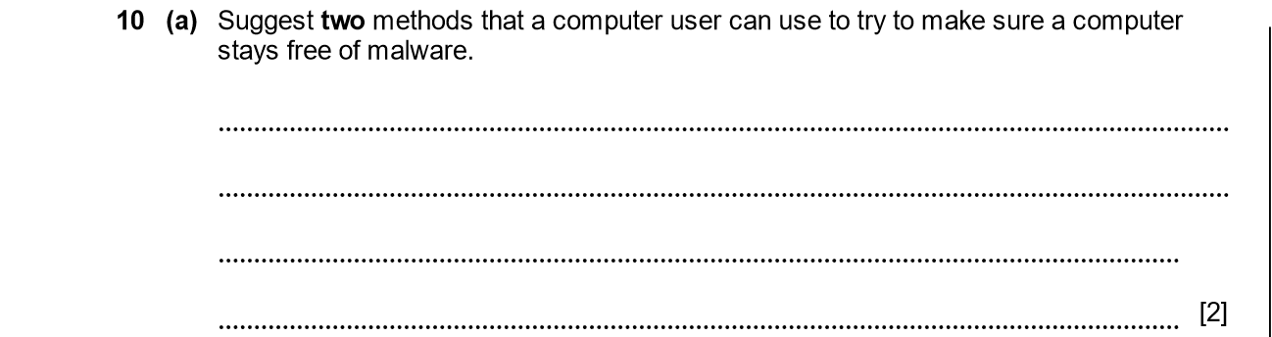

ANSWERS
Part | Answer | Mark | Additional Guidance
10 (a) | Use an up to date virus scanner / anti-virus program on the computer.  Avoid clicking on links in an email without first viewing the URL of the link.  Avoid downloading software without checking that it is likely to be safe.  Avoid ‘pirate’ software.  Avoiding ‘dubious / unfamiliar’ sites.  Installing anti-spyware, anti-phishing software etc.  Avoid sharing external storage devices. | 1  1  1  1  1  1  1  (Max 2) | Any 2 reasonable points.

DATA SECURITY. DATA INTEGRITY. 2015-2016 (PAPER 1)

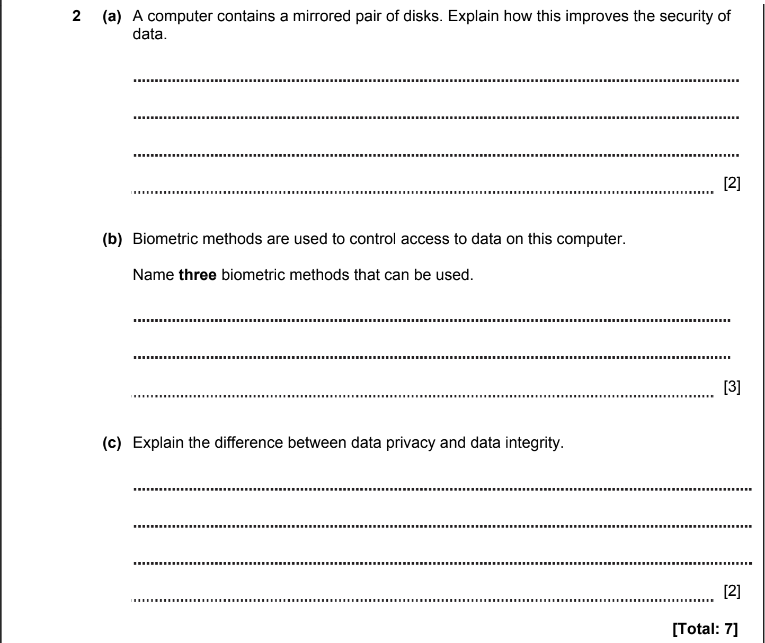

ANSWERS
2a)
Identify compromised data in order to enact remediation protocols.
Restore critical information and minimize downtime.
Frequently accessed files in highly classified vaults can be directly obtained from share

2c)
Data security is the practice of protecting digital information from unauthorized access, corruption
Privacy/Confidentiality – information that should be available only to authorized users.
Integrity means that information cannot be lost or changed from its original state.

DATA SECURITY. DATA INTEGRITY. 2015-2016 (PAPER 1)
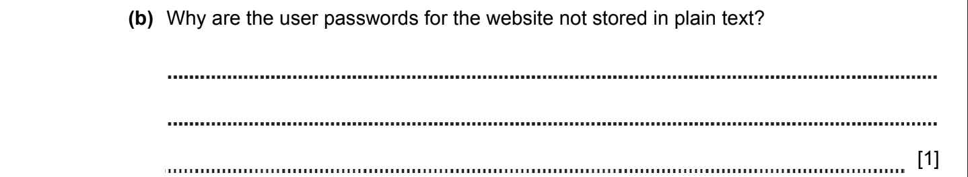
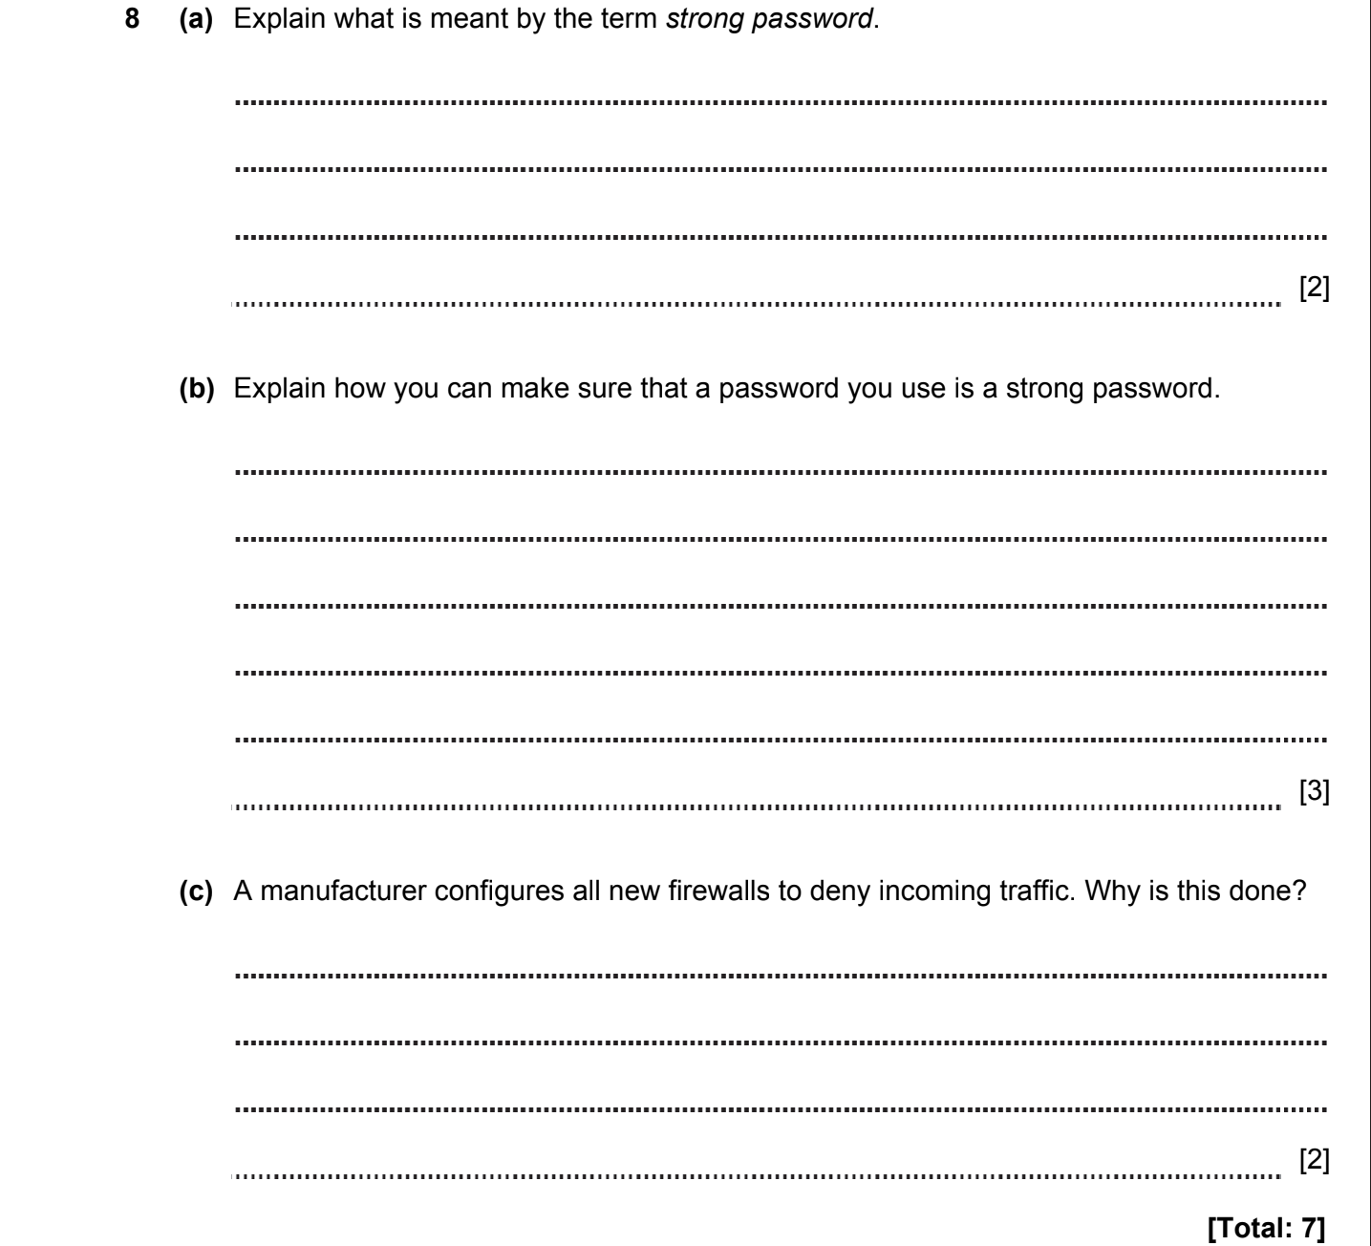

ANSWERS
Passwords can’t be transmit in plain text, for instance with using JS, because it’s not secure and private data can be stolen.
Strong password when password contain symbols, numbers, characters, also letters with different cases (lowercase, uppercase)
For protect internal devices and software from vulnerability (malware, damage and stolen important information and data)

DATA SECURITY. DATA INTEGRITY. 2015-2016 (PAPER 2)


ANSWERS
Part | Answer | Mark | Additional Guidance
10 | Identifies issues involving hacking.  Identifies issues involving malware.  Identifies issues around speeding.  Identifies issues around accidents. | 1 per issue [max 2]  1 per issue [max 2]  1 per issue  [max 2]  1 per issue  [max 2]
Total |  | 5

DATA SECURITY. DATA INTEGRITY. 2016-2017 (PAPER 1)

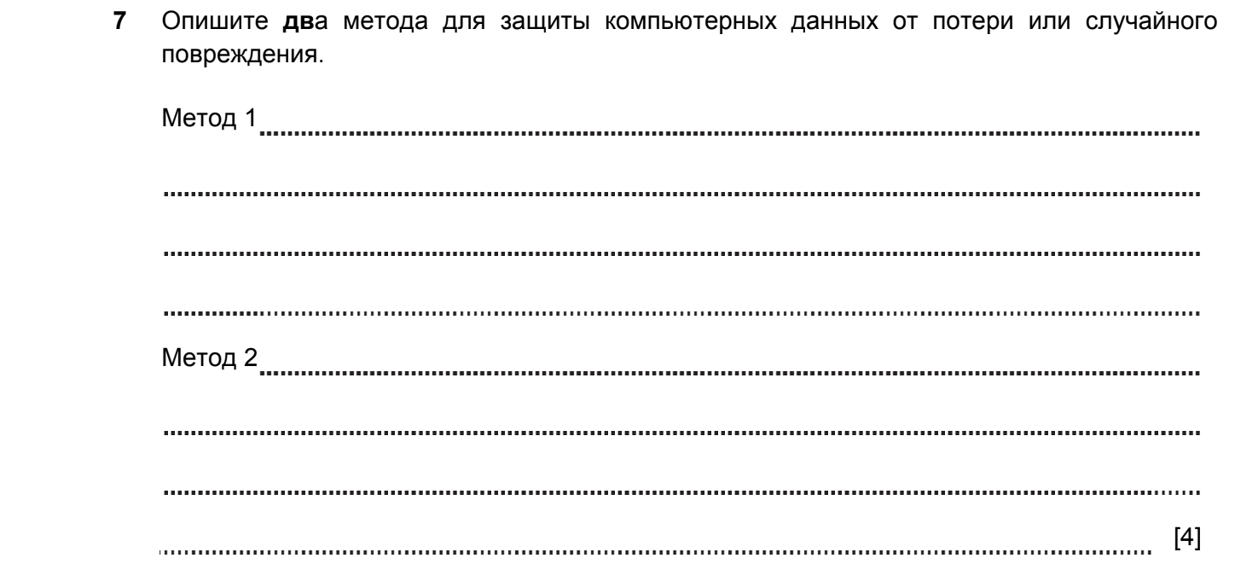

ANSWERS
Part |  |  | Answer | Mark | Additional Guidance
7 |  |  | Require password to log on to the computer. This prevents access to files by unauthorised users.  Make sure that regular backups are taken in case the disk fails.  Save multiple versions of critical files which will allow the user to revert to an earlier version if unwanted changes are made  Use anti-virus software to protect against damage due to malware | 1+1  1+1  1+1  1+1  Max 4 | 1 mark for each reasonable method and 1 mark for reason for its use
Total |  |  |  | 4

DATA SECURITY. DATA INTEGRITY. 2017-2018 (PAPER 1)

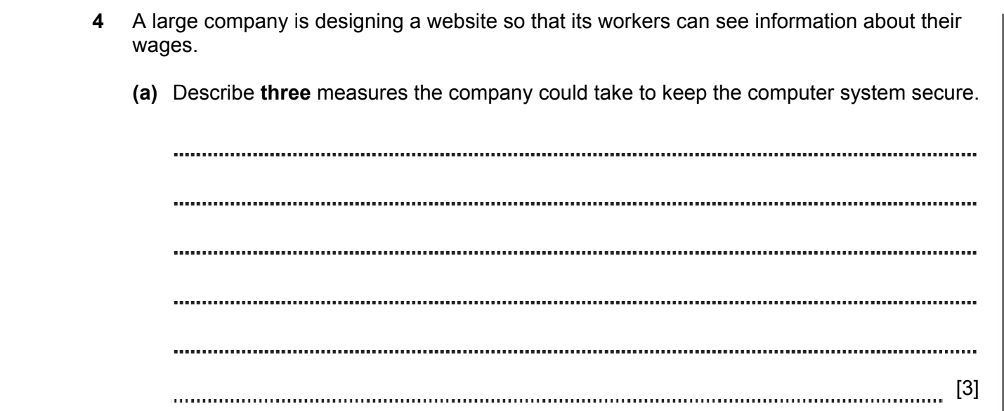

ANSWERS
Part | Answer | Mark | AO | Further Information
4(a) | Website must require password.  Database should be encrypted to protect against access to the stolen data.  Computer systems storing the data should be firewalled so that only access is via website.  Log should be kept of all access so that intruders can be identified. | 1  1  1  1  [max 3] | AO1  (2)  AO2  (1) | Allow https protocol, backup, mirroring, LAN (without Internet) and other reasonable answers with descriptions.

DATA SECURITY. DATA INTEGRITY. 2017-2018 (PAPER 1)

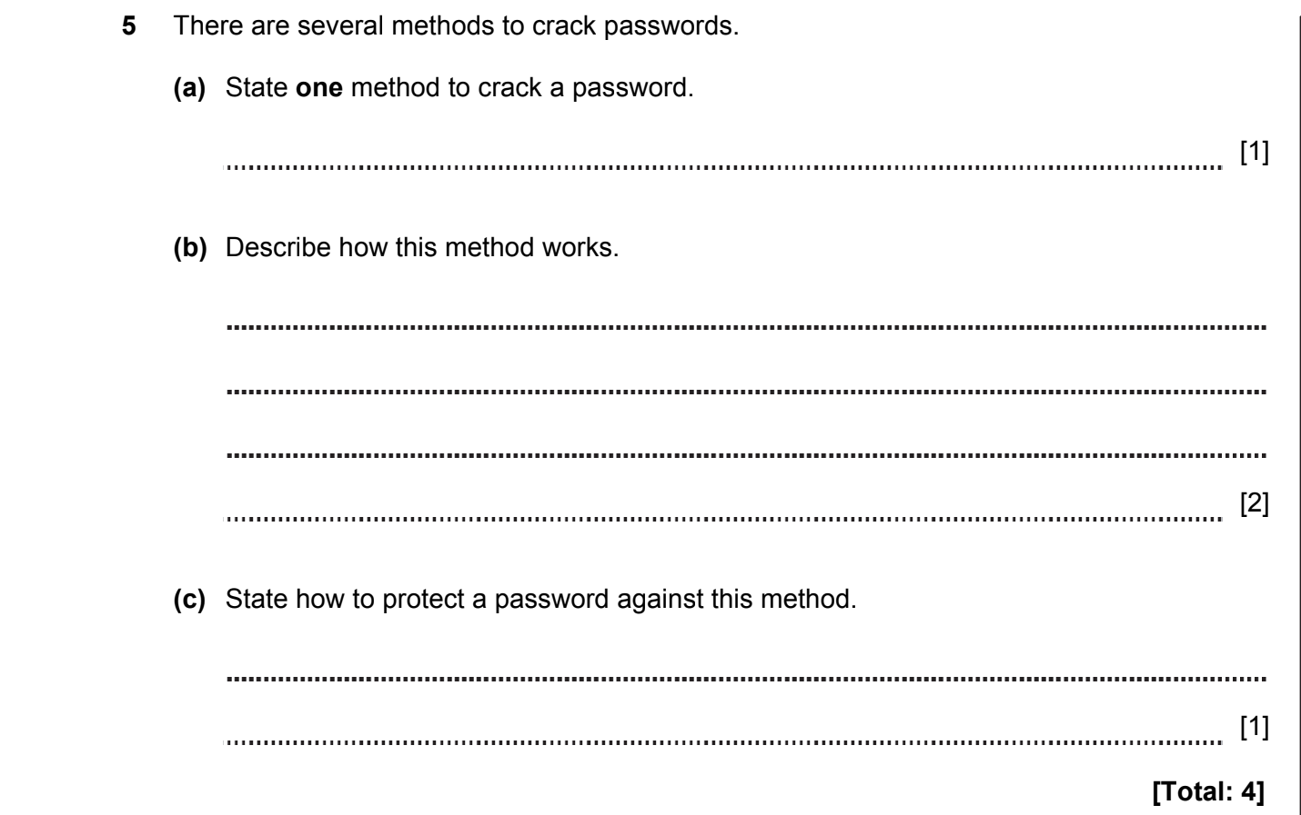

ANSWERS
Part | Answer | Mark | AO | Further Information
5(a) | Brute force  Dictionary attack | 1  1  [max 1] | AO1 | Allow other cracking methods.
(b) | Brute force means that a computer program will build all possible strings.  Each string is tried against the account to see if it is the correct password.  OR  Dictionary attack means that a computer will take each word in a dictionary in turn.  Each string is tried against the account to see if it is the correct password.  The dictionary is made up of commonly used passwords. | 1  1  1  1  [max 2] | AO1 | The description of the method must match the stated method in question 5(a).
(c) | Brute force  Choose a very long password.  OR  Dictionary attack  Choose a password that is not in a dictionary.  Add numeric / punctuation / etc.  Is made up from other words.  Uses other character sets.  Uses upper and lower case.  Do not use names, dates, the same word twice or words with number appended. | 1  1  1  [max 1] | AO1 | The protection method must match the stated method in question 5(a).  Allow answers:  requiring users to create complex passwords;  limiting the number of times a user can unsuccessfully attempt to log in;  temporarily locking out users who exceed the specified maximum number of failed login attempts.
Total |  |  | 4

DATA SECURITY. DATA INTEGRITY. 2017-2018 (PAPER 1)

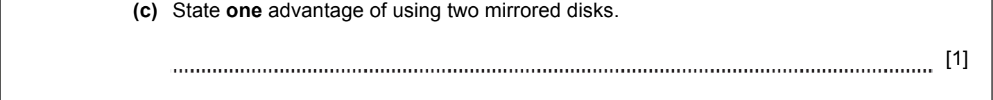

ANSWERS
Part | Answer | Mark | AO | Further Information
(c) | Increases data security.  If one disk fails the other disk contains the data. | 1  1  [max 1] | AO1

DATA SECURITY. DATA INTEGRITY. 2017-2018 (PAPER 2)

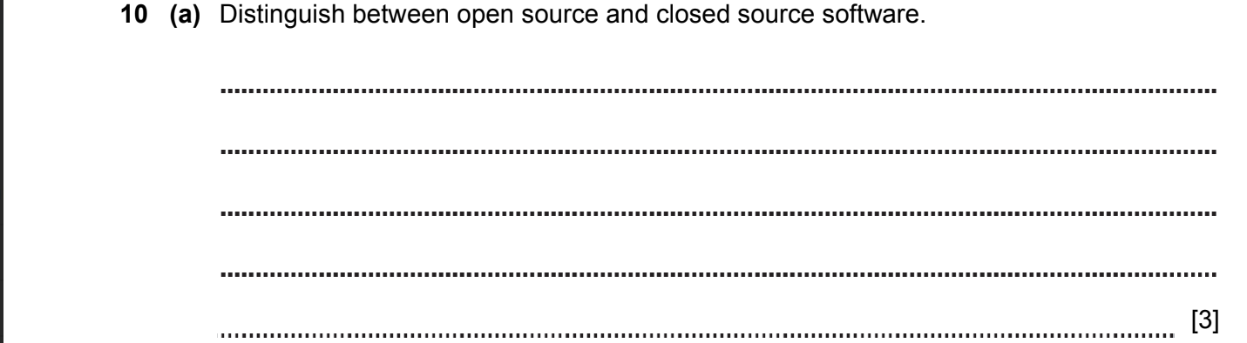

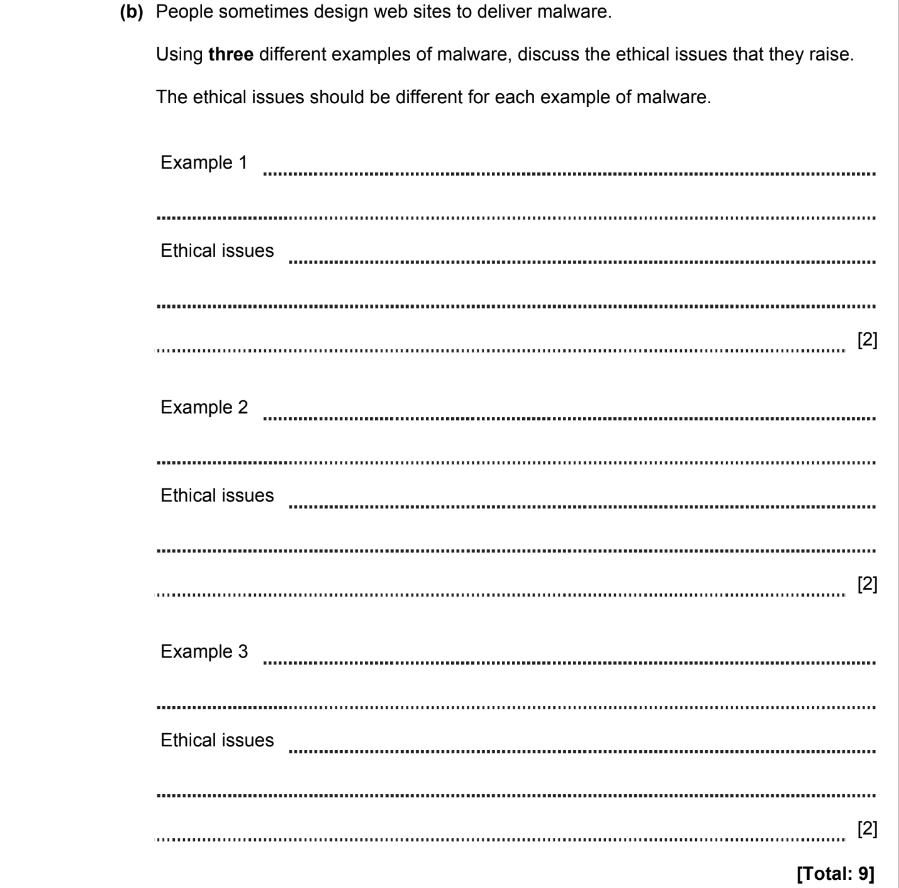
ANSWERS
Part | Answer | Mark | AO | Further Information
10(a) | Open source software means that the source code of the program can be seen by anyone | 1 | AO1 | MAX = 3 (Max 2 mark from EACH)
10(a) | OR  closed source only allows the binary content to be used | 1 | AO1 | MAX = 3 (Max 2 mark from EACH)
10(a) | You can make changes to open source code | 1 | AO1 | MAX = 3 (Max 2 mark from EACH)
10(a) | OR  You cannot make changes to closed source code | 1 | AO1 | MAX = 3 (Max 2 mark from EACH)
10(a) | Closed source software is subject to copyright | 1 | AO1 | MAX = 3 (Max 2 mark from EACH)
10(a) | Copyright in open source software is normally retained by the  author … | 1 | AO1 | MAX = 3 (Max 2 mark from EACH)
10(a) | … but you can make changes to it provided you acknowledge the original author | 1 | AO1 | MAX = 3 (Max 2 mark from EACH)
10(b) | Adware:  Unwanted adverts on the computer | 1 | AO1 | MAX = 6  Accept any other valid malware with a relevant ethical issue  Note: There is no mark for only identifying the type or name of malware
10(b) | Privacy is compromised and adverts are usually obtrusive | 1 | AO1
10(b) | Virus:  Can destroy / corrupt data | 1 | AO1
10(b) | Can spread to other people’s computers | 1 | AO1
10(b) | Trojan:  Deception to accept other unwanted software | 1 | AO1
10(b) | This software could be harmful | 1 | AO1
10(b) | Keylogger:  Reveal passwords | 1 | AO1
10(b) | Access personal information | 1 | AO1
10(b) | Botnet:  Computer performance is degraded … | 1 | AO1
10(b) | … can be used for illegal purposes | 1 | AO1
10(b) | Ransomware:  Access to computer data denied / encrypted | 1 | AO1
10(b) | Payment for access to computer | 1 | AO1
Total |  | 9
DATA SECURITY. DATA INTEGRITY. 2018-2019 (PAPER 1)



ANSWERS
Part | Answer | Indicative Content | AO | Further Information
10 | Mark Band 3 – High Level (6 – 8 marks)  The candidate demonstrates a thorough knowledge and understanding of a wide range of considerations in relation to the question; the material is generally accurate and detailed.  The candidate is able to apply their knowledge and understanding directly and consistently to the context provided. Evidence/examples will be explicitly relevant to the explanation.  There is a line of reasoning presented with some structure.  The information presented is relevant and substantiated.  Mark Band 2 – Mid Level (3 – 5 marks)  The candidate demonstrates reasonable knowledge and understanding of a range of considerations in relation to the question; the material is generally accurate but at times underdeveloped.  The candidate is able to apply their knowledge and understanding directly to the context provided although one or two opportunities are missed. Evidence/examples are for the most part implicitly relevant to the explanation.  The information presented is in the most part relevant and supported by some evidence.  Mark Band 1 – Low Level (1 – 2 marks)  The candidate demonstrates a basic knowledge of considerations with limited understanding shown; the material is basic and contains some inaccuracies.  The candidate makes a limited attempt to apply acquired knowledge and understanding to the context provided.  The candidate provides nothing more than an unsupported assertion. The information is basic and communicated in an unstructured way.  The information is supported by limited evidence and the relationship to the evidence may not be clear.  0 marks  No attempt to answer the question or response is not worthy of credit. | Explains how passwords are used to protect access to the data of the bank system.  Explains how firewalls are used to protect the bank system.  Explains how a user account is used to control access to the bank system.  Explains how digital signatures are used to authenticate transactions in the bank system.  Explains how biometric authentication is used to control access to the bank system.  Band 3 learners must explain that security in banks comes from many forms of security.  Examples:  - use of two factor authentication,  - use of hashing for passwords,  - not requiring users to enter entire password (e.g. “please enter digit 3 and 5 of your password”),  - use of proactive methods to check security (e.g. penetration testing). | AO2 | Accept any other suitable method.
 | TOTAL | 8

DATA SECURITY. DATA INTEGRITY. 2018-2019 (PAPER 2)
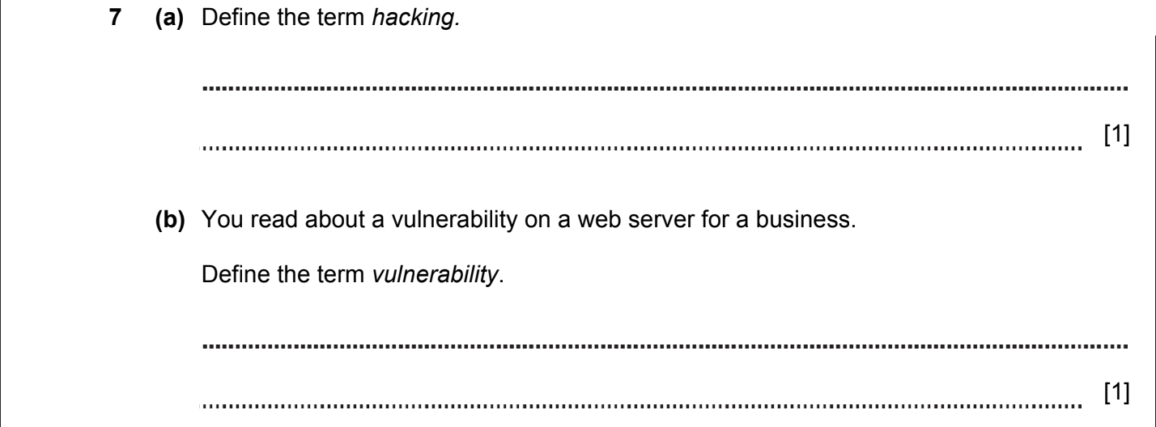



ANSWERS
Part | Answer | Mark | Further Information | AO
7(a) | Unauthorised access to or an attempt to access data / computer / network / system. | [1] |  | AO1
7(b) | Is possible to gain unauthorised access.  Is a fault in the software/hardware.  Exposed to the possibility of harm.  Allows the system to be hacked. | 1  1  1  1  [Max 1] |  | AO1
7(c) | Mark Band 3 – High Level (6 – 8 marks)  The candidate demonstrates a thorough knowledge and understanding of a wide range of considerations in relation to the question; the material is generally accurate and detailed.  The candidate is able to apply their knowledge and understanding directly and consistently to the context provided. Evidence/examples will be explicitly relevant to the explanation.  The candidate is able to include reference to the impact on all areas showing thorough recognition of influencing factors.  There is a line of reasoning presented with some structure.  The information presented is relevant and substantiated.  Mark Band 2 – Mid Level (3 – 5 marks)  The candidate demonstrates reasonable knowledge and understanding of a range of considerations in relation to the question; the material is generally accurate but at times underdeveloped.  The candidate is able to apply their knowledge and understanding directly to the context provided although one or two opportunities are missed. Evidence/examples are for the most part implicitly relevant to the explanation.  The information presented is in the most part relevant and supported by some evidence.  Mark Band 1 – Low Level (1 – 2 marks)  The candidate demonstrates a basic knowledge of considerations with limited understanding shown; the material is basic and contains some inaccuracies.  The candidate makes a limited attempt to apply acquired knowledge and understanding to the context provided.  The candidate provides nothing more than an unsupported assertion. The information is basic and communicated in an unstructured way.  The information is supported by limited evidence and the relationship to the evidence may not be clear.  0 marks  No attempt to answer the question or response is not worthy of credit. | Indicative content:  Ethical  - “white hat” hackers can find vulnerabilities and report back.  - Hacking can help to improve defences for future users.  - Hacking as protest / civil action (e.g. Anonymous).  Social  - Increased online data storage and electronic system usage means more and more people need to understand risks of hacking.  - Increased need for education regarding risks of hacking (e.g. in schools / by banks).  - Digital divide – some users (e.g. elderly) are particularly at risk from social engineering and other forms of hacking.  Legal  - Law of the Republic of Kazakhstan on Copyright and Related Rights makes hacking illegal.  - Legislation that defines country borders causes issues; e.g. what happens if a hacker in the UK accesses data from a Swedish user that is stored on a server in the USA? Where did the crime occur? |  | AO2
 | TOTAL | 10

DATA SECURITY. DATA INTEGRITY. 2020-2021 (PAPER 1)
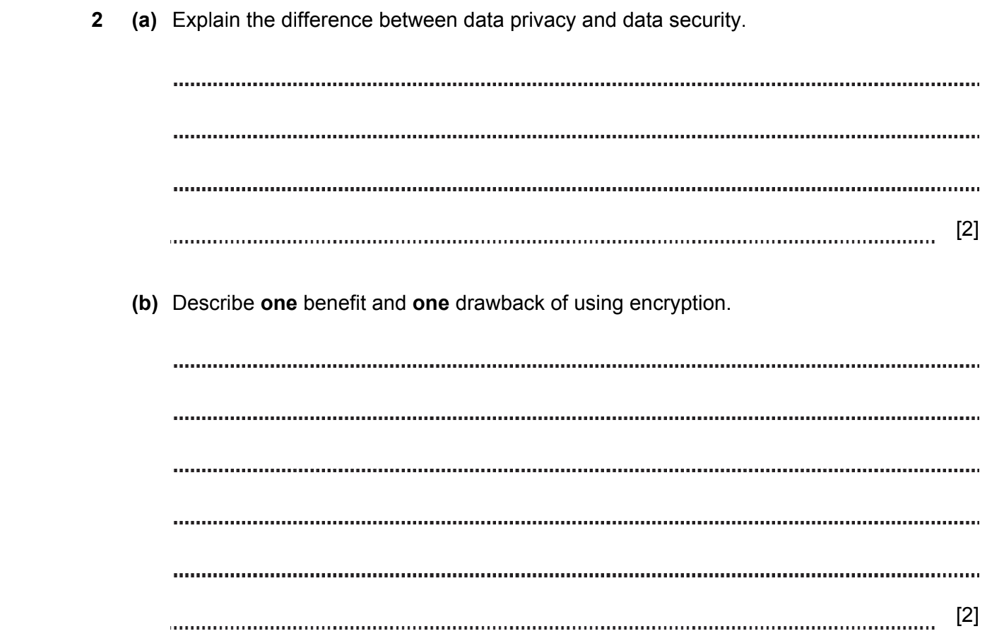
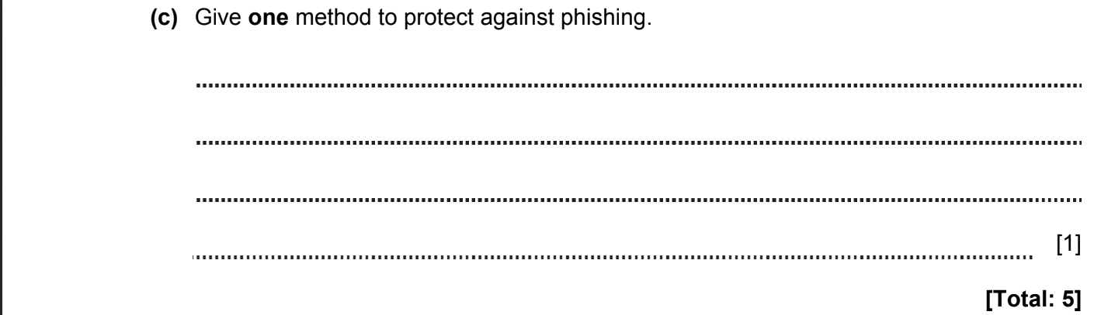

ANSWERS
2a | Data security protects data from physical risks, accidental loss and hacking.  Data privacy is the necessity to protect any personal information from being accessed by a third party. | 1  1  [2] |  | Do not accept only examples without discussion of what data security and privacy are
2b | Benefits  Confidentiality. Encrypted data can be read and understood only with the key.  Encryption provides security for data, during data transport and storing.  Drawbacks  In case of key loss, data will not be understood.  False Sense of Security. There is a difference between encryption and good encryption and relying overmuch on bad encryption can lead you to make bad security decisions. | 1  1  1  1  [max 2] |  | 1 mark for benefit and 1 mark for drawback
2c | Сheck the URL, for errors in writing.  Use secure https connections.  Be suspicious of any letter with attachments and links.  Do not use open Wi-Fi networks to access online banking and other financial services.  Use two-factor authentication. | 1  1  1  1  1  [max 1]
 | Total | 5

DATA SECURITY. DATA INTEGRITY. 2020-2021 (PAPER 1)

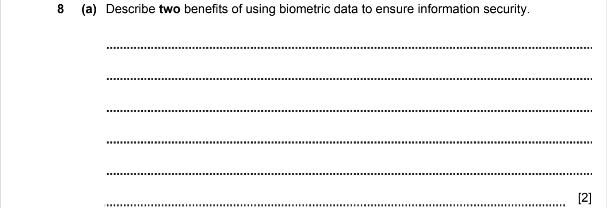
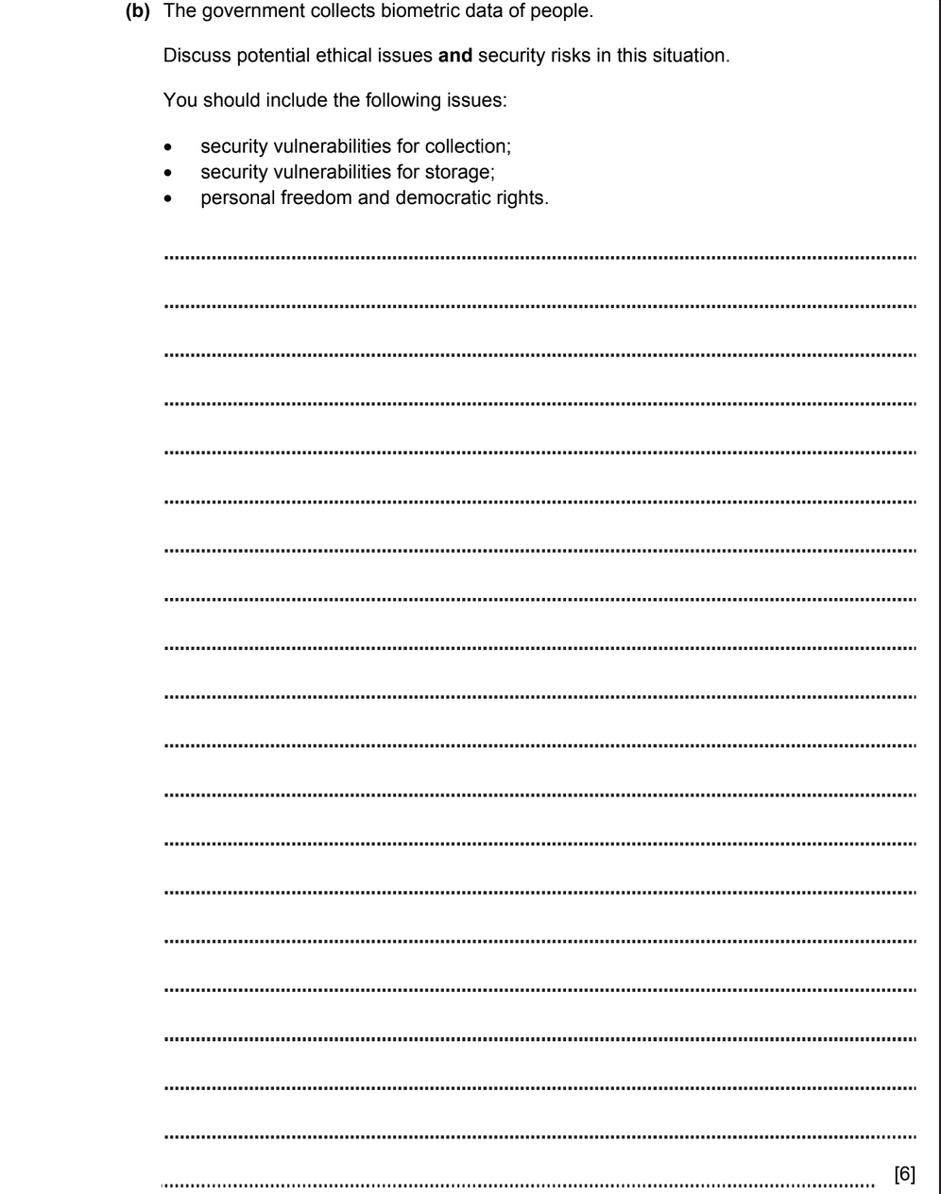

ANSWERS
8a | Biometric data is always with you.  Impossible to forget.  Cannot be faked (copied). | 1  1  1  [max 2] |  | Allow any reasonable answers.
8b | For the question 8(b) please use the following labels:  ✓C – for security vulnerabilities for collection, e.g.:  biometric data captured with errors;  fake fingerprints;  spyware data collection  ✓S – security vulnerabilities for storage, e.g.:  alter or corrupt stored templates;  stored data could be stolen;  feed false data;  ✓R – personal freedom and democratic rights, e.g.:  violation of data privacy;  personal data can be compromised and used without user consent;  use of data to make influence on decisions;  presenting biased information;  etc.
 | High level (5-6 marks)  The candidate demonstrates profound knowledge and understanding of a wide range of considerations in connection with the issue; the material is usually accurate and detailed.  A candidate can apply his knowledge and understanding directly and consistently in context. Evidence / examples will have a direct bearing on the explanation.  The candidate can weigh both sides of the discussion, referring to the influence in all areas, and demonstrating a deep understanding of the influencing factors.  There is a well-developed line of reasoning, which is understandable and logically structured. The information presented is current and reasonable.  Middle level (3-4 marks)  The candidate demonstrates reasonable knowledge and understanding of a number of considerations in connection with the issue; the material is usually accurate, but at times underdeveloped.  A candidate can apply his knowledge and understanding directly in context, although one or two possibilities may be missed. Evidence / examples for the most part implicitly relate to the explanation.  The candidate makes a reasonable attempt to discuss the impact on most areas, demonstrating a reasonable understanding of the influencing factors.  There is a line of reasoning represented by some structure. The presented information is mostly relevant and supported by some evidence.  Low level (1-2 marks)  The candidate demonstrates basic knowledge of considerations with limited understanding; the material is simple and contains some inaccuracies.  The candidate makes a limited attempt to apply the acquired knowledge and understanding to the context provided.  The candidate represents nothing more than an unsupported statement. The information is basic and is transmitted in an unstructured manner.  The information is supported by limited evidence, and the connection with the evidence may be unclear.  0 points  No attempt to answer a question or answer deserves no credit. | [max 6] |  | Max 6 marks for covering all three points (C, S and R)  Max 4 marks for covering any two of C, S or R  Max 2 marks if only one of the points C, S or R is covered.
 | Total | 8

DATA SECURITY. DATA INTEGRITY. 2021-2022 (PAPER 1)

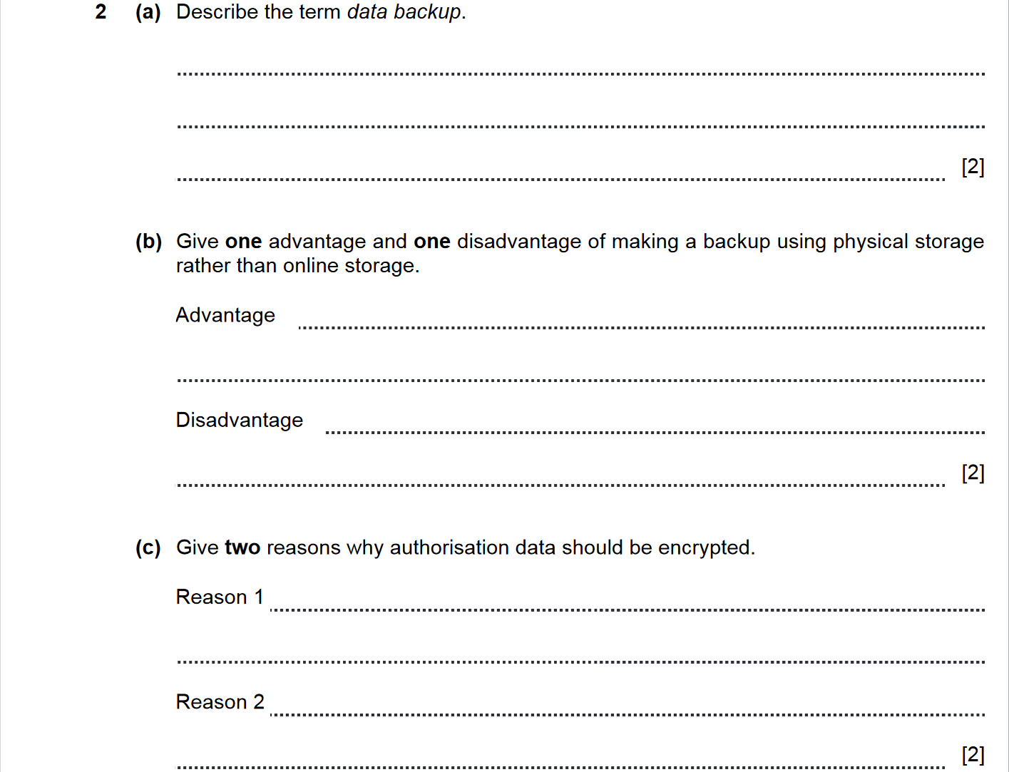
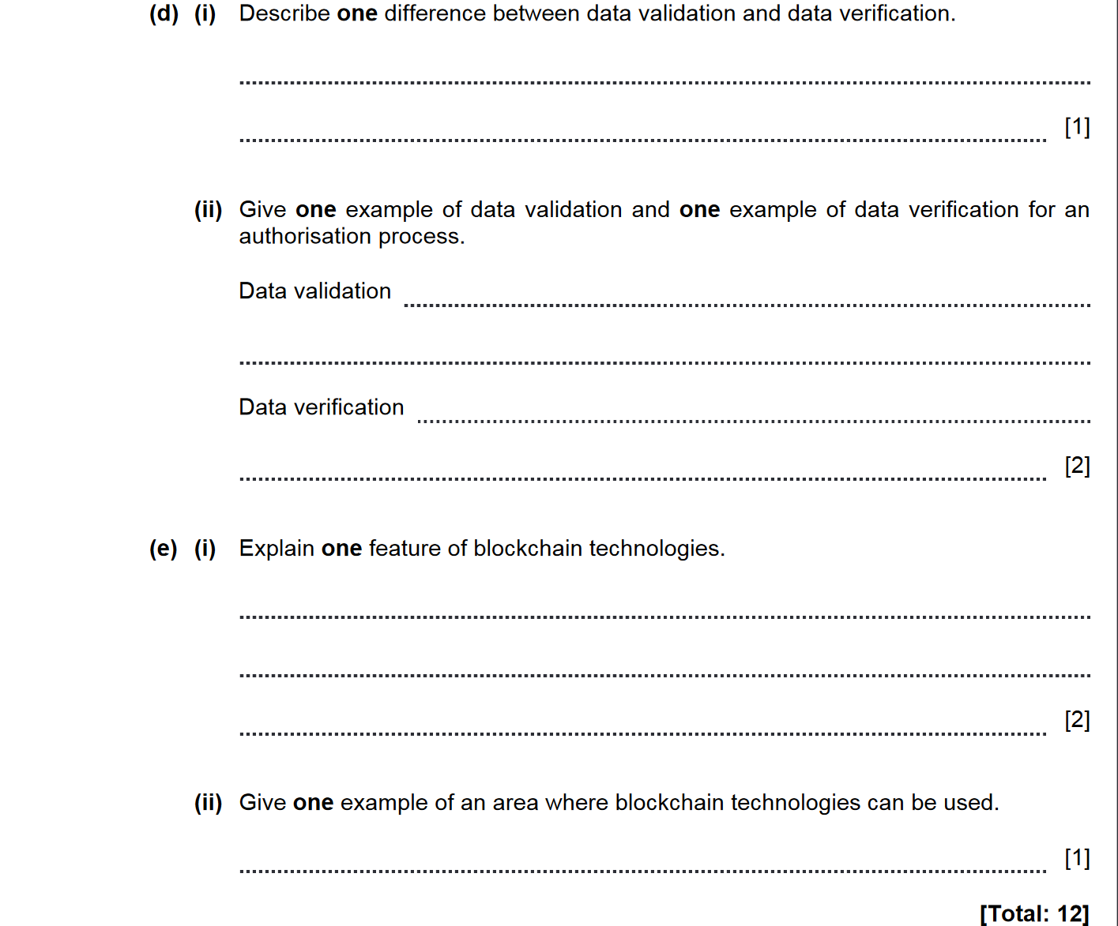

ANSWERS

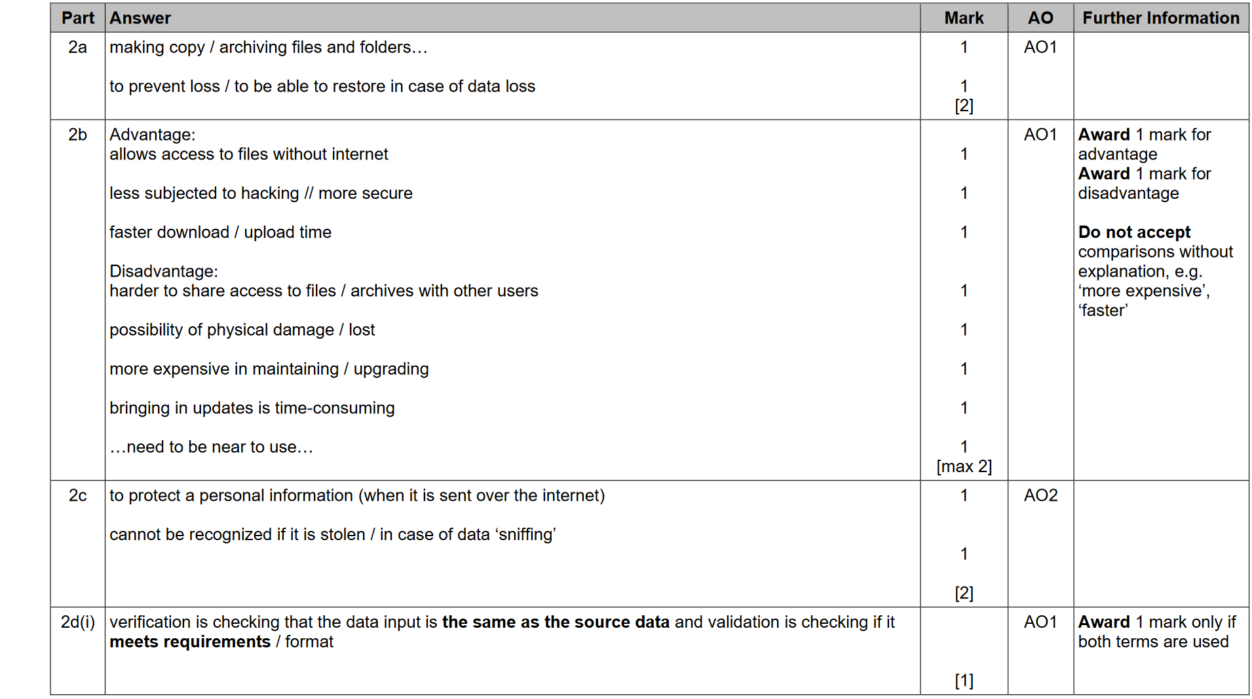
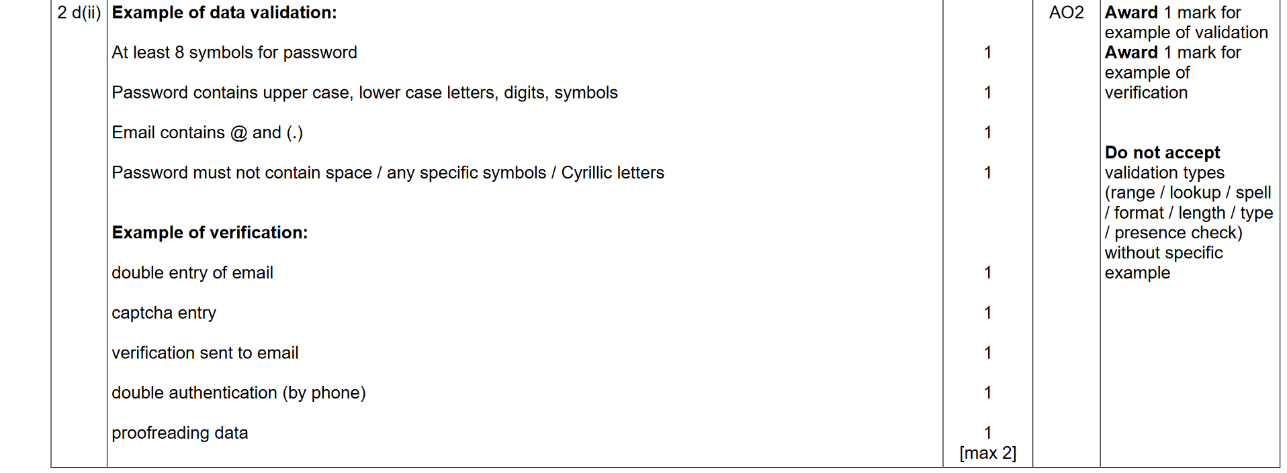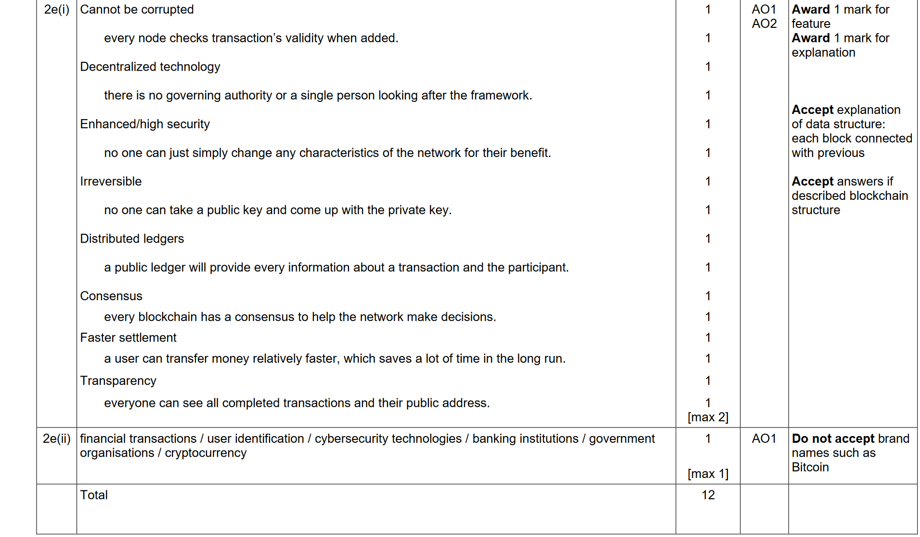

DATA SECURITY. DATA INTEGRITY. 2021-2022 (PAPER 1)

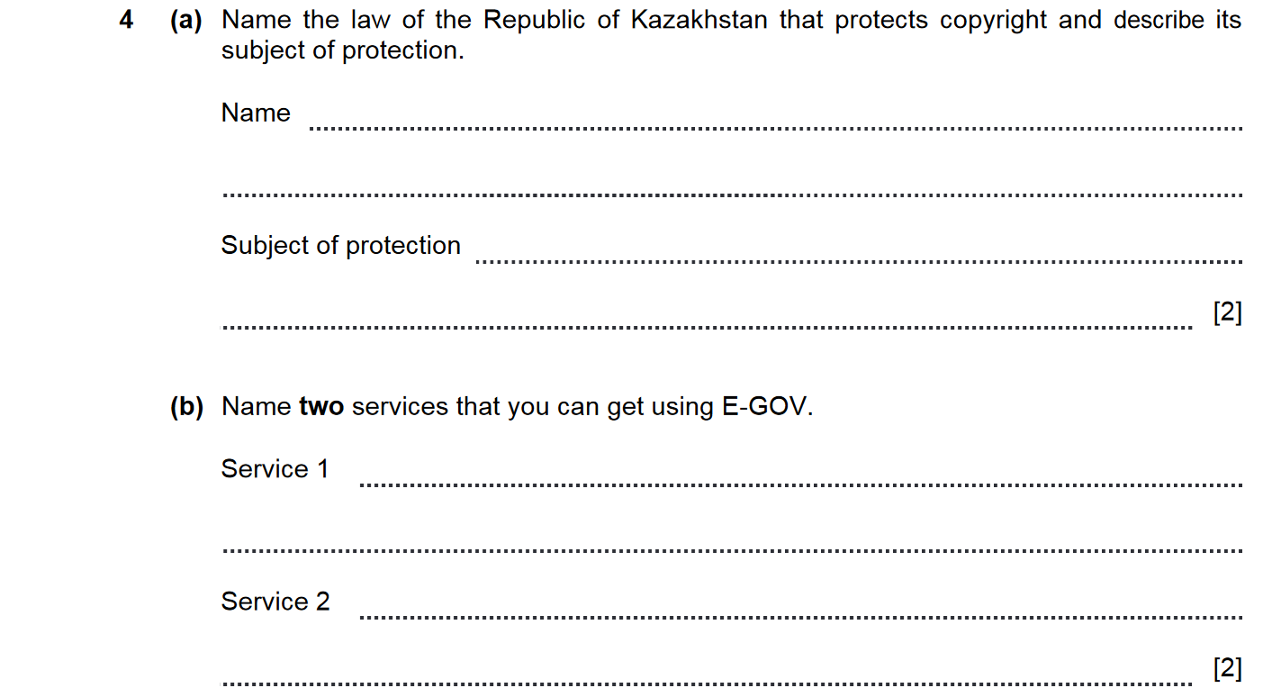
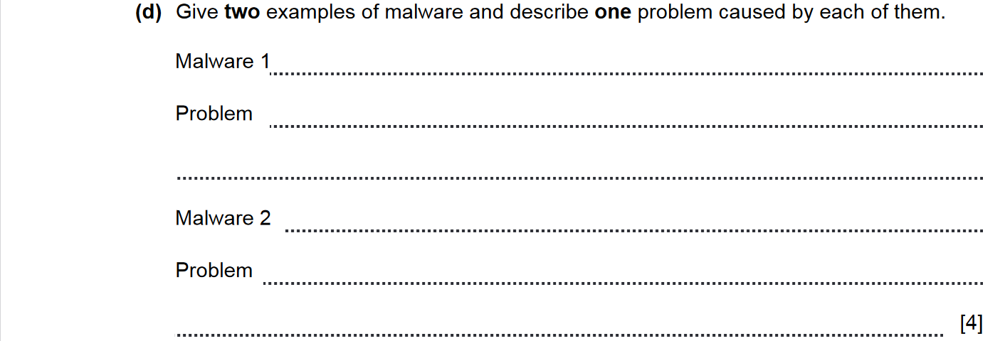
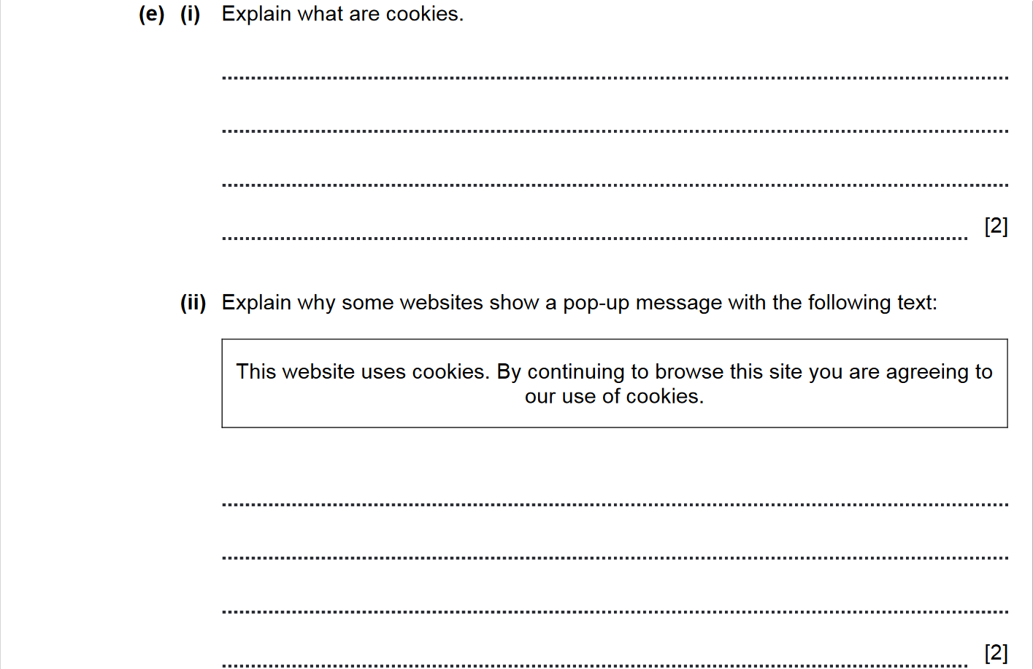
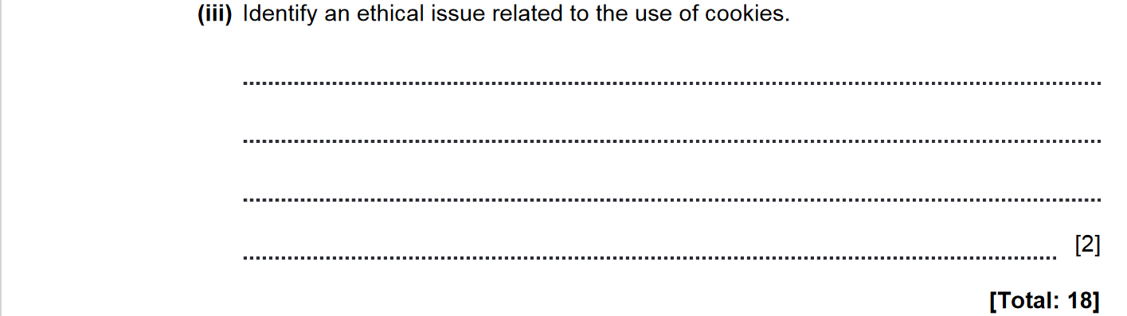

ANSWERS
