PROGRAMMING PARADIGMS. TRANSLATORS. 2013-2014 (PAPER 1)

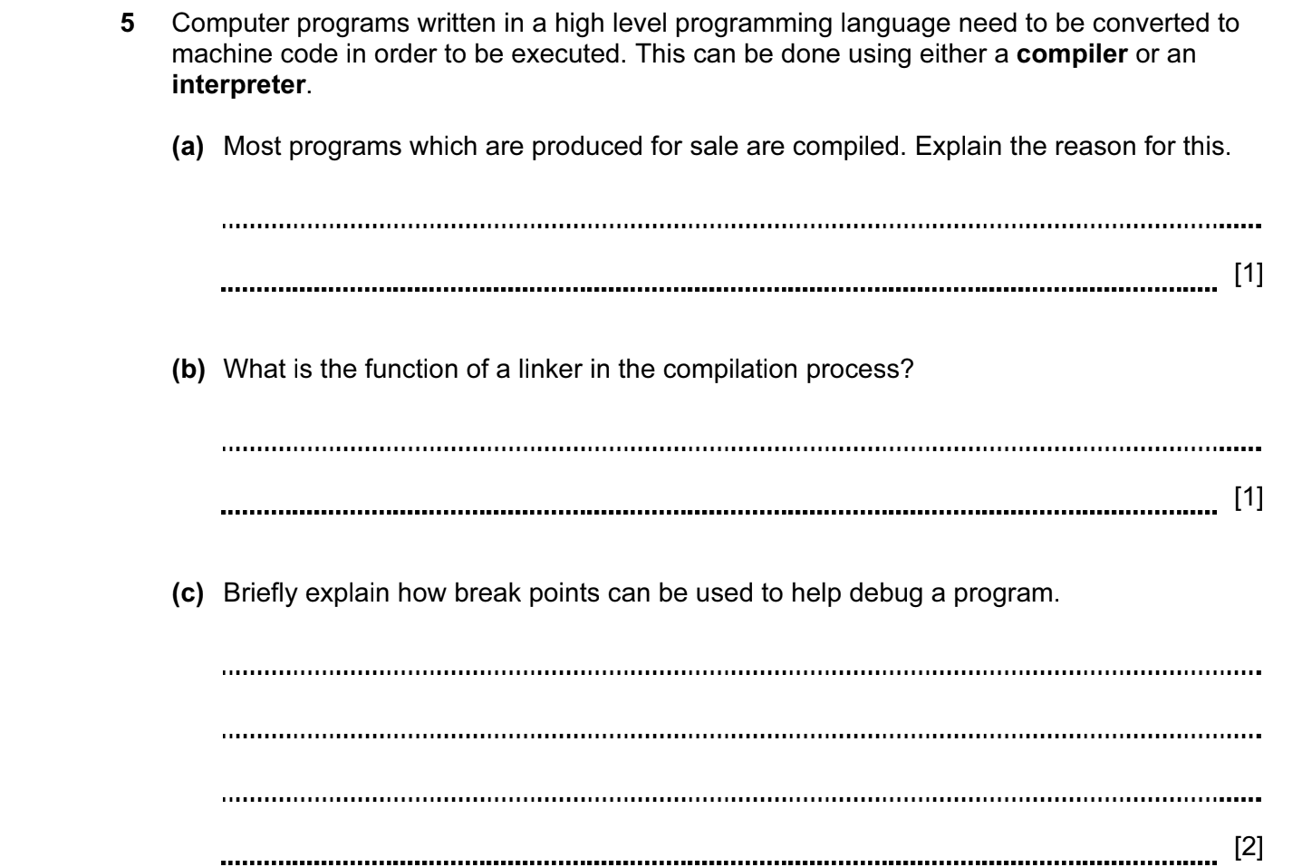

ANSWERS

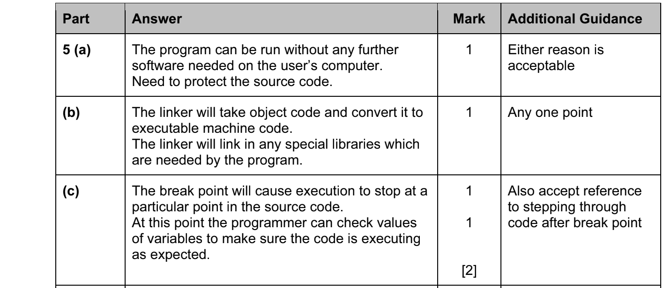

PROGRAMMING PARADIGMS. TRANSLATORS. 2014-2015 (PAPER 2)

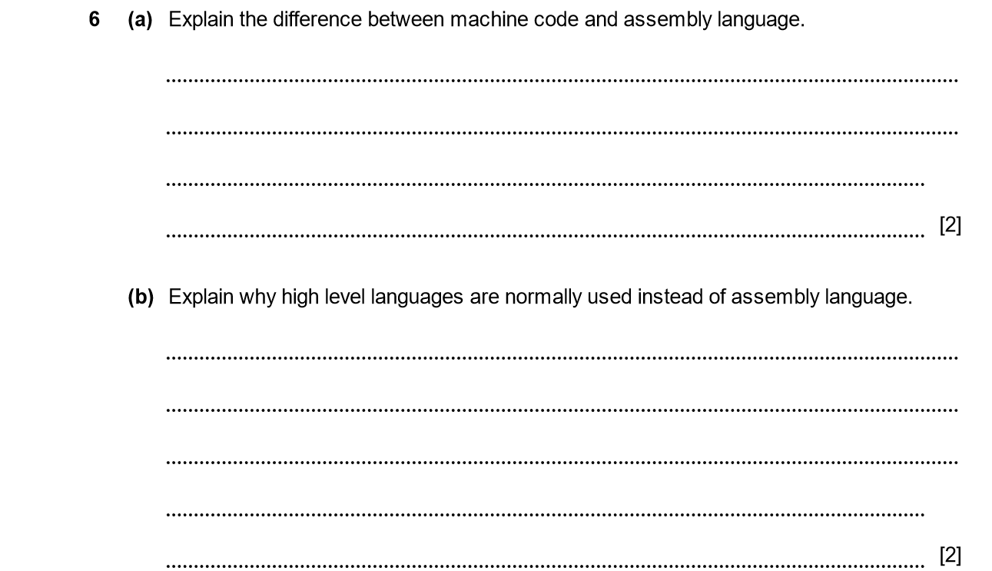

ANSWERS
Part | Answer | Mark | Additional Guidance
6 (a) | Machine code is the binary instructions that can be decoded and executed by the CPU.  Assembly language is a text representation of the binary codes.  Assembly language makes use of short codes (mnemonics) and symbolic addressing. | 1  1  1  [Max 2] | Any 2 points.
(b) | Much harder to write assembly language.  Assembly language not portable to other CPUs.  Needs a detailed understanding of the CPU structure / registers / memory management. | 1  1  1  [Max 2] | Any 2 points.

PROGRAMMING PARADIGMS. TRANSLATORS. 2014-2015 (PAPER 2)

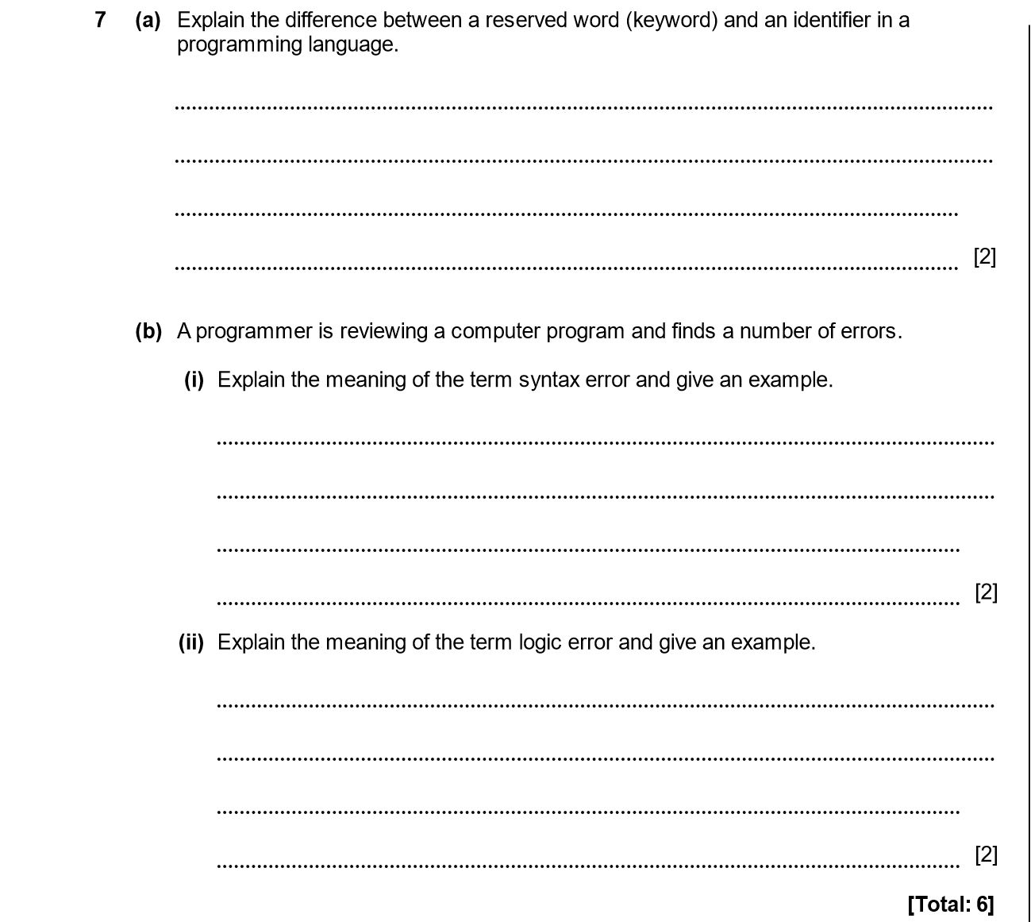

ANSWERS
Part | Answer | Mark | Additional Guidance
7 (a) | A reserved word is a special word used in the programming language which has a specific meaning.  An identifier is used to refer to a variable or constant.  Reserved words cannot be used as identifiers. | 1  1  1  [Max 2] | Any two points.
(b) (i) | A syntax error means that a mistake has been made in the grammar of the program.  For example:  PRINT value X 2 instead of PRINT value * 2 | 1  1 | 1 mark for description.  1 mark for example.
(ii) | A logic error means that a mistake has been made in the meaning of the program.  For example:  PRINT value * 20 instead of PRINT value + 20 | 1  1 | 1 mark for description.  1 mark for example.
Total |  | 6

PROGRAMMING PARADIGMS. TRANSLATORS. 2014-2015 (PAPER 2)

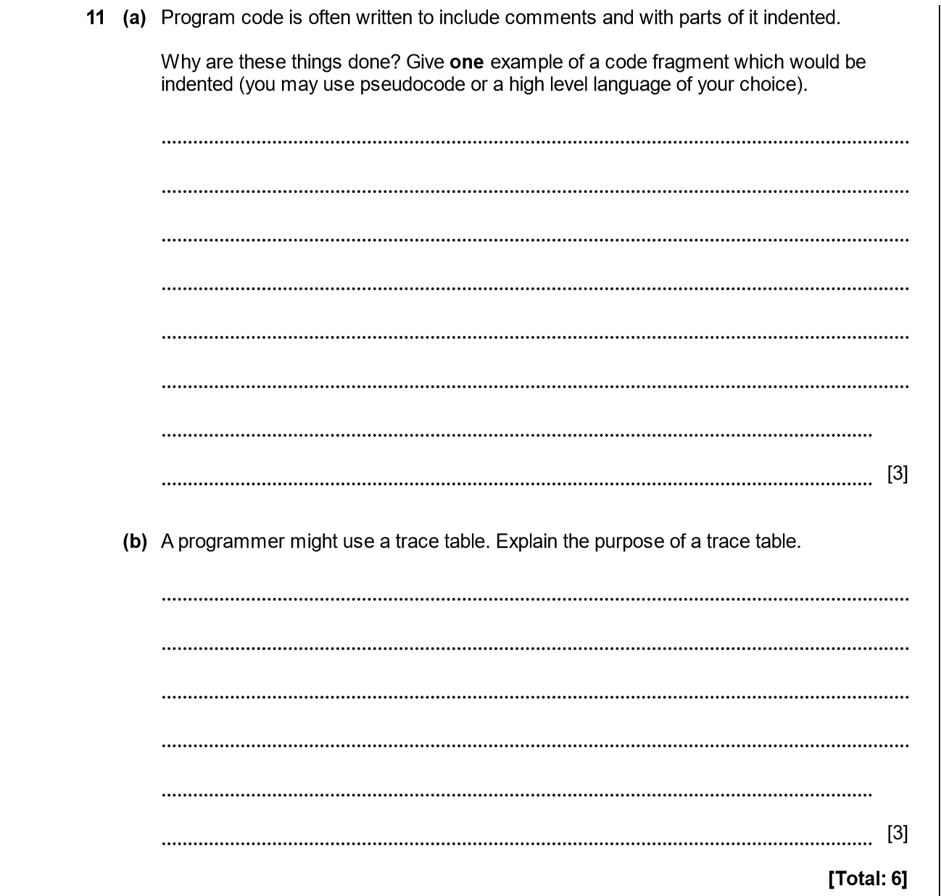

ANSWERS
Part | Answer | Mark | Additional Guidance
11 (a) | Comments added to make clear the purpose / workings of the code.  Indents used to show the control structures – eg loops, if .. then .. end if  IF X=2 THEN  PRINT “X has value 2”  END IF | 1  1  1 | Example not needed here but could say something like indents used to show start and end of loop.  Accept that indents may be compulsory.  Any reasonable example that includes an indent.
(b) | Trace table is used to find the value of variables at each step in an algorithm / program.  It may be used when debugging a program.  The manually calculated value at each stage of the program is compared with that actually set in the program.  It may be used when designing a program by writing an algorithm.  A trace table is useful for designing or debugging a loop structure. | 1  1  1  1  1  [Max 3]
Total |  | 6

PROGRAMMING PARADIGMS. TRANSLATORS. 2015-2016 (PAPER 2)

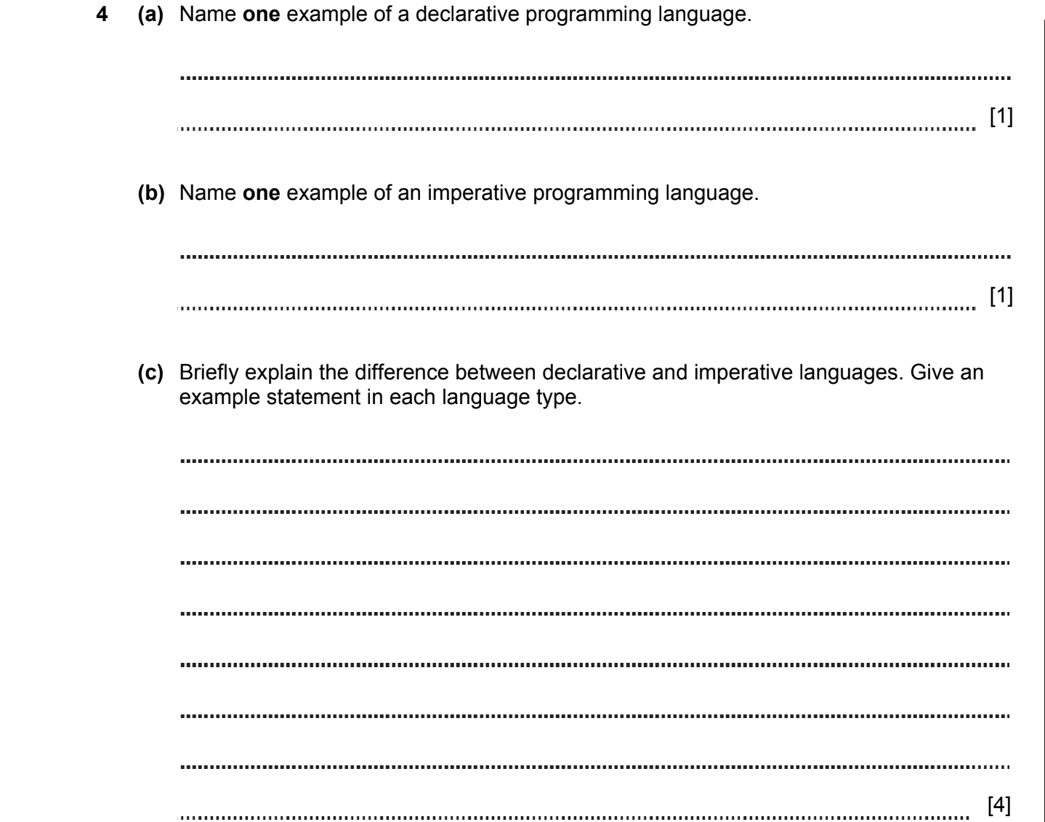
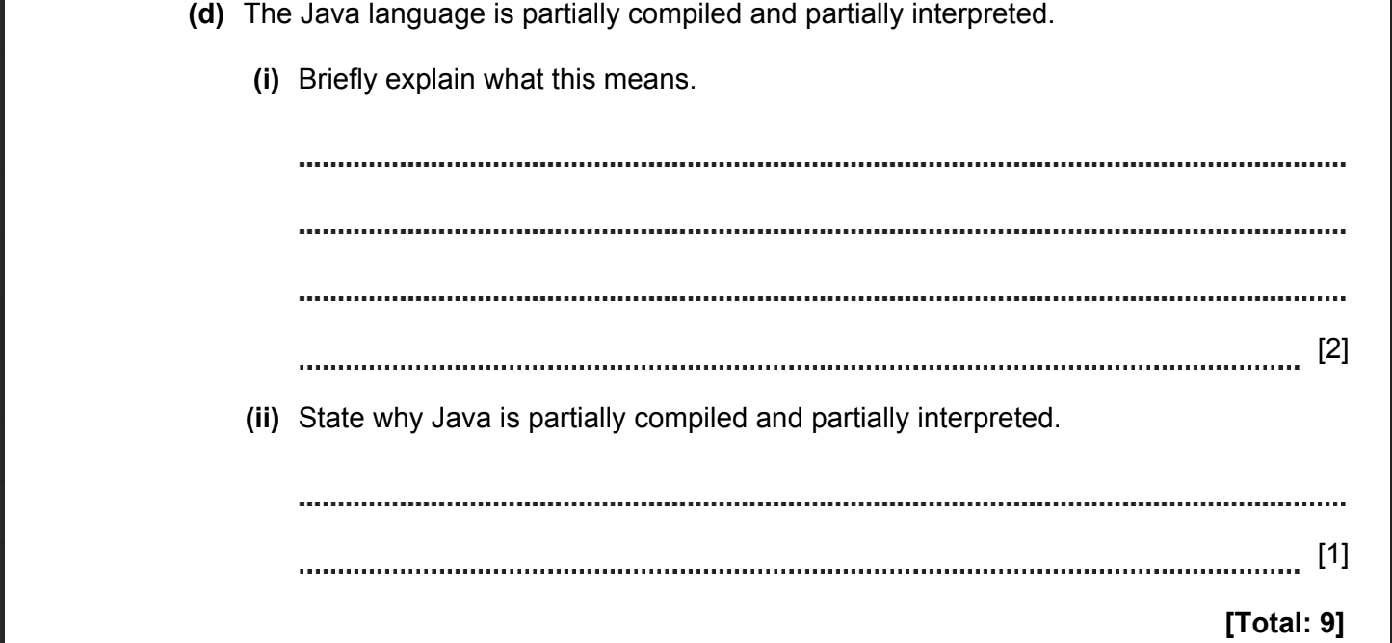

ANSWERS
Part | Answer | Mark | Additional Guidance
4 (a) | Declarative – Prolog, SQL, CSS | 1 | Accept any valid language
(b) | Imperative – VB.Net, Delphi, C, Python, Assembler | 1 | Accept any valid language
(c) | A declarative language consists of statements of facts. These facts can be consulted using questions to be used to query those facts.  For example, if a Prolog file contains:  likes(mary,food).  likes(mary,tea).  then the question  likes(mary, food).  Will return “yes”  An imperative language consists of statements which cause actions to happen/ give commands for the computer to perform. For example, in Visual Basic:  x = 26  Or  MsgBox("Hello World") | 1  1  1  1 | In each case, 1 mark for description, 1 for valid example  Row is correct if it omits repeating values.
(d) (i) | Java is compiled to bytecode/intermediate code by the developer.  The bytecode is then interpreted by the Java Runtime Environment. | 1  1 | 1 mark for compiling at development time  1 mark for “just in time” interpreting (need not use the JIT term or name JRE)  Order is important
(ii) | The benefit is that the same Java bytecode can be used on almost any computer as long as it has a JRE (interpreter). | 1 | 1 for “run anywhere”
Total |  | 9

PROGRAMMING PARADIGMS. TRANSLATORS. 2016-2017 (PAPER 1)

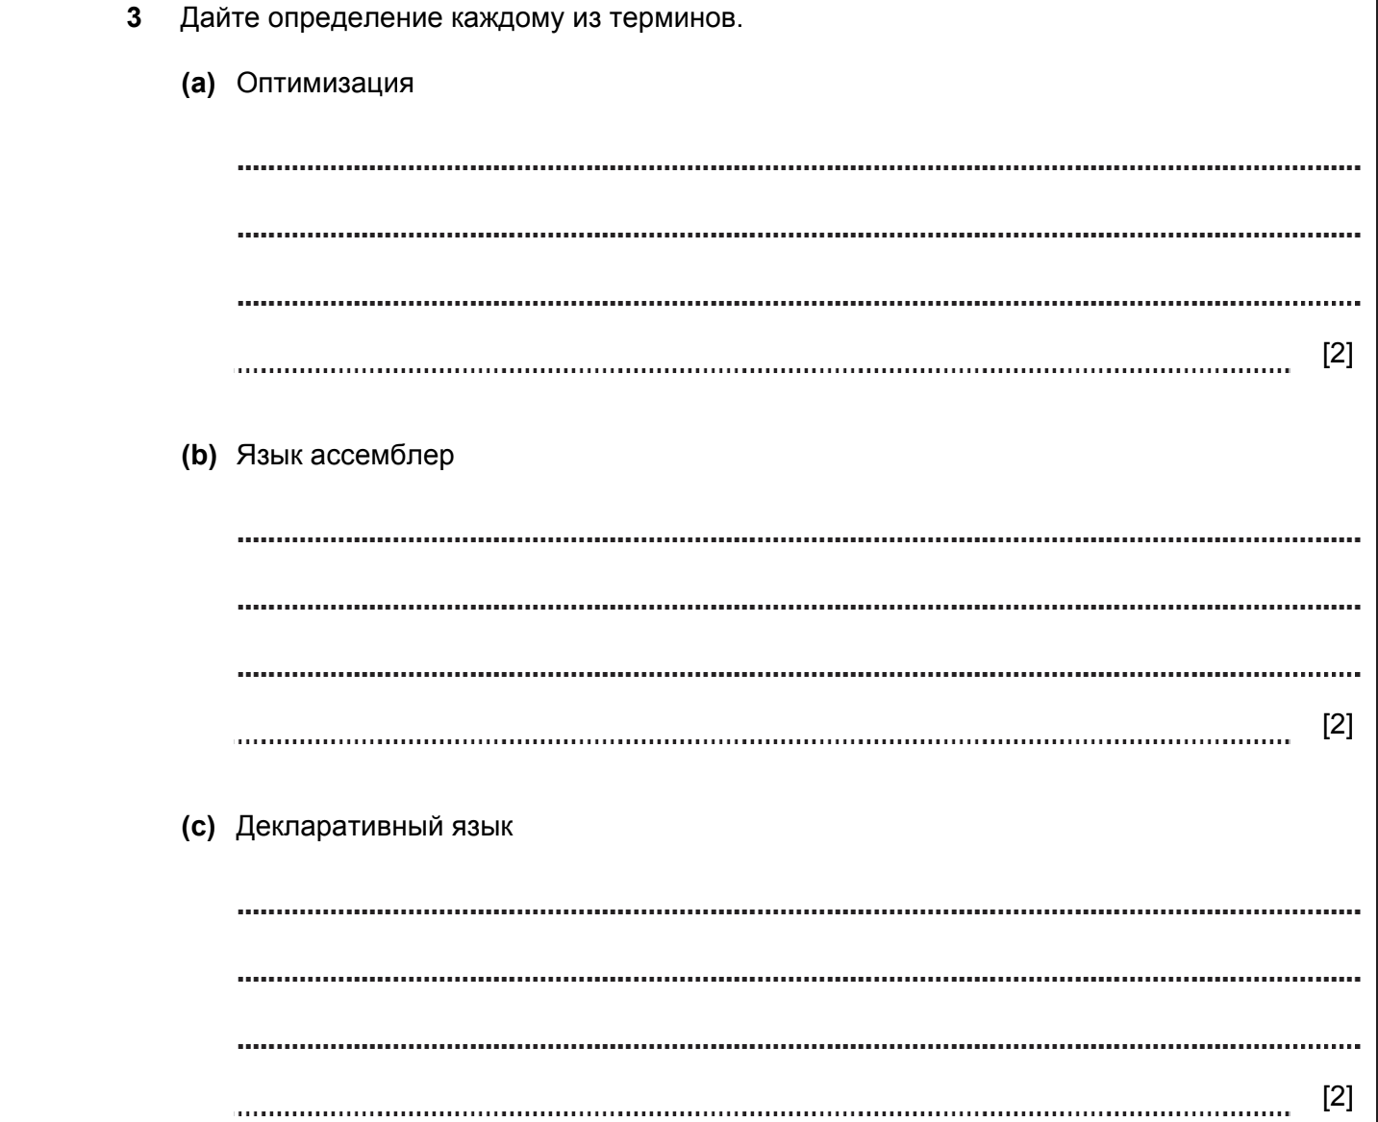

ANSWERS
Part |  |  | Answer | Mark | Additional Guidance
3 | (a) |  | Optimisation means taking code and removing redundant sections.  It means replacing slow running code with faster code.  Structuring code for specific architecture / CPU. | 1  1  1  Max 2 | Any 2 valid points; max 2
 | (b) |  | Assembly language is a low level programming language.  It is made up of mnemonics.  Each line of assembly language translates to exactly 1 machine code instruction.  Uses symbolic addressing. | 1  1  1  1  Max 2 | Any 2 valid points; max 2
 | (c) |  | In a declarative language the code specifies how data are related and what should happen to them.  It does not specify how the data is processed or the control but just what should happen.  Declarative programming contains logic statements and relationships. | 1  1  1  Max 2 | Any 2 valid points; max 2
Total |  |  |  | 6

PROGRAMMING PARADIGMS. TRANSLATORS. 2016-2017 (PAPER 1)

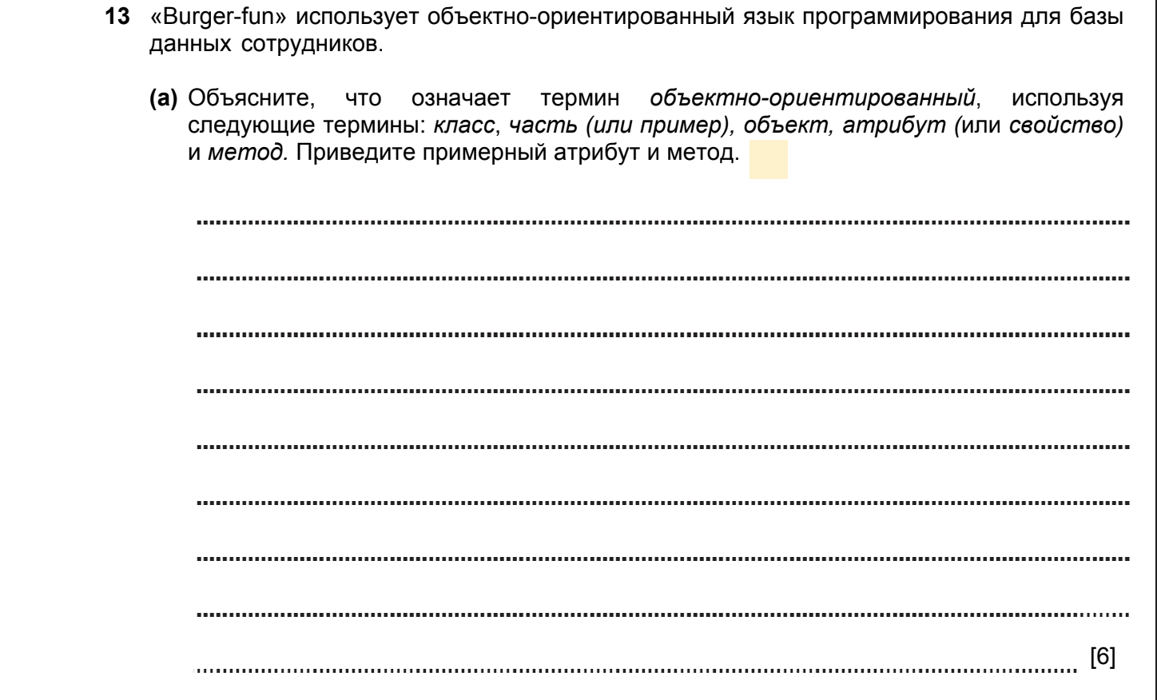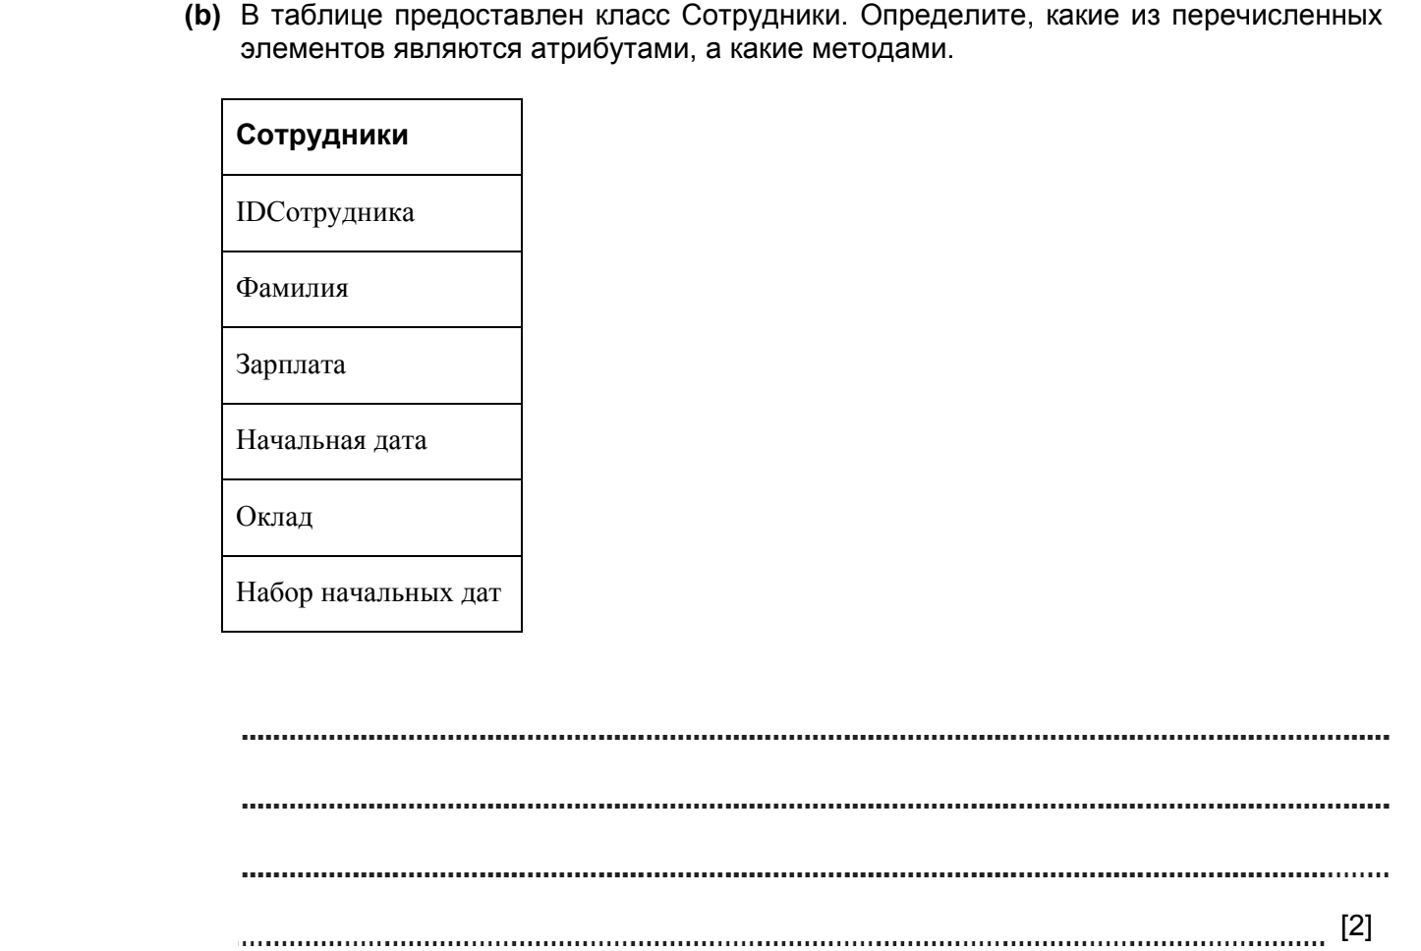
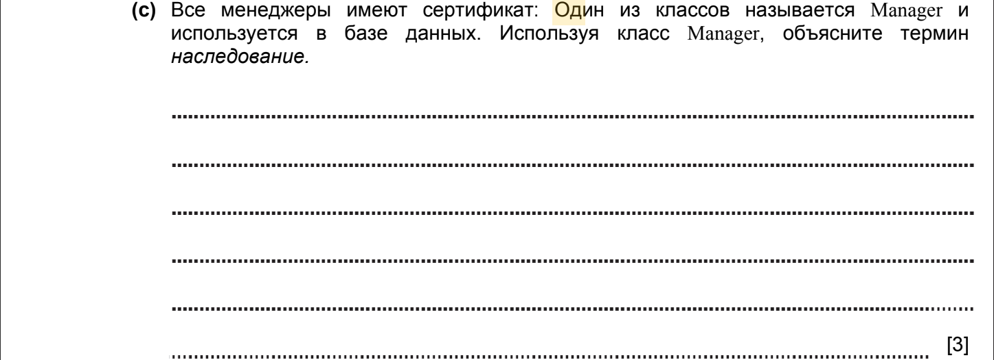

ANSWERS
Part |  |  | Answer | Mark | Additional Guidance
13 | (a) |  | An object oriented programming language is one which treats all data as objects.  Each object will be a member of a class which defines the type of object.  Each object in a class will have one or more attributes (for example a class called “person” might have Name, DateOfBirth as attributes)  Each object in a class will have one or more methods attached to it (for example, a class called TextFile might have a method called GetFileContent or DeleteFile) | 1  1  1  1  1  1  Max 6
 | (b) |  | StaffID, Surname, Wage, StartDate are attributes  SetWage and SetStartDate are methods | 1  1 | Must get all right for the mark
 | (c) |  | Inheritance means one class is based on another class  In this case, the manager class could be inherited / derived from the staff class.  It will have the same properties and methods but will also have a property called “certificate” / method called “SetCertificate” | 1  1  1
Total |  |  |  | 11

PROGRAMMING PARADIGMS. TRANSLATORS. 2016-2017 (PAPER 2)



ANSWERS
Part |  |  | Answer | Mark | Additional Guidance
6 | (a) |  | Handles calculations / comparisons  controls the fetching and execution of all instructions.  RAM stores the currently executing program and the data being processed. | 1  1  1  1 | 1 mark for calculation or similar  1 mark for fetch / execute  1 mark for program storage, and 1 mark for data
 | (b) |  | Allows extra interface cards to be added to the computer.  The cards might be for graphics or sound  Allows for fast disks to be connected. | 1  1  1  Max 2 | One mark for each valid point.
 |  |  |  | 6

PROGRAMMING PARADIGMS. TRANSLATORS. 2017-2018 (PAPER 1)

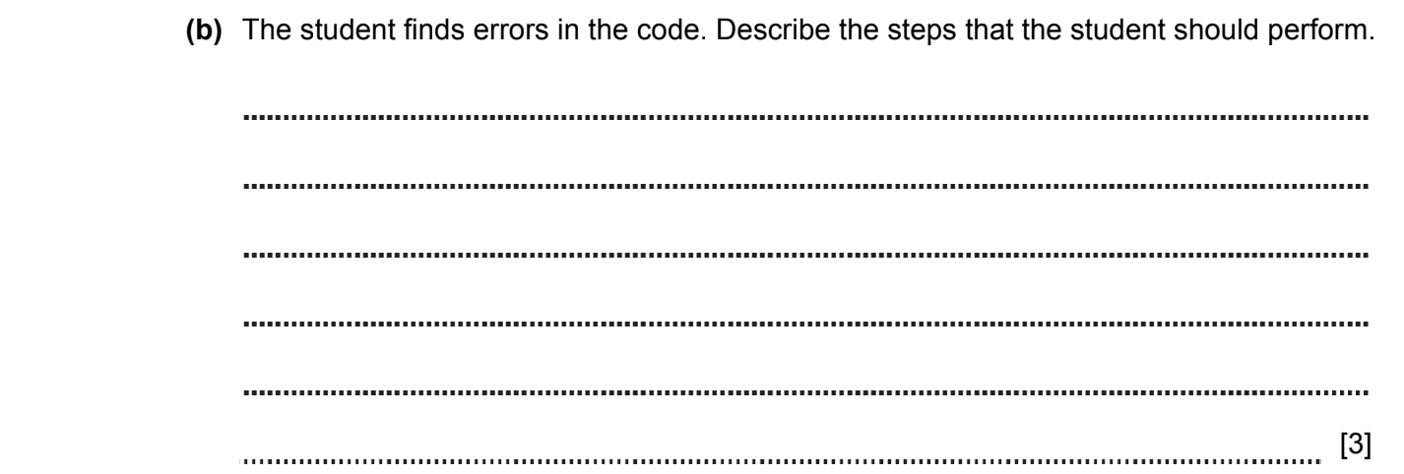

ANSWERS
Part | Answer | Mark | AO | Further Information
8 (b) | The student attempts to fix the faults.  The student re-tests the program.  The student continues this until the faults are repaired. | 1  1  1  [max 3] | AO2 | Answers do not need to refer to the students directly.  Accept the answer if the student determines the type of error.
Total |  | 8

PROGRAMMING PARADIGMS. TRANSLATORS. 2017-2018 (PAPER 2)

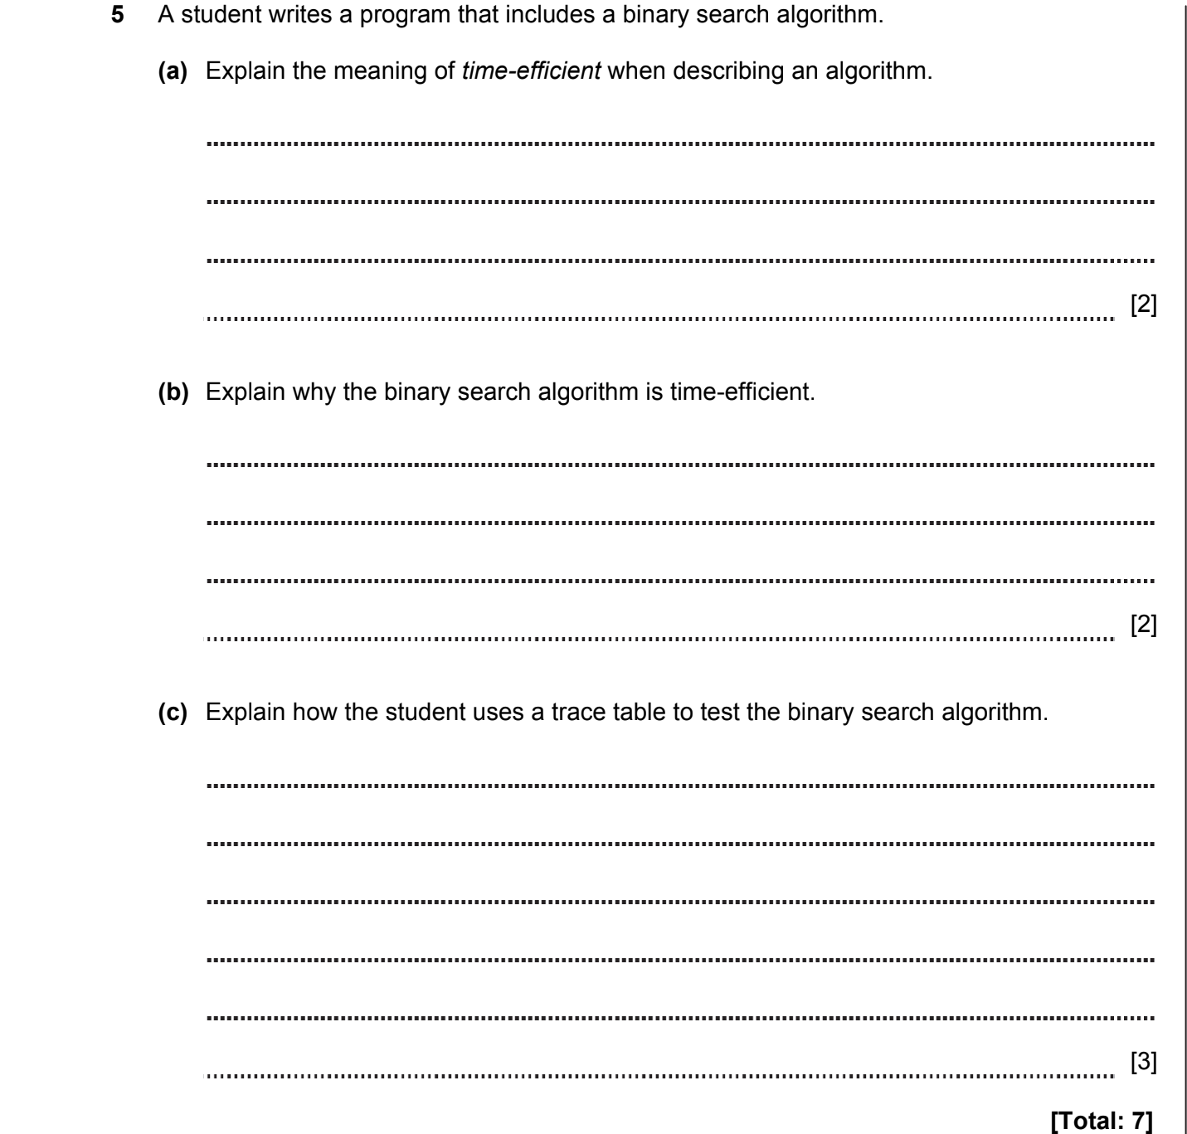

ANSWERS
Part | Answer | Mark | AO | Further Information
5(a) | Time efficient means that the algorithm will complete as quickly as possible | 1 | AO1 | Accept reference to binary search
5(a) | It has been optimised to remove unnecessary or repetitive steps | 1 | AO1 | Accept reference to binary search
(b) | The binary search is efficient because in a sorted list you can immediately eliminate half the data from the search at each stage | 1 | AO1
(b) | The algorithm does not need to compare every item in the list to the search item | 1 | AO1
(b) | Binary search takes contents space (O(1)) so the space taken by the algorithm is the same for any number of elements in the array | 1 | AO1
(b) |  | [max 2] | AO1
(c) | A trace table shows the values of each variable at each stage of the process | 1 | AO1  (1) | Accept answers with reference to the binary search
(c) | The steps of the algorithm are manually followed | 1 | AO2  (2) | Allow selectors/classes/ID/tags
(c) | The variables in the table are updated to show the result of each step | 1 | AO2  (2)
Total |  | 7

PROGRAMMING PARADIGMS. TRANSLATORS. 2018-2019 (PAPER 2)

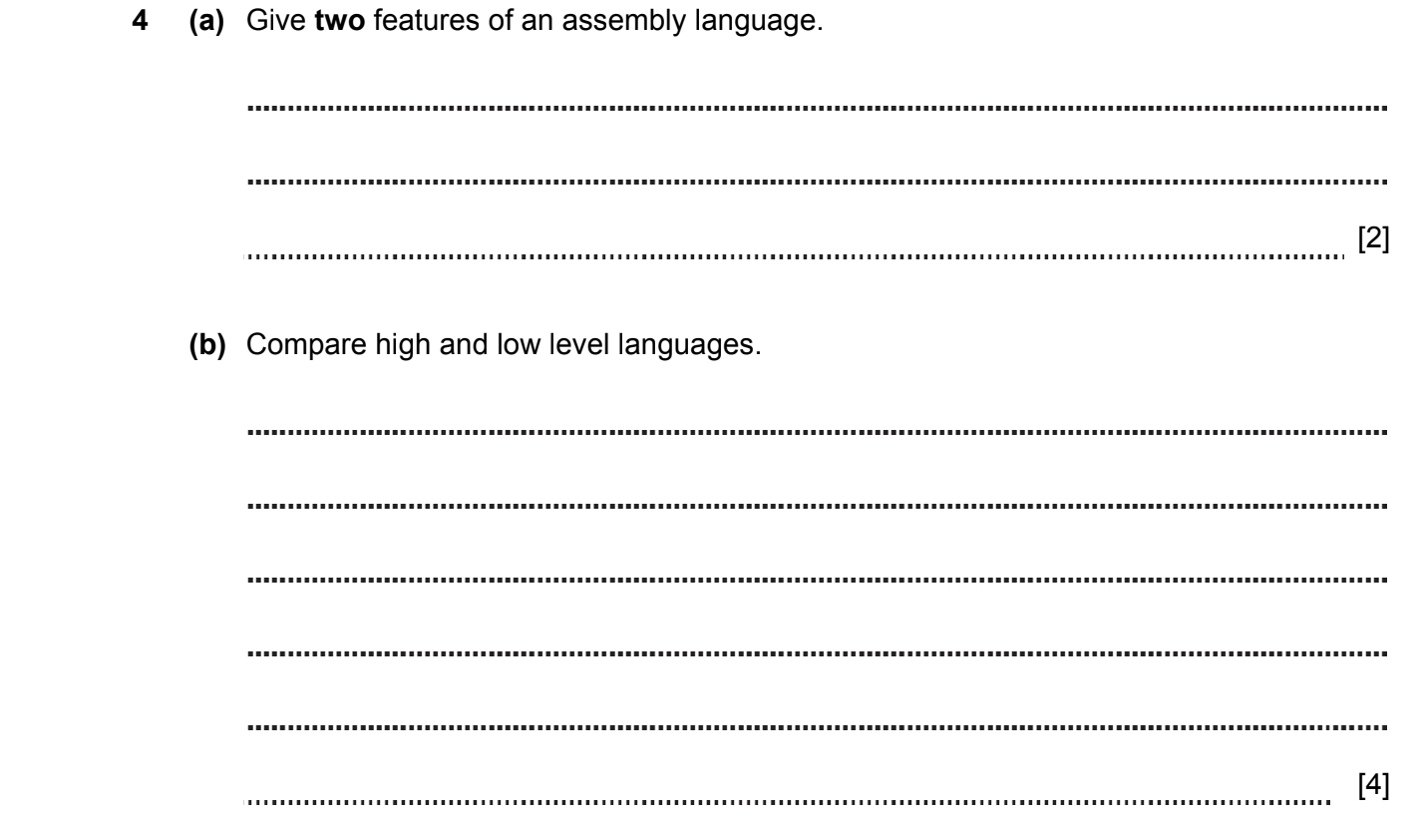
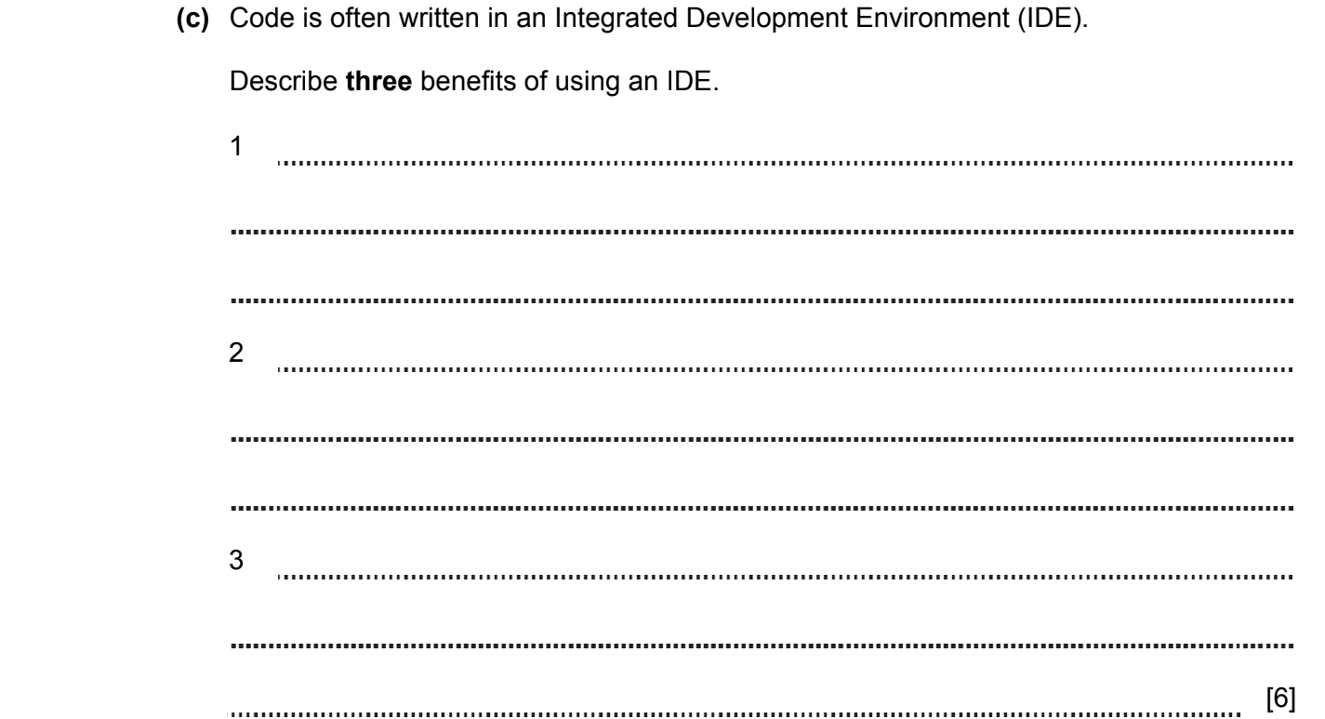
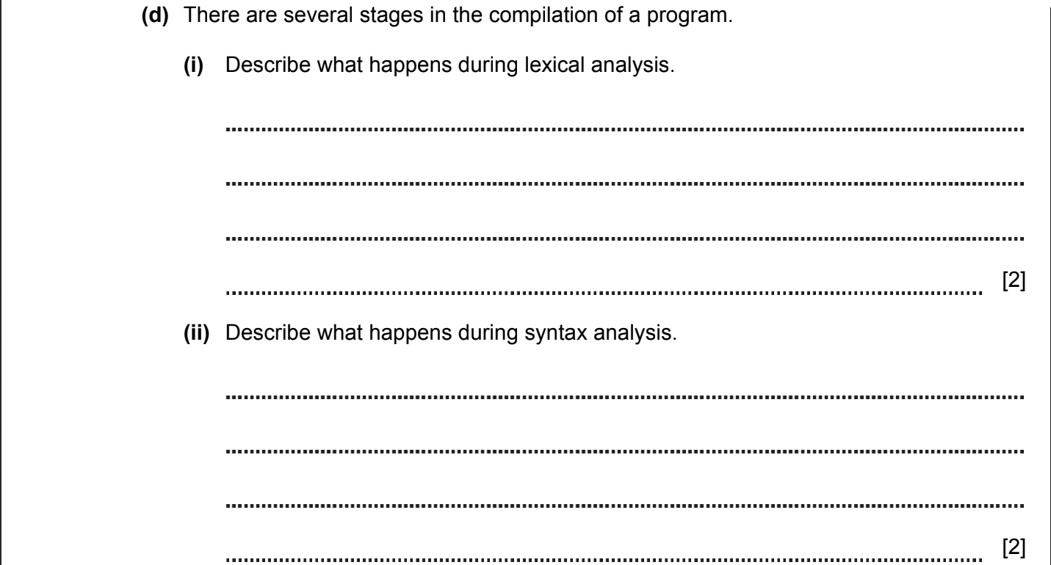

ANSWERS
Part | Answer | Mark | AO | Further Information
4(a) | Is classed as a low level language.  Is written in mnemonics.  One assembly code instruction represents one machine code instruction.  Assembly language code resembles the machine code of the processor.  Assembly code is converted to machine code using an assembler. | 1  1  1  1  1  [Max 2] | AO1 | Award 1 mark per point up to a maximum of 2 marks.
4(b) | Indicative content  Low Level  Close to machine code.  Is faster to process as closer to machine code and produces faster programs.  Complex to understand.  Code written is often specific for a CPU.  Usually used to write programs for hardware.  High Level  Closer to human language.  Slow to process.  Uses abstraction.  Can be run on many machines and different types of hardware.  Usually used to write application software. | 1  1  1  1  1  1  1  1  1  1  [Max 4] | AO1 | Answer must make a comparison or contrast between the languages. Award 1 mark per comparison.  Comparison can be:  Low to high level  Or  High to low level.  Candidates cannot score 2 marks by stating the same feature for both low and high level languages.

Part | Answer | Mark | AO | Further Information
4(c) | IDE can use an error checker  …to identify and debug any errors.  Provides debugging tools such as step through  …to help identify where errors in logic occur.  Provides an editor to write code  …which can be syntax checked.  Auto completion  …which minimises errors / saves time.  Includes a translator  …which allows you to compile / interpret / debug code.  Allows break points to be set  …which makes code more readable / helps bug fixing.  Allows automated testing  …which is more efficient.  Variable values can be displayed whilst code is running  …which allows the variables to be traced in real time.  Bracket matching  …which minimises errors.  Line numbering  …which helps navigating complex code.  Auto formatting  ...auto indent / colour coding key words. | 1  1  1  1  1  1  1  1  1  1  1  1  1  1  1  1  1  1  1  1  1  1  [Max 6] | AO1

Part | Answer | Mark | AO | Further Information
4(d)(i) | Takes source code from language.  Written in the form of sentences.  Creates a table of tokens.  If it finds an invalid token it generates an error.  Is the first phase of a compiler.  Removes white space. | 1  1  1  1  1  1  [Max 2] | AO1
4(d)(ii) | Parsing  Takes the input from a lexical analyser  …in the form of token streams.  The tokens are compared against a set of rules to  …detect syntax errors in the code. | 1  1  1  1  1  [Max 2] | AO1

PROGRAMMING PARADIGMS. TRANSLATORS. 2020-2021 (PAPER 2)
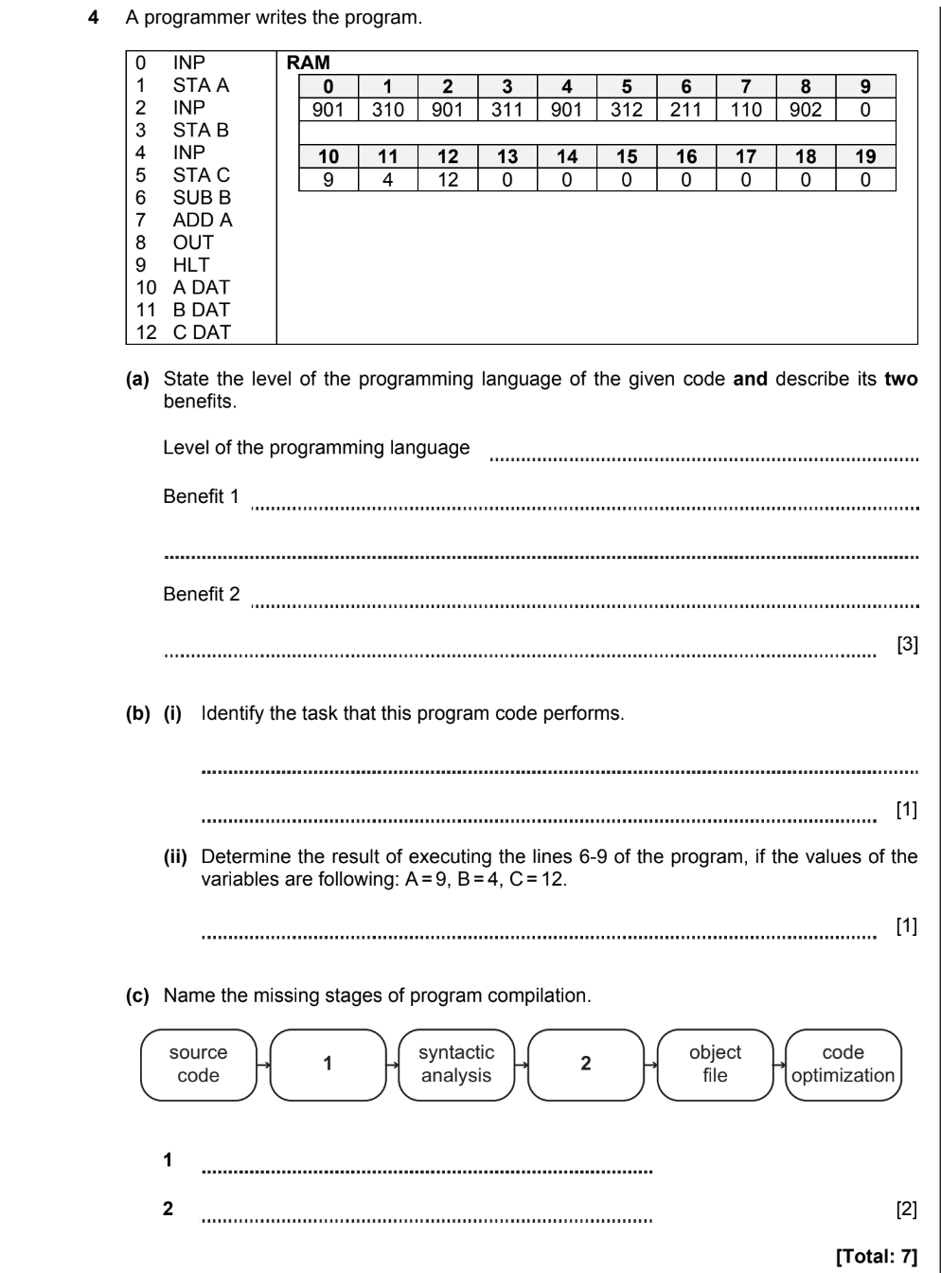
ANSWERS
Part | Answer | Mark | AO | Further Information
4a | Low level language  Benefits:  High speed of executing program.  Interacts with hardware directly. | 1  1  1  [3] | AO1 | Accept any reasonable answer
4b(i) | Returns the value of an expression C-B+A | [1] | AO2 | Accept either word description of task OR letter expression
4b(ii) | 17 | [1] | AO2
4c | 1. Lexical analysis  2. Code generation | 1  1  [2] | AO1
 | Total | 7

PROGRAMMING PARADIGMS. TRANSLATORS. 2020-2021 (PAPER 2)



ANSWERS
Part | Answer | Mark | AO | Further Information
9a | male (Talgat)  female (Gulmira)  parent (Arman, Talgat)  parent (Gulmira, Talgat) | 1  1  1  [max 3] | AO2
9b | The program code of the imperative language has its own strict sequence, while the program code of the declarative language does not have a strict sequence.  The imperative language answers the question "How to do?", And the declarative "What to do?"  Declarative programming simplifies the program and Imperative programming can increase the complexity of the program. | 1  1  1  [max 2] | AO1 | Accept other correct comparisons.
 | Total | 5

PROGRAMMING PARADIGMS. TRANSLATORS. 2021-2022 (PAPER 2)

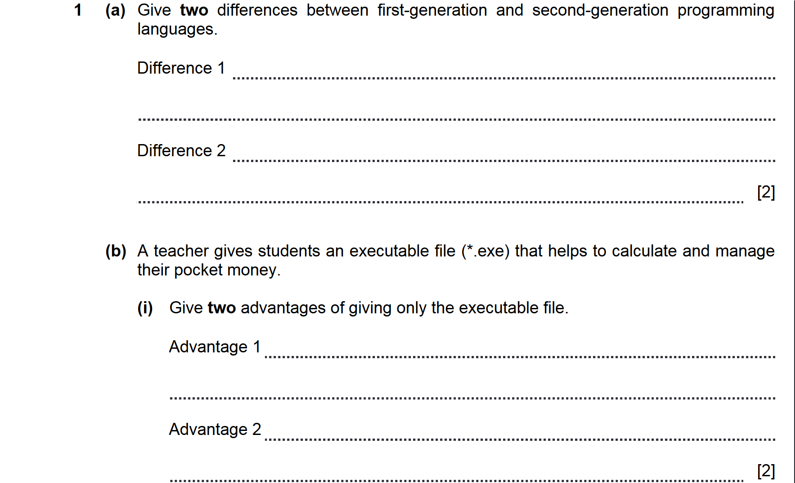
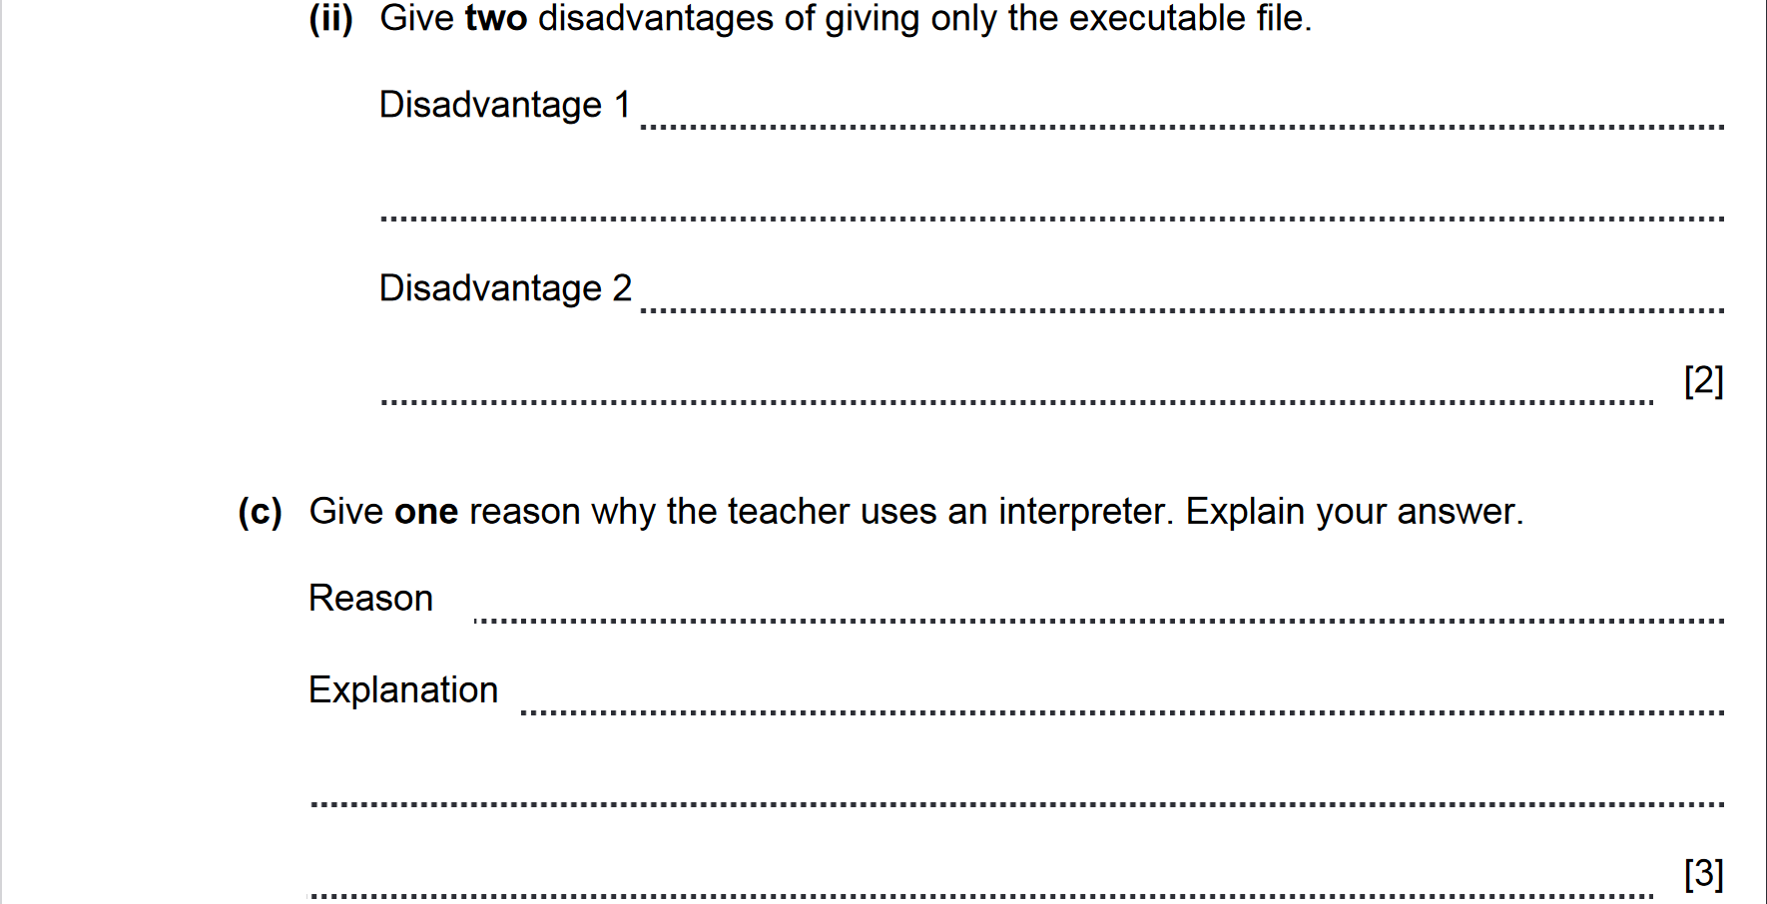
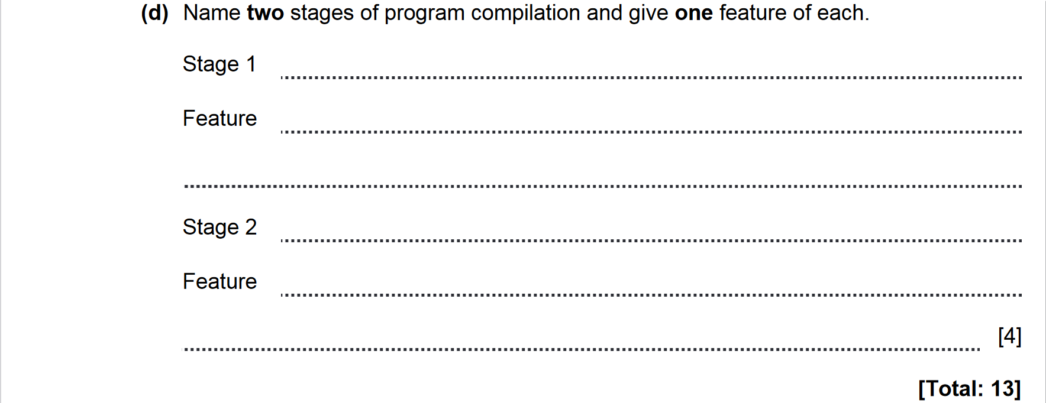

ANSWERS
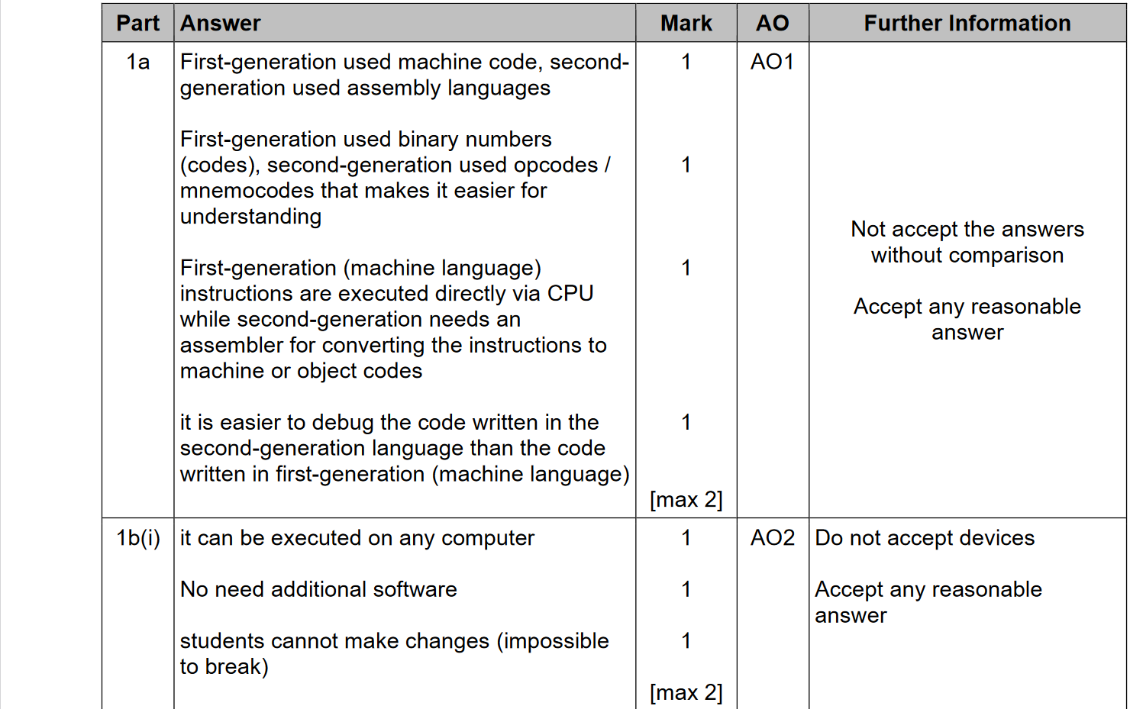
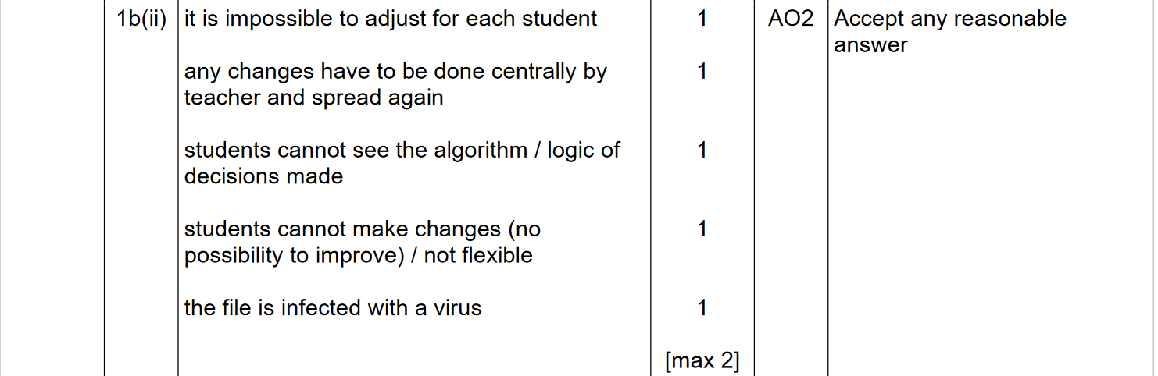
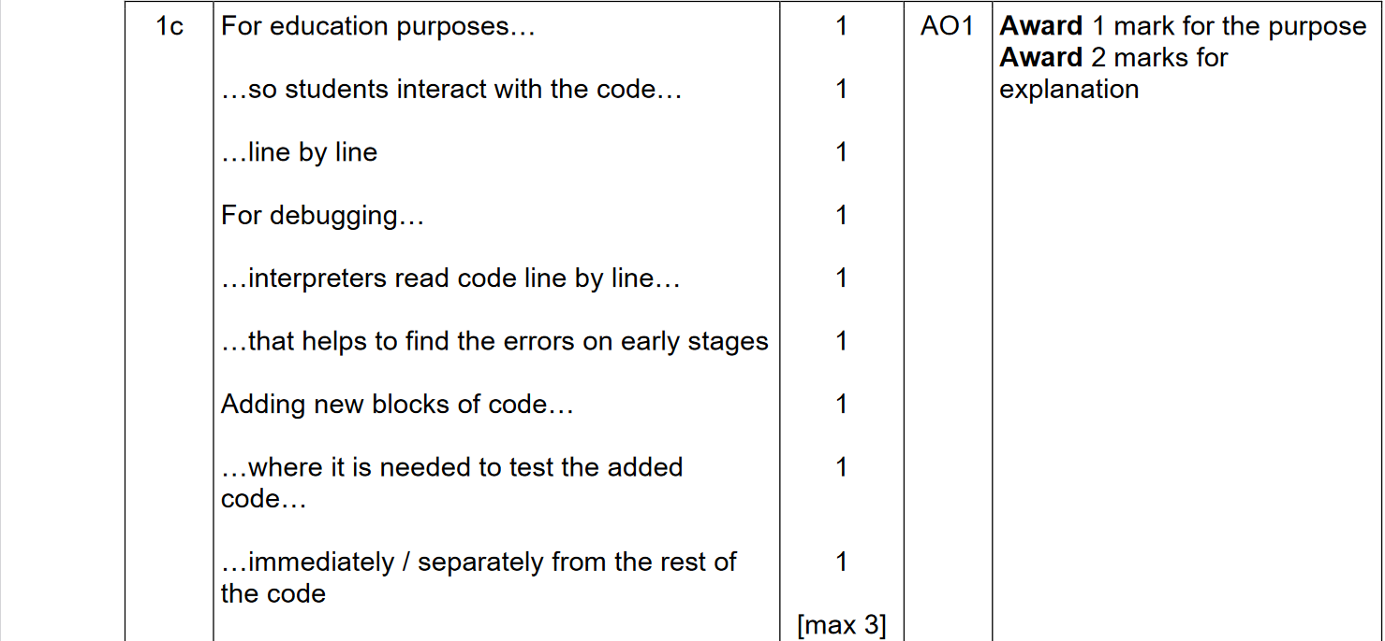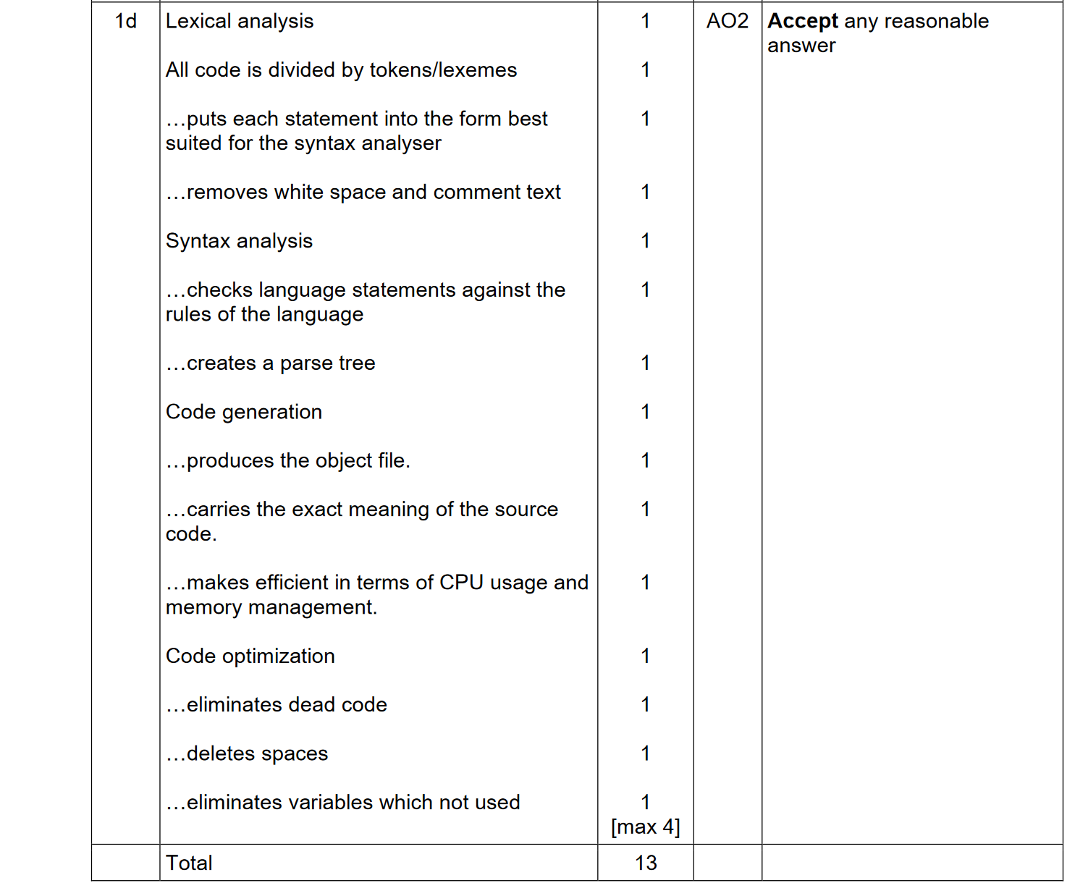
PROGRAMMING PARADIGMS. TRANSLATORS. 2021-2022 (PAPER 2)

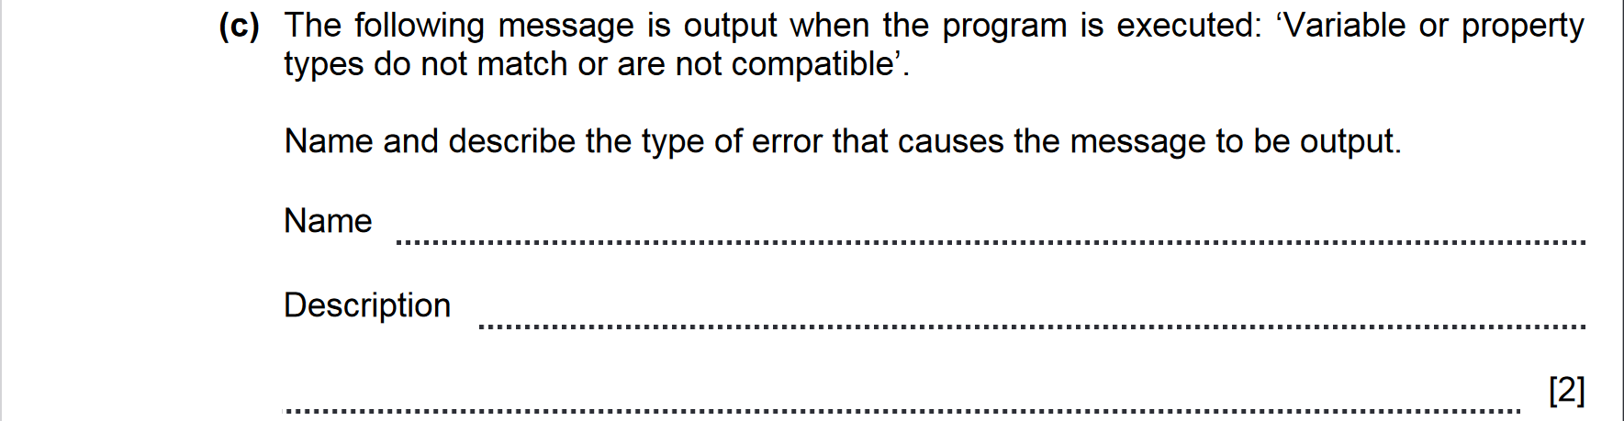

ANSWERS
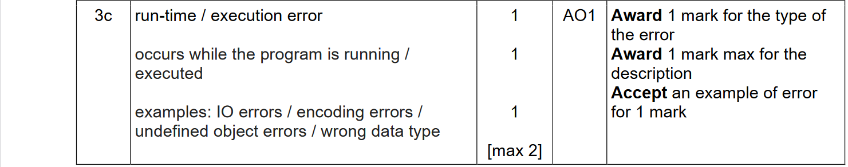

PROGRAMMING PARADIGMS. TRANSLATORS. 2021-2022 (PAPER 2)

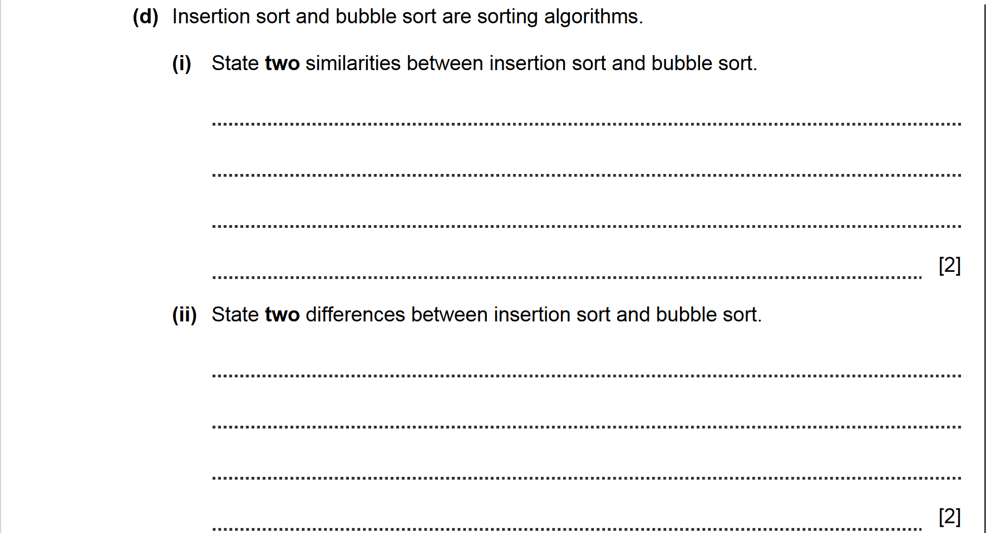

ANSWERS
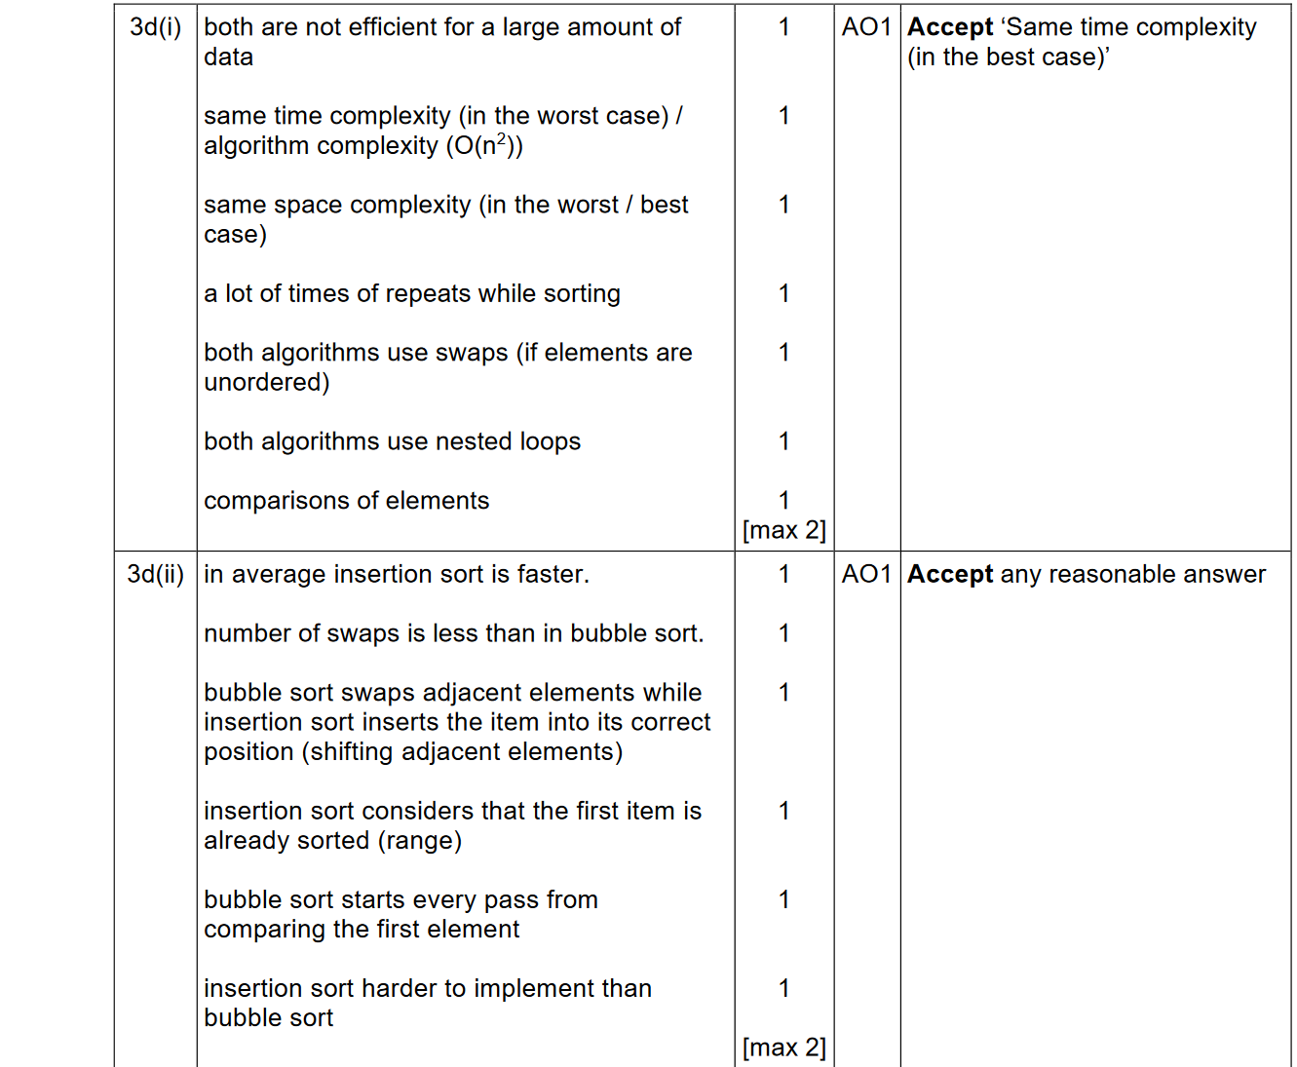

PROGRAMMING PARADIGMS. TRANSLATORS. 2021-2022 (PAPER 2)

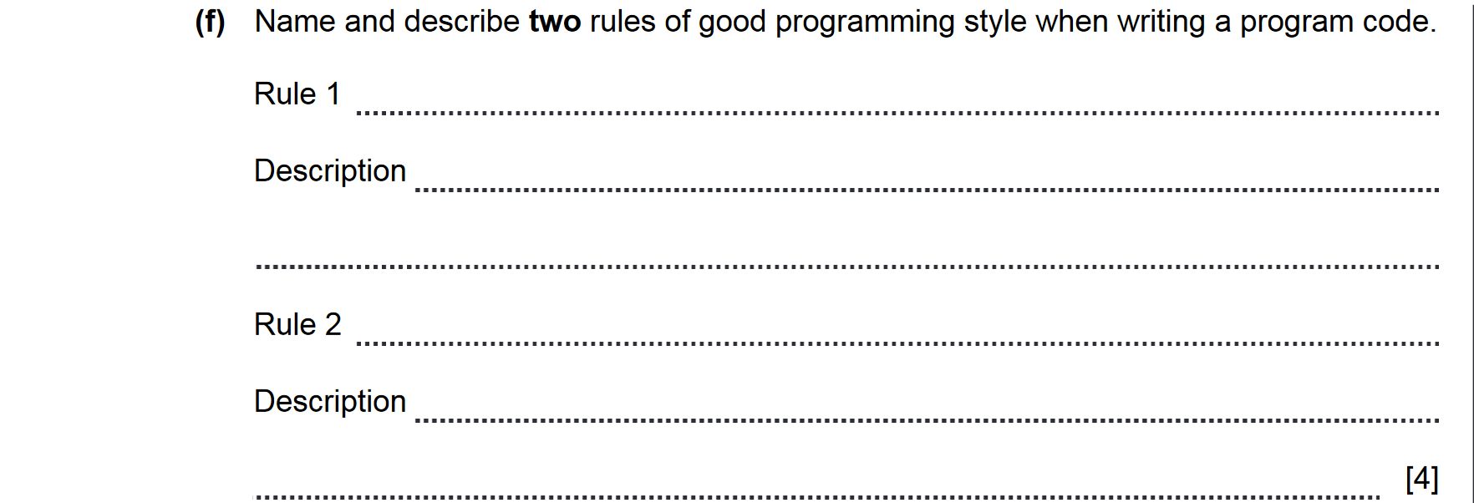

ANSWERS
3f | Readability  to be easily understood by colleagues  properly and consistently formatted and uses clear, meaningful names for functions and variables  decomposition of the software’s functionality into simple and specific functions  any tricky sections are clearly noted  Comments  explain clearly everything about a program which is not obvious to a peer programmer  block comments should go at the top of every source file  comments should precede functions with a description of the function’s purpose  inline comments should go near important lines of code within functions or with variables when they are initialized.  Meaningful identifier name  names given to classes, variables, and functions should be unambiguous and descriptive  the names x and y should only be used to describe coordinates  the names i, j, and k should only be used as variables in for loops  other one-letter names should be avoided  Indentation  within any bracketed block, all code is indented in one tab  each additional for, while, if, or switch structure introduces a new block which is indented  White Space  should be used consistently to improve readability  between functions  in the expressions  Function Usage  shortens program and improves readability  should perform only one task  Output  all the input and / or output data should be clearly labelled to make it understandable for users | 1  1  1  1  1  1  1  1  1  1  1  1  1  1  1  1  1  1  1  1  1  1  1  1  1  1  1 | AO1 | Award 2 marks for naming the rules  Award 2 marks for their explanation  [max 4]

