ALGORITHMS, DATA STRUCTURES, TRACE TABLES. 2013-2014 (PAPER 1)

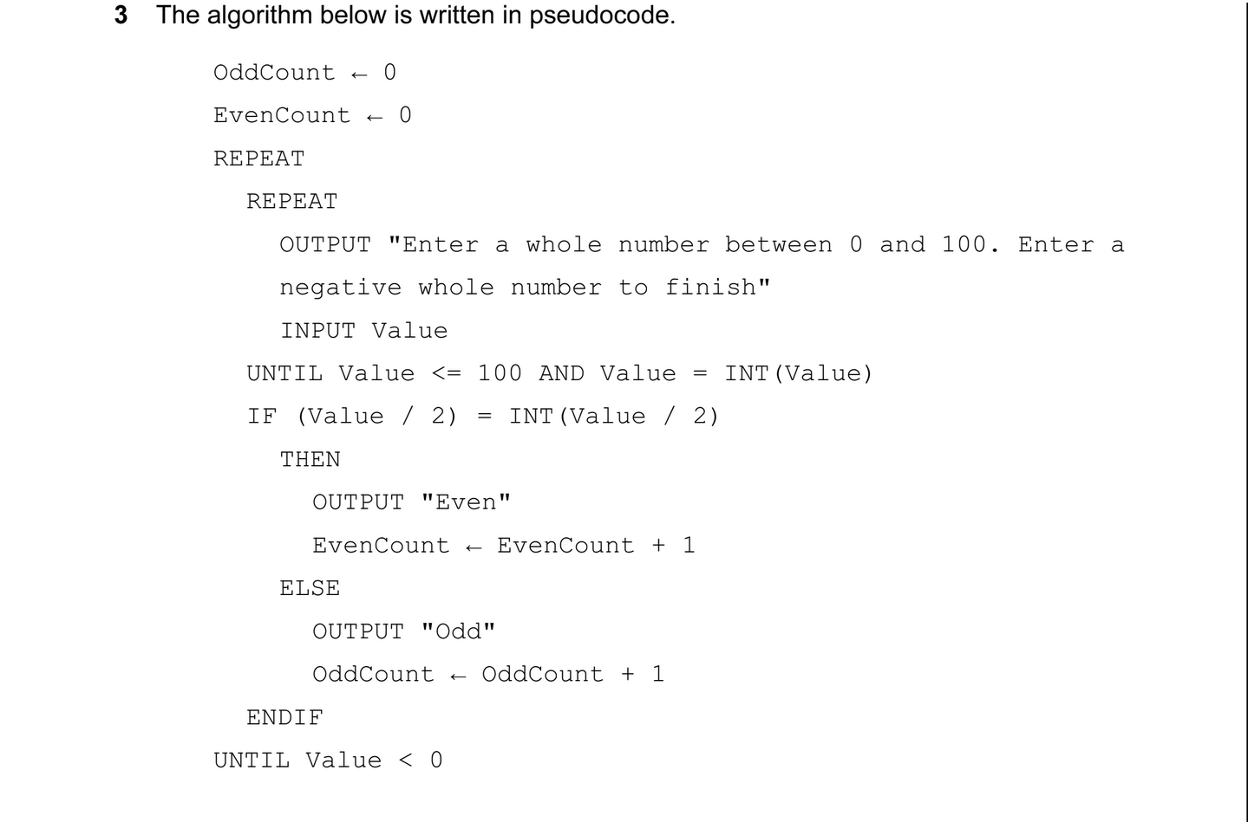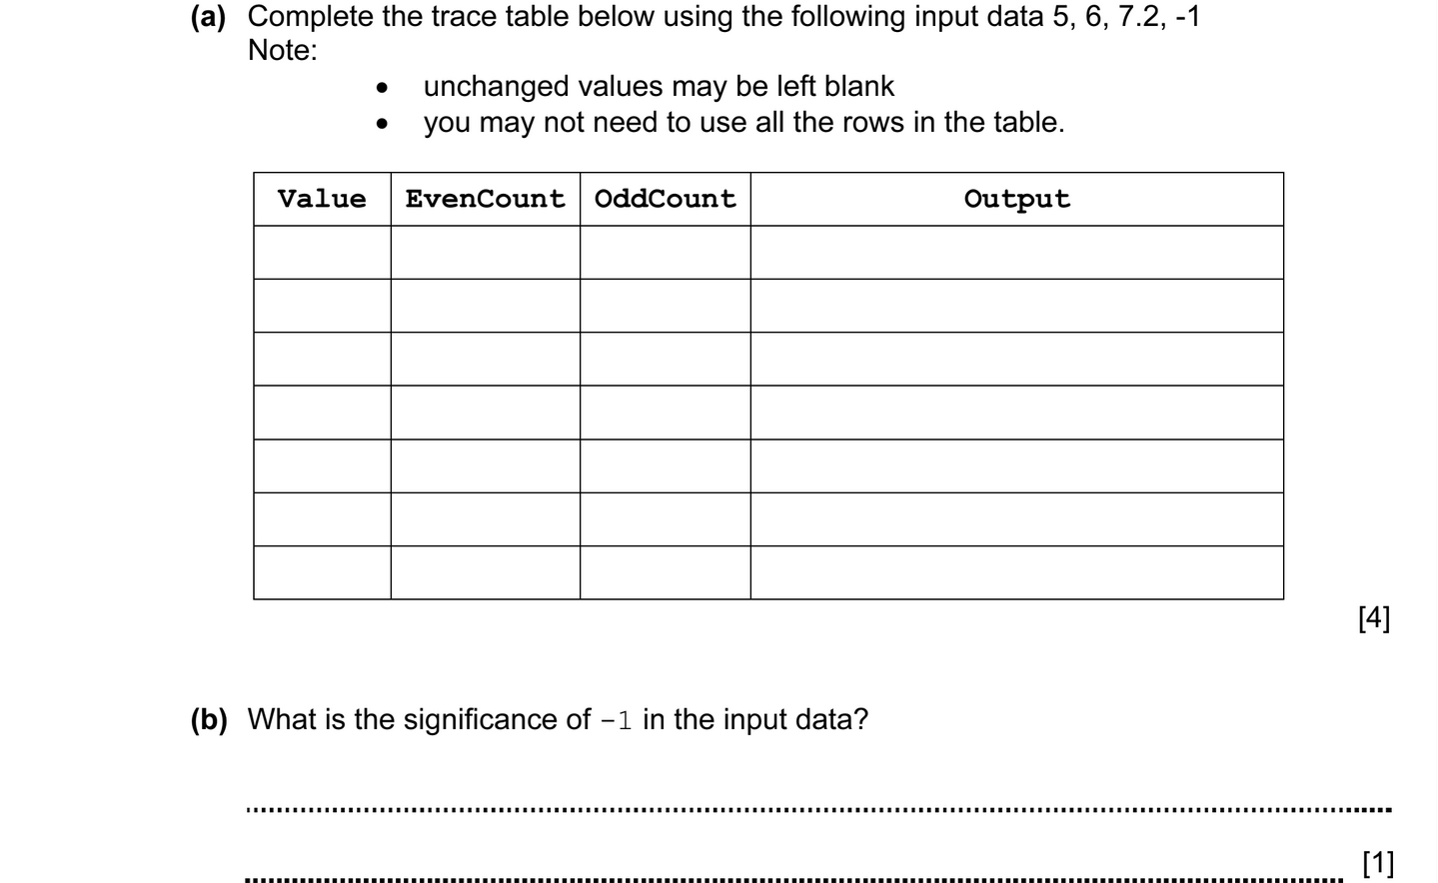
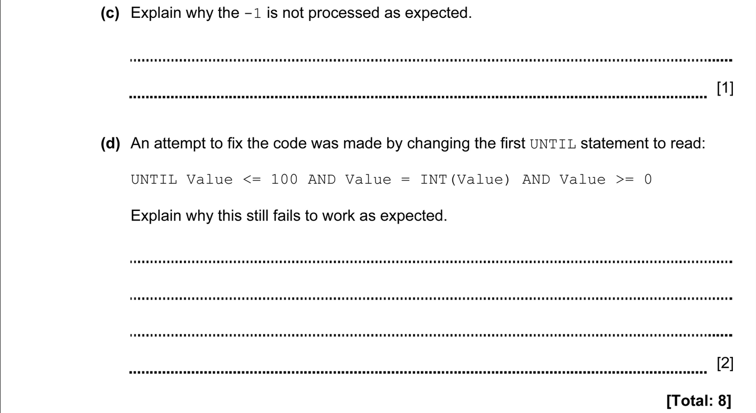

ANSWERS
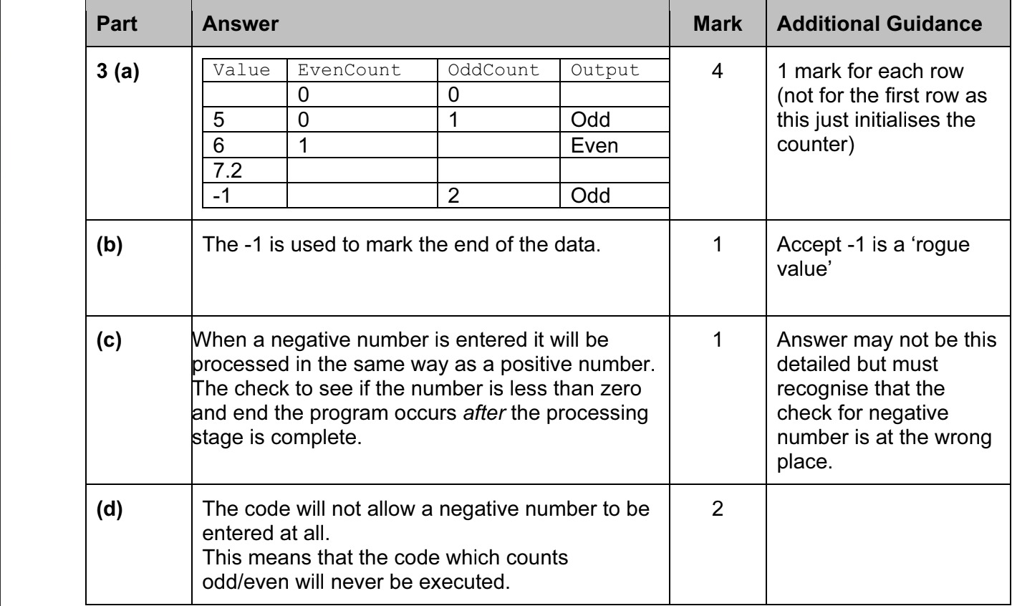

ALGORITHMS, DATA STRUCTURES, TRACE TABLES. 2013-2014 (PAPER 1)

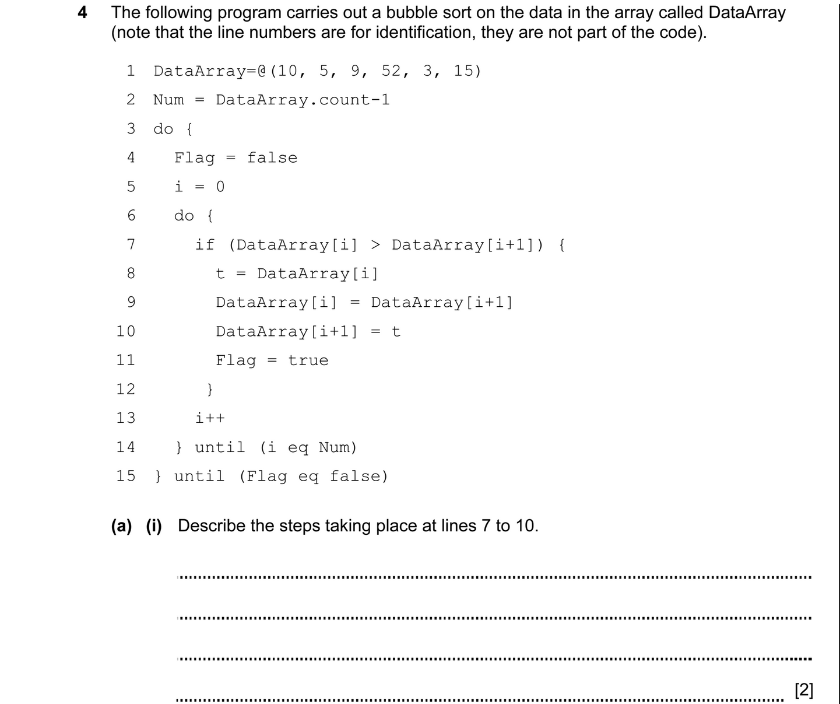
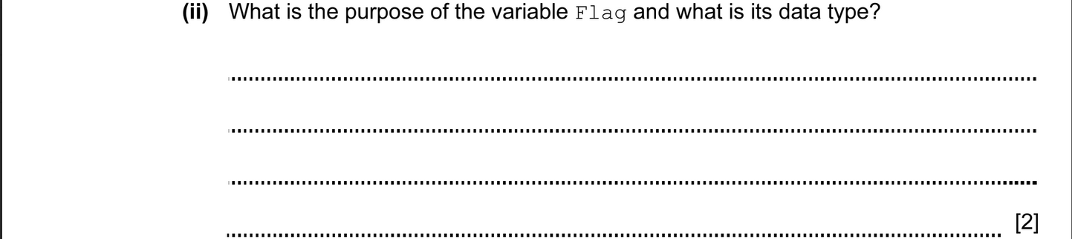

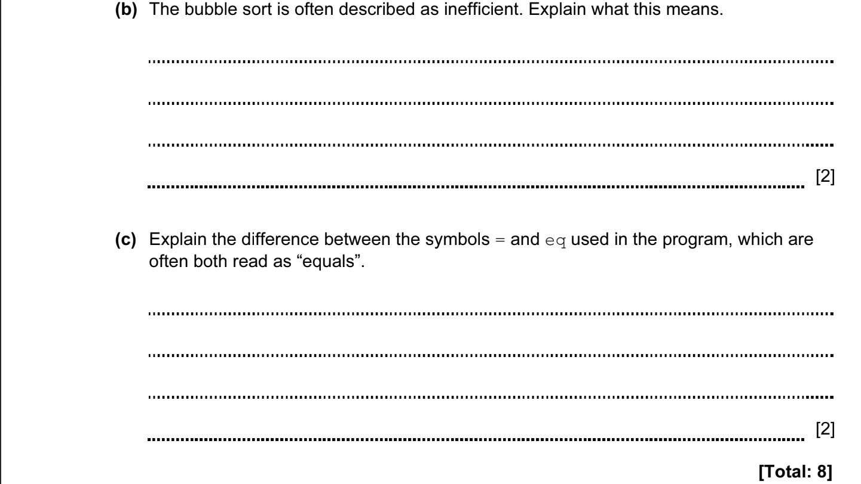

ANSWERS
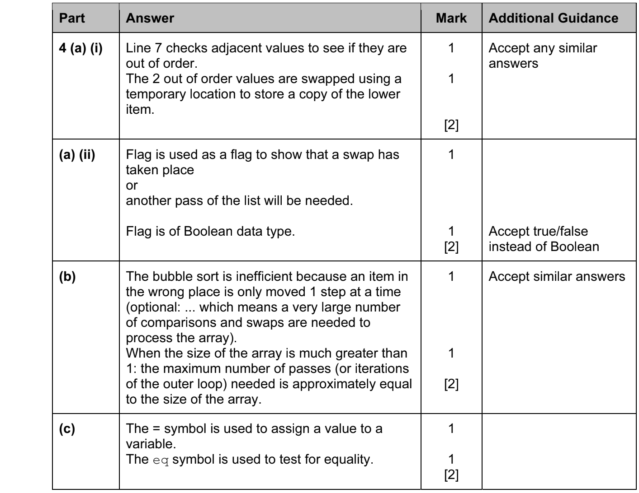

ALGORITHMS, DATA STRUCTURES, TRACE TABLES. 2013-2014 (PAPER 1)

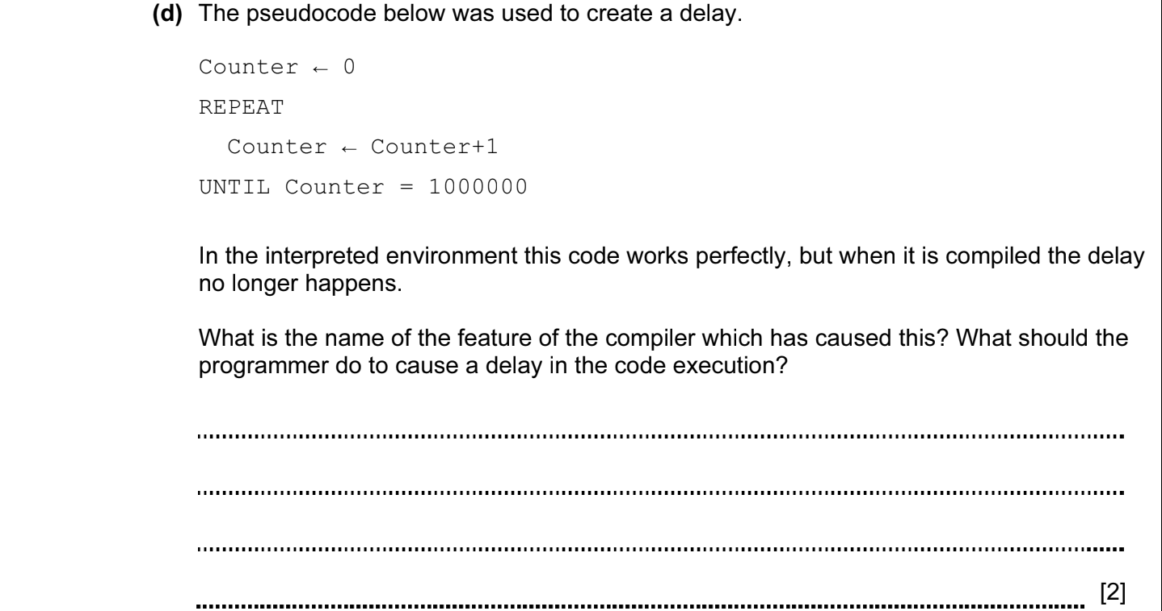

ANSWERS
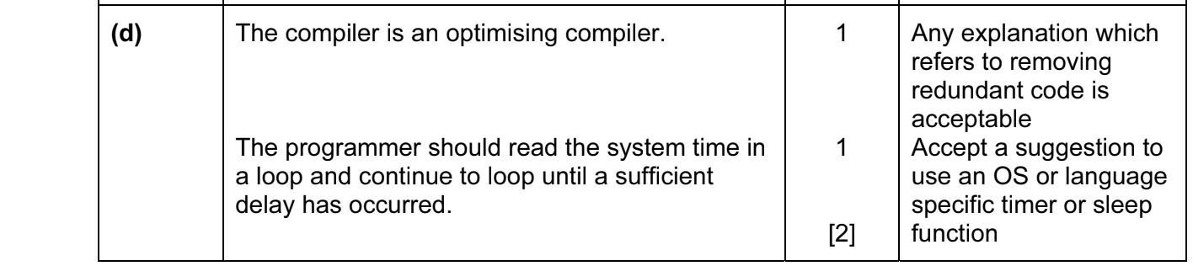

ALGORITHMS, DATA STRUCTURES, TRACE TABLES. 2013-2014 (PAPER 1)

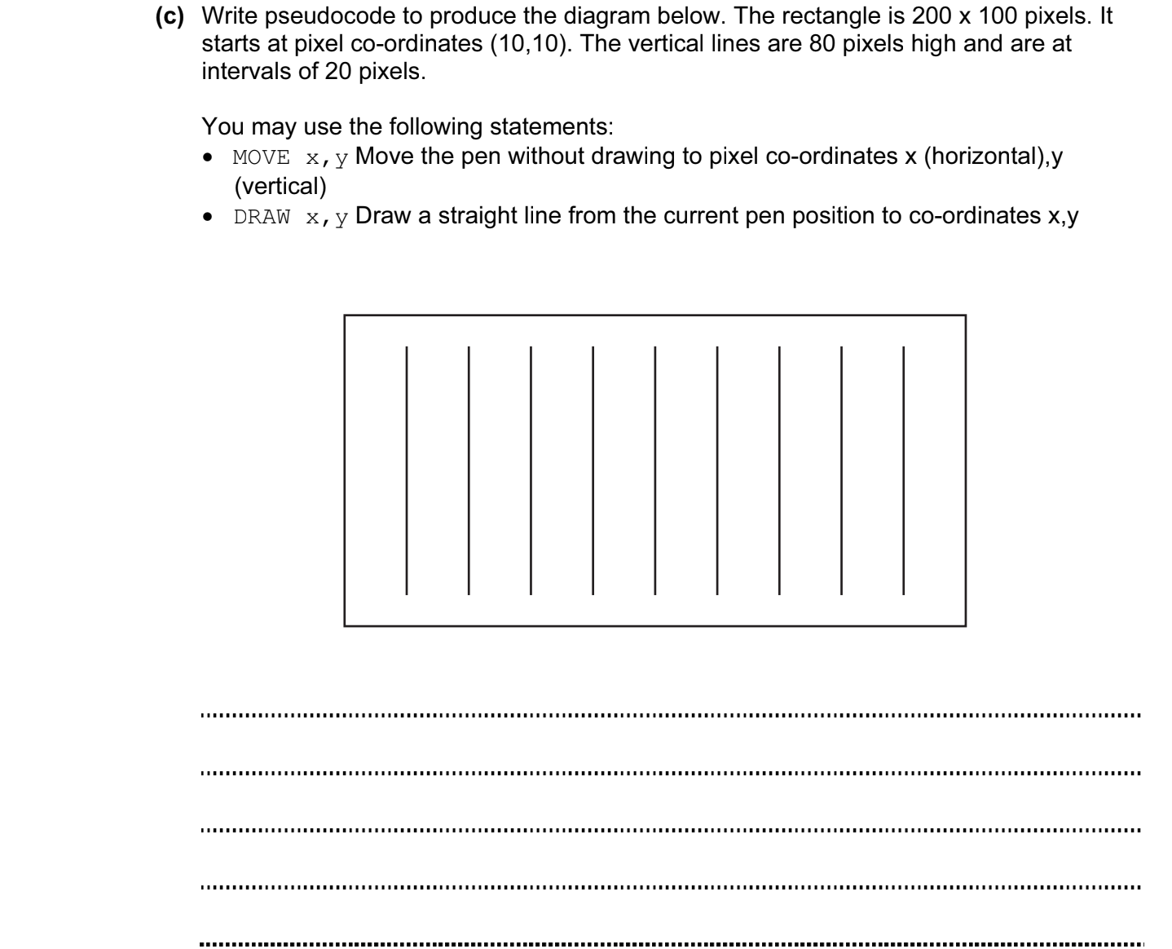
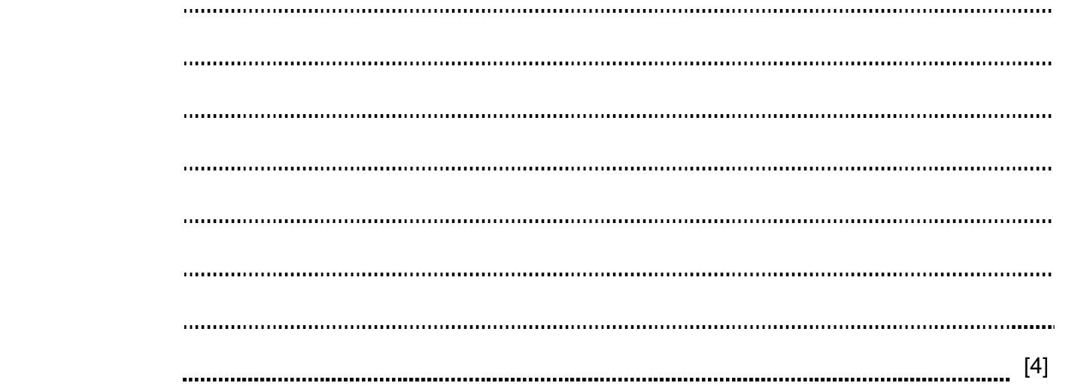

ANSWERS
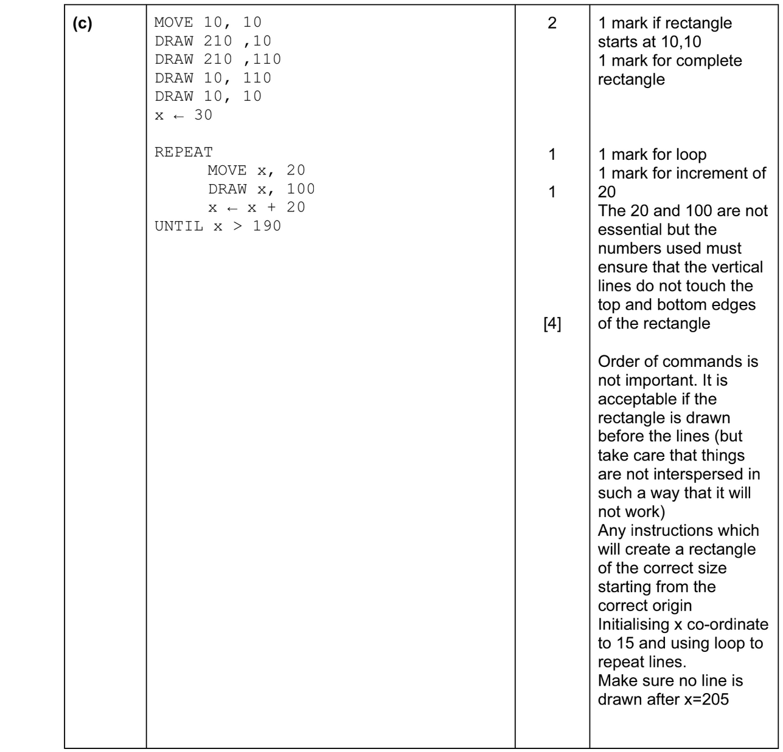

ALGORITHMS, DATA STRUCTURES, TRACE TABLES. 2013-2014 (PAPER 2)

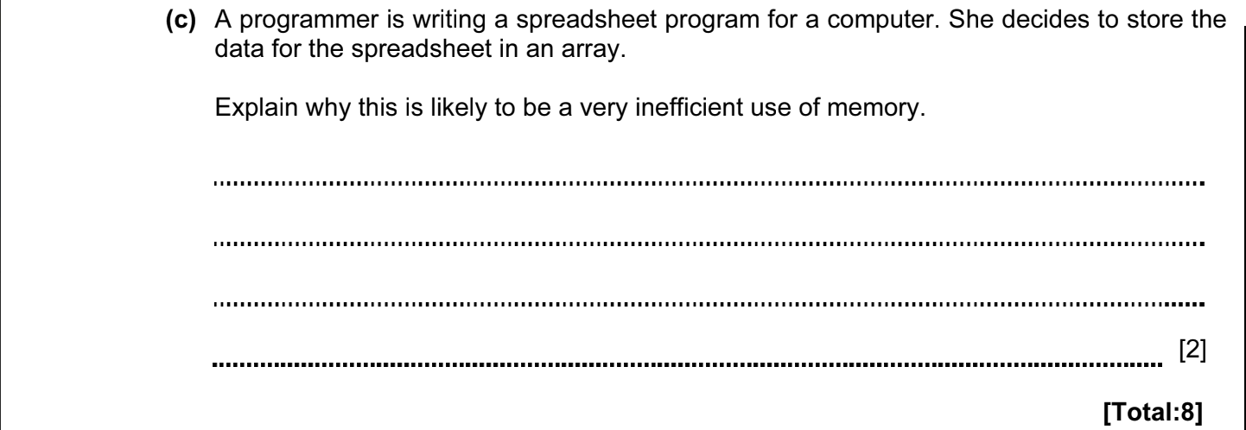

ANSWERS
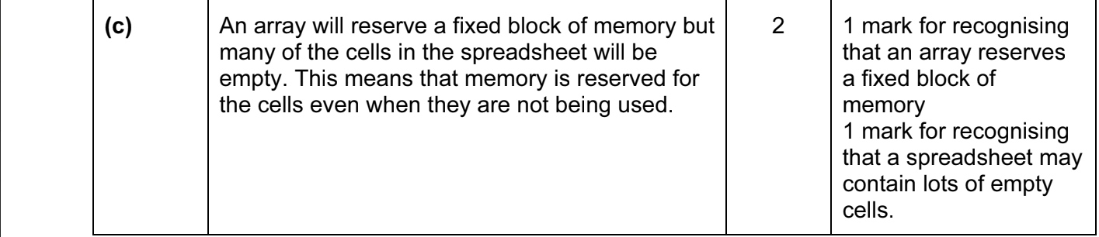

ALGORITHMS, DATA STRUCTURES, TRACE TABLES. 2014-2015 (PAPER 1)

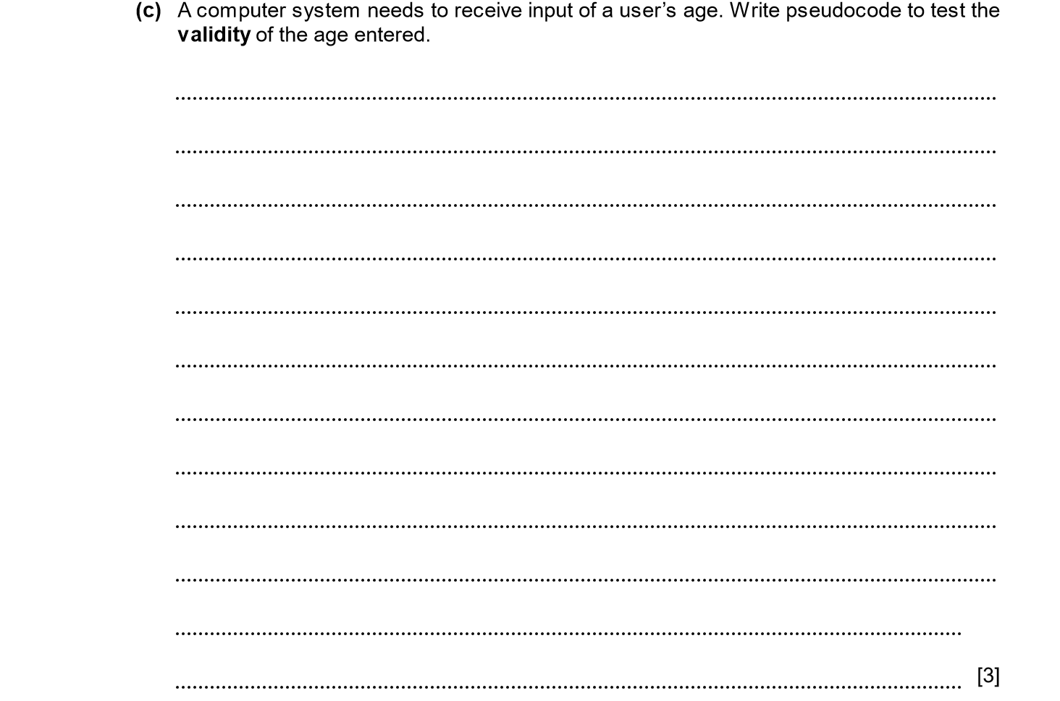

ANSWERS
(c) | REPEAT OUTPUT  “Please enter an age between 0 and 120”  INPUT(AGE > 0) AND (AGE < = 120)  // Rest of programme | 3 | 1 mark for checking entered number.  1 mark for rejecting negative ages.  1 mark for rejecting ages too high (limit need not be 120 but should be sensible).  Need not include loop (could just abort if age not entered sensibly).

ALGORITHMS, DATA STRUCTURES, TRACE TABLES. 2014-2015 (PAPER 2)

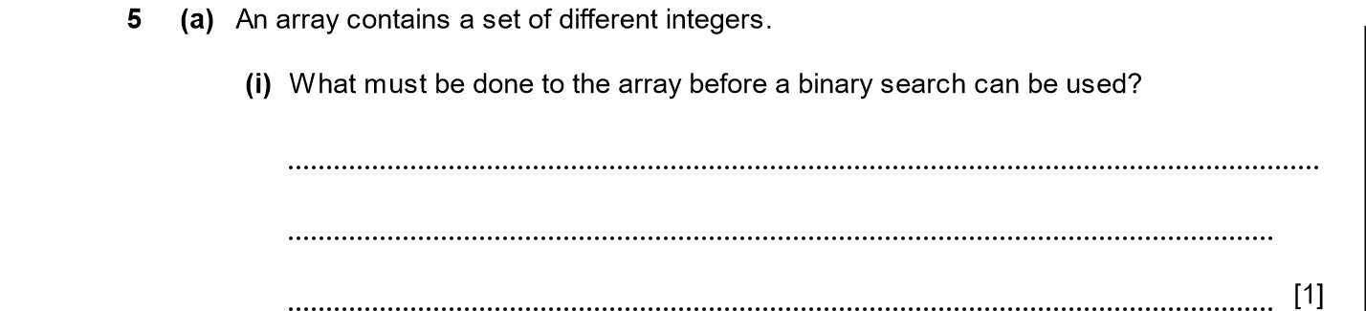
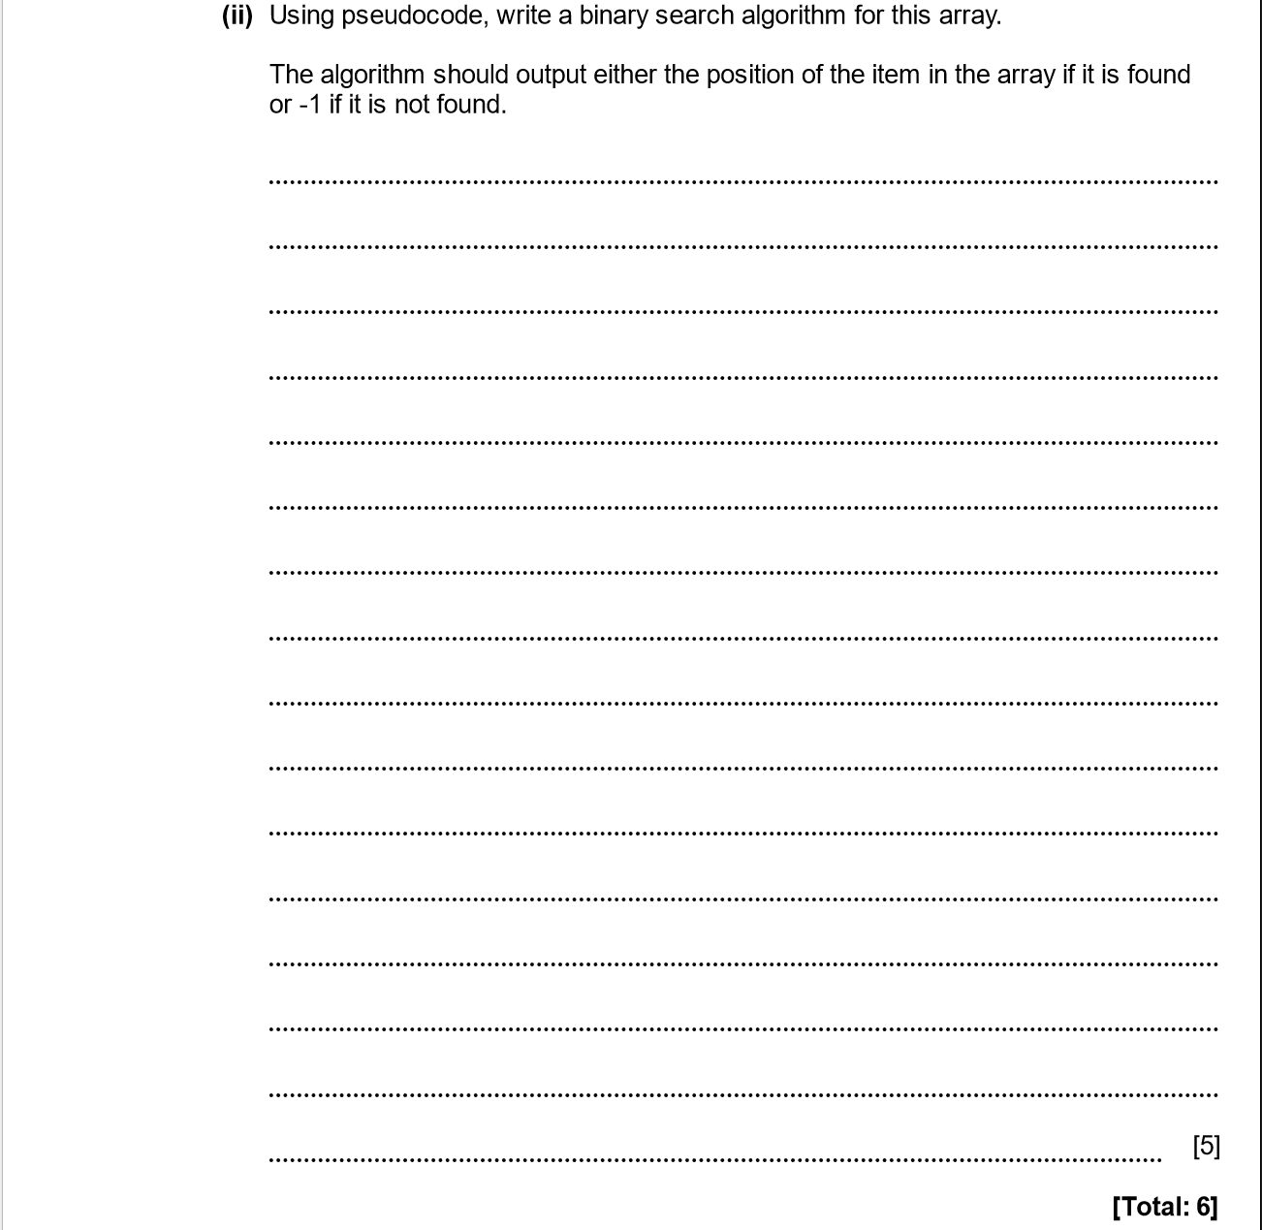

ANSWERS
Part | Answer | Mark | Additional Guidance
5 (a) (i) | Array must be sorted into numerical order. | 1 | Accept “sorted into order”.
(ii) | binary_search(array, item_to_find)  Low ← 1  High ← Size of(Array)  while (Low <= High)  Middle ← Low + (High – Low) /2  if array(Middle) = Item to find  display Middle  exit procedure  else if array(Middle) < Item_to_find  Low = Middle + 1  else  High = Middle -1  end while  display -1 | 5 | 1 mark for a reasonable loop (could be repeat / until, for next etc).  1 mark for finding mid-point inside loop.  1 mark for moving upper / lower bound appropriately.  1 mark for returning array index when found.  1 mark for returning -1 when not found.  Array can be zero based.
Total |  | 6

ALGORITHMS, DATA STRUCTURES, TRACE TABLES. 2014-2015 (PAPER 2)

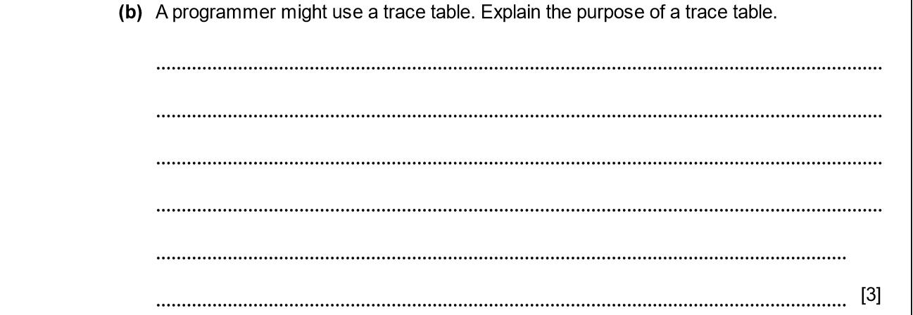

ANSWERS
(b) | Trace table is used to find the value of variables at each step in an algorithm / program.  It may be used when debugging a program.  The manually calculated value at each stage of the program is compared with that actually set in the program.  It may be used when designing a program by writing an algorithm.  A trace table is useful for designing or debugging a loop structure. | 1  1  1  1  1  [Max 3]

ALGORITHMS, DATA STRUCTURES, TRACE TABLES. 2015-2016 (PAPER 1)
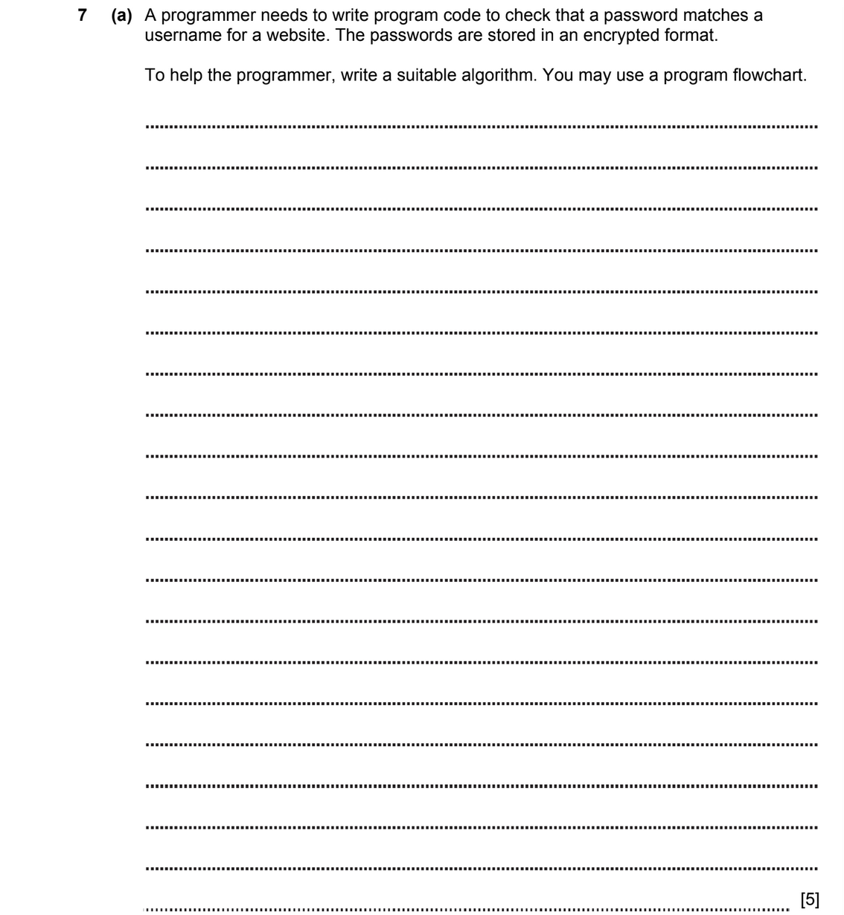

ANSWERS
(c) | If (isset($_POST[‘button’])  $user = $_POST[‘user’]  $pass = $_POST[‘pass’]  $sql = mysqli_query($connection, “SELECT * FROM usertable;”);  $data = mysqli_fetch_assoc($sql)  if $data[‘userpass’] == $pass and $data[‘username’] == $user {  echo “Success”  } else {  echo “Enter correct username or password”  } | 1  1  1
 | OR
 | User = “user”  Pass = “pass”  REPEAT OUTPUT  “Enter correct name and password”  Input (username != user)  and (password != pass) | 1  1  1

ALGORITHMS, DATA STRUCTURES, TRACE TABLES. 2015-2016 (PAPER 2)

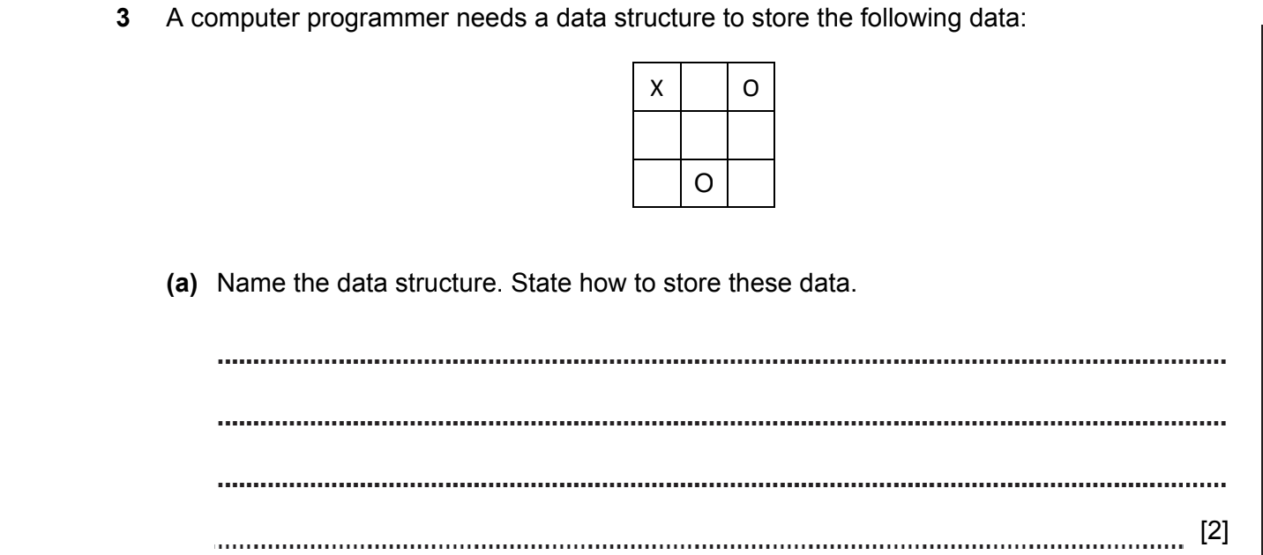
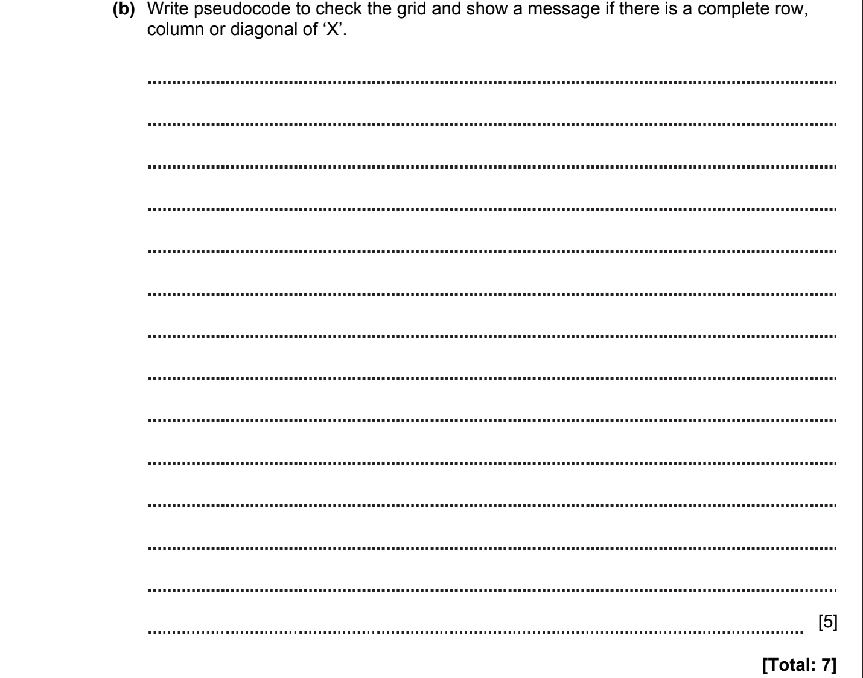

ANSWERS
Part | Answer | Mark | Additional Guidance
3 (a) | 2D array could be used.  Each element of the array would contain “X”, “O” or a null string. | 1  1 | Need to specify 2D array; need not state size or data type.  Exact words not critical but candidate must show that they recognises that each array element corresponds to one square in the grid.
(b) | DIM Grid[3, 3]  Complete ← FALSE  FOR Index ← 0 TO 2  // check vertical  IF Grid[Index, 0] = 'X' AND Grid[Index, 1] = 'X' AND Grid[Index, 2]= 'X' THEN Complete ← TRUE  // check horizontal  IF Grid[0, Index] = 'X' AND Grid[0, Index] = 'X' AND Grid[2, Index] = 'X' THEN Complete ← TRUE  NEXT  // check one diagonal  IF Grid[0, 0] = 'X' AND Grid[1, 1] = 'X' AND Grid[2, 2] = 'X' THEN Complete ← TRUE  // check other diagonal  IF Grid[0, 2] = 'X' AND Grid[1, 1] = 'X' AND Grid[2, 0] = 'X' THEN Complete ← TRUE  // display a message  IF Complete = TRUE THEN OUTPUT "Complete" | 1  1  1  1  1 | 1 mark for using a 2D array but it need not be declared as 3 x 3 or other size  1 mark for checking all 3 verticals  1 mark for checking all 3 horizontals  1 mark for checking both diagonals  1 mark for appropriate output  Do not need comments  Do not need to use loop  Variable names unimportant  Do not need to initialise Complete variable  Do not need to include comments  Accept comparison of numbers and indexes
Total |  | 7

ALGORITHMS, DATA STRUCTURES, TRACE TABLES. 2015-2016 (PAPER 2)

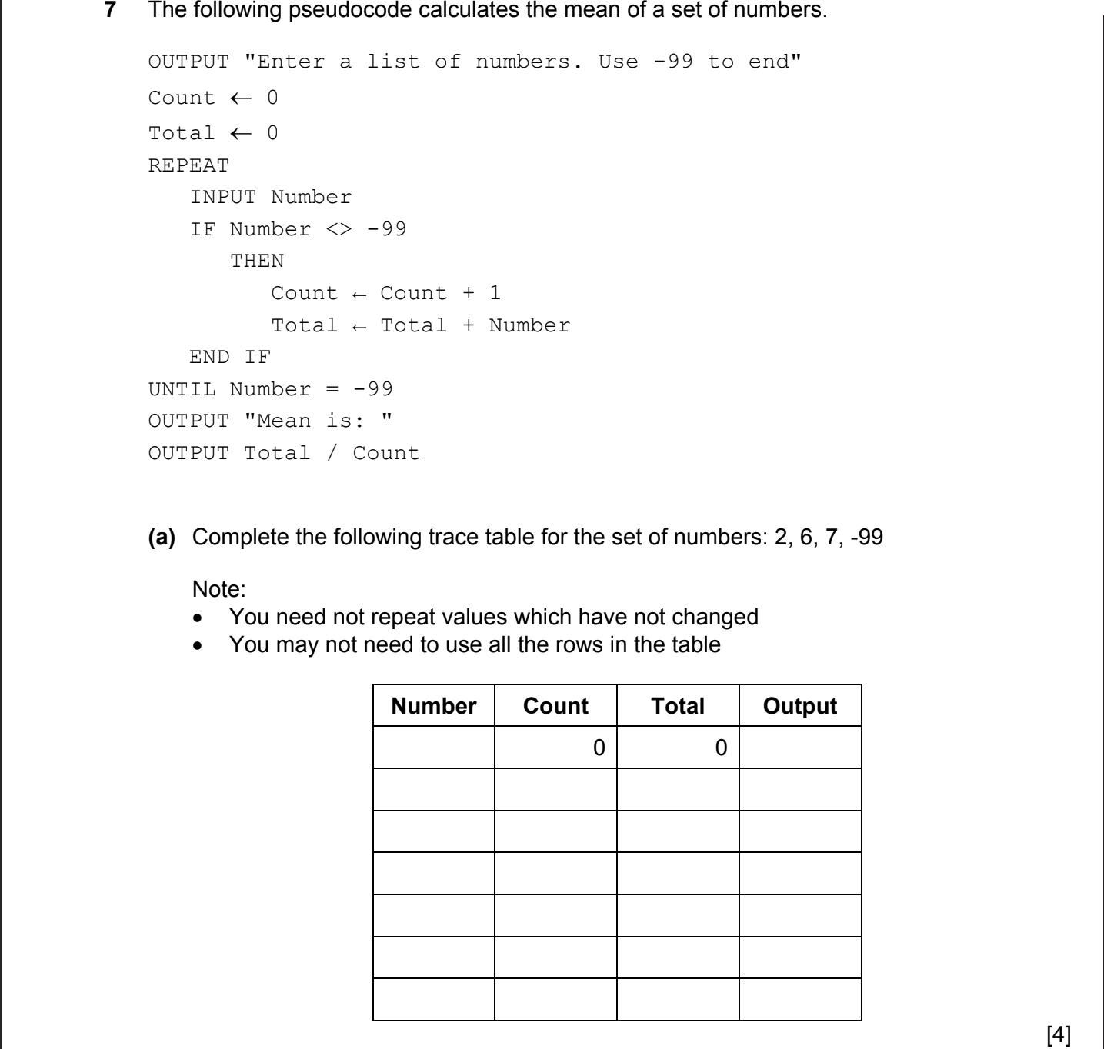
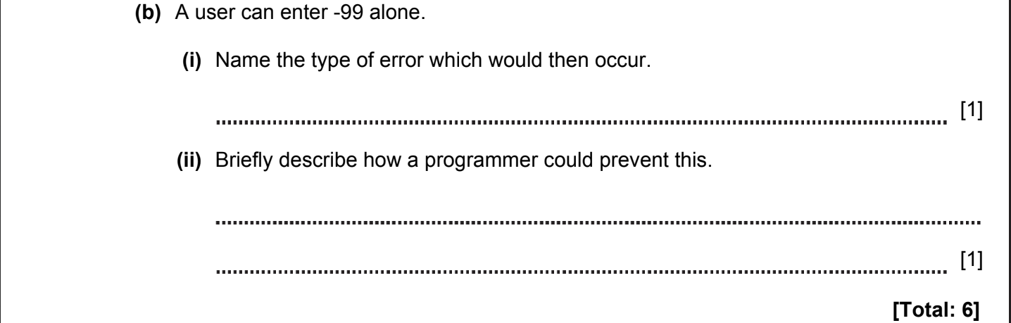

ANSWERS
Part | Answer | Mark | Additional Guidance
7 (a) |  | 1  1  1  1 | 1 mark for each correct row
  Number | Count | Total | Output
   | 0 | 0
  2 | 1 | 2
  6 | 2 | 8
  7 | 3 | 15
  -99 | 3 | 15 | Mean is: 5
(b) (i) | Runtime error  divide by zero error  Arithmentic overflow error  Logic error | 1  1  1  1  [max 1] | Any correct name for 1 mark
(ii) | Incorporate a check to make sure that at least 1 valid number has been entered.  Check that Count is not zero before doing division. | 1  1  [max 1] | 1 mark for any valid description
Total |  | 6

ALGORITHMS, DATA STRUCTURES, TRACE TABLES. 2016-2017 (PAPER 2)


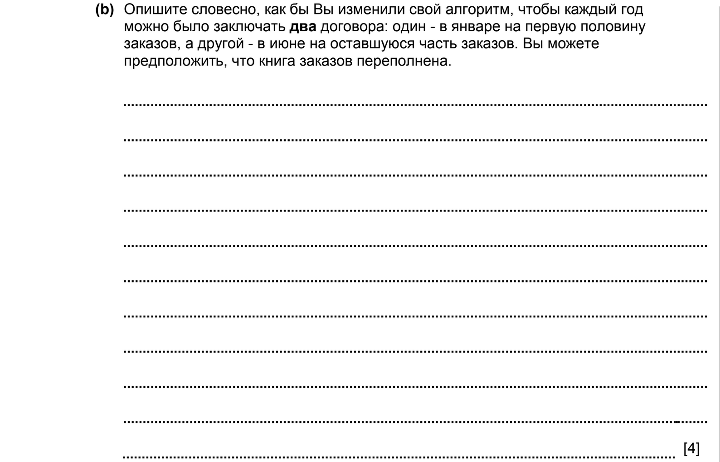

ANSWERS
Part |  |  | Answer | Mark | Additional Guidance
4 | (a) |  | Initialise Small, Medium and Large to zero (1)  Search all 50 orders using a counter for the array index (1)  Inside loop  If SR[index] = True (1)  check Size[index] for small etc. (1)  update appropriate variable (1)  After loop  output Small, Medium and Large (1) | Max 6 | Must be a flowchart.  Many correct answers can be mapped to these points
 | (b) |  | Split the index counter (1)  1 to 25 and 26 to 50 (1)  Provide two sets of output (1)  One for the January order and one for the June order (1) | Max 4
 | (c) |  | Initialise variable to store number of brown horses to zero (1) e.g. BrownNo = 0  Loop 50 times using a counter for the array index (1)  Inside loop  If Colour[index] = ˈBrownˈ then (1)  Update variable (1)  output week number or date (1)  After loop  Output message and variable (1) e.g. Print(ˈNumber of brown horses is ˈ, BrownNo) | Max 6
Total |  |  |  | 16

ALGORITHMS, DATA STRUCTURES, TRACE TABLES. 2016-2017 (PAPER 2)

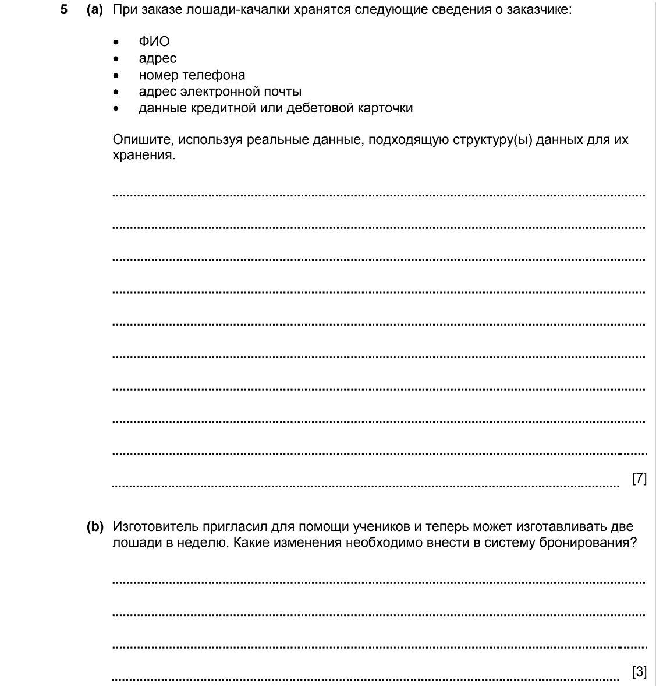

ANSWERS
Part |  |  | Answer | Mark | Additional Guidance
5 | (a) |  | Array 2 D (1) string (1)  or Record(1) text fields (1)  or 5 Lists/Arrays(1) text/string(1)  Name - Tanya Bergova (1)  Address - Batyr Street 11/1, Astana (1)  Telephone number - +7 (7172) 475 489 (1)  Email address - Tanya@XYZ.kz (1)  Credit/debit card - 1234 1234 1234 1234 (1) | Max 7 | 1 mark for data structure(s), 1 mark for data type and 1 mark per item for example.  These must be realistic in order to gain the marks  Many correct samples, example only given
 | (b) |  | Order number from 1 to 100 (1)  the week number needs to be calculated (1)  e.g. WeekNo = Div((order number + 1)/2) (1) | Max 3
Total |  |  |  | 10

ALGORITHMS, DATA STRUCTURES, TRACE TABLES. 2017-2018 (PAPER 2)

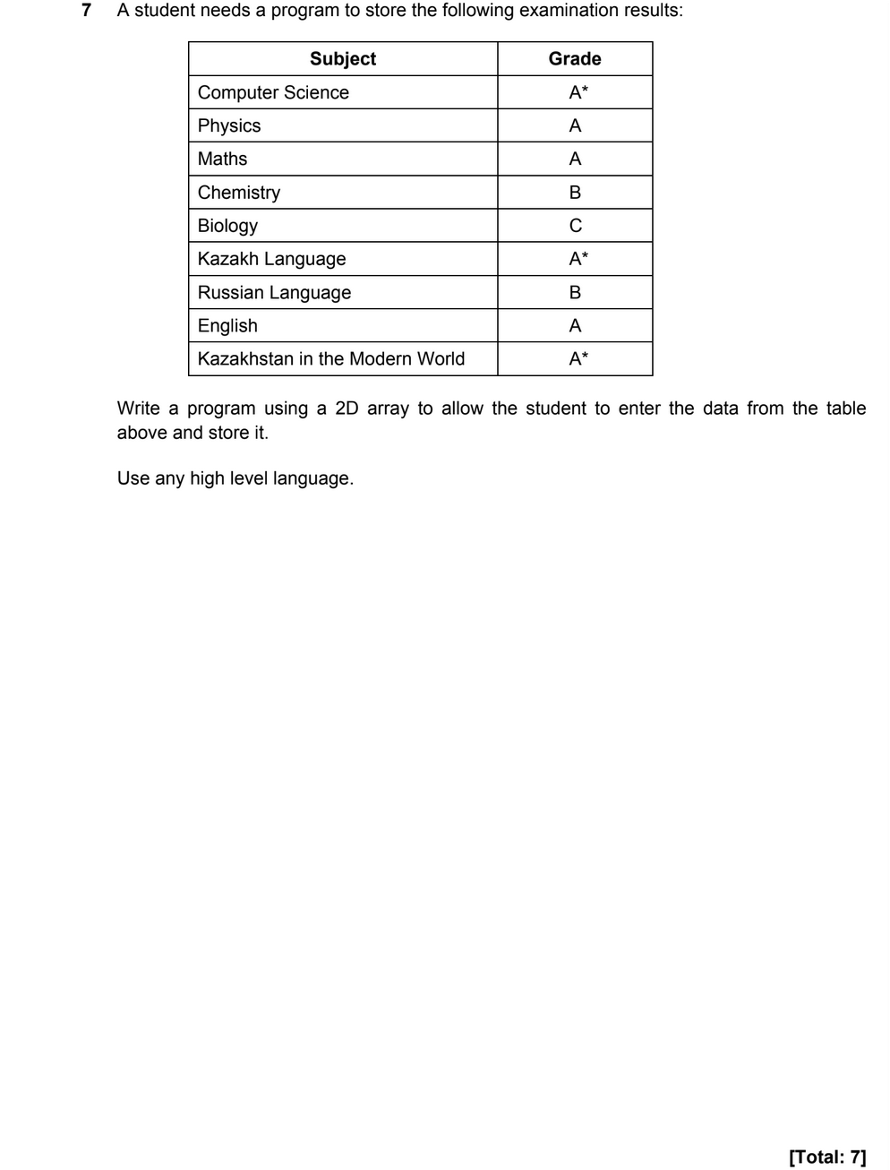
ANSWERS
Part | Answer | Mark | AO | Further Information
7 | Valid loop | 1 | AO2 | Allow using pseudo code  Allow errors in syntax
7 | Correct range (e.g. 1 to 9) | 1 | AO2 | Allow using pseudo code  Allow errors in syntax
7 | 2D array | 1 | AO2 | Allow using pseudo code  Allow errors in syntax
7 | Loop variable used to index array | 1 | AO2 | Allow using pseudo code  Allow errors in syntax
7 | Data input | 1 | AO2 | Allow using pseudo code  Allow errors in syntax
7 | Subject data goes into appropriate cell | 1 | AO2 | Allow using pseudo code  Allow errors in syntax
7 | Correct grade goes into matching cell | 1 | AO2 | Allow using pseudo code  Allow errors in syntax
Total |  | 7

ALGORITHMS, DATA STRUCTURES, TRACE TABLES. 2018-2019 (PAPER 1)

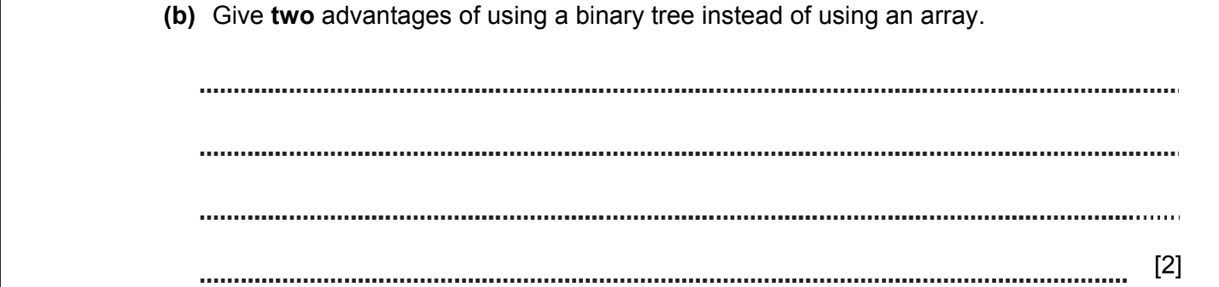

ANSWERS
2(b) | Elements in the tree are inserted in sorted order.  Fast searching of the elements is possible.  Binary search can be used.  The size of the tree is not fixed. | 1  1  1  1  [Max 2] | AO2 | Do not accept answer regarding efficiency without an explanation.

ALGORITHMS, DATA STRUCTURES, TRACE TABLES. 2020-2021 (PAPER 2)

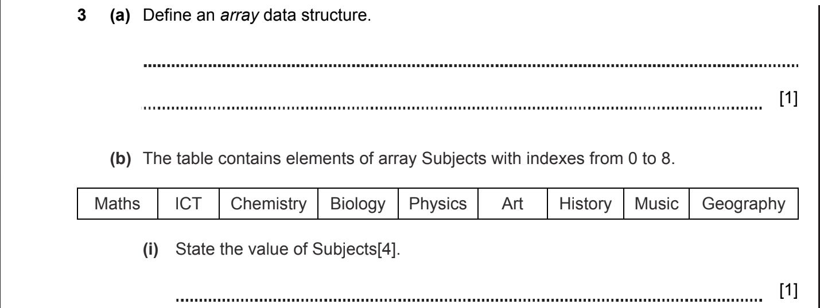
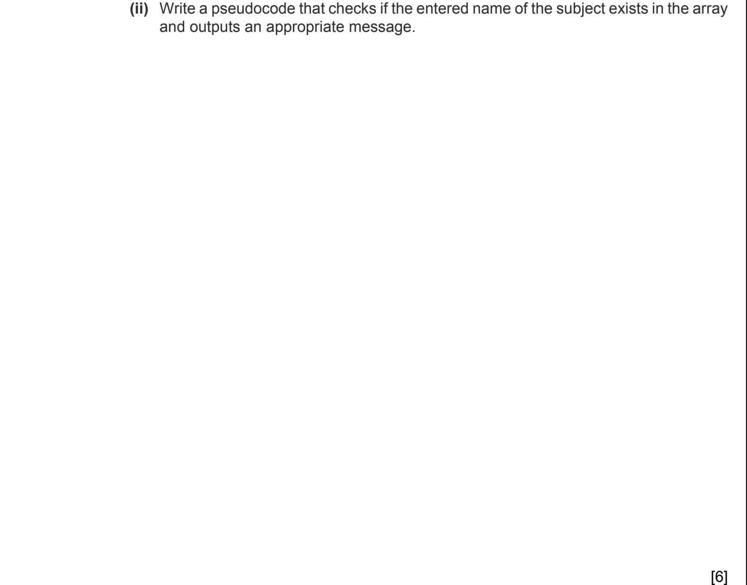
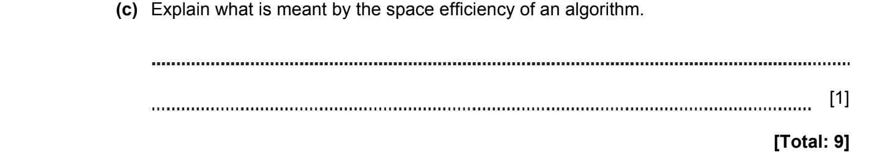

ANSWERS
Part | Answer | Mark | AO | Further Information
3a | An array is a data structure that contains a group of related elements of the same type that are united by the same name. | [1] | AO1 | Accept any reasonable answer
3b(i) | Physics | [1] | AO2
3b(ii) | Input name of subject.  Using loop correctly.  Comparing array elements with search key.  Exit the loop if the search key exists.  Check the search result.  Output a message about search results. | 1  1  1  1  1  1  [6] | AO2 | Accept any reasonable answer  Pseudocode solution example:  INPUT subjectName  i = 0  Found = False  WHILE i<=8  IF Subjects[i] = subjectName THEN  FOUND = True  BREAK  END IF  i = i+1  END WHILE  If FOUND=True THEN OUTPUT “exists”  ELSE OUTPUT “Doesn’t exist”
3с | The amount of memory required by an algorithm to run | [1]
 | Total | 9

ALGORITHMS, DATA STRUCTURES, TRACE TABLES. 2021-2022 (PAPER 1)

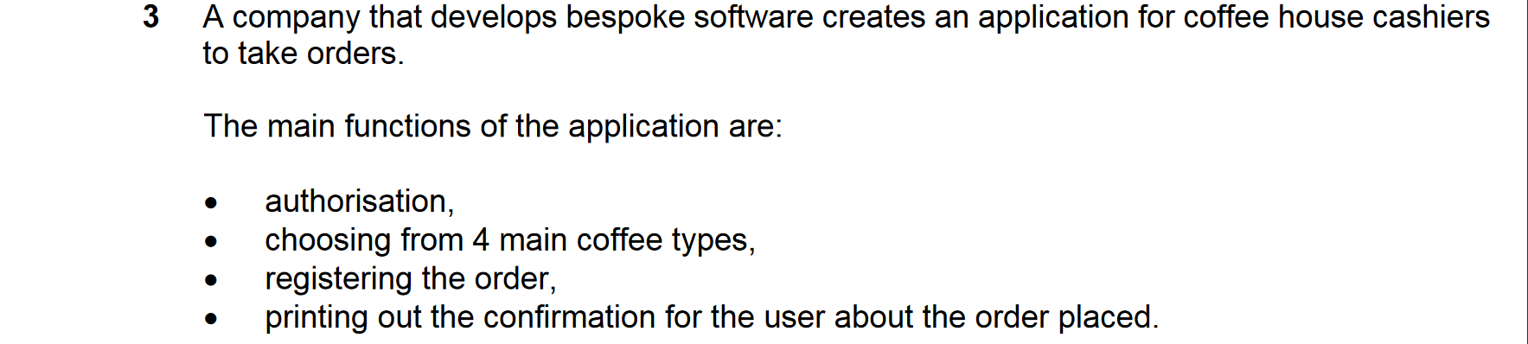

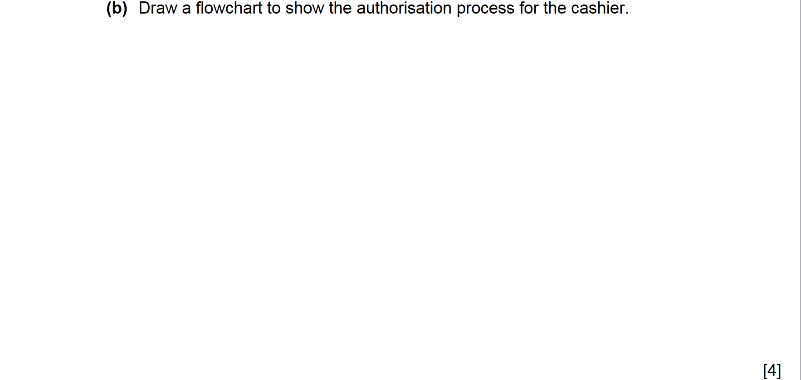

ANSWERS
3b | input login and password  correct check of entered data  returning in case of error / output error message  success / enter to app / access to the system  Example: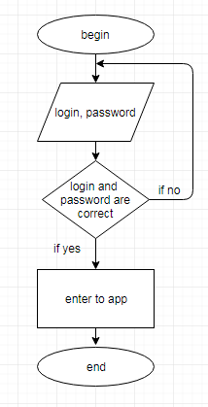 | 1  1  1  1  [4] | AO2

ALGORITHMS, DATA STRUCTURES, TRACE TABLES. 2021-2022 (PAPER 2)

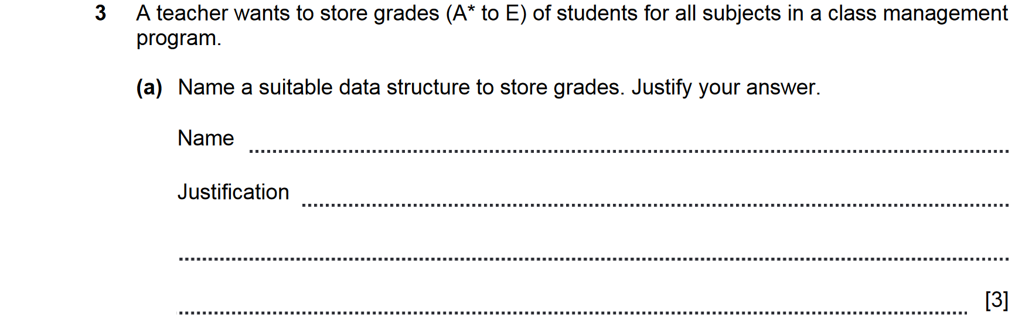

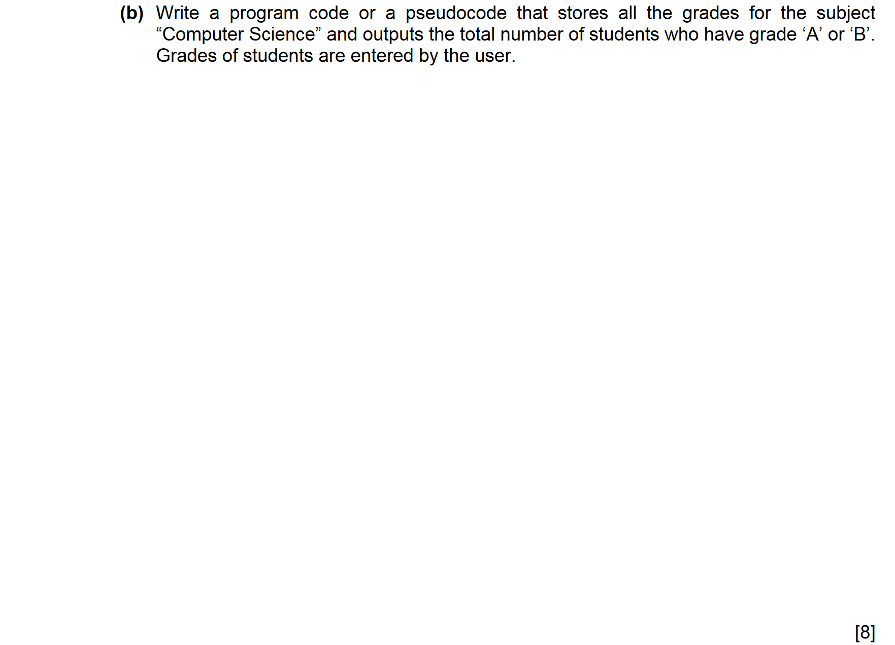

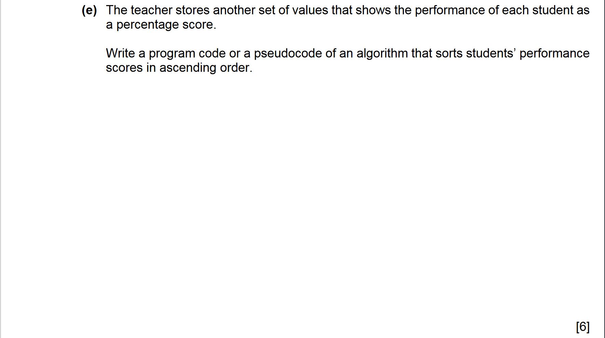

ANSWERS
Part | Answer | Mark | AO | Further Information
3a | Array  all grades are the same data type  for each student separate array  one name for all elements  each row / column will be given for a student and column / row for a subject  all elements have own index | 1  1  1  1  1  1  [max 3] | AO2 | Accept answers that students give beyond Subject programme, e.g. lists, with appropriate justification
3b | input / initialise number of students  loop  input grades into each element  use of array 1D / 2D  counter initialised  using IF  OR in condition / nested IF  output | 1  1  1  1  1  1  1  1  [8] | AO3 | Do not award marks for fragments that are implemented incorrectly  Examples:  INPUT NumberOfStudents  StudentsWithAB ← 0  FOR i ← 0 TO NumberOfStudents-1  INPUT CSGrades[i]  IF (CSGrades[i]=’A’) OR (CSGrades[i]=’B’) THEN StudentsWithAB++  ENDFOR  OUTPUT StudentsWithAB  OR  INPUT NumberOfStudents  StudentsWithAB ← 0  i ← 0  WHILE i < NumberOfStudents DO  INPUT CSGrades[i]  i++  IF (CSGrades[i]=’A’) OR (CSGrades[i]=’B’) THEN StudentsWithAB++  ENDWHILE  OUTPUT StudentsWithAB
3e | outer loop / one loop  inner loop  ranges of outer loop  ranges of inner loop  elements’ comparison  swap | 1  1  1  1  1  1  [6] | AO3 | Accept solution in any sorting algorithm  Accept pseudocode  Examples:  for i from 1 to N  for j from 0 to N-1  if a[j]>a[j+1]  temp a[j]  a[j] a[j + 1]  a[j + 1] temp  OR  for i from 1 to N  key a[i]  j i - 1  while j >= 0 and a[j] > key  a[j+1] a[j]  j j - 1  a[j+1] key  Accept swap(element1, element2) instead of three-line swap action

