SDLC. ANALYSIS, DESIGN, IMPLEMENTATION, TESTING 2013-2014 (PAPER 2)

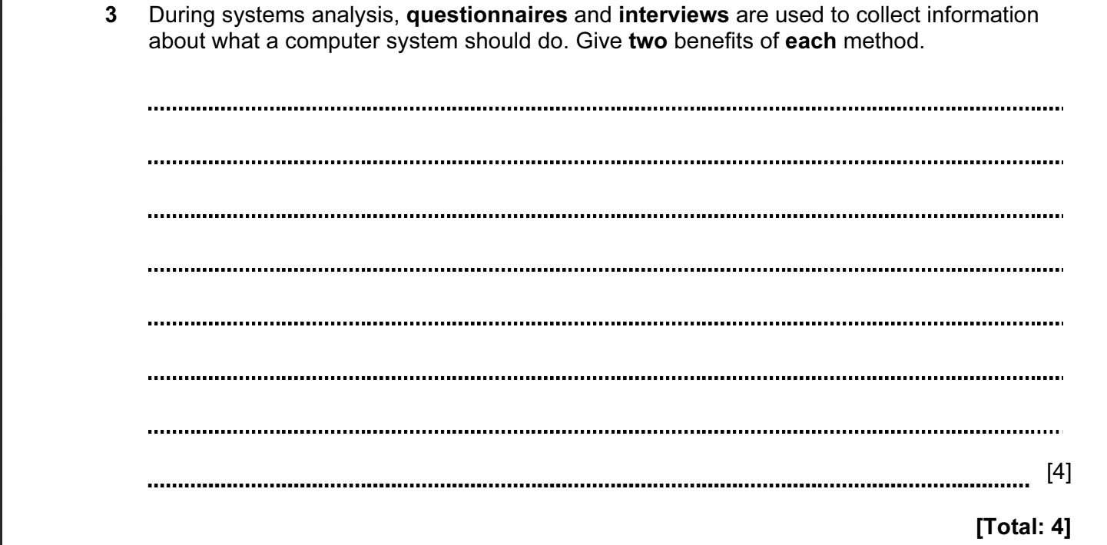

ANSWERS
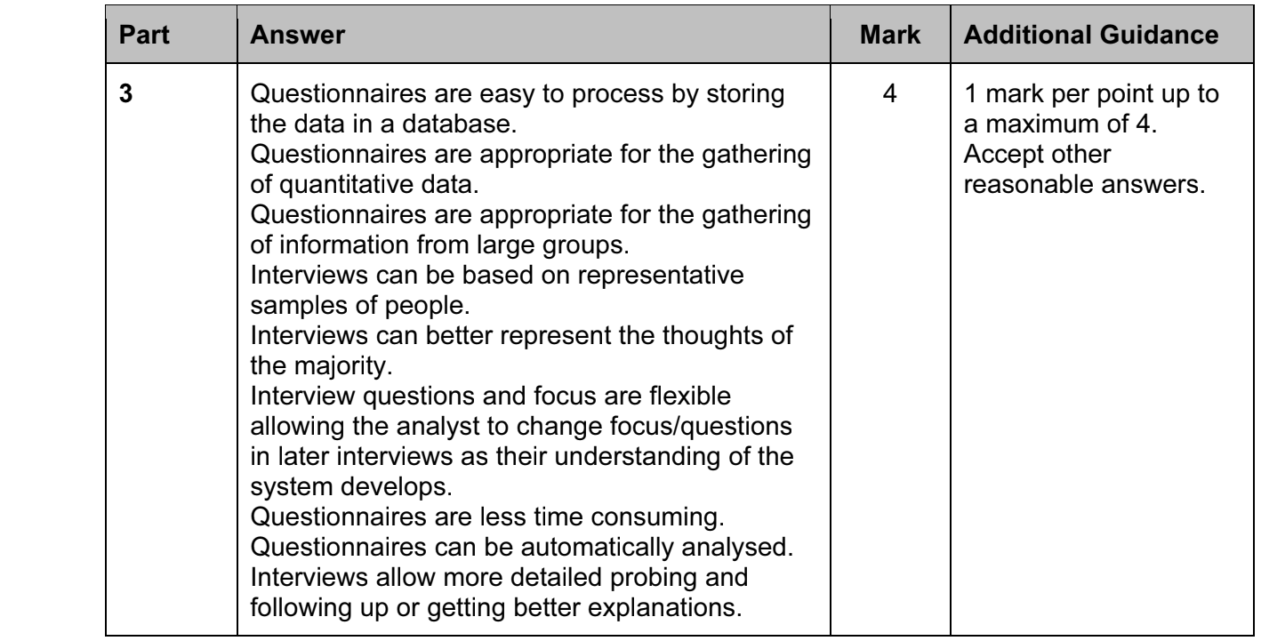

SDLC. ANALYSIS, DESIGN, IMPLEMENTATION, TESTING 2014-2015 (PAPER 1)\

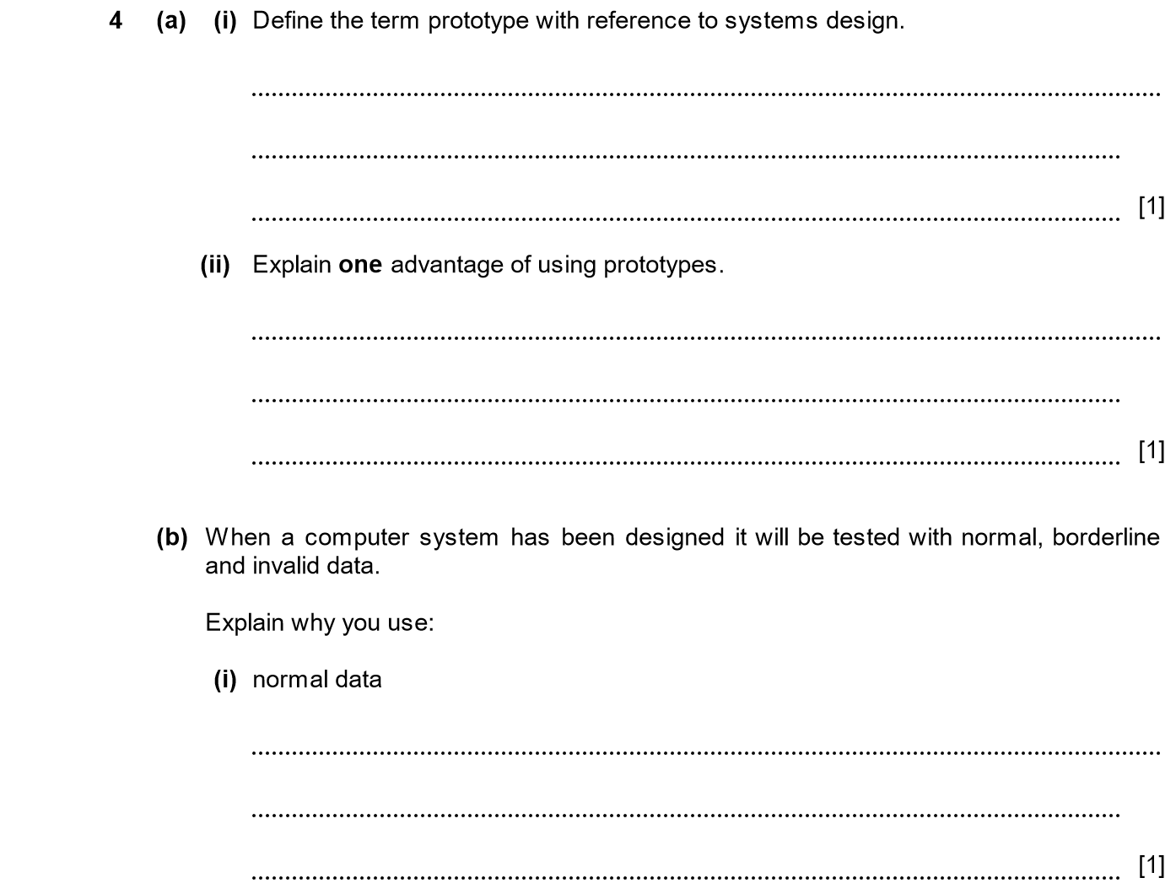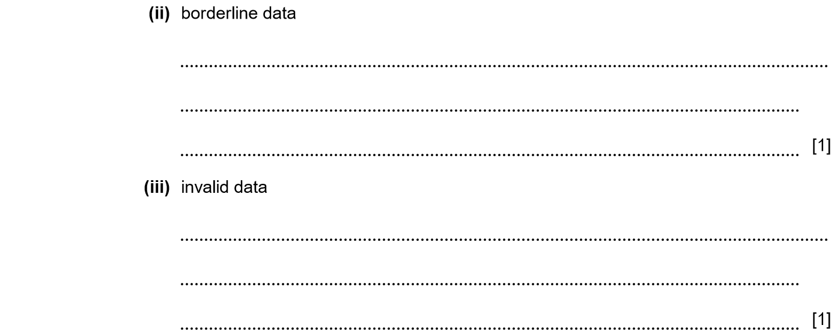

ANSWERS
Part | Answer | Mark | Additional Guidance
4 (a) (i) | A prototype is a model of the intended system. | 1 | Accept “mock up”.
(a) (ii) | To give the user the opportunity to become involved in the design process.  To test that the design will meet the user’s needs.  To help the designer discover that the design is what the user wants. | 1 | Accept any reason for 1 mark.
(b) (i) | Normal data is used to make sure that the system gives expected results when presented with the normal type of input. | 1
(b) (ii) | Borderline data is used to make sure that the system continues to work even with very large or small entries which are still to be expected in use.  Used to test values at the boundaries of different cases. | 1 | Accept any reason for 1 mark.
(b) (iii) | Invalid data is used to make sure that the system rejects it but does not fail when presented with invalid data. | 1

SDLC. ANALYSIS, DESIGN, IMPLEMENTATION, TESTING 2014-2015 (PAPER 1)
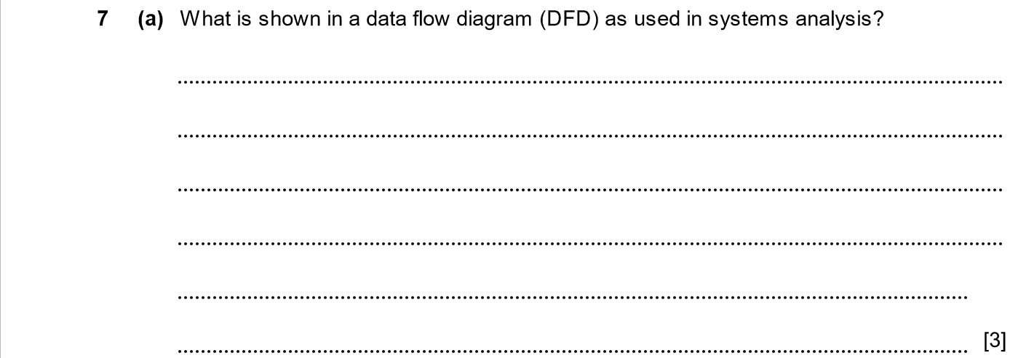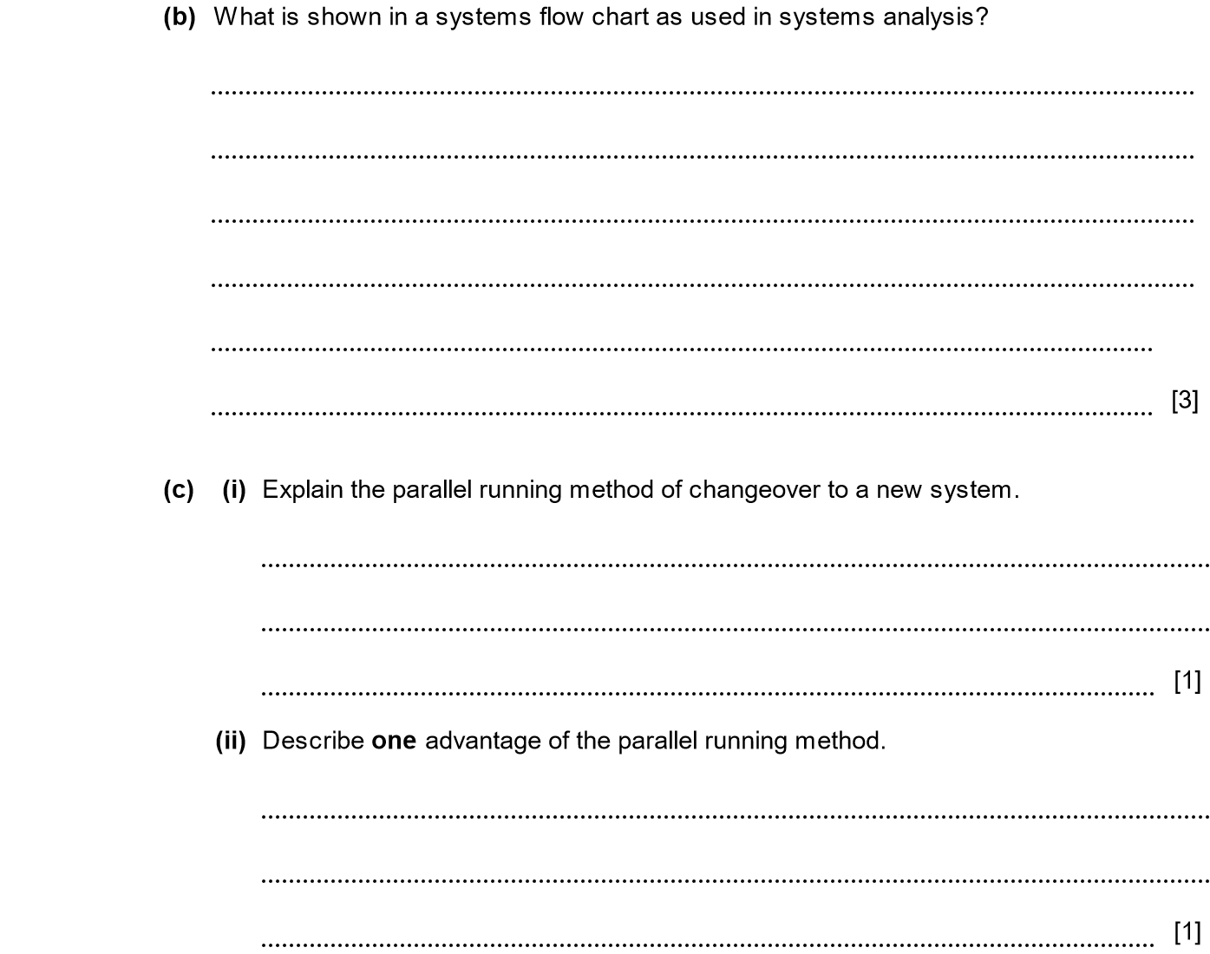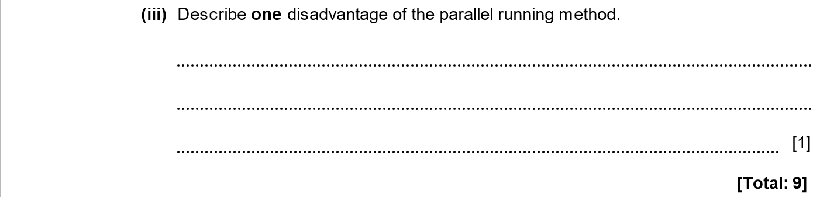
ANSWERS
Part | Answer | Mark | Additional Guidance
7 (a) | How data enters and leaves.  or  External entities connected to the system.  What / how information is processed in the system.  What / where data is stored (files/database).  Labelled arrows showing the movement of data between entities, process and stores.  Distinctive symbols for entities, process and stores. | 1  1  1  1  1  [Max 3] | Accept “enters and leaves the system”.
(b) | All the stages of the processing in order.  Decision points where more than one outcome is possible and how the decision can be made.  Any inputs or outputs which are needed.  Arrows showing flow of data and / or control.  Distinctive symbols for operators, processing, types of store and communication line. | 1  1  1  1  1  [Max 3]
(c) (i) | Parallel running means that the new system is run alongside the old system until there is confidence that the new system is working properly. | 1
(c) (ii) | One advantage is that if there are any problems with the new system, the old system is still available with all the data, etc. | 1
(c) (iii) | One disadvantage is that all the data has to be entered and processed twice which can be very wasteful. | 1 | Accept extra expense, more costly, more time consuming or similar point.
Total |  | 9

SDLC. ANALYSIS, DESIGN, IMPLEMENTATION, TESTING 2015-2016 (PAPER 1)

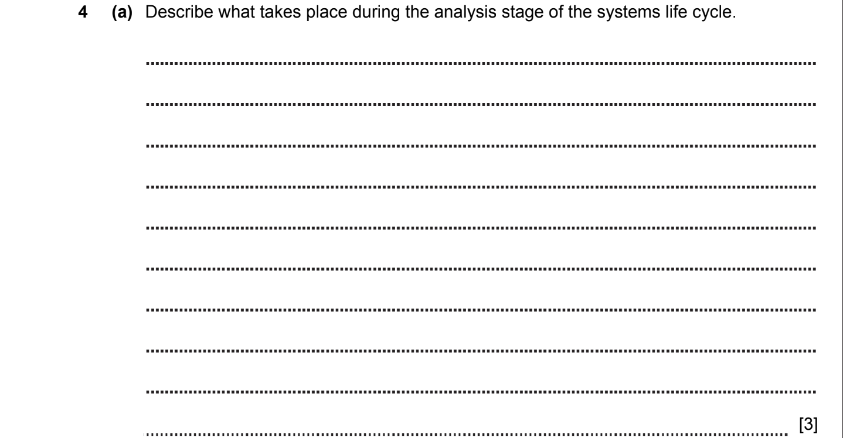
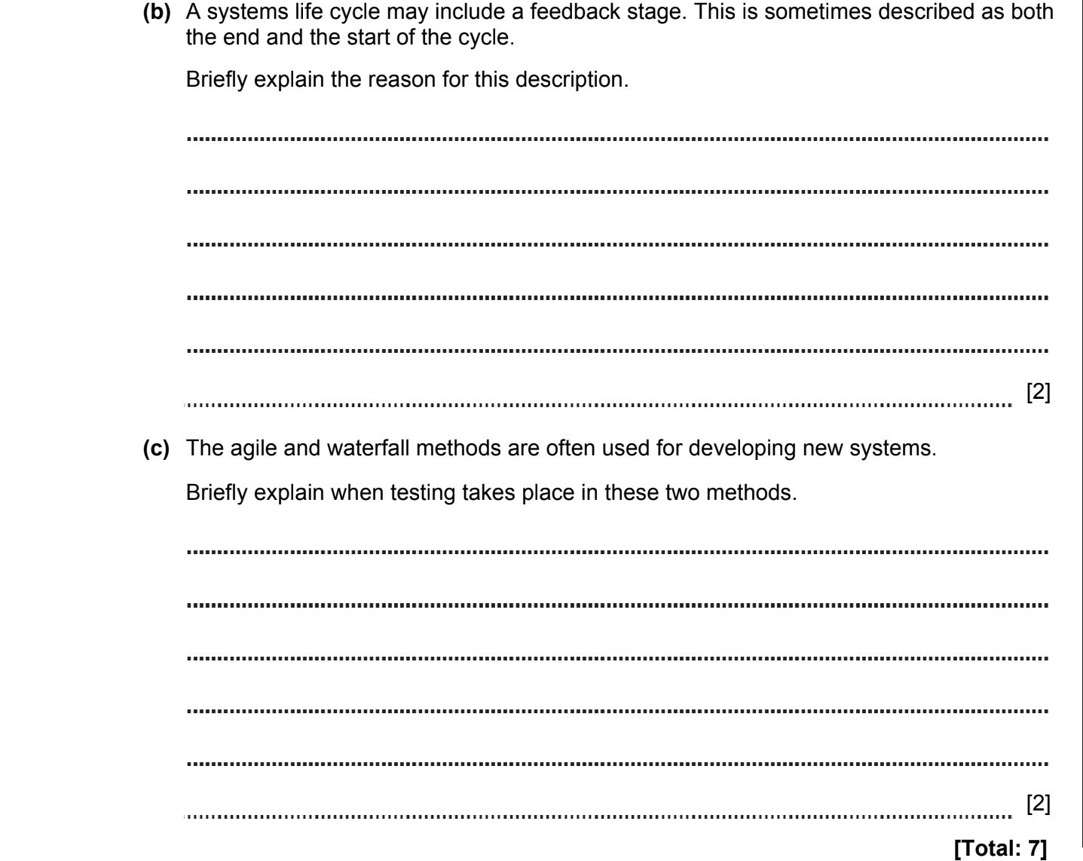
ANSWERS
• Analysis. This is the first step when the team decides what the software needs to do. The main point is to think about what the user will want from the program. At this stage, it might be a good idea to ask other people what they want from the software. Who is going to use it? What information do they need to input? What information or data does it need to output? Consider existing similar systems or determine how the current system works.
• Testing - this involves testing the program under various conditions to make sure it is going to work. You need to think about what devices it could be used on and what might cause the program to crash.

When to use the waterfall model  - This model is used only when the requirements are very well known, clear and fixed.  - Product definition is stable.  - Technology is understood.  - There are no ambiguous requirements  - Ample resources with required expertise are available freely  - The project is short. | The agile model believes that every project needs to be handled differently and the existing methods need to be tailored to best suit the project requirements. In Agile, the tasks are divided to time boxes (small time frames) to deliver specific features for a release.

SDLC. ANALYSIS, DESIGN, IMPLEMENTATION, TESTING 2016-2017 (PAPER 1)

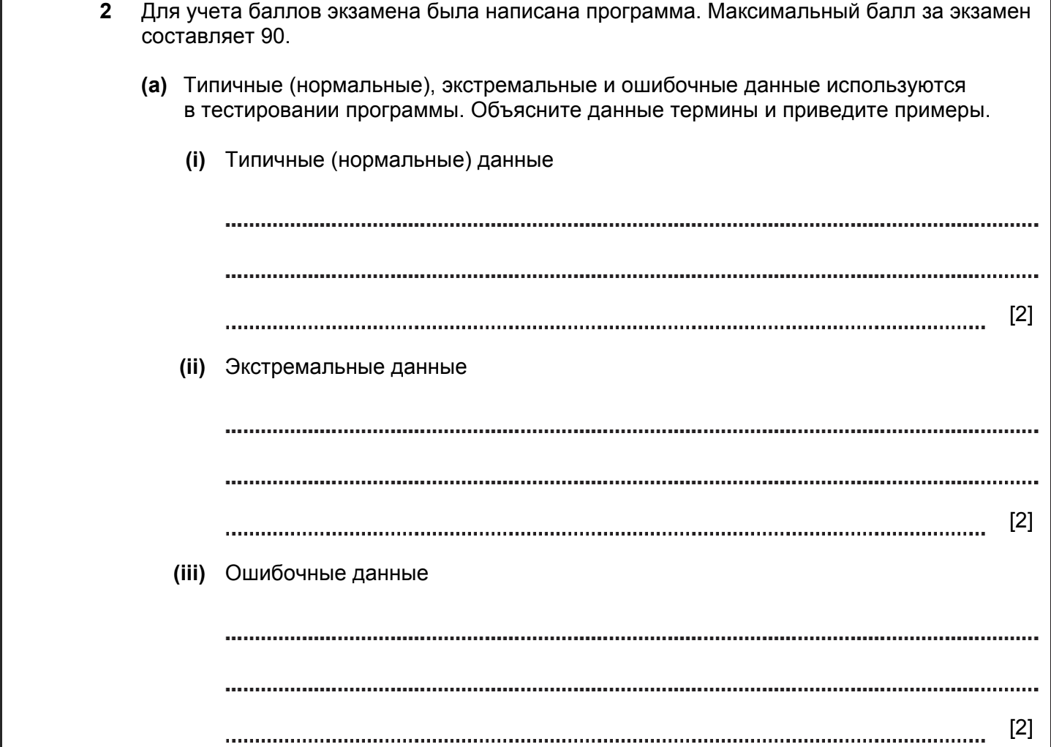

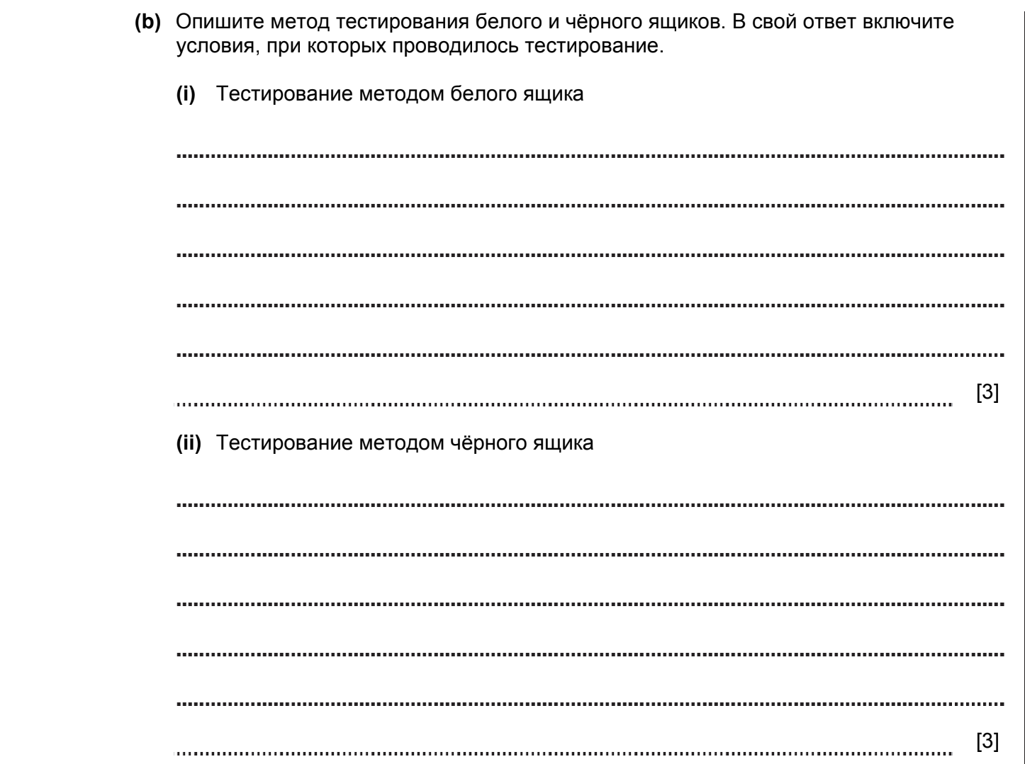

ANSWERS
Part |  |  | Answer | Mark | Additional Guidance
2 | (a) | (i) | Data that is within the parameters for the project, e.g. 30 | 2 | 1 mark for description and 1 for acceptable example
 |  | (ii) | Data on the limits of acceptability, e.g. 0 or 90 | 2
 |  | (iii) | Data that is not within the parameters for the project / is of the wrong data type, e.g. 130 / thirty | 2
 | (b) | (i) | White box testing where the different paths through the software are tested to ensure they produce the result intended.  It will be used when the tester understands the program code.  It tests each branch of the program code and each function within the program code.  Tends to be used during design, need not wait for the system to be complete. | 1  1  1  1  Max 3 | Any 3 valid points; max 3
 |  | (ii) | Black box testing where test data is used for which the intended result is known.  A set of test inputs are provided and fed into the program to make sure that the expected outputs are produced.  The tester is not expected to know anything about the working of the internal code.  Tends to be used for acceptance testing by user when system complete. | 1  1  1  1  Max 3 | Any 3 valid points; max 3
Total |  |  |  | 12

SDLC. ANALYSIS, DESIGN, IMPLEMENTATION, TESTING 2016-2017 (PAPER 1)



ANSWERS
Part |  |  | Answer | Mark | Additional Guidance
5 |  |  | Modelling physical systems, e.g. calculating the forces when designing a new bridge.  Modelling a financial system, e.g. what will happen to a bank if a large number of people withdraw all their money at the same time  Modelling the weather, e.g. working out if the sun will shine or if it will rain by working out how clouds are moving | 1+1  1+1  1+1 | 1 mark for each example and 1 mark for a description with the example  Accept any reasonable type of modelling and example
Total |  |  |  | 6

SDLC. ANALYSIS, DESIGN, IMPLEMENTATION, TESTING 2016-2017 (PAPER 1)
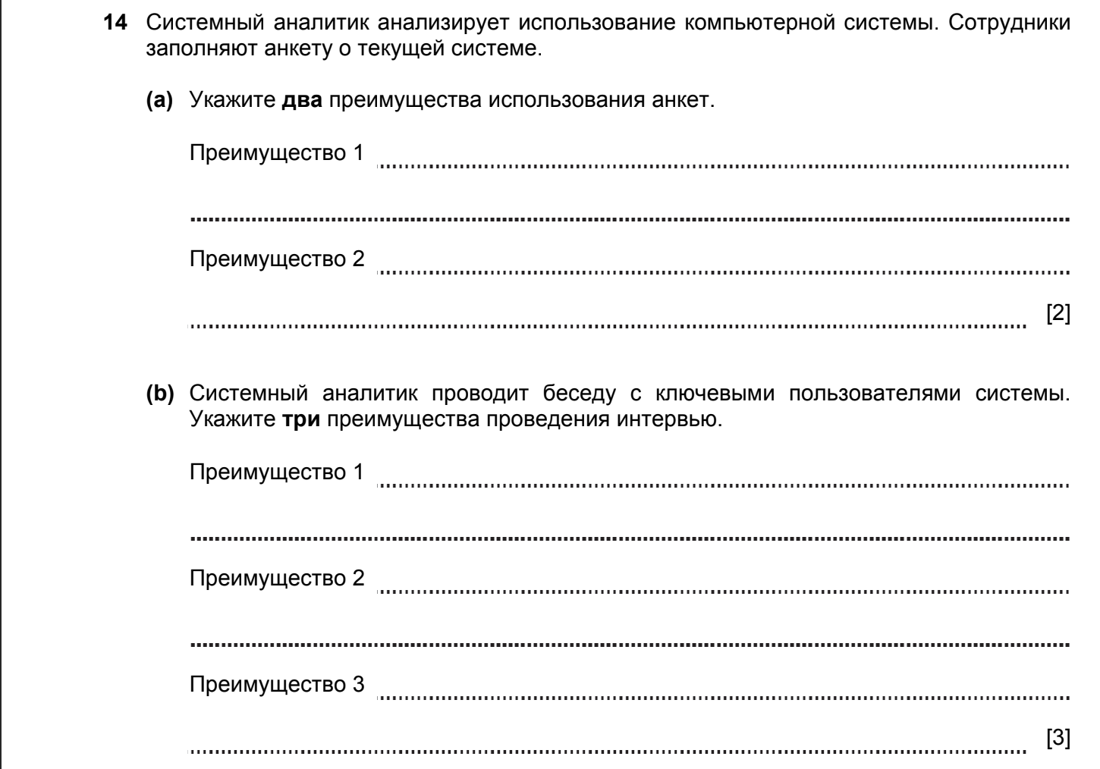

ANSWERS
Part |  |  | Answer | Mark | Additional Guidance
14 | (a) |  | Quick for users to complete  Easy to analyse data  Focus on specific topics  Very structured data | 1  1  1  1  Max 2 | Any 2 valid points
 | (b) |  | Can explain questions  Can probe more fully  Can ask follow up questions | 1  1  1  Max 3 | Any 3 valid points
Total |  |  |  | 5

SDLC. ANALYSIS, DESIGN, IMPLEMENTATION, TESTING 2017-2018 (PAPER 1)

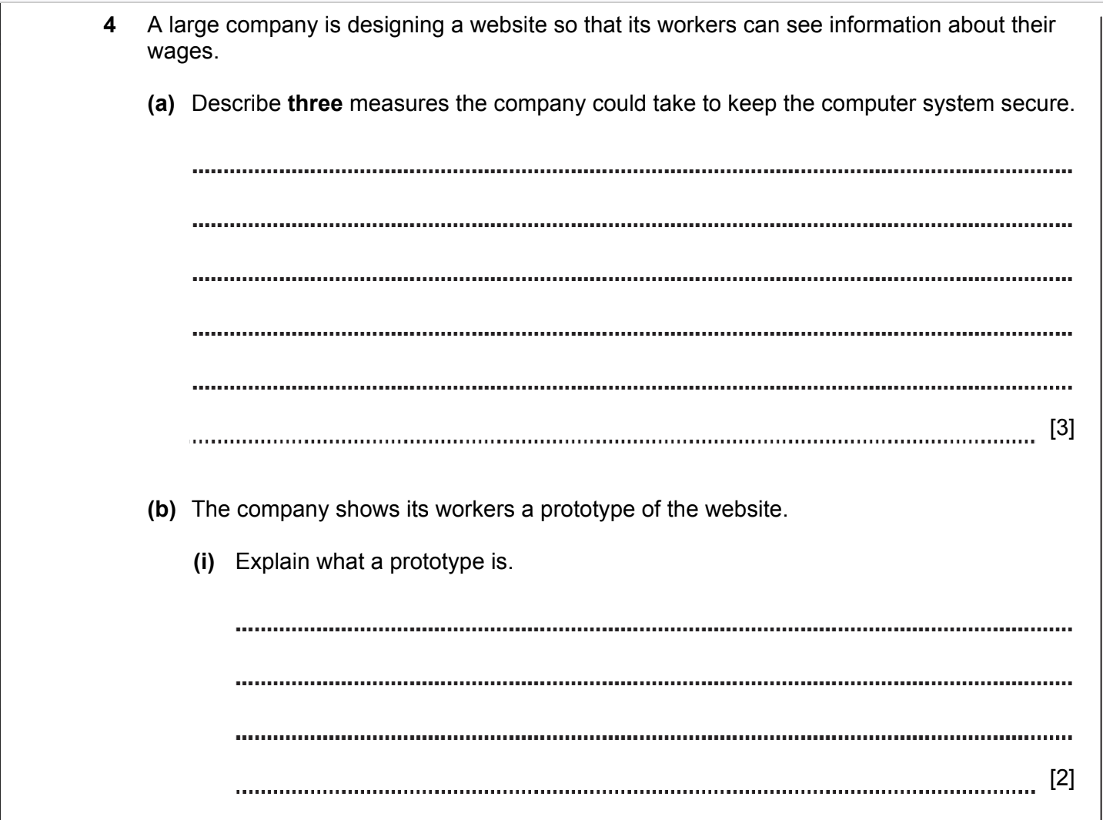
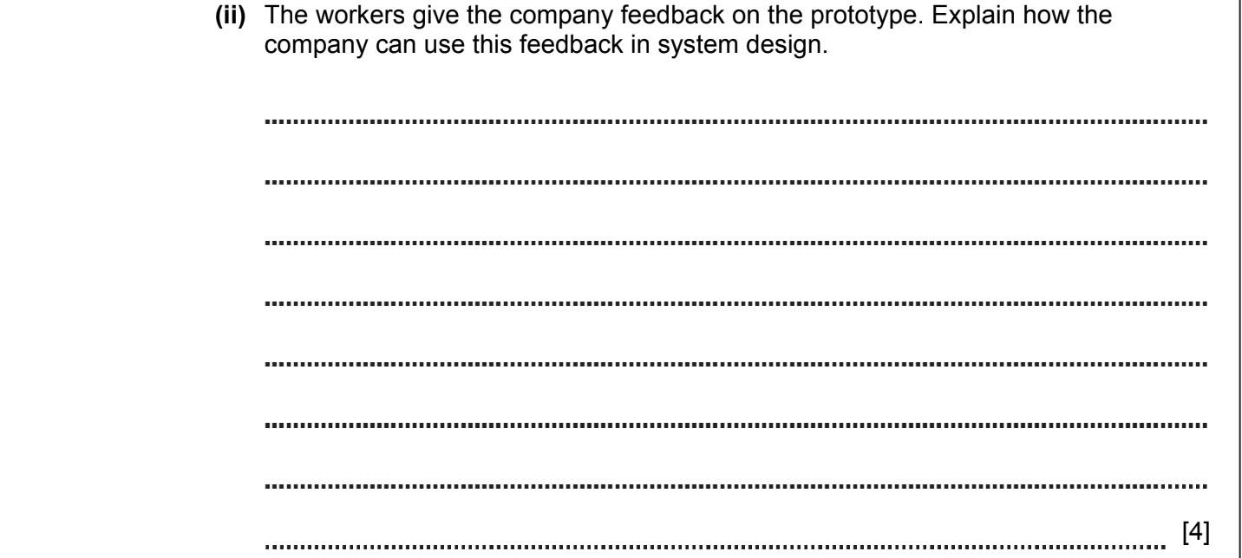

ANSWERS
Part | Answer | Mark | AO | Further Information
(b) (i) | A prototype is a model of the final product.  The prototype does not work but will allow users to see the way in which the web-site/system will function.  Prototype will show screen layouts, menus, forms etc. | 1  1  1  [max 2] | AO1
(ii) | Workers will make comments on the parts of the prototype that might not work or are not easy to understand.  The design will be changed if necessary / The user interface will be improved.  Functions added / improved.  A new prototype will be produced and re-tested.  This continues until all issues are resolved. | 1  1  1  1  1  [max 4] | AO2 | Allow аny other reasonable answers

SDLC. ANALYSIS, DESIGN, IMPLEMENTATION, TESTING 2017-2018 (PAPER 1)

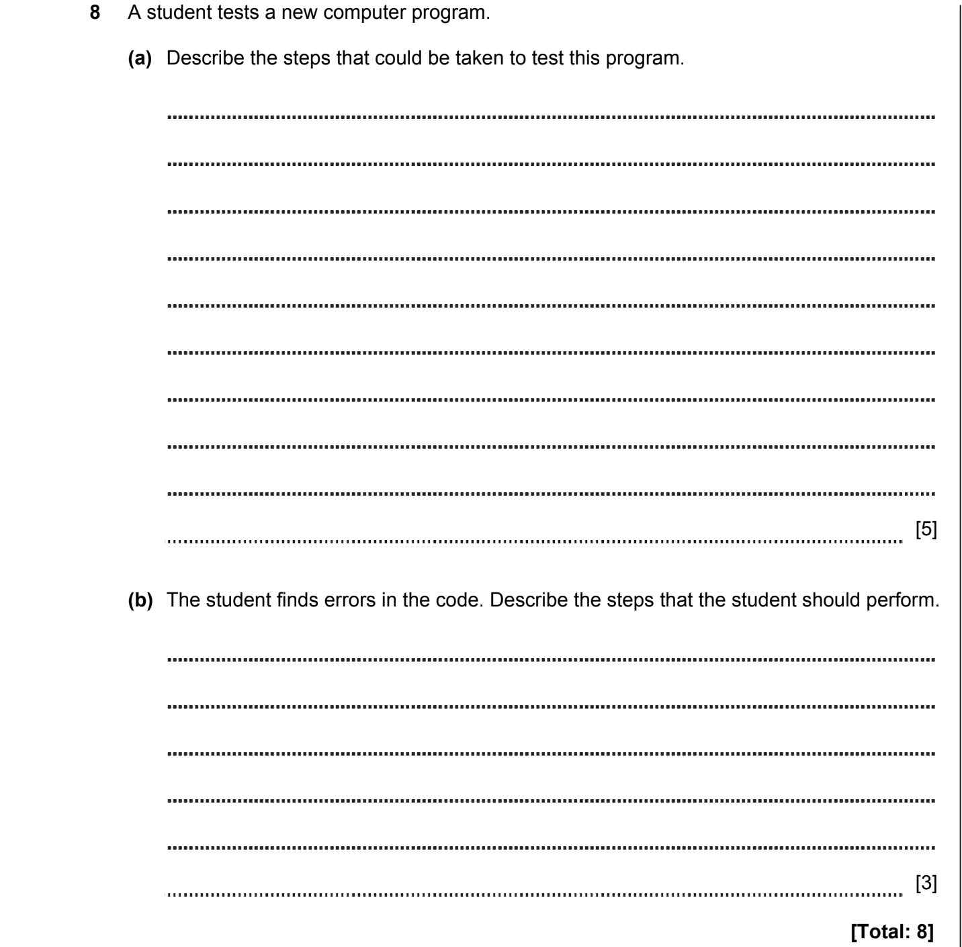

ANSWERS
Part | Answer | Mark | AO | Further Information
8(a) | Three types of test data are chosen.  Normal, extreme and invalid.  Each set of data is entered into the computer.  The results produced are checked to make sure that they are correct for the normal and extreme data.  The program should reject the invalid data.  Records are made of the success or otherwise of the testing. | 1  1  1  1  1  1  [max 5] | AO1 | Allow other valid answers.
(b) | The student attempts to fix the faults.  The student re-tests the program.  The student continues this until the faults are repaired. | 1  1  1  [max 3] | AO2 | Answers do not need to refer to the students directly.  Accept the answer if the student determines the type of error.
Total |  | 8

SDLC. ANALYSIS, DESIGN, IMPLEMENTATION, TESTING 2018-2019 (PAPER 1)

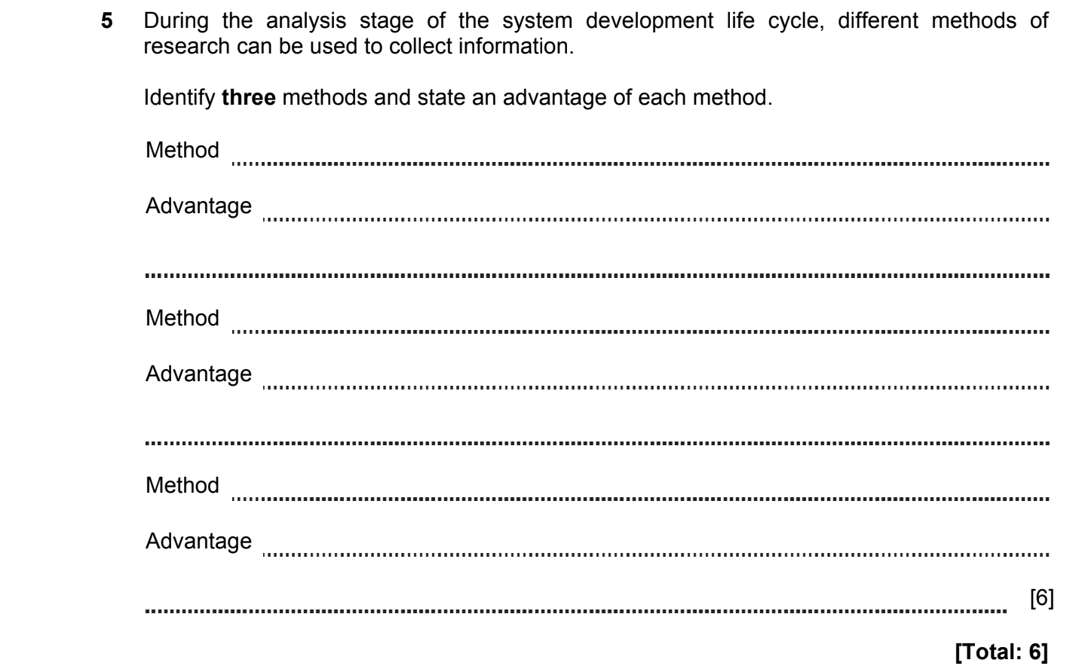

ANSWERS
Part | Answer | Mark | AO | Further Information
5(a) | Time efficient means that the algorithm will complete as quickly as possible | 1 | AO1 | Accept reference to binary search
5(a) | It has been optimised to remove unnecessary or repetitive steps | 1 | AO1 | Accept reference to binary search
(b) | The binary search is efficient because in a sorted list you can immediately eliminate half the data from the search at each stage | 1 | AO1
(b) | The algorithm does not need to compare every item in the list to the search item | 1 | AO1
(b) | Binary search takes contents space (O(1)) so the space taken by the algorithm is the same for any number of elements in the array | 1 | AO1
(b) |  | [max 2] | AO1
(c) | A trace table shows the values of each variable at each stage of the process | 1 | AO1  (1) | Accept answers with reference to the binary search
(c) | The steps of the algorithm are manually followed | 1 | AO2  (2) | Allow selectors/classes/ID/tags
(c) | The variables in the table are updated to show the result of each step | 1 | AO2  (2)
Total |  | 7

SDLC. ANALYSIS, DESIGN, IMPLEMENTATION, TESTING 2018-2019 (PAPER 1)

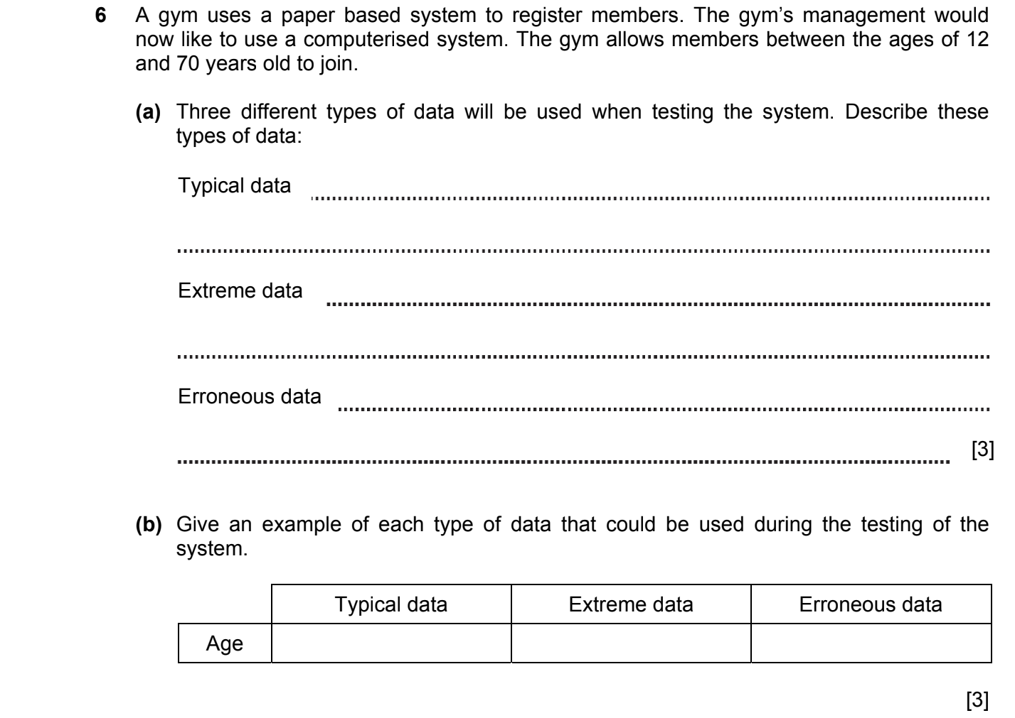

ANSWERS
Part | Answer | Mark | AO | Further Information
6(а) | Typical data – data that will work within the system/ enter the specified range  Extreme data is on the boundary of normal or erroneous but is valid.  Erroneous data – data that should definitely fail or data that is the wrong data type/ not within the specified range | 1  1  1  [3] | AO2
6(b) | Typical/valid data between 12 and 70, e.g. 23  Extreme data e.g. 12 or 70  Erroneous/invalid data e.g. -15 or ‘fifteen’ or ‘gjkhg’ or 5.8 or 11 or 71 or blank response | 1  1  1  [3] | AO1

SDLC. ANALYSIS, DESIGN, IMPLEMENTATION, TESTING 2020-2021 (PAPER 1)

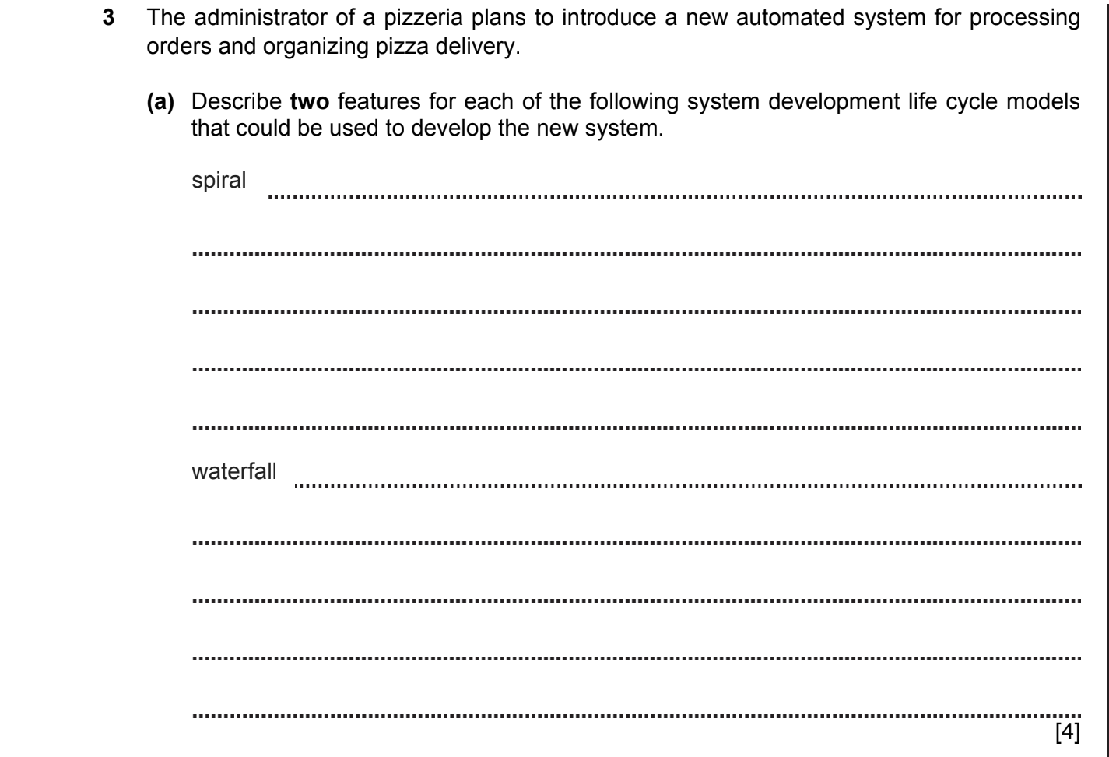
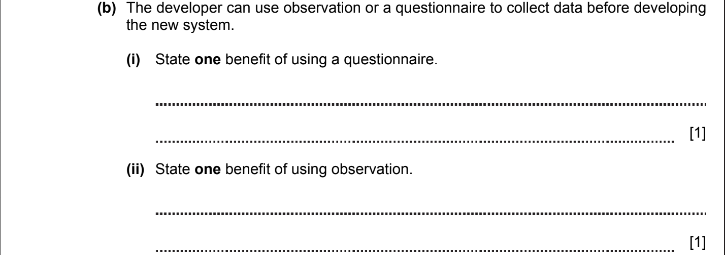

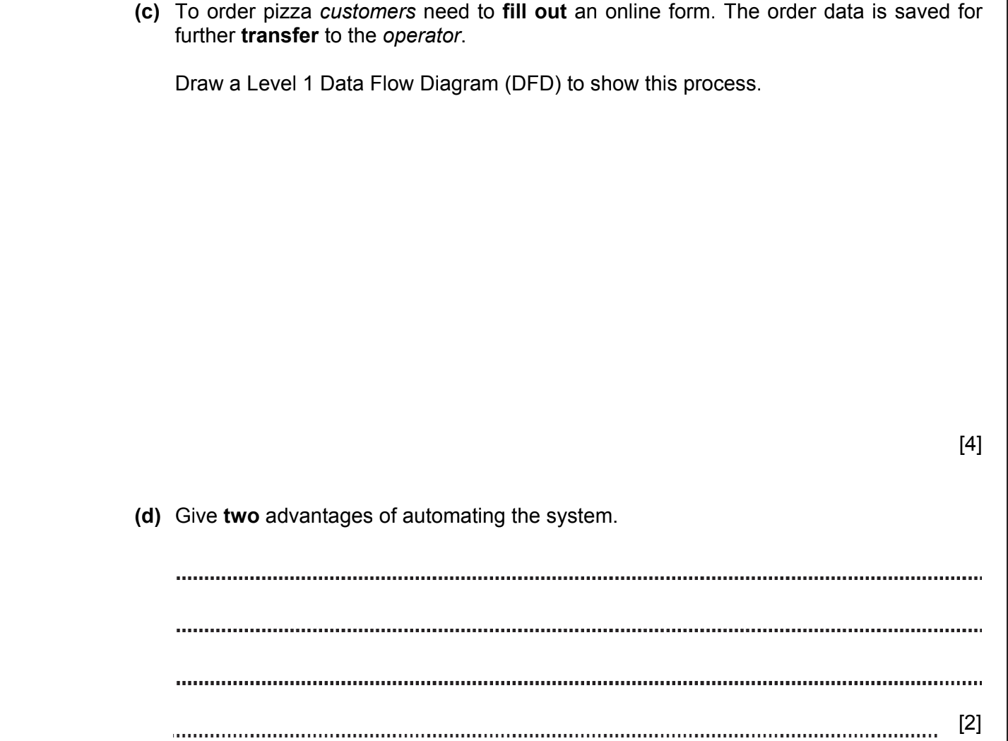
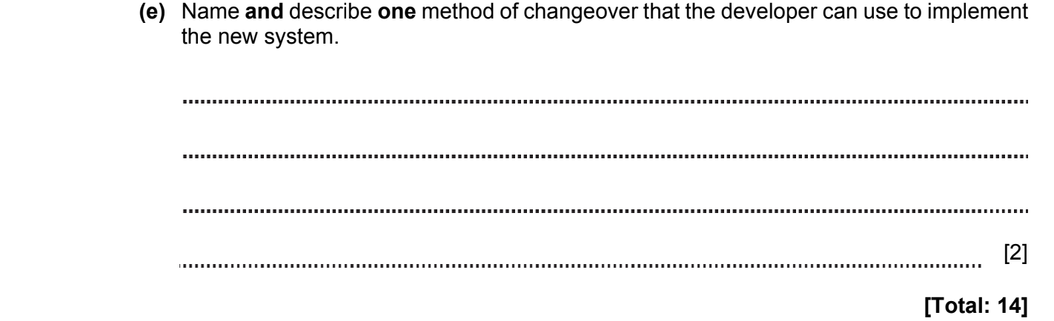

ANSWERS
Part | Answer | Mark | AO | Further Information
3a | Spiral  Spiral is an iterative process.  Each completed cycle represents a working version of the system.  Customer’s feedback after each completed cycle.  Waterfall  The quality of the product is evaluated at each stage.  Feedback is absent between stages.  All stages are performed sequentially.  All details are discussed at an early stage.  The transition to the next stage is not possible without completing the previous one. | 1  1  1  1  1  1  1  1  [max 4] |  | Max 2 marks for each model.  Accept any correct answers.
3b(i) | Gives quantitative information.  Large number of people are involved. | 1  1  [max 1] |  | Allow any reasonable answers.
3b(ii) | Direct contact between the developer and the client (system). | [1] |  | Allow any reasonable answers.
3c | For entities (Customer, Operator)  For process (Fill the form, Output / Transfer)  For data storage (e.g. Orders)  For data flow  Example:  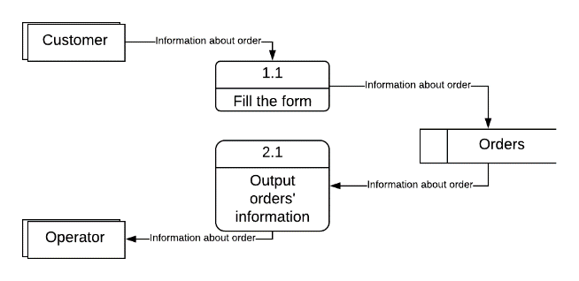 | 1  1  1  1  [max 4] |  | Do not allow data flow without labels and correct arrows.
3d | Security. Only manager has an access to the data.  Easy management and data control.  Manager can edit and search for data very quickly. | 1  1  1  [max 2] |  | Allow any reasonable answers.
3e | Direct implementation  To start a new system, the old system completely stops working. All the data that was previously entered in the old system, now go to a new one.  Parallel implementation  The old system and the new system work together until the effectiveness of the new system is proven.  Phased implementation  The new system is introduced step by step, gradually replacing parts of the old system.  Pilot implementation  The new system is primarily piloted (tested) in one part of the business / organization (for example, only in one office or only in one department).  Once the pilot system is working successfully, a new system is introduced into the entire business / organization. | 1  1  1  1  1  1  1  1  [max 2] |  | 1 mark for the name of any method  1 mark for its description
 | Total | 14

SDLC. ANALYSIS, DESIGN, IMPLEMENTATION, TESTING 2021-2022 (PAPER 2)
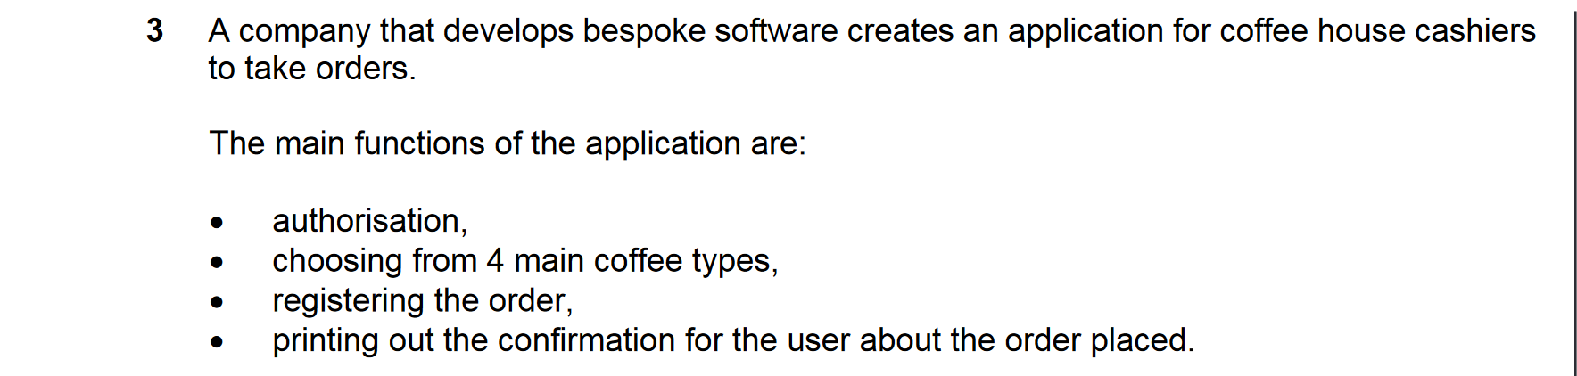
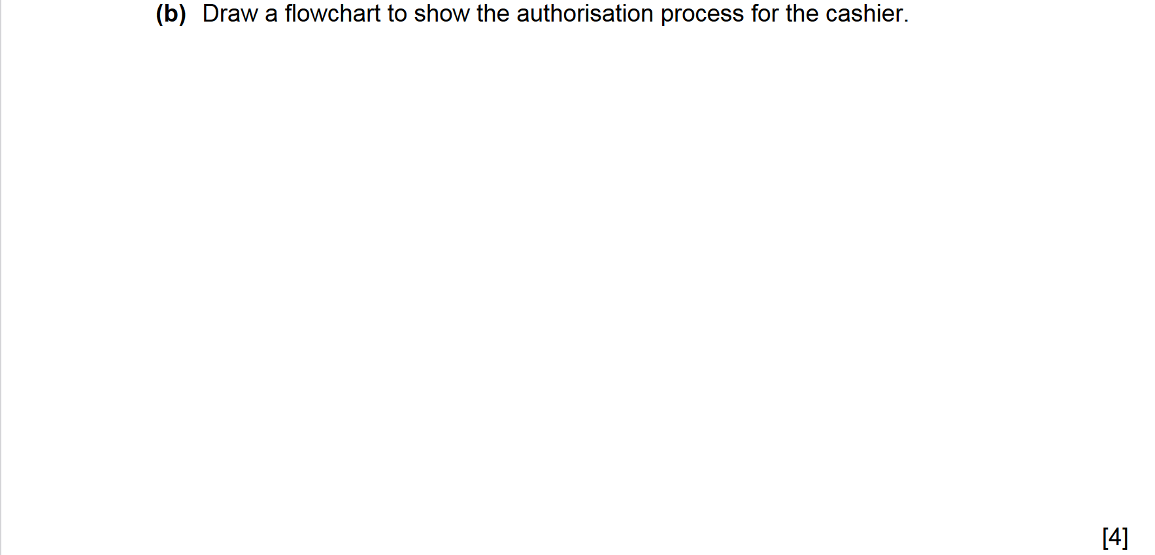

ANSWERS
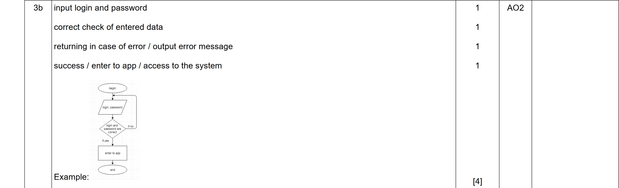

SDLC. ANALYSIS, DESIGN, IMPLEMENTATION, TESTING 2021-2022 (PAPER 2)

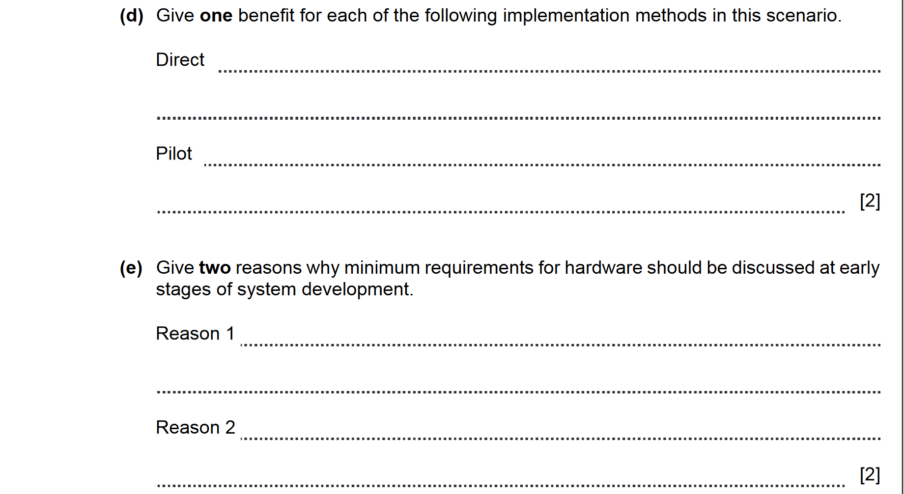

ANSWERS
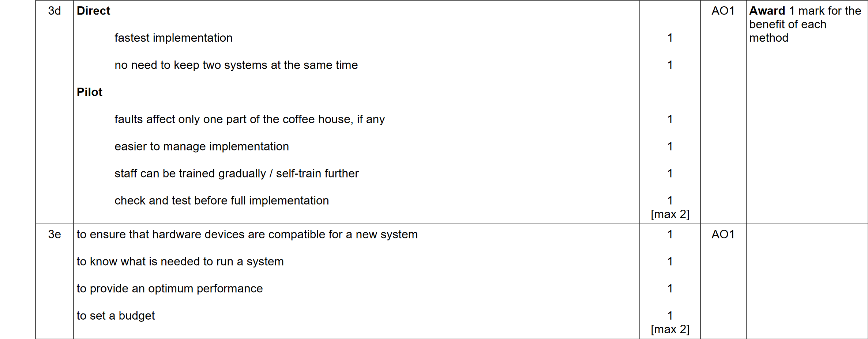

SDLC. ANALYSIS, DESIGN, IMPLEMENTATION, TESTING 2021-2022 (PAPER 2)

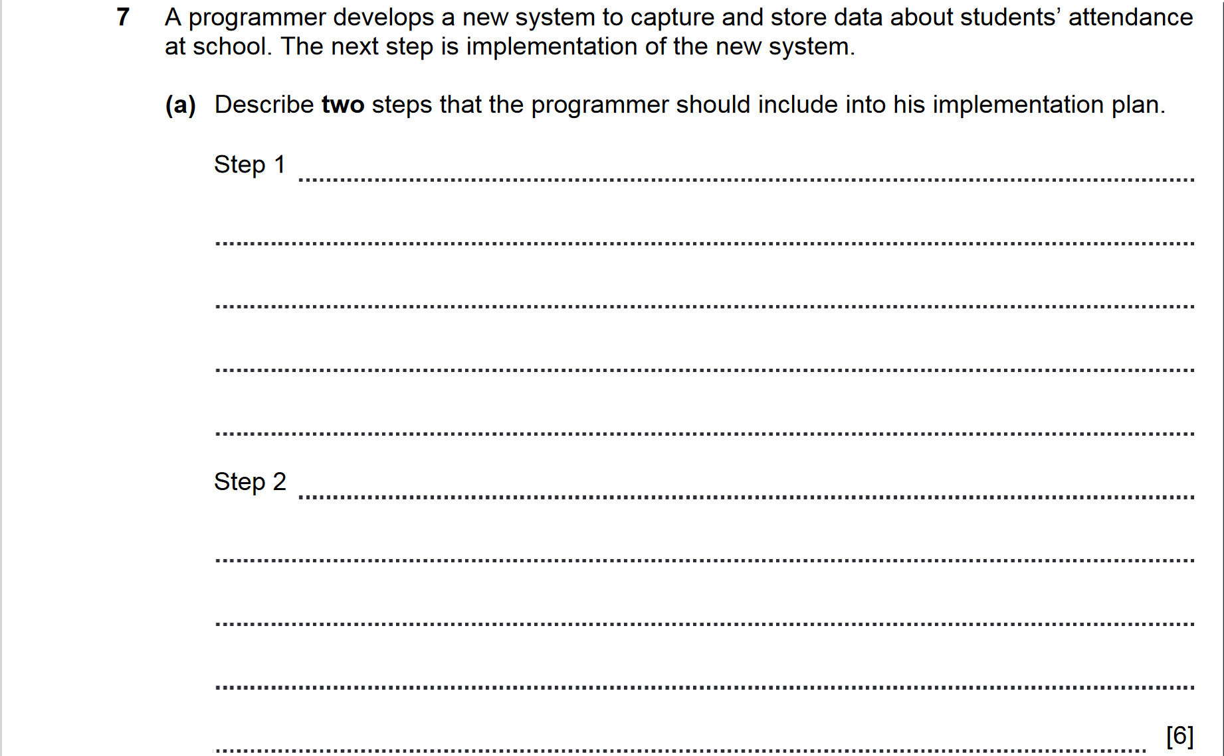

ANSWERS
